What is phonics?

Phonics is a way of teaching children how to read and write. It helps children hear, identify and use different sounds that distinguish one word from another in the English language.Written language can be compared to a code, so knowing the sounds of individual letters and how those letters sound when they’re combined will help children decode words as they read.

Understanding phonics will also help children know which letters to use when they are writing words.

Phonics involves matching the sounds of spoken English with individual letters or groups of letters. For example, the sound *k* can be spelled as c, k, ck or ch.

Teaching children to blend the sounds of letters together helps them decode unfamiliar or unknown words by sounding them out. For example, when a child is taught the sounds for the letters *t*, *p*, *a* and *s*, they can start to build up the words: “tap”, “taps”, “pat”, “pats” and “sat”.

*Definition taken from The National Literacy Trust*

How do we teach phonics at Springvale Primary School?

Once our children begin in school we find out what they already know. Some children are at the very beginnings of hearing and discriminating between sounds and some may already know some sounds and letters. We then make sure that all children receive their next steps in learning and are placed in an appropriate teaching group.

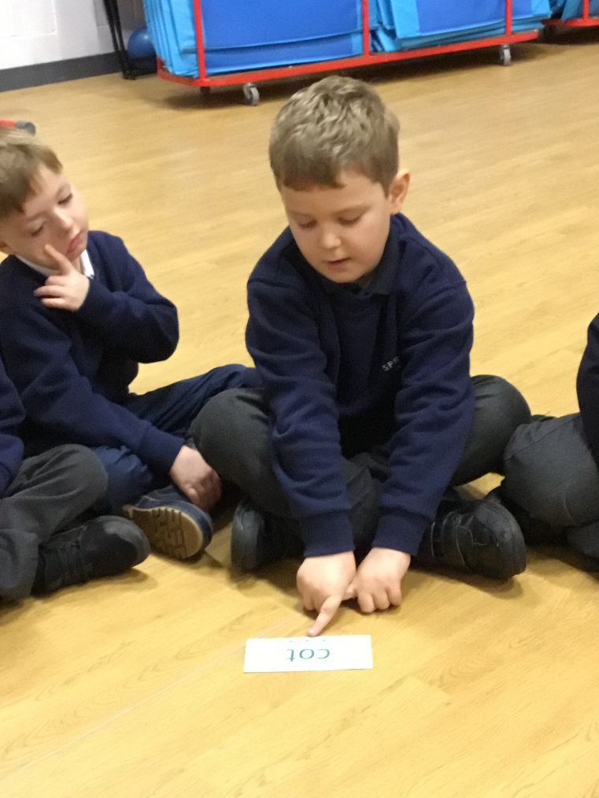Between 9.05 and 9.30am we teach phonics using the Read, write inc teaching materials and resources.

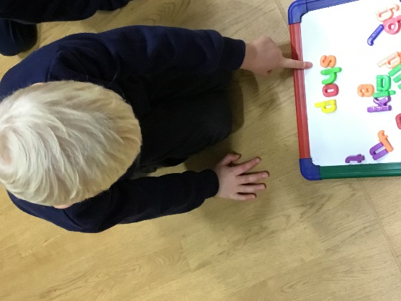 Children work in various groups from F2

to Y3. Children learn letter sounds and quickly

begin ‘blending’ them together to read whole

words. Children learn about how there

are ‘special friends’ where two letters join to

make one sound ie ‘sh’.

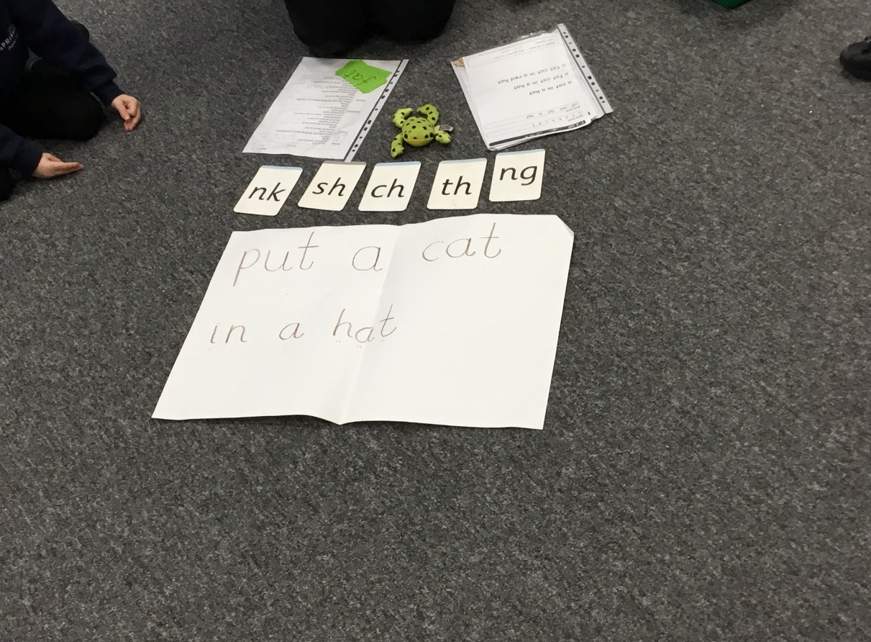Teaching then moves onto children

being able to read and write simple

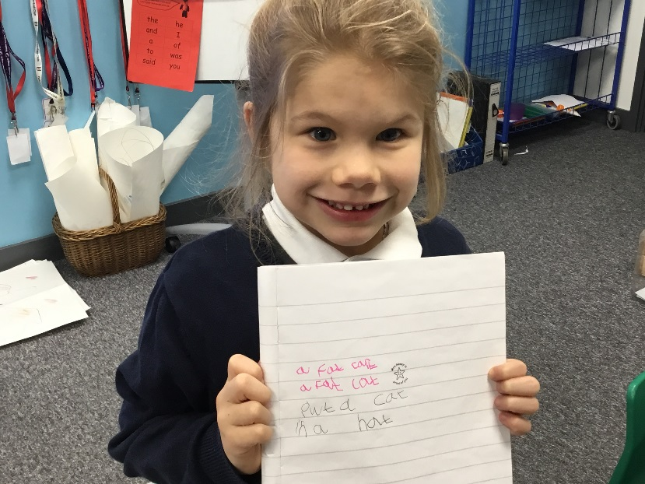captions.

Children learn and practise to read whole words that they will need in the story book. Stories and captions are repeated several times throughout the week to develop fluency in reading. They gain confidence by working with partners.

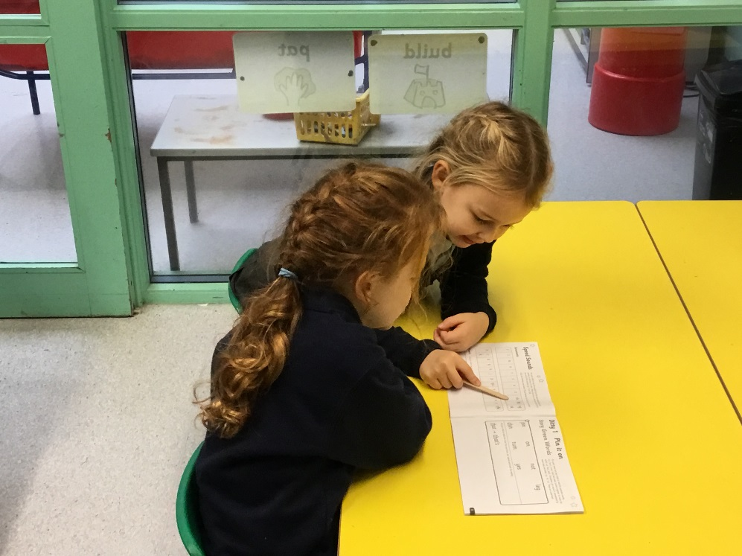

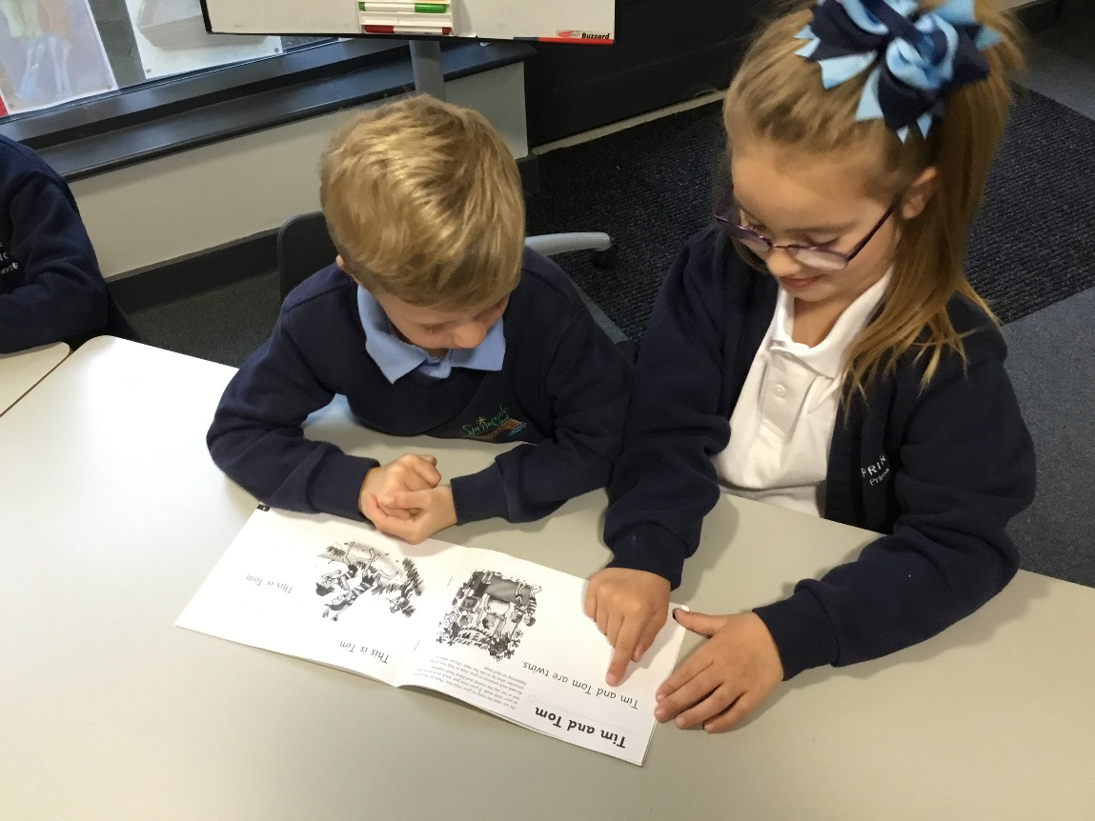

As well as learning to read words that can be phonetically blended ie ‘r-oo-f’, ‘ch-ai-n’ (referred to as green words in read, write inc), children also learn the common exception words that cannot be blended (referred to as red words in read, write inc).

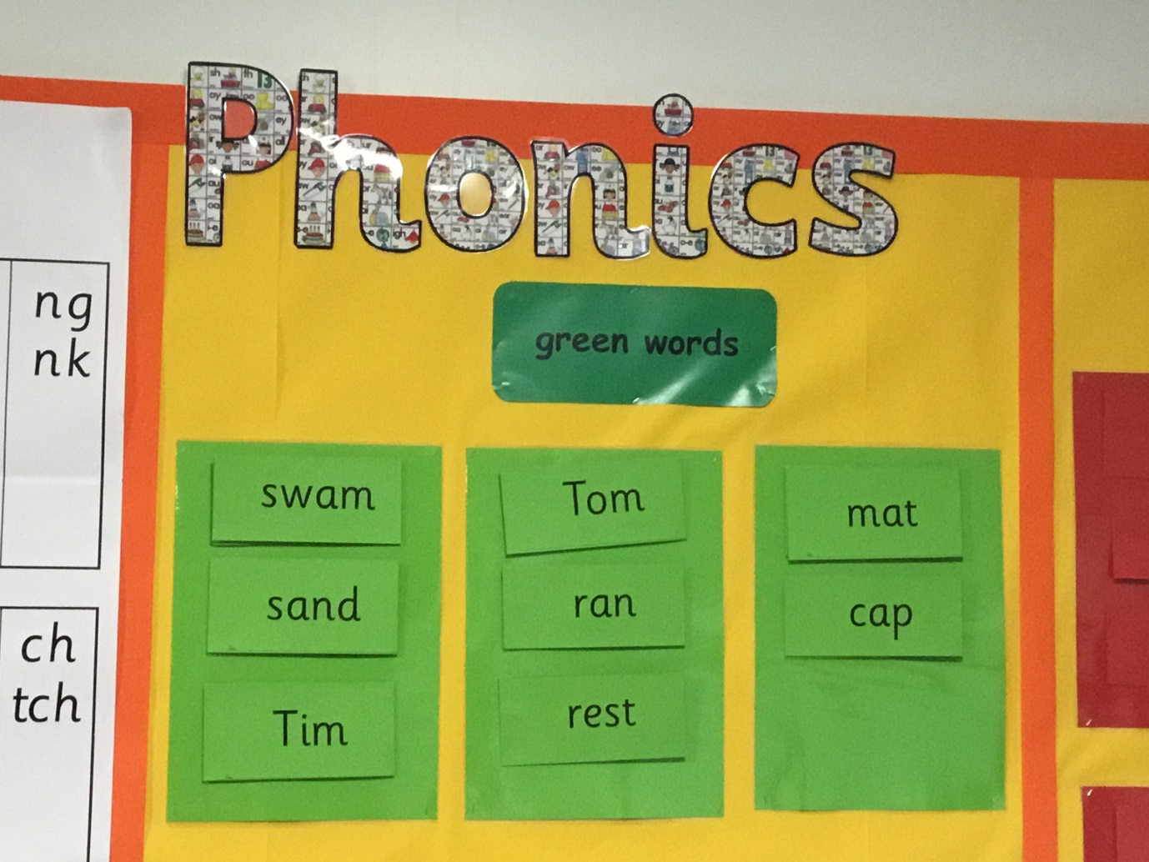

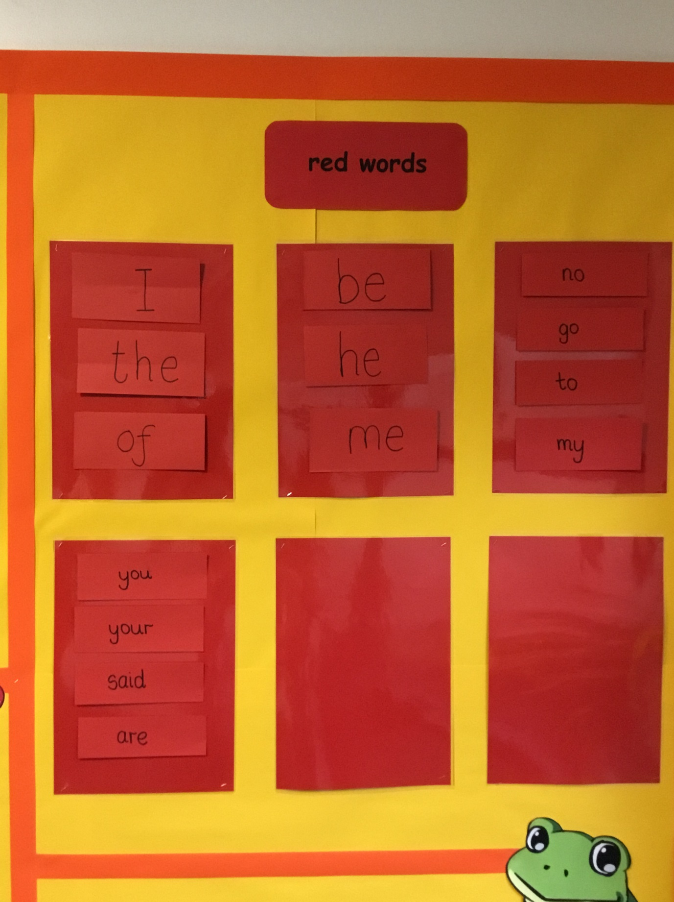

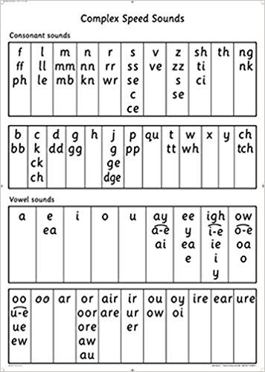They learn that there are many ways to spell one sound.

For example, there is ‘or’ as in ‘for’

‘aw ‘as in ‘paw’

‘oor’ as in ‘poor’

‘ore’ as in ‘store’

There can also be more than one way to read a sound!

For example, there is ‘oo’ as in ‘food’

‘oo’ as in ‘took’

Posters and sound mats are displayed and used as resources to help children learn these sounds.

Children can then begin to learn how to read words that are multi-syllabic. They learn to ‘sound out’ and then blend the sounds altogether.

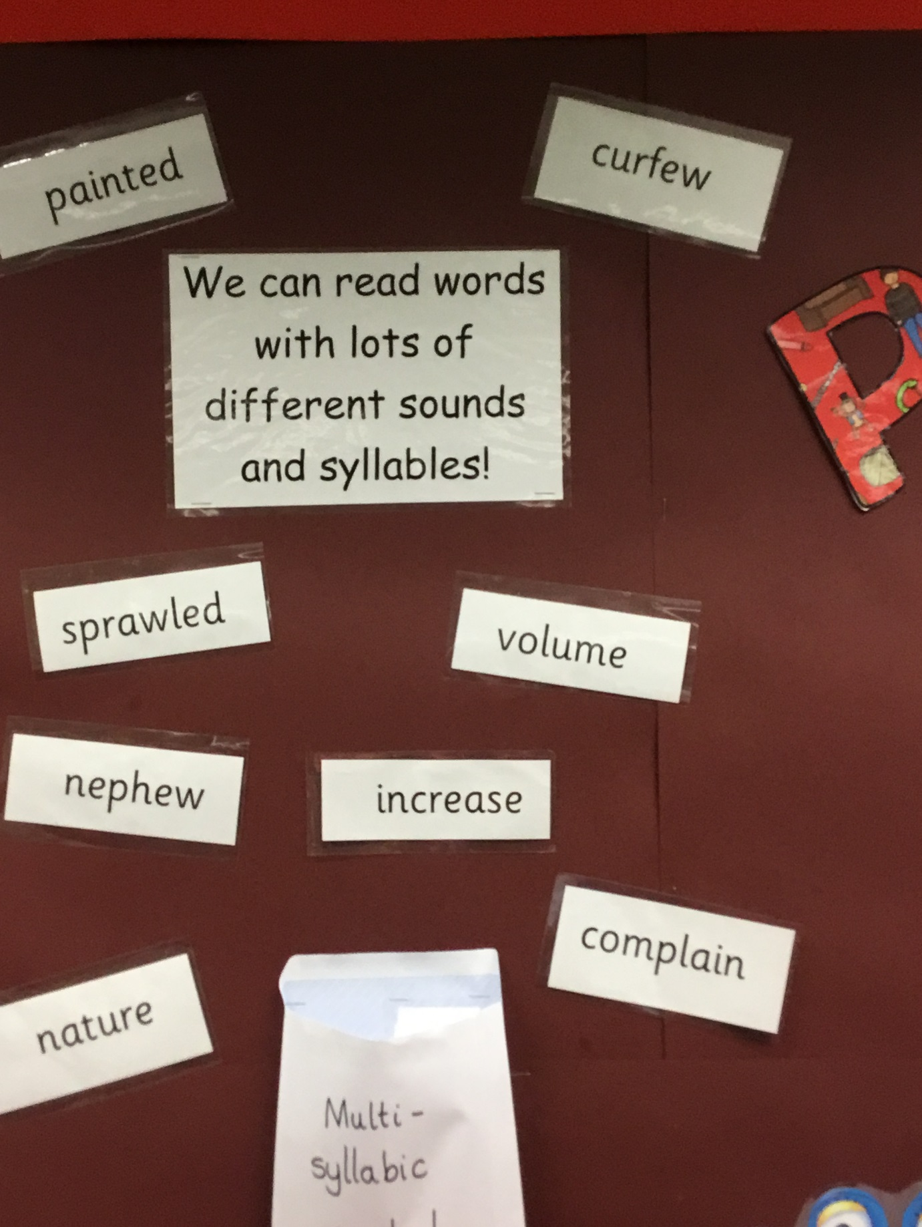

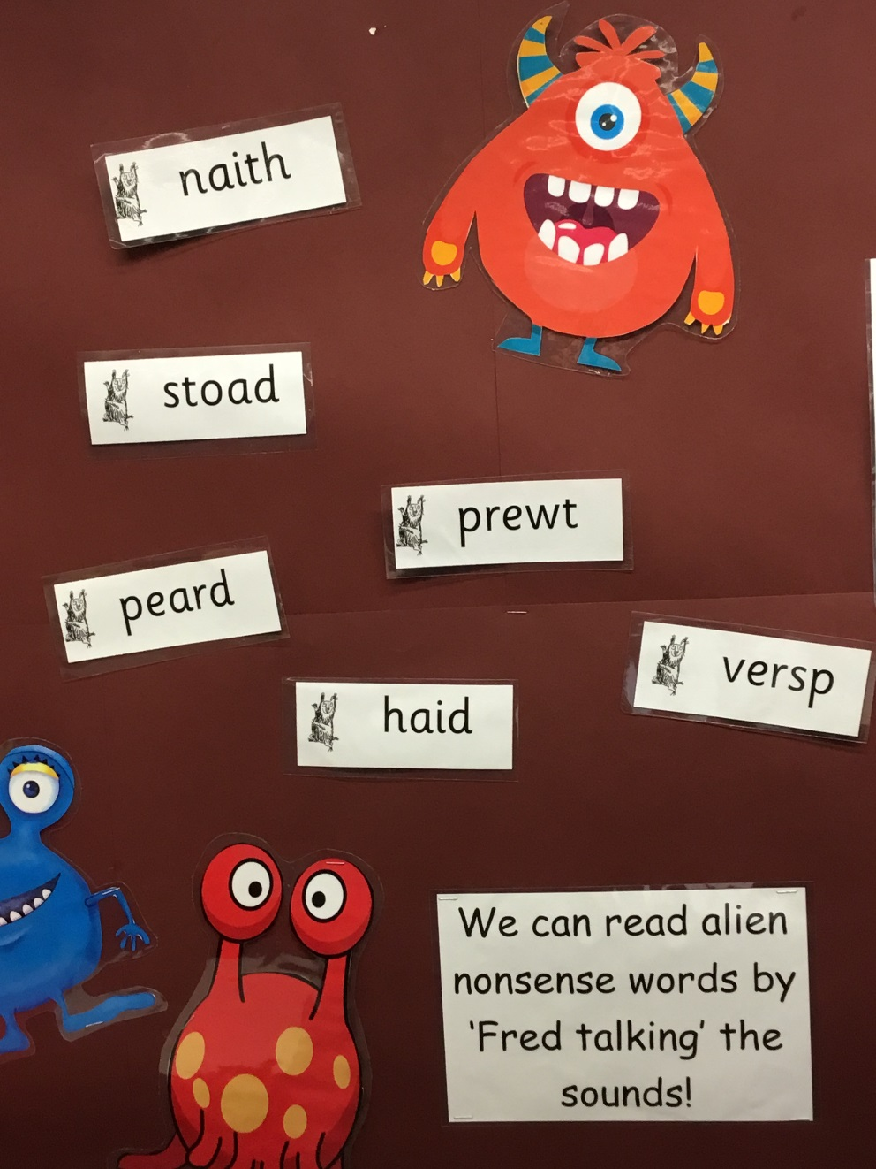As well as reading real words it is important that children have opportunity to read ‘alien’ or ‘nonsense’ words. This really tests their skills of decoding and using the sounds taught!

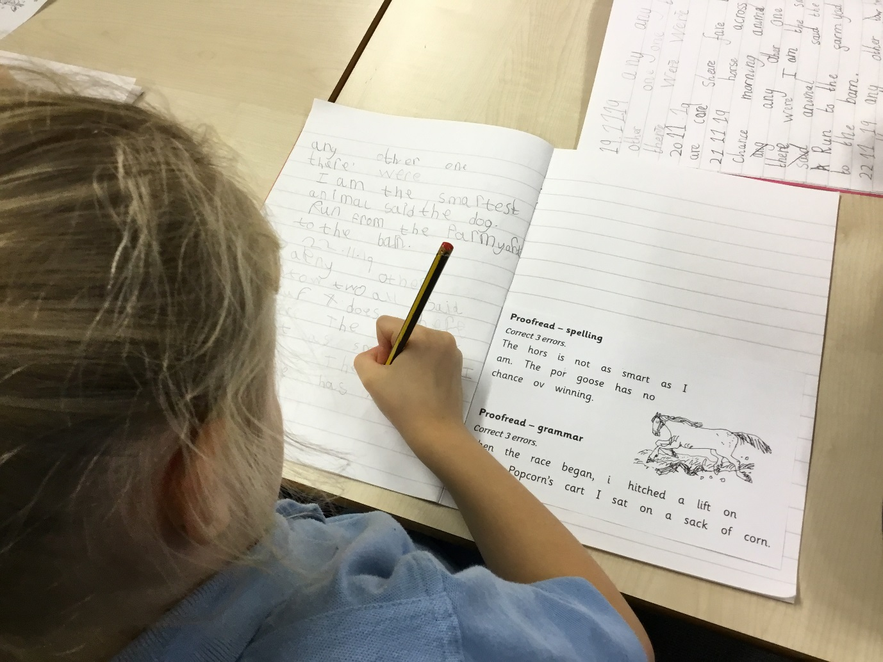Punctuation and grammar are introduced too.

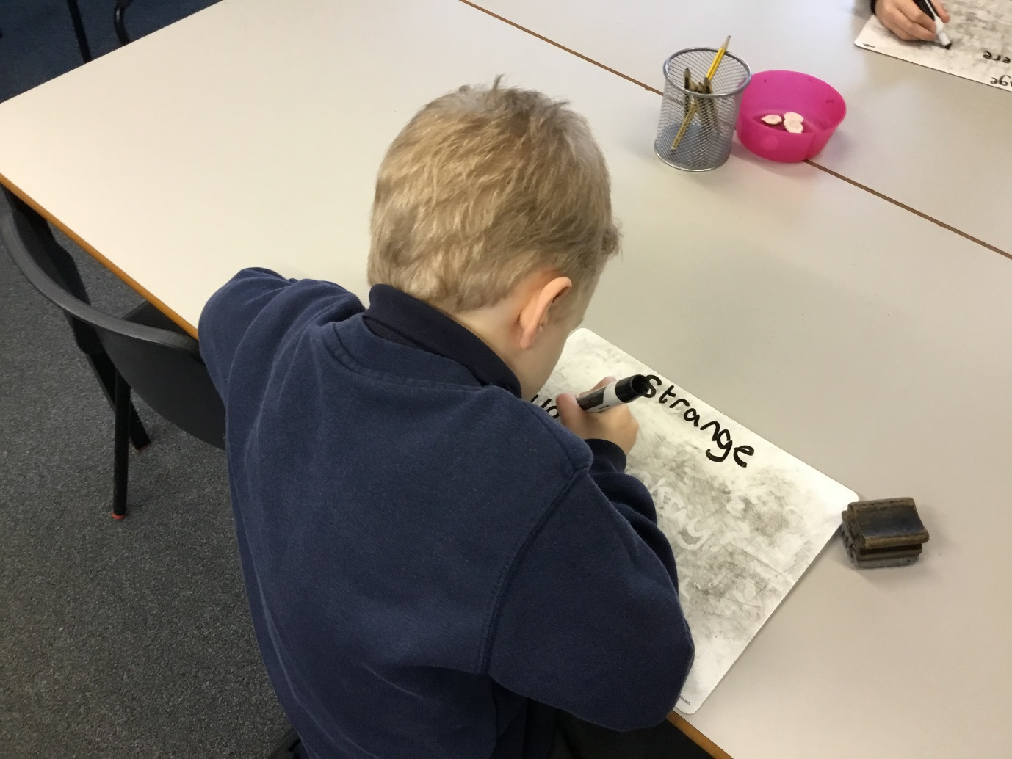As children move through Key Stage 1 they will learn new, alternative spelling patterns and apply these in their writing. Here they are learning ‘ge’ for example.

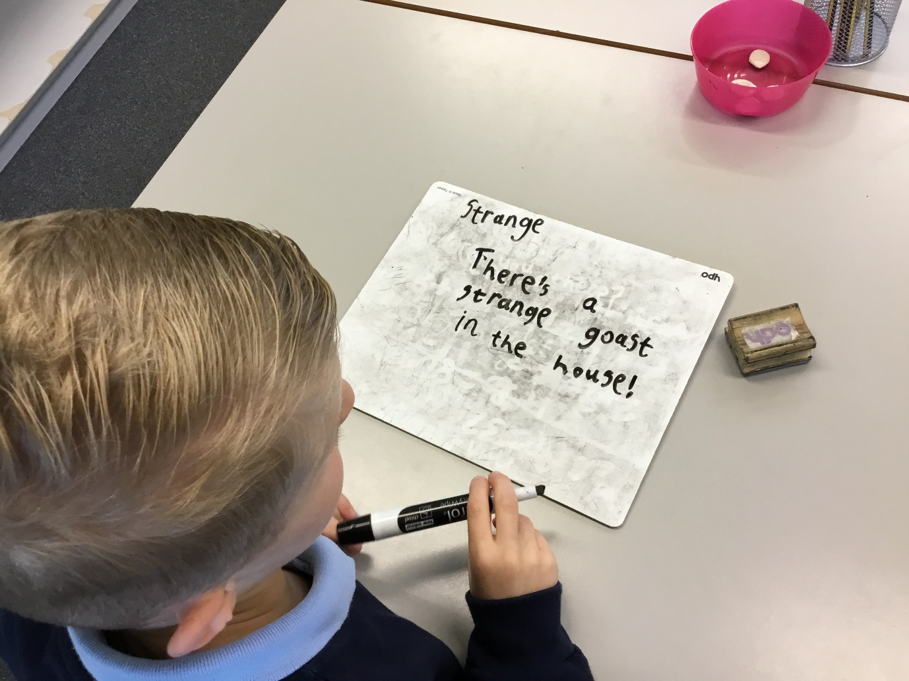This word has been applied into a sentence. He has used a capital letter, apostrophe and exclamation mark. He has spelt ‘ghost’ as ‘goast’ because he has sounded it out using the spelling pattern he knows.