**Springvale Primary School**

**Intent Statement**

**Art & Design**

**2019-20**

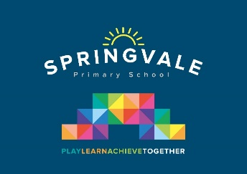

***Leaders: Mrs R Tomlinson***

**Art & Design Statement of Intent**

***‘Intent’***

At Springvale Primary school our curriculum for art and design intends to ensure that all pupils: produce creative work, exploring their ideas and recording their experiences, become proficient in drawing, painting, sculpture and other art, craft and design techniques, evaluate and analyse creative works using the language of art, craft and design and know about local and great artists, craft makers and designers.

By the end of Key Stage 1 the children will have the knowledge and skills to experiment, invent and create their own works of art, craft and design. They will have learned about the work of a selection of artists through history and will be confident in themselves as artists.

By the end of Key Stage 2 pupils will have deepened their knowledge of artists and their impact on the world. They will have developed their own skills as an artist over time building on skills learned in drawing, painting and sculpture throughout their primary years. They will have learned to observe artwork closely and created their own artwork using the techniques and styles pioneered by others. Children will have visited art galleries locally and know where the great art works of the world can be seen.

**This statement sits alongside our ‘Curriculum and Learning Policy’**

|  |  |  |
| --- | --- | --- |
| K**NOWLEDGE…I know** | **…therefore….** | **SKILLS…I can** |
| I know that collage is a piece of art made by sticking different materials on to a backing. | … | I can create sunflowers using collage technique to produce a piece of art work that represents The Van Gogh Sunflowers painting |
| I know that a self-portrait is an image of the artist created by the artist | … | I can draw a self-portrait using pencil lines and shading |
| I know about great artists, architects and designers in history. | … | I can use wire to make a sculpture of a face in the style of Alexander Calder and compare the similarities and differences between the two. |
| I know and recognise the intricate designs and style of Viking jewellery | … | I can sketch and draw Viking jewellery through careful observation |