**Springvale Primary School**

**Intent Statement**

**Design Technology**

**2019-20**

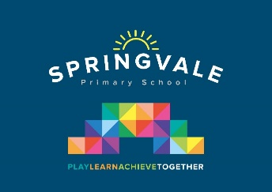

***Leaders: Mrs R Tomlinson***

**DT Curriculum Statement**

At Springvale Primary School we aim to provide all children with a broad and balanced curriculum which prepares them for life beyond primary education. We encourage children to use their creativity and imagination, to design and make products that solve real and relevant problems within a variety of contexts, considering their own and others’ needs, wants and values. Design and Technology encourages children to learn to think and intervene creatively to solve problems both as individuals and as members of a team. At Springvale Primary the Design and Technology curriculum combines skills, knowledge, concepts and values to enable children to tackle real problems. It can improve analysis, problem solving, practical capability and evaluation skills. We aim to, wherever possible, link work to class topics and incorporate other disciplines such as mathematics, science, computing and art. The children are encouraged to become innovators and risk-takers.

**DT Statement of Intent**

The intent of our design technology curriculum is to deliver a curriculum which is accessible to all and that will maximise the outcomes for every child so that they know more, remember more and understand more. At Springvale Primary School, design technology education enables our children to become problem solvers and risk takers.

***‘Intent’***

To build a design technology curriculum which develops learning and results in the acquisition of knowledge, understanding and skills needed to engage within the process of designing and making. The children will work in a range of contexts including the school, playground, gardens and within the local community.

**This statement sits alongside our ‘Curriculum and Learning Policy’**

|  |  |  |
| --- | --- | --- |
| **KNOWLEDGE…I know** | **…therefore….** | **SKILLS…I can** |
| I know where food comes from | … | I can use the basic principles of a healthy and varied diet to prepare dishes |
| I know which tools and equipment to select for a specific purpose | … | I can build structures and investigate how they can be made stronger, stiffer and more stable |
| I know how key events and individuals in design and technology have helped shape the world | … | I can use research and develop design criteria to inform the design of innovative, functional, appealing products that are fit for purpose, aimed at particular individuals or groups |
| Know how to shape and join materials to create a finished product with increasing accuracy | … | I can cut, shape, join and finish accurately |