

Dear Parents / Carers,

In the summer of 2016 many will remember how Sheffield was taken over by the ‘Herd of Sheffield’ in support of Sheffield Children’s Hospital. We are excited to announce that our school has signed up to support the ‘Bears of Sheffield’ due for the summer of 2020!

We will be fundraising between now and May 2020 with all the funds going towards a new Cancer and Leukaemia ward at the hospital. Our children will have the opportunity to get involved in the design of our bear, create a chosen design and fundraise towards our target of £750.

As Christmas is approaching, we thought this an opportune moment to begin our efforts. All our staff are extremely appreciative of the kind gifts sent in by parents as we lead up to Christmas and these are never expected. We would like to suggest donations are made towards our bear in lieu of presents and we can then continue to fund raise in the New Year. Our Christmas fair fundraising team have also offered the teddy tombola stall proceeds to go towards our bear.

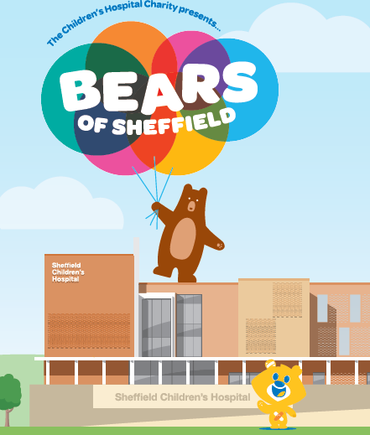  
We look forward to planning some great fundraising events and of course design our own bear!

Kind regards,

Mr. McClure and Mrs. Royston