Information for the website

Useful websites/apps:

* BBC Bitesize

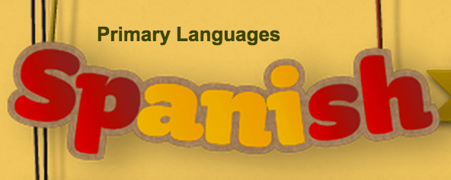

KS1 - https://www.bbc.co.uk/bitesize/subjects/zhyb4wxKS2 - <https://www.bbc.co.uk/bitesize/subjects/zxsvr82>

* Duolingo  - https://**www.duolingo.com**

Learning with **Duolingo** is fun and addictive. Earn points for correct answers, race against the clock, and level up.

* RockAlingua - https://rockalingua.com/Games, songs, worksheets and other tools for making Spanish for kids fun*.*

Many free games available.

