**Springvale Primary School**

**Intent Statement**

**Wellbeing and Community (PSHE, SMSC and mental health)**

**2019-20**

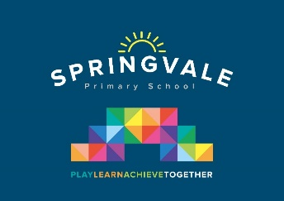 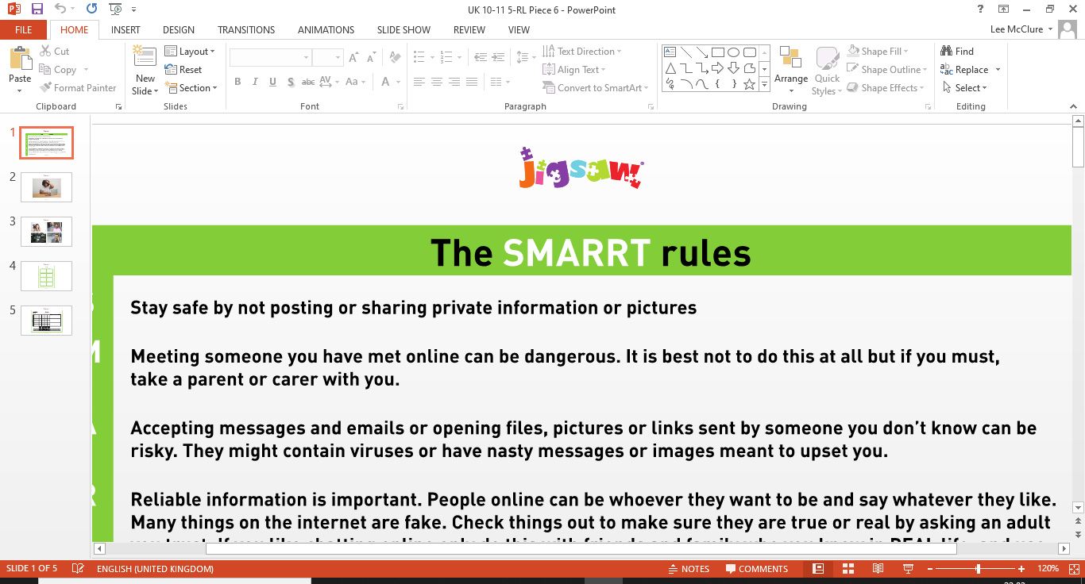

***Leaders: Mr L McClure and Mrs D Royston***

**Wellbeing Curriculum Statement**

At Springvale Primary School we combine many different aspects of learning in our wellbeing curriculum. These include personal, social, health and economic (PSHE) education which is an embedded part of our broad and balanced curriculum. Pupils’ spiritual, moral, social and cultural (SMSC) development is at the heart of our school ethos. British Values are promoted through the overarching aims and objectives of PSHE by supporting our children to become healthy and responsible members of society, as well as preparing them for life and work in modern Britain.

**Wellbeing Statement of Intent**

The intent of our wellbeing curriculum is to deliver a curriculum which is accessible to all and that will maximise the outcomes for every child so that they know more, remember more and understand more. At Springvale Primary School, wellbeing education enables our children to become healthy, independent and responsible members of a society. It aims to help them understand how they are developing personally and socially, and tackles many of the moral, social and cultural issues that are part of growing up. We provide our children with opportunities for them to learn about rights and responsibilities and appreciate what it means to be a member of a diverse society. Our children are encouraged to develop their sense of self-worth by playing a positive role in contributing to school life and the wider community.

***‘Intent’***

To build a wellbeing curriculum which develops learning and results in the acquisition of knowledge and skills which enables children to access the wider curriculum and to prepare children to be a global citizen now and in their future roles within a global community.

The curriculum will demonstrate appropriate subject knowledge, skills and understanding to fulfil the duties of the Relationship and Sex Education (RSE) and Health Education (HE) whereby schools must provide a ‘balanced and broadly-based curriculum which promotes the spiritual, moral, cultural, mental and physical development of pupils and prepares them for the opportunities and responsibilities and experiences for later life.

**This statement sits alongside our ‘Curriculum and Learning Policy’**

*‘Implementation Examples’*

*We follow the JIGSAW programme of PHSE and we employ a school counsellor. We also have wellbeing programme for pupils and staff that run throughout the year.*

|  |  |  |
| --- | --- | --- |
| **KNOWLEDGE…I know** | **…therefore….** | **SKILLS…I can** |
| I know that there are many different types of people who look, speak and act differently to each other. I know they have different beliefs and values. | … | I can recognise Britain as a multi-cultural society. |
| I know what values are and how they represent a person’s behaviours and attitudes to life. | … | I can articulate and reflect on my own beliefs and values. |
| I know the qualities that make a good friend. I know the behaviours that are not appropriate and conducive to a good friendship. | … | I can be a good friend to a wide range of people who I learn and work with. |
| I know that people have many different beliefs. I know the importance of listening and understanding other people. | … | I understand that there may be more than one side to a moral argument. |