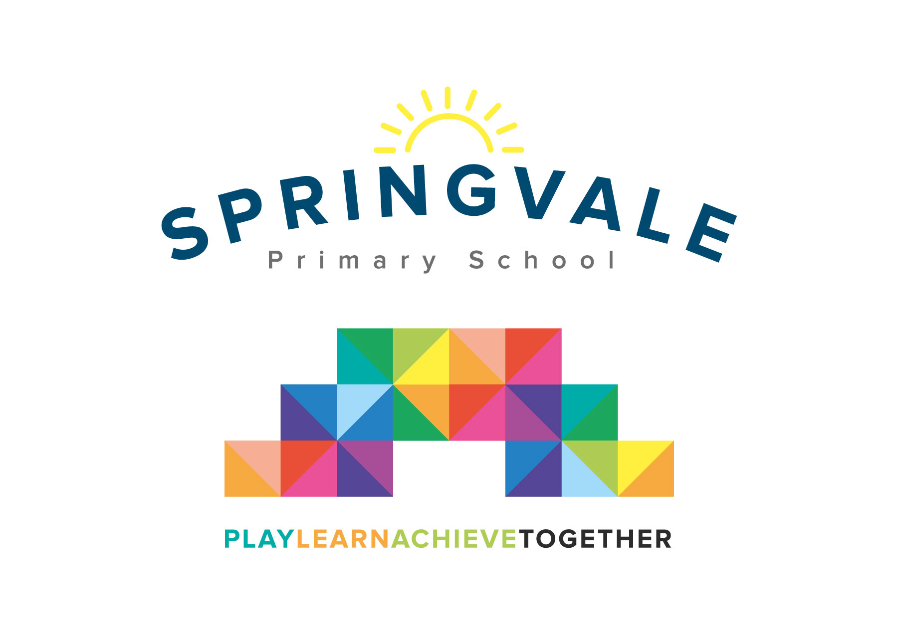

**SPRINGVALE PRIMARY SCHOOL**

**01226 760930**

**Headteacher: Mr L McClure**

**l.mcclure@springvaleprimary.org**

**www.springvaleprimary.org**

@SpringvalePS

Lower Key Stage 2 trips

As part of our summer topics, Year 3 and 4 are going on two exciting educational visits.

The first visit will be to the **National Coal Mining Museum in Wakefield** on **Thursday 23rd April** to launch our topic “Going Underground”

During this visit, children will have the opportunity to go underground, with an ex coal-miner as their personal tour guide and discover the jobs children had in the coal mines. They will also take part in a workshop called “Sally and Sam Fletcher” where they will discover in more detail what life was like in the 19th century for a family of pit workers.

The second visit will be on **Tuesday 30th June**, where children will go to **Centenary Riverside** to explore ‘pond dipping’ for half a day as part of our animal habitat topic “Who lives in a house like this”

The cost for the two trips and coaches will be £15- reduction for Pupil premium children.

You will receive an email & text notification with information about how to pay for this trip on the ‘Schoolmoney’ system. Please follow the link on this message to login to your account.

We will send out another separate letter closer to the time to remind you what children will need on each visit.

Thank you for your continuous support with your child’s education.

Miss Alderson, Mr Venus and Miss McNaught

# **Please tick your child’s lunch option and return to school by Monday 30th March:**

Child’s Name: ________________________ Class: ______________

**National Coal Mining Museum:** **Date of Trip: Thursday 23rd April**

Own Sandwiches Grab a bag

# Grab a Bag Flavour

# Ham Cheese Tuna Mayo

___________________________________________________________________

Child’s Name: ________________________ Class: ______________

**Centenary Riverside**: **Date of Trip: Tuesday 30th June**

Own Sandwiches Grab a bag

*Grab a Bag Flavour*