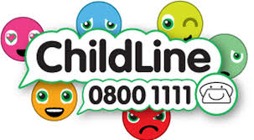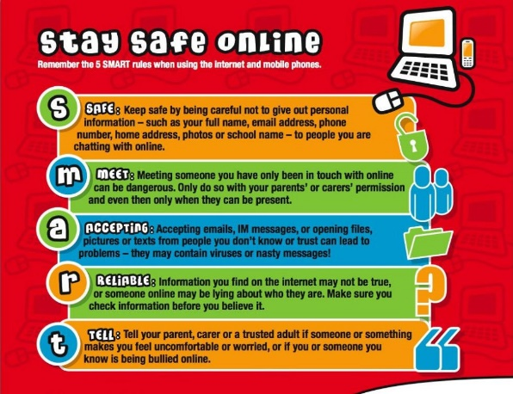

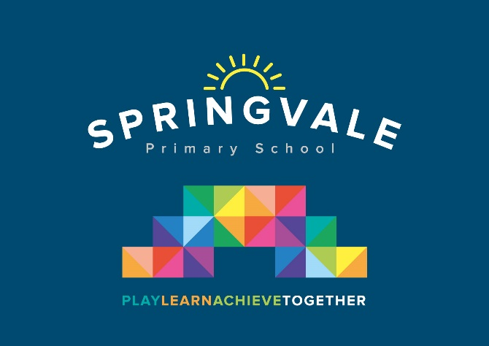

|  |  |
| --- | --- |
| **Learning Project WEEK 3 - Viewpoints** | |
| **Age Range:** Y5- 6 – Mrs. Fearn and Mrs. Henstock/Mrs Mayston | |
| **Weekly Maths Tasks (Aim to do 1 per day)** | **Weekly Reading Tasks (Aim to do 1 per day)** |
| * Get your child to play on [Times Table Rockstars](https://play.ttrockstars.com/auth/school). * Ask your child to show everything they know about fractions on a piece of paper. This could be pictures, diagrams, explanations, methods etc. Get them to be as creative as they want to be. * Allow your child to play on [Hit the Button](https://www.topmarks.co.uk/maths-games/hit-the-button) - focus on times tables, division facts and squared numbers. * Direct your child to practise [matching fractions](https://phet.colorado.edu/sims/html/fraction-matcher/latest/fraction-matcher_en.html) on this game. Get them to work on the mixed numbers. * Daily [arithmetic](https://www.topmarks.co.uk/maths-games/daily10) for different areas of maths. Ask your child to work on level 4, 5 and 6 activities and try to focus on fractions. * Get your child to work on their [reasoning and problem solving](https://primarysite-prod-sorted.s3.amazonaws.com/springcroft-primary-school/UploadedDocument/915522a464444cfa96a70bc9bdaee45d/ultimate-ks2-maths-sats-organiser-y6-daily-mini-videos-puzzles-for-y5.pdf) by practising past SATs questions that are broken down into topic areas and have videos linked to them that can be watched if needed. As these are older papers these are suitable for both years 5 and 6. Click on one of the topic areas listed to gain access to the questions. * Use White Rose video lessons and worksheets. <https://whiterosemaths.com/homelearning/year-5/>   Continue( or start at week 1, week 2 then summer term week 1)  These are directly what we would have been studying in class and the videos are excellent. Do as much as you feel you can – no pressure! | * Ask your child to read a chapter from their home reading book * Continue to read a wide variety of literature-   comics, magazines, poetry, jokes, non-  fiction, newspapers, own books etc.   * Following this, ask your child to create a set of multiple choice questions about what they have read. * Encourage your child to note down any unfamiliar words from the chapter they have read. Explore the meanings of these words by using a dictionary, reading around the sentence or using print conventions. * Using Twinkl (website), find a reading   comprehension that your child is interested in and try writing the answers to the questions. Alternatively, try the reading comprehension on Gandhi (Twinkl).  <https://www.bl.uk/childrens-books>  **Some great ideas for Literacy from the British Library.** |
| **Weekly Spelling Tasks (Aim to do 1 per day)** | **Weekly Writing Tasks (Aim to do 1 per day)** |
| * Encourage your child to practise the Year 5/ 6 Common Exception Words   Convenience, correspond, criticise, curiosity, definite, desperate, determined, develop, dictionary, disastrous, embarrass, environment   * Then ask your child to choose 5 Common Exception words. They can then write a synonym, antonym, the meaning and an example of how to use the word in a sentence. * Ask your child to create a word bank of feelings that they have felt over the week. They may be able to identify any spelling rules the adjectives contain. Encourage them to try and include an adjective with a silent letter. * Get your child to proofread their writing from the day. They can use a dictionary to check the spelling of any words that they found challenging. This will also enable them to check that the meaning of the word is suitable for the sentence. * Try the word search with silent letters (attached) | * Ask your child to write a blog post summarising the events from the day/week. Encourage them to think about how the language they use may be more informative. * Your child will be composing an email or writing a formal letter to a 12 year child from a country of their choice. Ask them to describe what is happening in the world at the moment. They can then compose a reply. How does each world differ? * Encourage your child to put themselves in their Mum’s or another family member’s shoes. Can they write a poem about how they might be feeling with what is happening in the world currently? * ***People should be able to express their opinion on social media platforms.*** Do you agree/disagree? Your child can write a discussion about this statement. * **Story Task:** They’ve now created a setting and character for a story genre of their choice. Talk to your child about what is going to happen in their story? Ask them to plan their story thinking about a book of the same genre. Whose viewpoint are they going to write the story from? |
| **Learning Project - to be done throughout the week** | |
| **The project this week aims to provide opportunities for your child to learn more about different viewpoints. Learning may focus on physical viewpoints in terms of what you can see outside of the window at home, what others can see looking into your home and then progress onto personal viewpoints and of others.**   * **Viewpoints and Mood -** Ask your child to look into a room in the home and think about how it makes them feel. They can then either draw something linked to how they feel when looking in the room or draw an object from the room and then colour, shade or paint it in a colour that reflects their current mood. * **Penistone Views-** The viaduct, the countryside and St John’s Church are just some of the famous viewpoints within Penistone. Your child can choose a Penistone viewpoint and use Google Earth or Google Maps to create an accurate scaled map of the location of the landmark. They may wish to identify other Penistone viewpoints on their map. * **Viewpoints from Around the World -** Your child can research famous viewpoints from around the world (e.g. The Eiffel Tower). Ask them to draw what they think they would see from this viewpoint. After this, they can design and create a miniature scale of the landmarks that give these viewpoints. Encourage them to evaluate their creations. * **A change in Viewpoints-** How did Gandhi and Rosa Park’s actions and views shape society today? Challenge your child to compare and contrast viewpoints from then and now on people’s race, culture and religion. How has this improved society’s attitudes towards those who are different to ourselves? * **Debate-** Is good more powerful than evil? Is it worse to fail at something or never attempt it in the first place? Is it more important to be liked or respected? Ask your child to choose a question to answer, write a speech and use real -life examples to justify their opinion. | |
| **Additional learning resources parents may wish to engage with** | |
| [**Classroom Secrets Learning Packs**](https://classroomsecrets.co.uk/free-home-learning-packs/) **-** These packs are split into different year groups and include activities linked to reading, writing, maths and practical ideas you can do around the home.  [**Twinkl**](https://www.twinkl.co.uk/offer/UKTWINKLHELPS?utm_source=promo&utm_medium=email&utm_campaign=England_coronavirus_schools_email&utm_content=offer_link) **-** to access these resources click on the link and sign up using your own email address and creating your own password. Use the offer code UKTWINKLHELPS.  [**Headteacherchat**](https://www.headteacherchat.com/post/corona-virus-free-resources-for-teachers-and-schools) - This is a blog that has links to various learning platforms. Lots of these are free to access. | |
| **#TheLearningProjects** | |

Wordsearch from Mrs Henstock:

