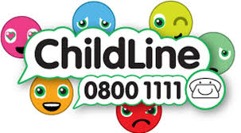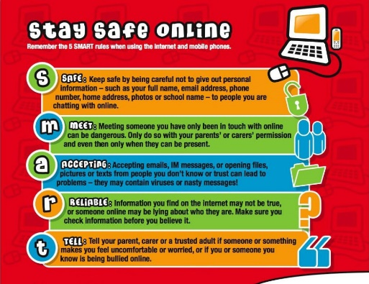

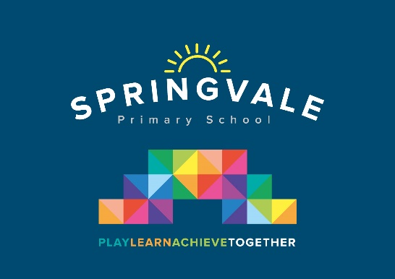

|  |  |
| --- | --- |
| **Learning Project WEEK 4- Animals** | |
| **Age Range:** EYFS  FS2 The Curious Cubs | |
| **Weekly Maths Tasks (Aim to do 1 per day)** | **Weekly Reading Tasks (Aim to do 1 per day)** |
| * Watch a Numberblocks clip each day at: [BBC](https://www.bbc.co.uk/iplayer/episodes/b08bzfnh/numberblocks?page=2) or [CBeebies](https://www.bbc.co.uk/cbeebies/shows/numberblocks). Use this guide [here](https://www.bbc.co.uk/cbeebies/joinin/numberblocks-help-your-child-with-maths) to give you ideas on what to do with your children whilst watching an episode. * Working on [Numbots](https://numbots.com) - your child will have an individual login to access this.   Watch Numberblocks Fourteen (series 3) to introduce 14. Collect 14 objects. Take one away so that you have one less. How many do you have now? Make 14 again and add one more object. How many do you have now?   * Practise counting backwards from 20. This can be done through playing hide and seek, singing number songs, chanting, board games etc. * Use the ‘Tens Frames’ or ‘Five Frames’ on this [game](https://www.fuelthebrain.com/games/number-flash/) and practise recognising amounts. This can also be done by reading a dice when playing board games, playing with cards, identifying how many food items on the plate etc. * Continue to explore with pattern. Go to topmarks.co.uk and search for the game Finish the Pattern. Shape Patterns is also a fun game. | * Read a variety of books at home. Favourites can be repeated. Hearing the patterns of language in a story will support your child’s language development. * Reception age children: Children to read to parents daily. Visit Oxford Owl for free eBooks that link to your child’s book band. You can create a [free account.](https://www.oxfordowl.co.uk/for-home/)   Complete the linked Play activities for each book.   * With your child, look in magazines, newspapers and books for the tricky words they are currently learning. They could use a highlighter to highlight in magazines and newspapers. |
| **Weekly Phonics Tasks (Aim to do 1 per day)** | **Weekly Writing Tasks (Aim to do 1 per day)** |
| Our children are all in very different places for learning sounds. Please ask your child which adult they work with for phonics and focus on these sounds  Mrs Cliffe/Mrs Honey and Mrs Parr  Sound of the week: ng (thing on a string)  Read and spell words such as ring, song, long, king, sing  Mrs Slack/Mrs Gale/Mrs Evans  Sound of the week: oo (poo at the zoo!)  Read and spell words such as , zoo, moon, zoom, boot, pool   * Daily phonics - Practice the sounds your child is working on and blend words. This can be oral blending (e.g. spoken out loud c-a-t) or written if appropriate. See these [Interactive games.](https://www.phonicsplay.co.uk/)   On phonicsplay.co.uk play Make a Match sh ch th ng, read the word on the egg and feed the real and fake words to the dragons.  Play Phonics Pop (ictgames.com) Select the soundsyou want to practice***ch sh th ng***, or ***ay ee igh oo.*** Then listen to the target sound and pop as many as you can. | * Draw an animal of your choice. Label the parts of the animal. Reception children could create a fact file e.g. where does it live? What does it eat? * Practice name writing. Can they write their first name? Middle name? Surname? * Practice forming the letters **j u y** * Ask your child to write out the tricky words they are working on at the moment on pieces of paper and turn them into a pairs game. |
| **Learning Project - to be done throughout the week** | |
| **The project this week aims to provide opportunities for your child to learn more about key animals they are interested in. Learning may focus on exploring the physical aspects of an animal, their habitat, categorising animals etc.**   * **Read the story,** [**‘Dear Zoo’**](https://www.youtube.com/watch?v=rudDGRQ9QGA) **or watch the online video** -   + Visit the book’s website and play the[**interactive games**](http://www.dearzooandfriends.com/games)   + Add your own animal into the story and label it e.g. So they sent me a...hedgehog, but he was too prickly....so I sent him back.   + Choose a soft toy animal or small animal figure and create a junk modelled container for it. * **Identify the birds in your garden-**    + Use the [**RSPB**](https://www.rspb.org.uk/birds-and-wildlife/wildlife-guides/identify-a-bird/) bird identifier website   + Draw a picture of the birds you can see. * **Play animal charades-**   + Take it in turns to act as different animals. Add in noises as a clue… * **Learn the song,** [**‘The Animals Went in Two by Two’**](https://www.topmarks.co.uk/Flash.aspx?bbc=animals-went-in-two-by-two)    + Ask your child to draw out two of each animal and practice writing the numeral 2. * **Looking after your pet-**   + If you have a pet at home encourage your child to take part in their daily care. They could help feed, groom and clean up after your pet. * **Big and small animals-**    + Draw as many big animals as you can on one piece of paper and as many small animals as you can on another sheet of paper. Some children may be able to write a list as an alternative. * **Find all of the animal books in your house-**   + Ask your child to look through the books in your house and to find any with animals on the front cover. Ask them to sort the books into groups of their choice e.g. animals that can fly, swim, big, small, live on a farm/ at the zoo. * **Create an animal den-**    + Provide your child with blankets and sheets to make an animal den. Act out being an animal in the den. | |
| **Additional learning resources parents may wish to engage with** | |
| [**Classroom Secrets Learning Packs**](https://classroomsecrets.co.uk/free-home-learning-packs/) **-** These packs are split into different year groups and include activities linked to reading, writing, maths and practical ideas you can do around the home.  [**Twinkl**](https://www.twinkl.co.uk/offer/UKTWINKLHELPS?utm_source=promo&utm_medium=email&utm_campaign=England_coronavirus_schools_email&utm_content=offer_link) **-** to access these resources click on the link and sign up using your own email address and creating your own password. Use the offer code UKTWINKLHELPS.  [**Headteacherchat**](https://www.headteacherchat.com/post/corona-virus-free-resources-for-teachers-and-schools) - This is a blog that has links to various learning platforms. Lots of these are free to access. | |
| **#TheLearningProjects** | |