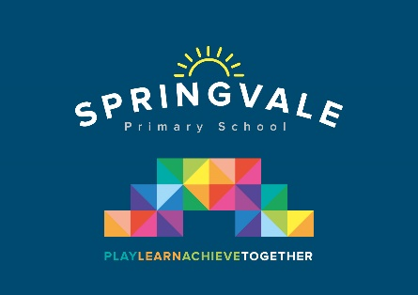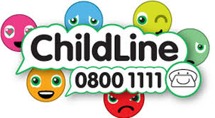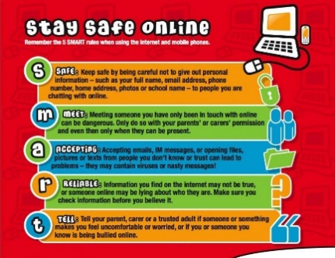

|  |  |
| --- | --- |
| **Learning Project WEEK 4 - Animals** | |
| **Age Range:** KS1 | |
| **Weekly Maths Tasks (Aim to do 1 per day)** | **Weekly Reading Tasks (Aim to do 1 per day)** |
| * Working on [Numbots](https://numbots.com) - your child will have an individual login to access this. * Play on [Number Fact Families](https://www.topmarks.co.uk/maths-games/5-7-years/addition-and-subtraction) - find the addition and subtraction fact families. Year 1 find the + and – fact families for numbers up to 10 and 20 (extra challenge up to 50!). Year 2 find the + and – fact families up to 20, 50 or 100. * Practise counting in 2s, 5s and 10s.   This [game](http://www.sheppardsoftware.com/mathgames/earlymath/BalloonPopSkip.htm) could support this.  Year 2 extra challenge; try the game above to count in 3’s and 4’s.   * Go out in the garden and observe the different creatures/animals that can be seen. Count how many of each animal/creature you can find. Can you represent the data in a tally chart, pictogram or block graph?      * Practise learning about money by playing this [game.](https://www.doorwayonline.org.uk/activities/cashing-in/cashing-in.html) You could also use real coins and play a similar game with family members. * Select a number between 2 and 20. Make a poster showing how many different ways to make this number using addition, subtraction, multiplication etc. | * Can you read fiction, non- fiction and poems about animals? * Can you find adjectives in the books used to describe the animal? * Listen to the melody of the Little Blue Butterfly:   <https://www.bbc.co.uk/cbeebies/stories/melody-little-blue-butterfly>   * There are lots of animal stories here <https://www.bbc.co.uk/cbeebies/topics/animals> * Create a bookmark with animal facts |

|  |  |
| --- | --- |
| **Weekly Phonics/Spellings**  **Tasks (Aim to do 1 per day)** | **Weekly Writing Tasks (Aim to do 1 per day)** |
| Our children are all in very different places for learning sounds and spellings. We have provided a list of sounds / words, which increase in challenge to suit all needs.  Set 2 sound of the week **ow**  Read and spell words such as: grow, slow, snow, show, know, low, blow  Set 3 sound of the week: **i-e** Read and spell words such as: time, ride, slide, inside, invite, pipe, mice, bride  Year 1 common exception spellings of the week: **go, so, by, my, here, there, where, love.**  Extra challenge – can you write these words in a sentence?  Year 2 common exception words of the week: **everybody, even, after, past, last, fast, father, class, grass, pass.**  Extra challenge – can you write these words in a command / question / statement or exclamation sentence?  Year 2 adding suffixes: **-less**  **Careless, harmless, helpless, hopeless, speechless, spotless.**  Extra challenge – can you write these words in a command / question / statement or exclamation sentence?   * Daily phonics - your child to practice their sounds and blend words. Interactive games found on links below. * [Phonics play](https://www.phonicsplay.co.uk/) * [Top Marks](https://www.topmarks.co.uk/english-games/5-7-years/letters-and-sounds) * [Spelling](https://www.topmarks.co.uk/english-games/5-7-years/words-and-spelling) * Spell the days of the week | * A-Z Animal list:Can you think of an animal for each letter of the alphabet. Can you add sound buttons? * Draw a picture of your animal and label it. Can you write sentences using adjectives? * Write a set of questions about animals you would like to find out about. * Create a fact file about your favourite animal. Research an animal of your choice and explore the vocabulary required to describe them. * Describe similarities and differences between animals. |
| **Learning Project - to be done throughout the week: Animals** | |
| **The project this week aims to provide opportunities for your child to learn more about key animals they are interested in. Learning may focus on exploring the physical aspects of an animal, their habitat, categorising animals etc.**  **Find out about:**  What are mammals?  What are amphibians?  What are birds?  What are fish?  What are reptiles?  What are minibeasts?  [**https://www.bbc.co.uk/bitesize/topics/z6882hv**](https://www.bbc.co.uk/bitesize/topics/z6882hv)  **Create a mask:** Using different materials around the house, create a mask of their favourite animal. Think about the colours and shape. Can they add different textures to their mask?  **Where does your animal live?** Work through [this](http://resources.hwb.wales.gov.uk/VTC/animal_homes/eng/Introduction/default.htm) online lesson to develop understanding of where different animals live. (You may want to provide headphones for activity 6!)  **Animal grouping:** Get your child to group animals into two columns. Identifying animals that can fly and cannot fly. What do animals eat? Scientists group animals into three different groups according to what animals eat. These groups are carnivores, herbivores and omnivores. Carnivores eat other animals, herbivores eat plant material including fruit, leaves, vegetables, and omnivores eat a mixture of meat and plant material. *(Animals that eat other animals are called carnivores. Animals that eat plants are called herbivores. Animals that eat both plants and other animals are called omnivores)*  You can use toy animals you have at home, draw animals or download these [**Sorting Cards**](https://www.twinkl.co.uk/resource/t-t-19730-animal-groups-sorting-cards-photos)  **Needs of an animal.** Can all animals be kept as a pet? Think about a particular animal and find out if that animal could be a pet. Draw pictures of different animals. Sort the animals into two groups; suitable for a pet and not suitable for a pet. Explain why animals were sorted in a particular way.  You may be able to find some information here: <https://education.rspca.org.uk/education/teachers/primary/lessonplans/pets>  Design a leaflet explaining to potential pet owners what each animal will need. - Interview a pet owner to discuss the responsibilities involved with looking after an animal. How often do they need to find their pet? Who helps clean? What does their pet eat?    Find some pegs at home. Can you create your own mini animal or object, cut it in half and stick it to a peg.  **Nocturnal animals** - What do they think this word means? [Watch](https://www.bbc.co.uk/bitesize/clips/zsshfg8) and discuss the animals they saw. Have they seen these animals? How could they describe them? [Play](https://ictgames.com/mobilePage/nocturnal/index.html)  Nocturnal animals are more active at night than during the day. These animals sleep during the day, often in a burrow or den. They have special adaptations that help them survive in the dark. Over millions of years, these animals have developed traits that help them survive in the darkness. Nocturnal animals may have larger ears to hear better, bigger eyes to see better, and body parts that glow in the night. Create your own big-eyed nocturnal [animal art](https://www.greenkidcrafts.com/6-nocturnal-animal-crafts/). | |
| **Additional learning resources parents may wish to engage with** | |
| [**Classroom Secrets Learning Packs**](https://classroomsecrets.co.uk/free-home-learning-packs/) **-** These packs are split into different year groups and include activities linked to reading, writing, maths and practical ideas you can do around the home.  [**Twinkl**](https://www.twinkl.co.uk/offer/UKTWINKLHELPS?utm_source=promo&utm_medium=email&utm_campaign=England_coronavirus_schools_email&utm_content=offer_link) **-** to access these resources click on the link and sign up using your own email address and creating your own password. Use the offer code UKTWINKLHELPS.  [**Headteacherchat**](https://www.headteacherchat.com/post/corona-virus-free-resources-for-teachers-and-schools) - This is a blog that has links to various learning platforms. Lots of these are free to access. | |
|  | |