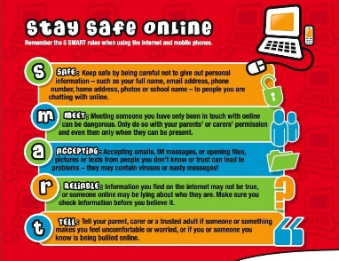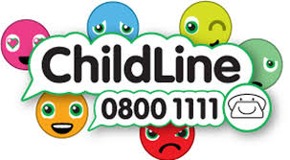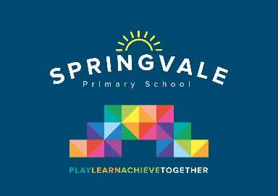

|  |  |
| --- | --- |
| **Learning Project WEEK 5- Environments** | |
| **Age Range:** EYFS  The Curious Cubs | |
| **Weekly Maths Tasks (Aim to do 1 per day)** | **Weekly Reading Tasks (Aim to do 1 per day)** |
| * Watch a Numberblocks clip each day at: [BBC](https://www.bbc.co.uk/iplayer/episodes/b08bzfnh/numberblocks?page=2) or [CBeebies](https://www.bbc.co.uk/cbeebies/shows/numberblocks). Use this guide [here](https://www.bbc.co.uk/cbeebies/joinin/numberblocks-help-your-child-with-maths) to give you ideas on what to do with your children whilst watching an episode.      * Working on [Numbots](https://numbots.com) - your child will have an individual login to access this.   Watch Numberblocks Fifteen Tween Scenes to introduce 15. Go to **topmarks.co.uk** and play **Teddy Numbers** or **Helicopter Rescue** to practise recognition of your teen numbers.  Challenge yourself with **Chopper Squad** to find one more or less than a number up to 20.   * Play the Numberblocks add and subtract [quiz.](https://www.bbc.co.uk/cbeebies/puzzles/numberblocks-number-magic-quiz-level-1?collection=numbers-and-letters) * Write out the digits 0 – 15 on some paper or card, cut them up and ask a grown-up to mix them or hide them around the room. How quickly can you find them and put them in order? * Play games to practice counting on from different starting points, such as ‘I count, you count’. The adult begins by counting as you point to themselves, when you point to your child, they continue the count:   1 2 3 4 5 6 7 8  1 2 3 4 5 6 7 8 9 | * Read a variety of books at home. Favourites can be repeated. Hearing the patterns of language in a story will support your child’s language development. * Reception age children: Children to read to parents daily. Visit Oxford Owl for free eBooks that link to your child’s book band. You can create a [free account](https://www.oxfordowl.co.uk/for-home/).   Complete the linked Play activities for each book.   * With your child, look in magazines, newspapers and books for the tricky words they are currently learning. They could use a highlighter to highlight in magazines and newspapers. |
| **Weekly Phonics Tasks (Aim to do 1 per day)** | **Weekly Writing Tasks (Aim to do 1 per day)** |
| Our children are all in very different places for learning sounds. Please ask your child which adult they work with for phonics and focus on these sounds  Mrs Cliffe/Mrs Honey and Mrs Parr  Sound of the week: nk (I think I stink!)  Read and spell words such as rink, link, pink, bank, tank, sink, wink   * Practice the sounds your child is working on and blend words. This can be oral blending (e.g. spoken out loud c-a-t) or written if appropriate. See these [Interactive games.](https://www.phonicsplay.co.uk/)   On **topmarks.co.uk** play **Letter Planet**. You can also practise ch sh th ng by playing **Help A Hedgehog** (Select Phase 3 ch sh th ng)  Mrs Slack/Mrs Gale/Mrs Evans  Sound of the week: oo (look at a book)  Read and spell words such as , cook, look, book, wood, foot, shook   * Play Phase 3 Rolland Read – Short and Long oo available to download on twinkl.co.uk * Sing the song, ‘Incy, Wincy Spider’ and add in the rain sounds using your rainmaker (from the learning project below). | * Practice name writing. Can they write their first name? Middle name? Surname? * Practice forming the letters **n m r.** * Ask your child to write out the tricky words they are working on at the moment on pieces of paper and turn them into a pairs game. * Take your child for a litter pick around your front and back garden. Create a poster to remind people to put rubbish in the bin.   **When you are supporting your child remember to encourage them to write independently and use their phonic knowledge. At this age we practise learning how to spell correctly the red tricky words. Encourage your child to use their red word cards to help with this.** |
| **Learning Project - to be done throughout the week** | |
| **The project this week aims to provide opportunities for your child to learn more about the environment. Learning may focus on changes to different environments, the impact of humans on environments, climate change etc .**   * **Create a daily weather chart-**   + Record using pictures and written labels (where appropriate). How has the weather changed over the week?   + If it is raining, leave a container outside to collect the rain e.g. a water bottle with the funnel cut off. Draw a line or make a mark to show where the rain came up to. Repeat overnight or the next day and compare your results. * **Recycling/ Exploring Materials-**   + Provide your child with a selection of packaging to sort into groups to recycle. Can they identify plastic, paper, card, metal. * **Create your own rain cloud-**    + Use a plastic container with a lid (e.g. a water bottle) and make small holes on one side. You could stick on cotton wool to decorate. Fill the container with water and watch as the water drips out. * **Weather sounds (Rainmakers)**   + Provide your child with either a plastic container, bottle or other junk modelling item. Pour in a spoon or two of rice or lentils and secure with a bottle lid or sellotape. Decorate with stickers, glitter and sequins if you have them available. Have fun exploring making rain sounds. * **Ice-**   + Watch ‘[Frozen- In Summer](https://www.youtube.com/watch?v=ZPe71yr73Jk%20.)’. Discuss with your child what they think will happen to Olaf when it gets warm. Support your child to fill up ice cube trays or plastic containers, if ice cube trays are not available, and freeze. Once frozen, take them out and explore how quickly they melt: in your hands, in the fridge, on the windowsill and when blown with the hairdryer.   + Search on Google Maps for the UK. Discuss with your child the colour of the land and sea. Scroll up to look at the Arctic. Discuss why the land looks different in the Arctic, because the land is covered in snow and ice. Discuss the differences in temperature in the UK and the Arctic. Look at a picture of an [igloo on google.](https://www.google.com/search?q=igloo+&tbm=isch&ved=2ahUKEwilt5CizJ7oAhVQwIUKHTBYDWcQ2-cCegQIABAA&oq=igloo+&gs_l=img.3..0i67l4j0l3j0i67j0j0i67.25440.25755..26022...0.0..0.74.213.3......0....1..gws-wiz-img.yXGP--8w5pI&ei=aDtvXqXjMdCAlwSwsLW4Bg&rlz=1CAQIMT_enGB814&safe=active&ssui=on)   Fill an ice cube tray with water and when frozen take out and support your child to create their own igloo out of the ice cubes. | |
| **Additional learning resources parents may wish to engage with** | |
| [**Classroom Secrets Learning Packs**](https://classroomsecrets.co.uk/free-home-learning-packs/) **-** These packs are split into different year groups and include activities linked to reading, writing, maths and practical ideas you can do around the home.  [**Twinkl**](https://www.twinkl.co.uk/offer/UKTWINKLHELPS?utm_source=promo&utm_medium=email&utm_campaign=England_coronavirus_schools_email&utm_content=offer_link) **-** to access these resources click on the link and sign up using your own email address and creating your own password. Use the offer code UKTWINKLHELPS.  [**Headteacherchat**](https://www.headteacherchat.com/post/corona-virus-free-resources-for-teachers-and-schools) - This is a blog that has links to various learning platforms. Lots of these are free to access. | |
| **#TheLearningProjects** | |