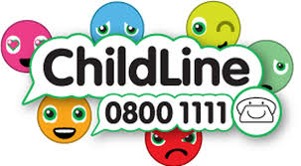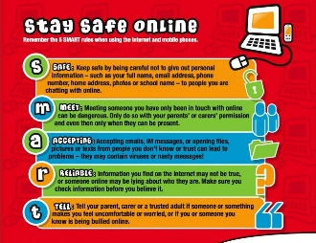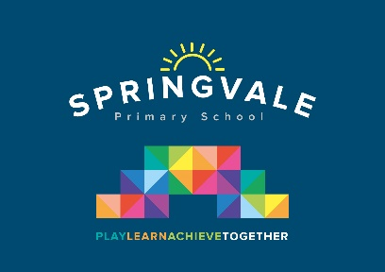

|  |  |
| --- | --- |
| **Learning Project WEEK 5- Environments** | |
| **Age Range: Nursery** | |
| **Weekly Maths Tasks (Aim to do 1 per day)** | **Weekly Reading Tasks (Aim to do 1 per day)** |
| * Watch a Numberblocks clip each day at: [BBC](https://www.bbc.co.uk/iplayer/episodes/b08bzfnh/numberblocks?page=2) or [CBeebies](https://www.bbc.co.uk/cbeebies/shows/numberblocks). Use this guide [here](https://www.bbc.co.uk/cbeebies/joinin/numberblocks-help-your-child-with-maths) to give you ideas on what to do with your children whilst watching an episode.      * Practise counting up to 20. This can be done through playing hide and seek, singing number songs, chanting, board games etc. * Write out the digits 0 - 9. * Practise recognising amounts up to [five](https://www.nctm.org/Classroom-Resources/Illuminations/Interactives/Five-Frame/) or up to [ten](https://www.nctm.org/Classroom-Resources/Illuminations/Interactives/Ten-Frame/) by playing these games. This can be done by reading a dice when playing board games, playing with cards, identifying how many food items on the plate etc. * Listen to a number song from the [CBeebies](https://www.bbc.co.uk/cbeebies/watch/number-songs-from-numberblocks#playlist) website. After listening to them, watch again and sing along if you can. Talk about the maths you can see in the video clip. | * Read a variety of books at home. Favourites can be repeated. Hearing the patterns of language in a story will support your child’s language development * Write the sounds that your child is learning on small cards and hide them round the house. Go on a treasure hunt. Perhaps use the sounds in your child’s name first and when they have found all the sounds, they have to write their name. |
| **Weekly Phonics Tasks (Aim to do 1 per day)** | **Weekly Writing Tasks (Aim to do 1 per day)** |
| * Sing Nursery Rhymes and songs together. Add in actions and change the words. Can children think of different rhyming words to add in? Repeat old favourites and learn new rhymes. You can find an A-Z of [Nursery Rhymes here.](https://allnurseryrhymes.com/) * Daily phonics - Practice the sounds your child is working on. See how many sounds you can spot when you go out for a walk. * Sing the song, ‘Incy, Wincy Spider’ and add in the rain sounds using your rainmaker (from the learning project below). | * Practice name writing. Can they write their first name? Middle name? Surname? * Practice forming the letters of the alphabet. Follow your school’s script. Write rainbow letters. Write a sound with the 7 colours of the rainbow. * Take your child for a litter pick around your front and back garden. Create a poster to remind people to put rubbish in the bin. |
| **Learning Project - to be done throughout the week** | |
| **The project this week aims to provide opportunities for your child to learn more about the environment. Learning may focus on changes to different environments, the impact of humans on environments, climate change etc .**   * **Create a daily weather chart-**   + Record using pictures and written labels (where appropriate). How has the weather changed over the week?   + If it is raining, leave a container outside to collect the rain e.g. a water bottle with the funnel cut off. Draw a line or make a mark to show where the rain came up to. Repeat overnight or the next day and compare your results. * **Recycling/ Exploring Materials-**   + Provide your child with a selection of packaging to sort into groups to recycle. Can they identify plastic, paper, card, metal. * **Create your own rain cloud-**    + Use a plastic container with a lid (e.g. a water bottle) and make small holes on one side. You could stick on cotton wool to decorate. Fill the container with water and watch as the water drips out. * **Weather sounds (Rainmakers)**   + Provide your child with either a plastic container, bottle or other junk modelling item. Pour in a spoon or two of rice or lentils and secure with a bottle lid or sellotape. Decorate with stickers, glitter and sequins if you have them available. Have fun exploring making rain sounds. * **Ice-**   + Watch ‘[Frozen- In Summer](https://www.youtube.com/watch?v=ZPe71yr73Jk%20.)’. Discuss with your child what they think will happen to Olaf when it gets warm. Support your child to fill up ice cube trays or plastic containers, if ice cube trays are not available, and freeze. Once frozen, take them out and explore how quickly they melt: in your hands, in the fridge, on the windowsill and when blown with the hairdryer.   + Search on Google Maps for the UK. Discuss with your child the colour of the land and sea. Scroll up to look at the Arctic. Discuss why the land looks different in the Arctic, because the land is covered in snow and ice. Discuss the differences in temperature in the UK and the Arctic. Look at a picture of an [igloo on google.](https://www.google.com/search?q=igloo+&tbm=isch&ved=2ahUKEwilt5CizJ7oAhVQwIUKHTBYDWcQ2-cCegQIABAA&oq=igloo+&gs_l=img.3..0i67l4j0l3j0i67j0j0i67.25440.25755..26022...0.0..0.74.213.3......0....1..gws-wiz-img.yXGP--8w5pI&ei=aDtvXqXjMdCAlwSwsLW4Bg&rlz=1CAQIMT_enGB814&safe=active&ssui=on)   Fill an ice cube tray with water and when frozen take out and support your child to create their own igloo out of the ice cubes. | |
| **Additional learning resources parents may wish to engage with** | |
| [**Twinkl**](https://www.twinkl.co.uk/offer/UKTWINKLHELPS?utm_source=promo&utm_medium=email&utm_campaign=England_coronavirus_schools_email&utm_content=offer_link) **-** to access these resources click on the link and sign up using your own email address and creating your own password. Use the offer code UKTWINKLHELPS | |
| **#TheLearningProjects** | |