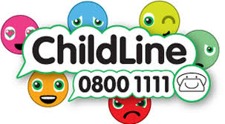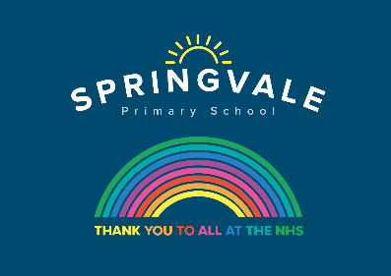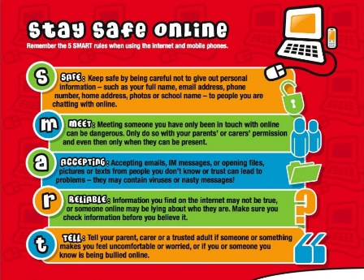

|  |  |
| --- | --- |
| **Learning Project WEEK 7- Celebrations** | |
| **Age Range:** EYFS  FS2 The Curious Cubs | |
| **Weekly Maths Tasks (Aim to do 1 per day)** | **Weekly Reading Tasks (Aim to do 1 per day)** |
| * Working on [Numbots](https://numbots.com) - your child will have an individual login to access this. * This week learn about number 17. Watch Numberblocks 17 on dailymotion amd meet Numberblock 17 who likes to paint. * Add number 17 to the 0 – 16 digit cards you have made and play hide and seek with them again. How quickly can you find them all and order them? * Play the Numberblocks add and subtract [game](https://www.bbc.co.uk/cbeebies/puzzles/numberblocks-number-magic-adding-and-subtracting?collection=numbers-and-letters). * Count to up to 20 and then back down. Try starting from different numbers, eg 13, 14, 15…./ 18, 17, 16 * See the attachment and play The Box Game (from nrich) to explore problem solving using addition and subtraction. | * Read a variety of books at home. Favourites can be repeated. Hearing the patterns of language in a story will support your child’s language development. * Reception age children: Children to read to parents daily. Visit Oxford Owl for free eBooks that link to your child’s book band. You can create a [free account](https://www.oxfordowl.co.uk/for-home).   Complete the linked Play activities for each book.   * Practise recognising your tricky red words * With your child, look in magazines, newspapers and books for the tricky words they are currently learning. They could use a highlighter to highlight in magazines and newspapers. * Use the [Small Talk](https://small-talk.org.uk/) website for ideas on supporting your child’s Communication and Language development. |
| **Weekly Phonics Tasks (Aim to do 1 per day)** | **Weekly Writing Tasks (Aim to do 1 per day)** |
| Our children are all in very different places for learning sounds. Please ask your child which adult they work with for phonics and focus on these sounds  Mrs Cliffe/Mrs Honey and Mrs Parr  Sounds Re-cap ch sh th ng nk  Mrs Slack/Mrs Gale/Mrs Evans  Sound of the week: or (shut the door)  Read and spell words such as, short, corn, north, fork, torch   * Go to newphonicsplay.co.uk and play Grab a Giggling Grapheme, to practise **oo ar or** * On Reading Robot your grown-up can enter some words for you to read using the sounds you have learnt so far, (ch sh th nk ng) or (ay ee igh ow oo oo ar or) * Viking Full Circle is also a fun game to play on ictgames.co.uk | * Practice forming the letters of the alphabet **k c a.** * Ask your child to write out the tricky words they are working on at the moment on pieces of paper and turn them into a pairs game. * Create a card for a celebration of your choice. Can your child use their phonics knowledge to write a message for the person they would like to give it to? * Ask your child to draw a picture of a celebration they have taken part in. Encourage them to use their phonics knowledge to write about their memory of that day. |
| **Learning Project - to be done throughout the week** | |
| **This project this week aims to provide opportunities for your child to learn more about celebrations. Learning may focus and different types of celebrations that take place and who may celebrate them. It could look at how people celebrate different events differently in other parts of the world.**   * **Family Photographs-**   + Look over a selection of photographs of family celebrations and discuss with your child: what the celebration was about, who attended, what you did to celebrate, when it took place, whether it is an event that happens each year. Can your child remember the event taking place? What do they remember of it?      * **Plan a family celebration-**    + Decide on a family celebration for the week. This could be a family indoor picnic, meal, dance etc. Ask your child to write invitations to family members to the party.   + Create homemade decorations using coloured paper (If you do not have coloured paper at home, you could use old newspaper or wrapping paper) You could make paper chains or bunting   + Plan a menu for the party and make the food together. * **Discover religious celebrations-**    + Watch the Let’s Celebrate video collection for [Easter.](https://www.bbc.co.uk/cbeebies/watch/lets-celebrate-easter) Discuss the celebrations with your child. Did they celebrate Easter? Which of the events did they take part in?   + Watch the Let’s Celebrate video collection for [Eid-al-Fitr.](https://www.bbc.co.uk/cbeebies/puzzles/lets-celebrate-eid) Discuss the celebrations with your child. Did they celebrate Eid-al-Fitr? How did they celebrate? Are there any similarities and differences between the celebrations they saw in the Easter videos?   + Look through the range of [videos](https://www.bbc.co.uk/cbeebies/shows/lets-celebrate) available on Cbeebies and watch together. Discuss who celebrates the event and any similarities and differences with celebrations your child has taken part in.      * **Birthdays**-   + Talk to your child about when they were born. Look at photographs of the day they were born, if you have them available. Do they know the date of their birthday? Support your child to create an all about me folding book (as pictured) with their birth date, current age and anything else they think is important for people to know about them. | |
| **Additional learning resources parents may wish to engage with** | |
| [**Classroom Secrets Learning Packs**](https://classroomsecrets.co.uk/free-home-learning-packs/) **-** These packs are split into different year groups and include activities linked to reading, writing, maths and practical ideas you can do around the home.  [**Twinkl**](https://www.twinkl.co.uk/offer/UKTWINKLHELPS?utm_source=promo&utm_medium=email&utm_campaign=England_coronavirus_schools_email&utm_content=offer_link) **-** to access these resources click on the link and sign up using your own email address and creating your own password. Use the offer code UKTWINKLHELPS.  [**Headteacherchat**](https://www.headteacherchat.com/post/corona-virus-free-resources-for-teachers-and-schools) - This is a blog that has links to various learning platforms. Lots of these are free to access. | |
| **#TheLearningProjects** | |