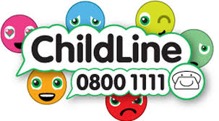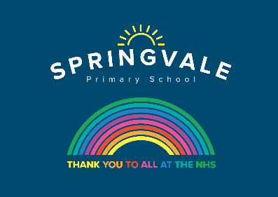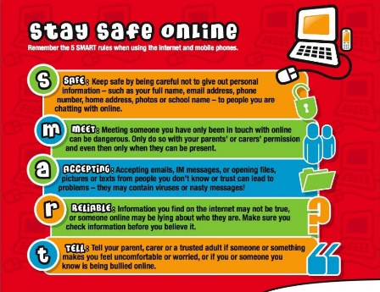

|  |  |
| --- | --- |
| **Learning Project WEEK 7- Celebrations** | |
| **Age Range:** Nursery | |
| **Weekly Maths Tasks (Aim to do 1 per day)** | **Weekly Reading Tasks (Aim to do 1 per day)** |
| * Watch a Numberblocks clip each day at: [BBC](https://www.bbc.co.uk/iplayer/episodes/b08bzfnh/numberblocks?page=2) or [CBeebies](https://www.bbc.co.uk/cbeebies/shows/numberblocks). Use this guide [here](https://www.bbc.co.uk/cbeebies/joinin/numberblocks-help-your-child-with-maths) to give you ideas on what to do with your children whilst watching an episode. * Play this [game](https://www.topmarks.co.uk/learning-to-count/gingerbread-man-game) to practise counting, ordering and matching numbers to 10. * Practise counting up to 20. This can be done through playing hide and seek, singing number songs, chanting, board games etc. * Listen to a number song from the [CBeebies](https://www.bbc.co.uk/cbeebies/watch/number-songs-from-numberblocks#playlist) website. After listening to them, watch again and sing along if you can. Talk about the maths you can see in the video clip. * To the tune of ’10 green bottles’, sing,   **5 birthday candles standing in a row (repeat)**  **Sing Happy Birthday, and give a great big blow,**  **There are 4 birthday candles standing in a row.**  (children should know this)   * Make a selection of birthday cards with numerals on the front. Can your child count out birthday candles (if you have them available). If you have a bun or cake, put candles on a cake, ask your child how many there are. If they get it right, light them to blow out. | * Read a variety of books at home. Favourites can be repeated. Hearing the patterns of language in a story will support your child’s language development. * With your child, if you have old birthday cards, look at them to find numbers and letters. * Use the [Small Talk](https://small-talk.org.uk/) website for ideas on supporting your child’s Communication and Language development. |
| **Weekly Phonics Tasks (Aim to do 1 per day)** | **Weekly Writing Tasks (Aim to do 1 per day)** |
| * Sing Nursery Rhymes and songs together. Add in actions and change the words. Can children think of different rhyming words to add in? Repeat old favourites and learn new rhymes. You can find an A-Z of [Nursery Rhymes](https://allnurseryrhymes.com/). * Daily phonics - Practice the sounds your child is working on. [Interactive games](https://www.phonicsplay.co.uk/). * Watch a video of a [fireworks display.](https://www.youtube.com/watch?v=gb_ihBSH4C4) Can your child explore using instruments (if available) or household objects e.g. pots and pans to make their own imitation of firework sounds. * Learn the song [‘On Bonfire Night’](https://stevegrocott.bandcamp.com/track/the-firework-song) and encourage your child to make marks to represent the sounds in the song e.g. whiz, whiz could be a swirling pattern | * Practice name writing. Can they write their first name? Middle name? Surname? * Practice forming the letters of the alphabet. Follow your school’s script. * Create a card for a celebration of your choice. Can your child use their phonics knowledge to write a message for the person they would like to give it to? * Ask your child to draw a picture of a celebration they have taken part in. Talk about the picture together. |
| **Learning Project - to be done throughout the week** | |
| **This project this week aims to provide opportunities for your child to learn more about celebrations. Learning may focus and different types of celebrations that take place and who may celebrate them. It could look at how people celebrate different events differently in other parts of the world.**   * **Family Photographs-**   + Look over a selection of photographs of family celebrations and discuss with your child: what the celebration was about, who attended, what you did to celebrate, when it took place, whether it is an event that happens each year. Can your child remember the event taking place? What do they remember of it? * **Birthdays**-   + Talk to your child about when they were born. Look at photographs of the day they were born, if you have them available. Do they know the date of their birthday? Support your child to create an all about me folding book (as pictured) with their birth date, current age and anything else they think is important for people to know about them.      * **Plan a family celebration-**    + Decide on a family celebration for the week. This could be a family indoor picnic, meal, dance etc. Ask your child to write invitations to family members to come to it. Your celebration could be our school sports day which takes place at home on Friday.   + Create homemade bunting and flags to decorate your garden for sports day, using coloured paper (If you do not have coloured paper at home, you could use old newspaper or wrapping paper).   + Plan a picnic for the day and make the food together.   + Listen to ‘Topsy and Tim-The Big Race@ story being read on You Tube.   + **Discover religious celebrations-**   + Look through the range of [videos](https://www.bbc.co.uk/cbeebies/shows/lets-celebrate) available on Cbeebies and watch together. Discuss who celebrates the event and any similarities and differences with celebrations your child has taken part in. | |
| **Additional learning resources parents may wish to engage with** | |
| [**Twinkl**](https://www.twinkl.co.uk/offer/UKTWINKLHELPS?utm_source=promo&utm_medium=email&utm_campaign=England_coronavirus_schools_email&utm_content=offer_link) **-** to access these resources click on the link and sign up using your own email address and creating your own password. Use the offer code UKTWINKLHELPS | |
| **#TheLearningProjects** | |