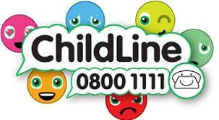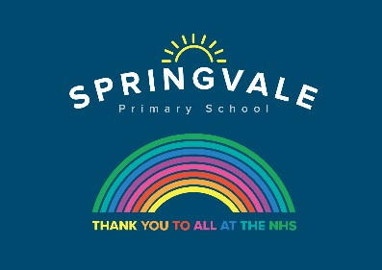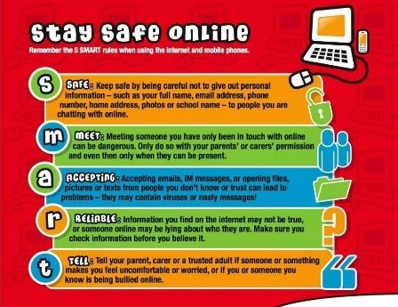

|  |  |
| --- | --- |
| **W/C 27.04.2020: Learning Project - Under the Sea** | |
| **Age Range:** EYFS | |
| **Weekly Reading Tasks** | **Weekly Phonics Tasks** |
| **Monday-** Share the story ‘The Snail and the Whale’. If you don’t have a copy at home watch this [online reading](https://safeyoutube.net/w/ivS5). | **Monday Introduce the sound of the week**  Mrs Slack/Mrs Gale/Mrs Evans  Sound of the week: Sound of the week: air (That’s not fair)  Read and spell words such as, fair, hair, lair, stair, chair  Mrs Cliffe/Mrs Honey and Mrs Parr  Sounds Re-cap ch sh th ng nk |
| **Tuesday-** Reception age children: Children to read to parents daily. Visit Oxford Owl for free eBooks that link to your child’s book band. You can create a [free account](https://www.oxfordowl.co.uk/for-home/). Complete the linked Play Activities for each book. | **Tuesday-** Buried Treasure: Write out some real words and made up words using the sound of the week and sounds that your needs to build to confidence (e.g. of nonsense words include tair, jor, fush). Place these in a pile and using 2 containers, label one as ‘Treasure’ and the other as ‘Bin’. Can your child read the word and decide if it is real? If it is real it goes in the treasure chest, if not it goes in the bin. Simplify this activity for Nursery by sounding the words out for them. |
| **Wednesday-** Read a variety of books at home in different places. Favourites can be repeated. Hearing the patterns of language in a story will support your child’s language development. | **Wednesday-** Play [Buried Treasure](https://new.phonicsplay.co.uk/resources/phase/2/buried-treasure) online on PhonicsPlay. |
| **Thursday-** Watch the online storybook- [‘Sharing a Shell’](https://safeyoutube.net/w/0vS5). Discuss how the crab felt in the story at each stage. Your child could draw a picture to represent the crab’s feelings. | **Thursday-** Sing ‘1,2,3,4,5 Once I caught a fish alive’. Click [here](https://www.bbc.co.uk/teach/school-radio/nursery-rhymes-1-2-3-4-5-once-i-caught-a-fish-alive/zdy6jhv) for the words. Can your child learn this by heart? |
| **Friday-** Ask your child to look at the books you have in your house. Can they find any other books about creatures that live under the sea? Can they group the animal books e.g. farm animals, jungle animals, under the sea animals? | **Friday-** Play Fishy Words – cut out some fish and write on words containing the sounds your child needs to practise. Can they catch a fish and read the word? |
| **Weekly Writing Tasks** | **Weekly Maths Tasks- Addition and Subtraction – Count on and Back** |
| **Monday-** Ask your child to draw a picture and write about their favourite underwater creature. They could label the picture too. | **Monday-** Create a countdown game by chalking numbers 10-0 leading from a ship down a ladder towards the sea . Provide a 1-3 dice (or 1 -3 number cards that can be turned over) Roll the dice and jump from 10-0. First to splash into the sea is the winner! |
| **Tuesday-** Have a try at Snail Writing. Using hair gel, shaving foam or any other slimy liquid, practise forming the letter ‘**s**’ using your finger. Try writing some words that use the sound of the week. | **Tuesday-** Play Hidden Items. Count out 5 cubes or objects and ask your child to check that there are 5. Cover the objects with a cloth & check that your child is happy there are still 5 under the cloth. Then as they watch, place 2 more cubes under the cloth. Ask your child to tell you how many cubes there are now. Encourage them to represent the cubes with their fingers and model counting on 5…6, 7  Key Questions  How many cubes did we have at the start?  How many cubes did I add?  How many will the under the cloth now?  How did you work it out? |
| **Wednesday- Ask your child to close their eyes and imagine being at the beach. Can they draw a picture list or, if they are able, use their phonics to write a word list of all the things you can see, taste, touch, smell and hear?** | **Wednesday-** Hidden Items can also be used for subtraction. Ensure your child knows how many cubes there are at the start. Cover them up and this time take some cubes out, counting while your child watches. Ask them to work out how many cubes will still be hidden.  Key Questions  How many cubes did we have at the start?  How many cubes did I take away?  How many will the under the cloth now?  How did you work it out? |
| **Thursday-** Use this [animated letter formation tool](https://www.doorwayonline.org.uk/activities/letterformation/) to help your child practise letter formation. You can select those they find most challenging. | **Thursday-** Uisng pebbles or shells ask your child to line up 10 . Playing with you, take turns to choose whether to take 1,2 or 3 pebbles. The winner is the player who avoids taking the last pebble. |
| **Friday-** Listen to the song [Henry the Crab](https://safeyoutube.net/w/lwS5)- Ask your child to draw a picture of what they think Henry the crab looks like.**CHALLENGE-** Can they write a letter to Henry and ask him about what it is like to live under the sea? | **Fishy Friday-Re-cap patterns.** Draw the outline of a fish for your child to make a pattern in. Could they make the pattern out of 2D shapes? Can they make a repeated pattern? |

|  |
| --- |
| **Learning Project - to be done throughout the week** |
| **The project this week aims to provide opportunities for your child to learn more about life in and around the sea. Learning may focus on the strange and wonderful creatures and plants that occupy our oceans, their habitats and how human beings affect this environment.**  **After listening to the story, ‘The Snail and the Whale’** (see reading task).   * Take your child on a snail hunt around the garden. Can they think about the places a snail might want to live? * Show your child a [picture of a sea snail.](https://www.nhm.ac.uk/discover/news/2019/december/getting-a-good-look-at-deep-sea-snails.html) Ask, how is it different from the snails they found in the garden? * Have a [Snail Race-](https://kidscraftroom.com/learn-snail-facts-by-snail-racing/) Use chalk to draw out lines on the ground (or sticks to mark out the lines) to create a race track. Place your snails at the starting line and watch them go! You could give your child a timer to measure how long it takes for the snails to make their way across. Share a picture of the winning snail on Twitter at [**#TheLearningProjects**](https://twitter.com/hashtag/thelearningproject)   **Make your own ‘Under the Sea’ Scene**   * Watch [this video](https://safeyoutube.net/w/PwS5) of the coral reef.Talk about the animals you can see. What are the animals called? * **Use junk modelling or craft items you have around your house to create the scene. You could even add in natural objects e.g. grass as seaweed.**   **Counting Undersea Creatures**   * Show your child how to play this [game.](https://www.topmarks.co.uk/learning-to-count/underwater-counting) There is a simpler version with amounts to 5 and a more challenging version with amounts to 10. **CHALLENGE**: Support your child to create a record of how many of each creature there were.     **Make your own Fishing Game**   * Make a fishing rod using a stick or similar (a wooden spoon would work well!). Tie some string on to one end and tie a magnet onto the end of the string (you could use a fridge magnet). * Using the rod, your child could explore which items are attracted to the magnet around the house   **Explore Floating and Sinking**   * Fill up a bowl, sink or basin and provide your child with a range of objects to explore. Which ones float and which sink? Ask them why they think they float/ sink? **CHALLENGE:** Keep a record of the objects that float and sink? This could be using pictures or written. |
| **STEM Learning Opportunities #sciencefromhome** |
| **Unplugged Coding**   * Watch [this video](https://bbc.in/2XBXWnp). * Create a simple under the sea obstacle course or draw an obstacle course on a piece of paper. Children have to guide an under-water robot (Parent/sibling/toy) through the obstacles by shouting out simply instructions. E.g. forwards, right, left, backwards. |
| **Additional learning resources parents may wish to engage with** |
| [**White Rose Maths**](https://whiterosemaths.com/homelearning/) online maths lessons. Watch a lesson video and complete the worksheet (can be downloaded and completed digitally).  [**Numbots**](https://numbots.com)**.** Your child can access this programme with their school login.  [**IXL**](https://uk.ixl.com/math/reception) Click on Maths, Reception. There are interactive games to play and guides for parents.  [**Talk for Writing Home-school Booklets**](https://www.talk4writing.co.uk/wp-content/uploads/2020/04/Reception-Unit.pdf) are an excellent resource to support your child’s speaking and listening, reading and writing skills. |
| The Learning Projects are based on the **National Curriculum expectations** for the key stage which your child is in. It may be that your child finds the tasks set within the Learning Project for their year group too simple. If this is the case, then we suggest that your child accesses the Learning Projects which are set for the key stage above. Equally, if the projects are too challenging, then we advise that your child accesses the projects for the key stage below.  If your child requires more of a challenge, or you believe that there are some gaps in their learning then [Century Tech](https://www.century.tech/about-us/) is a fantastic resource that is currently free for home learning. The app is designed to address gaps and misconceptions, provide challenge and enables children to retain new knowledge. It uses artificial intelligence to tailor the learning to your child’s needs. Sign up [here](https://courses.century.tech/registration). |
| **#TheLearningProjects** |