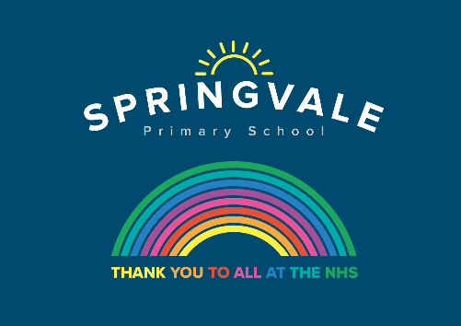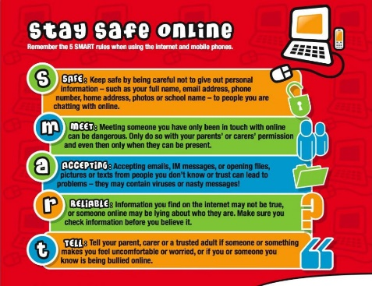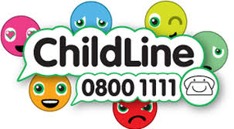

|  |  |
| --- | --- |
| **W/C 6.7.20 : Learning Project - Music** | |
| **Age Range:** Nursery | |
| **Weekly Reading Tasks** | **Weekly Phonics Tasks** |
| **Monday-** Story sound effects- Read a story together and add in your own musical sound effects e.g. make swishy swashy sounds with fabric to go with ‘We’re Going on a Bear Hunt’. You can repeat this with as many stories as you like! | **Monday-** Play [Odd Sound Out](https://www.phonicsbloom.com/uk/game/odd-sound-out?phase=2). You could play a practical version of this using objects from around the house. Can your child identify which object doesn’t begin with the same sound? |
| **Tuesday-** Read together the story of [Mr Big](https://safeyoutube.net/w/fkX5). Discuss with your child how Mr Big felt when the other animals didn’t want to be around him. | **Tuesday-** Choose a letter of the alphabet. How many words can your child name that begin with that sound? |
| **Wednesday-** Read and sing a variety of nursery rhymes with your child. Which one is their favourite? Do any of the rhymes have the same rhythm? | **Wednesday-** Play [Online Buried Treasure](https://new.phonicsplay.co.uk/resources/phase/2/buried-treasure) - Click on the sounds your child is learning. Can your child explain what the real word means? |
| **Thursday-** Have a look at some of the different ways music is played. Are there CD’s, vinyl records, tapes in the loft that you could show your child? | **Thursday-** Ask your child to find a stick from the garden and explore making music around the house by tapping, hitting and scraping. You could ask them to make loud sounds, quiet sounds, sounds that are short and long. |
| **Friday-** Talk about the different instruments people can play. Find pictures of them. Which instrument would you like to be able to play? | **Friday-** Play Washing Line Phonics- Peg along a washing line, or clothes airer, a number of different sounds. |
| **Weekly Writing Tasks** | **Weekly Maths Tasks- Shape** |
| **Monday-** Ask your child to think about how some musical instruments are played, for example bang a drum, tap a tambourine, shake the maracas. Play some instruments, if you have any. | **Monday-** Take your child on a shape hunt. Look around the house and garden for different objects that have: 2D shapes – circle, square, triangle, rectangle (oblong) |
| **Tuesday- Write an invitation to your own Family Music Show for a family member. They could watch the show on a video call.** | **Tuesday-** Sing these shape songs together: [2D shape song](https://safeyoutube.net/w/sGX5)**.** Then play the [Turtle Diary](https://www.turtlediary.com/game/exploring-shapes.html) online game. |
| **Wednesday-** Your child can draw a picture of the events from their favourite Nursery rhyme. **CHALLENGE:** Ask your child to write out the song title with your help. | **Wednesday-** Can your child draw around objects to create 2D shapes? Ask your child to name the shapes they have drawn. Can they cut the shapes out to make a 2D shape picture i.e. a house, rocket, robot? |
| **Thursday-** Ask your child to sing their favourite nursery rhyme.As they sing each line of the song, they can draw small pictures to help them remember the song. | **Thursday (theme)-** Make a clap beat for your child, can they repeat the clapping sequence? Can they make their own for you to follow? |
| **Friday-** Listen to a piece of classical music of your choice. Ask your child to draw/ paint along to the music. How does the music make them feel? | **Friday-** Find lots of different shaped recycled rubbish. e.g. boxes, bottles, tubes. Can you make the shapes into a picture? A man, an animal. |

|  |
| --- |
| **Learning Project - to be done throughout the week** |
| **The project this week aims to provide opportunities for your child to learn more about music. Learning may focus on famous musicians, listening to and performing music and exploring a range of music genres and instruments.**  **Drummers Drumming**   * Using pots, pans and baking trays from the kitchen lay out your own ‘drum kit’. Allow your child to explore by banging and tapping the pans to see the different sounds they make. Extend this activity by tapping out a rhythm and asking your child to listen to it then repeat it. You could make this more difficult by adding in a blindfold so they have to rely on the sound to identify which pot or pan they need to hit to copy.   **Make your own Music**   * **Your child could create a guitar using a plastic tub with elastic bands wrapped around it.**   **Play ‘What’s that Sound?’**   * **Game 1-** Hum a song to your child that they are likely to know. Can they guess which song it is from the tune alone? Take it in turns to hum out a tune. * **Game 2-**  Go into a room of the house while your child listens outside of the door. Make a sound or play a rhythm out on an item in the room e.g. tapping on the table. Open the door and ask your child to find what you used to make the sound.   **A Family Music Show**   * Ask each member of the family to prepare a song and then put on a singing performance. You could select someone to be the judge or ask a family member to watch on a video call and decide on the winner. Don’t forget to send the invite first (see writing task).   **Discovering Different Eras**   |  |  |  |  |  |  |  |  | | --- | --- | --- | --- | --- | --- | --- | --- | | [**1920’s**](https://safeyoutube.net/w/a9vK) | [**1930’s**](https://safeyoutube.net/w/9nZ5) | [**1940’s**](https://safeyoutube.net/w/voZ5) | [**1950’s**](https://safeyoutube.net/w/BpZ5) | [**1960’s**](https://safeyoutube.net/w/3qZ5) | [**1970’s**](https://safeyoutube.net/w/wrZ5) | [**1980’s**](https://safeyoutube.net/w/RrZ5) | [**1990’s**](https://safeyoutube.net/w/tsZ5) |  * Click on the links above and listen to a sample. Which era did your child find most enjoyable to listen to? Can they dance in the same style? |
| **Coronavirus and Wellbeing- Returning to/Being at School** |
| **The change that Covid-19 has caused to our lives has been difficult and has provided countless challenges. For many children, the uncertainty and disruption to everyday life has caused worry and anxiety. These tasks are designed to help children process the current situation, begin to make sense of it and plan for returning to a different normal.**  **Think**   * Ask your child to think about how they are feeling about returning to being at school. Can they list two or three feelings? Explain to your child that it is okay to feel like this and many children across the world are most likely feeling the same. Your child could draw a heart or a rainbow for other children and think of kind words for them.   **Talk**   * Does your child have any questions about what school will be like when they eventually return? Or any questions about what they have noticed since returning? Discuss the changes that will be in place when they return or the changes that are already in place e.g. more handwashing, how to social distance, etc. Then talk about all of the things that will remain the same e.g. wearing the same uniform, seeing the same teachers, etc.   **Do**   * The thought of returning to school will fill many children with a mixture of excitement and apprehension. Why not make a positivity box? Your child could add items to this box that make them feel safe and provide comfort e.g. a smooth stone to hold. When they are feeling apprehensive, they could choose an item from the box to hold and think about a time when they felt calm |
| **Making Instruments – Make Sound Shakers**   * Collect some different containers with lids, make sure you cannot see through them. The small plastic containers from inside chocolate eggs work really well. Put different materials in the containers. (Stones, rice, sugar, paper clips etc.) * How many shakers can you make? Do they all sound the same? Can you make a shaker that is difficult to recognise? Can you make loud and quiet sounds with them? * For more ideas take a look at the full resources [here](https://www.stem.org.uk/resources/elibrary/resource/34404/sounds-science). |