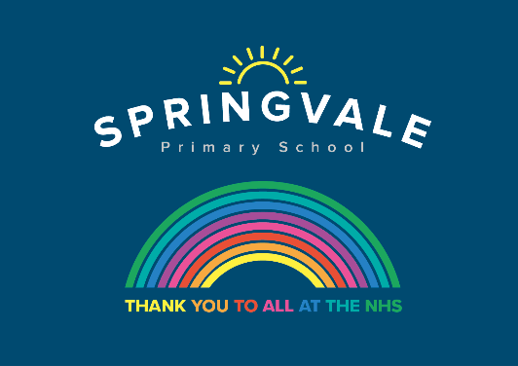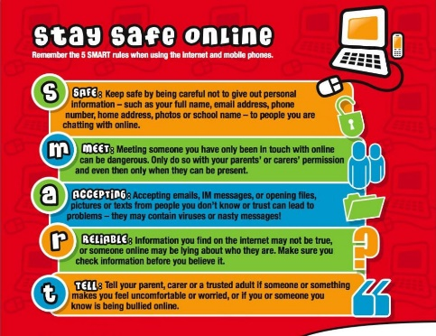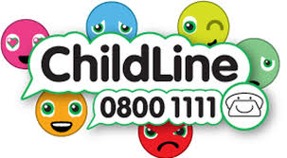

|  |  |
| --- | --- |
| **W/C 8.06.2020: Learning Project - Music** | |
| **Age Range:** EYFS  FS2 The Curious Cubs | |
| **Weekly Reading Tasks** | **Weekly Phonics Tasks** |
| **Monday-** Story sound effects- Read a story together and add in your own musical sound effects e.g. make swishy swashy sounds with fabric to go with ‘We’re Going on a Bear Hunt’. You can repeat this with as many stories as you like! | **Monday**  Mrs Slack/Mrs Gale/Mrs Evans  Revise/Re-cap Set 2 Sounds, (see Speed Sounds Set 2 mat attached).  Play Splat the Letter- Write out the letters for the sounds your child has been practising on pieces of paper and spread out on the floor. Take it in turns to shout out a sound and both players have to try and splat the sound with their hand.  Mrs Cliffe/Mrs Honey and Mrs Parr  Play Splat the Letter to re-cap: ch sh th ng nk ay ee  Introduce the sound of the week: igh (Fly high) by watching Alphablocks Word Magic T-IGH-T  Read and spell words such as, sigh, fight, light, might, right, tight. |
| **Tuesday-** Read together the story of [Mr Big](https://safeyoutube.net/w/fkX5). Discuss with your child how Mr Big felt when the other animals didn’t want to be around him. | **Tuesday**  Go to phonicsplay.co.uk and choose a game to play to rec-cap the sounds you know.  Play Roll and Read igh (see attached) |
| **Wednesday-** Read and sing a variety of nursery rhymes with your child. Which one is their favourite? Do any of the rhymes have the same rhythm? | **Wednesday**  Play Washing Line Phonics- Peg along a washing line, or clothes airer, a number of different readable words. Write each word on a piece of card, muddle them up and ask your child to re-arrange them so that they make sense.  Can I play with you?.  The cat and dog will fight. |
| **Thursday-** Have a look at some of the different ways music is played. Are there CD’s, vinyl records, tapes in the loft that you could show your child? Look at the writing on each and talk about how this gives people information about the music. | **Thursday**  Visit ictgames.co.uk and choose a game to play to rec-cap the sounds you know.  Play Real and Nonsense igh words (see attached) |
| **Friday-** Have a look at and explore musical notes. Talk about how people read the different notes to play different musical instruments. Talk about the different instruments people can play. Which instrument would you like to be able to play? | **Friday-**  **Try a different sentence on your washing line.** (See Wednesday)  I like going to the fair.  I can jump up high |
| **Weekly Writing Tasks** | **Weekly Maths Tasks- Length and Height** |
| **Monday-** Ask your child to think about how some musical instruments are played, for example bang a drum, tap a tambourine, shake the maracas. Write out the words and encourage your child to trace them. | **Monday-** Ask your child to make different rockets out of playdough or strips of paper. Can they make a long rocket? A short rocket? A thick rocket? |
| **Tuesday- Write an invitation to your own Family Music Show for a family member. They could watch the show on a video call.** | **Tuesday-** Your child can compare objects from around the house or outside. Ask them if the object is longer, the same length or shorter? Order the objects. |
| **Wednesday-** Your child can draw a picture of the events from their favourite Nursery rhyme. **CHALLENGE:** Ask your child to write out the words to a part of the song or the song title. | **Wednesday-** Ask your child to use Lego, blocks or cardboard boxes to build a tower that is the same height as them, taller than them and shorter than them. |
| **Thursday-** Ask your child to sing their favourite nursery rhyme.As they sing each line of the song, they can draw small pictures to help them remember the song. | **Thursday (theme)-** Make a clap beat for your child, can they repeat the clapping sequence? Can they make their own for you to follow? |
| **Friday-** Listen to a piece of classical music of your choice. Ask your child to draw/ paint along to the music. How does the music make them feel? **CHALLENGE:** Can they write onto their picture how it made them feel? | **Friday-** Play the online game [Let’s Compare](https://www.topmarks.co.uk/early-years/lets-compare). Following this, your child can sing the song [Short or Tall](https://safeyoutube.net/w/Aah6)**.** |

|  |
| --- |
| **Learning Project - to be done throughout the week** |
| **The project this week aims to provide opportunities for your child to learn more about music. Learning may focus on famous musicians, listening to and performing music and exploring a range of music genres and instruments.**  **Drummers Drumming**   * Using pots, pans and baking trays from the kitchen lay out your own ‘drum kit’. Allow your child to explore by banging and tapping the pans to see the different sounds they make. Extend this activity by tapping out a rhythm and asking your child to listen to it then repeat it. You could make this more difficult by adding in a blindfold so they have to rely on the sound to identify which pot or pan they need to hit to copy.   **Make your own Music**   * **Your child could create a guitar using a plastic tub with elastic bands wrapped around it. Post a picture of your musical instrument on Twitter at** [**#TheLearningProjects.**](https://twitter.com/hashtag/thelearningproject) **Can your child draw instructions on how to make a guitar for somebody else to follow?**   **Play ‘What’s that Sound?’**   * **Game 1-** Hum a song to your child that they are likely to know. Can they guess which song it is from the tune alone? Take it in turns to hum out a tune. * **Game 2-**  Go into a room of the house while your child listens outside of the door. Make a sound or play a rhythm out on an item in the room e.g. tapping on the table. Open the door and ask your child to find what you used to make the sound.   **A Family Music Show**   * Ask each member of the family to prepare a song and then put on a singing performance. You could select someone to be the judge or ask a family member to watch on a video call and decide on the winner. Don’t forget to send the invite first (see writing task).   **Discovering Different Eras**   |  |  |  |  |  |  |  |  | | --- | --- | --- | --- | --- | --- | --- | --- | | [**1920’s**](https://safeyoutube.net/w/a9vK) | [**1930’s**](https://safeyoutube.net/w/9nZ5) | [**1940’s**](https://safeyoutube.net/w/voZ5) | [**1950’s**](https://safeyoutube.net/w/BpZ5) | [**1960’s**](https://safeyoutube.net/w/3qZ5) | [**1970’s**](https://safeyoutube.net/w/wrZ5) | [**1980’s**](https://safeyoutube.net/w/RrZ5) | [**1990’s**](https://safeyoutube.net/w/tsZ5) |  * Click on the links above and listen to a sample. Which era did your child find most enjoyable to listen to? Can they dance in the same style? |
| **Coronavirus and Wellbeing- Returning to/Being at School** |
| **The change that Covid-19 has caused to our lives has been difficult and has provided countless challenges. For many children, the uncertainty and disruption to everyday life has caused worry and anxiety. These tasks are designed to help children process the current situation, begin to make sense of it and plan for returning to a different normal.**  **Think**   * Ask your child to think about how they are feeling about returning toor being at school. Can they list two or three feelings? Explain to your child that it is okay to feel like this and many children across the world are most likely feeling the same. Your child could draw a heart or a rainbow for other children and list kind words for them.   **Talk**   * Does your child have any questions about what school will be like when they eventually return? Or any questions about what they have noticed since returning? Discuss the changes that will be in place when they return or the changes that are already in place e.g. more handwashing, how to social distance, etc. Then talk about all of the things that will remain the same e.g. wearing the same uniform, seeing the same teachers, etc.   **Do**   * The thought of returning to school will fill many children with a mixture of excitement and apprehension. Why not make a positivity box? Your child could add items to this box that make them feel safe and provide comfort e.g. a smooth stone to hold. When they are feeling apprehensive, they could choose an item from the box to hold and think about a time when they felt calm.   **Visit**   * Use this [Balloon](https://www.childline.org.uk/toolbox/games/balloon/) or [Aeroplane](https://www.childline.org.uk/toolbox/games/aeroplane/) game to encourage your child to record their worries about returning to school. |
| **STEM Learning Opportunities #sciencefromhome** |
| **Making Instruments – Make Sound Shakers**   * Collect some different containers with lids, make sure you cannot see through them. The small plastic containers from inside chocolate eggs work really well. Put different materials in the containers. (Stones, rice, sugar, paper clips etc.) * How many shakers can you make? Do they all sound the same? Can you make a shaker that is difficult to recognise? Can you make loud and quiet sounds with them? * For more ideas take a look at the full resources [here](https://www.stem.org.uk/resources/elibrary/resource/34404/sounds-science). |
| **Additional learning resources parents may wish to engage with** |
| [**White Rose Maths**](https://whiterosemaths.com/homelearning/) online maths lessons. Watch a lesson video and complete the worksheet (can be downloaded and completed digitally).  [**Numbots**](https://numbots.com)**.** Your child can access this programme with their school login.  [**IXL**](https://uk.ixl.com/math/reception) Click on Maths, Reception. There are interactive games to play and guides for parents.  [**Talk for Writing Home-school Booklets**](https://www.talk4writing.co.uk/wp-content/uploads/2020/04/Reception-Unit.pdf) are an excellent resource to support your child’s speaking and listening, reading and writing skills. |
| The Learning Projects are based on the **National Curriculum expectations** for the key stage which your child is in. It may be that your child finds the tasks set within the Learning Project for their year group too simple. If this is the case, then we suggest that your child accesses the Learning Projects which are set for the key stage above. Equally, if the projects are too challenging, then we advise that your child accesses the projects for the key stage below.  If your child requires more of a challenge, or you believe that there are some gaps in their learning then [Century Tech](https://www.century.tech/about-us/) is a fantastic resource that is currently free for home learning. The app is designed to address gaps and misconceptions, provide challenge and enables children to retain new knowledge. It uses artificial intelligence to tailor the learning to your child’s needs. Sign up [here](https://courses.century.tech/registration). |
| **#TheLearningProjects** |

