MINDFULLNESS AND WELLBEING IDEAS

FOR SUMMER HOLIDAYS 2020

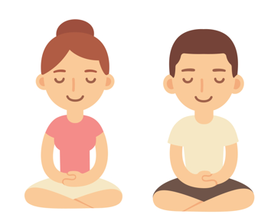

1. **A picture book for children worried about the Coronavirus:**

<https://en.calameo.com/read/000777721945cfe5bb9cc?authid=Xu9pcOzU3TQx>

1. **Mindfulness:**

Mindfulness colouring is a relaxing and calming activity which can also encourage children to explore their creativity while improving fine motor skills!

**Colouring in pages:**

<https://www.teachingideas.co.uk/2d-art/mindfulness-colouring-images-animals>

<https://www.bestcoloringpagesforkids.com/mindfulness-coloring-pages.html>

A five or ten-minute daily mindfulness practice can help to reduce stress and anxiety.

**5-10 minute activities:**

<https://www.teachstarter.com/gb/blog/classroom-mindfulness-activities-for-children-gb/>

1. **Meditation:**

Meditation can help to regulate children’s emotions as well as improve concentration and focus.

<https://annakaharris.com/mindfulness-for-children/>

1. **Self-esteem:**

Self-esteem helps children cope with mistakes and build their resilience. It helps them try again, even if they fail at first. As a result, self-esteem will help them do better at school, at home, and with friends. Children with low self-esteem feel unsure of themselves, so improving self-esteem, improves confidence.

<http://www.plantlovegrow.com/self-esteem.html>

<https://www.kidsplayandcreate.com/self-esteem-character-building-activities-for-kids/>

1. **Self-care:**

Self-care is about the things that we can do to look after our own mental health.

<https://www.annafreud.org/on-my-mind/self-care/>

<https://www.childline.org.uk/toolbox/calm-zone/>

1. **Yoga:**

Yoga helps children to boost confidence. Regular practicing of yoga helps your child to grow self-confidence.

<https://www.cosmickids.com/>