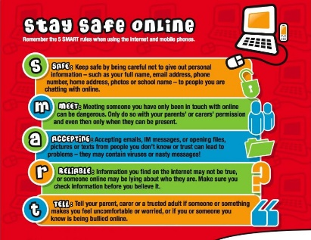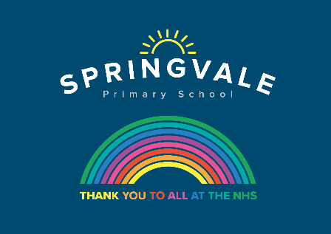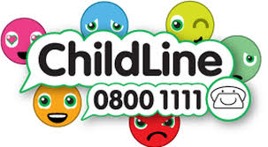

|  |  |
| --- | --- |
| **W/C 13.07.2020: Learning Project - Space** | |
| **Age Range: Y5/6 Mrs Henstock/Mrs Fearn/Mrs Mayston** | |
| **Weekly Reading Tasks** | **Weekly Spelling Tasks** |
| **Monday-** Task your child with reading unusual things in unusual spaces e.g. a recipe book in the bath. How many unusual spaces can they find over the week? | **Monday-** Pick 5 Common Exception words from the Year 5/6 spelling list [here](https://cdn.oxfordowl.co.uk/2019/08/29/13/56/09/5a42eb6a-f57f-4dc4-a66e-bd4c5e27e4b7/SpellingWordList_Y5-6.pdf). Challenge your child to create a word web by finding 5 other related words. |
| **Tuesday-** Write a book review of a book you have enjoyed recently, how would you persuade someone else that they need to read it? | **Tuesday-** Encourage your child to organise these synonyms from slowest to fastest: **quickly, speedily, swiftly, hurriedly** & **in a flash**. Which best describes a rocket launching into space? |
| **Wednesday-** Click [here](https://drive.google.com/file/d/1TMaZgfeTCqTr9xVPY5CBL1AdxM3H_Hkg/view?usp=sharing) for a reading activity about **Space Tourism**. Challenge your child to read the text in 3 minutes and complete the questions. | **Wednesday-** Some words contain the letter string [-ough-](https://www.bbc.co.uk/bitesize/topics/zt62mnb/articles/z9f2b82) Can your child use this knowledge to complete [these sentences against the clock?](https://www.spellzone.com/word_lists/games-29.htm) |
| **Thursday-** Ask your child to listen to or read along to the poem [Cosmic Disco](https://childrens.poetryarchive.org/poem/cosmic-disco/). What does your child think is the main idea in the poem? | **Thursday-** Task your child with identifying any space related words from the poem[Cosmic Disco](https://childrens.poetryarchive.org/poem/cosmic-disco/). Can they draw illustrations to represent these words too? |
| **Friday-** Encourage your child to research information on past space expeditions [here.](https://www.nasa.gov/kidsclub/text/nowinspace/Archive.html) Which expedition was the most impressive? Why? | **Friday-** Get your child to proofread their writing from the day. Encourage them to use a [dictionary](https://www.oxfordlearnersdictionaries.com/) to check the spelling of any words that they found challenging. |
| **Weekly Writing Tasks** | **Weekly Maths Tasks- Area and Perimeter** |
| **Monday-** Visit the Literacy Shed for this resource on [Broken: Rock, Paper, Scissors](https://www.literacyshedplus.com/en-gb/resource/broken--rock--paper--scissors-ks2-activity-pack) or your child can create a comic strip retelling [Armstrong's](https://www.bbc.co.uk/bitesize/topics/zjwvb82/articles/zhx4k2p) mission to the moon. | **Monday-** There are a range of interactive quizzes linked to area and perimeter that your child can work through on this [website](https://www.khanacademy.org/math/basic-geo/basic-geo-area-and-perimeter). There are videos to help too. |
| **Tuesday-** Ask your child to pretend they have woken up to find an alien at the end of their bed. Write a detailed description of the alien thinking about size, appearance and the sounds it makes. Draw it too! | **Tuesday-** Find objects around the home and get your child to estimate the area and perimeter and then measure the actual area and perimeter. If you have not got a ruler at home use this [online resource.](https://www.mathplayground.com/area_perimeter.html) |
| **Wednesday-** Get your child to imagine that they are a news reporter, reporting on this alien visit. They can write a newspaper report. [Remind your child of the features of a newspaper](https://schools.firstnews.co.uk/blog/journalistic-writing/features-of-a-newspaper-report-ks2/). If they have access to a PC, they can type up their finished report on Word or Google Docs. | **Wednesday-** Your child could make a map of a newly discovered planet. Provide them with a grid drawn onto paper. Each square on the map represents 5 metres squared (m²). It must include: mountains 220m², a water source 140m², three islands that must each be between 120m² and 240m². |
| **Thursday-** Ask your child to create a travel brochure for a newly discovered planet. Consider: travel time, location, accommodation and things to do and see. | **Thursday-** Ask your child to have a go at the different activities in this [NRICH task](https://nrich.maths.org/7280&part=). This can be done on paper. |
| **Friday-** Your child can write a persuasive letter/job application to NASA asking to be the next astronaut to go into space. Remind them that they must include the [skills](https://www.spacekids.co.uk/astronauts/) they have that would make them the best candidate. | **Friday-** Order the planets based on the number of Earth days it takes for them to orbit the Sun- Saturn: 10,759 days, Earth: 365 days, Mercury: 88 days, Uranus: 30,687 days, Jupiter: 4,333 days, Mars: 687 days, Venus: 225 days & Neptune: 60,190 days. |

|  |
| --- |
| **Learning Project - to be done throughout the week** |
| **The project this week aims to provide opportunities for your child to learn more about space. Learning may focus on our Solar System, the Sun and the Moon. It could look at life in outer space from the view of an astronaut and travelling through space.**   * **Moon Moves -** Get your child to research the importance of the [Moon](https://safeyoutube.net/w/miF6) to life on Earth. Ask your child to research the movement of the Moon relative to the Earth and create a model of the Earth, Moon and Sun. Here is an idea of how your child could do it. * **Through Space and Time-** Ask your child to research space exploration history and create a timeline of how people have travelled into space. Get them to think about when the first rocket was launched? When did the first man travel to space? How about the first woman? What other significant events can they add to their timeline? * **Connect the Dots-** Ask your child to examine the different life stages of a star and explore the names and shapes of some famous [constellations](https://www.ducksters.com/science/physics/constellations.php). Ask your child to create a poster displaying the different constellations which can be used to teach others. Tell them to make it as creative as possible. * **Dancing into Space-** Listen to Holst’s ['The Planets'](https://safeyoutube.net/w/6lF6) with your child. Ask them to select a planet and decide what they think that planet would be like. Get them to create a dance/ set of movements to go with the music which will portray this. Take a video of their dance to share with the family and encourage your child to self-evaluate whilst watching the video. Remember to tweet a video of their dance. * **Mission to Space-** Get your child to research the different components of a spacecraft and using their understanding of this, design their own spacecraft. Get them to think carefully about what it needs to include in order for astronauts to survive in space. Can they make a small scale model using resources from around the home? There might be inspiration [here](https://www.nasa.gov/kidsclub/index.html). |
| **STEM Learning Opportunities #sciencefromhome** |
| **Mission X – Building a Bionic Hand**   * It is difficult and tiring for humans to work in space. Bionic hands that can be remotely operated can help humans work more efficiently in space. Try making a model bionic hand using cardboard, straws, string and elastic bands. You will need to think about how a human hand works to help you with your design. You can find out more [here](https://www.stem.org.uk/resources/elibrary/resource/446379/building-bionic-hand). * Sign up and access all of the Mission X resources [here](https://www.stem.org.uk/missionx). |
| **Additional learning resources parents may wish to engage with** |
| * [**BBC Bitesize**](https://www.bbc.co.uk/bitesize/levels/zbr9wmn) **-** Lots of videos and learning opportunities for all subjects. * [**Classroom Secrets Learning Packs**](https://classroomsecrets.co.uk/free-home-learning-packs/) - Reading, writing and maths activities for different ages. * [**White Rose Maths**](https://whiterosemaths.com/homelearning/) online maths lessons. Watch a lesson video and complete the worksheet (can be downloaded and completed digitally). * [**Times Table Rockstars**](https://play.ttrockstars.com/auth/school)**.** Your child can access this programme with their school logins. On Times Table Rockstars, children should aim to play Soundcheck for 20 minutes daily. * IXL online. Click here for [**Year 5**](https://uk.ixl.com/math/year-5) or here for [**Year 6**](https://uk.ixl.com/math/year-6). There are interactive games to play and guides for parents. * [**Mastery Mathematics Learning Packs.**](https://www.mathematicsmastery.org/free-resources) Take a look at the mastery mathematics home learning packs with a range of different activities and lessons. * [**Y5 Talk for Writing Home-school Booklets**](https://www.talk4writing.co.uk/wp-content/uploads/2020/04/Y5-Unit.pdf) and [**Y6**](https://www.talk4writing.co.uk/wp-content/uploads/2020/04/Y6-Unit.pdf)are an excellent resource to support your child’s speaking and listening, reading and writing skills. |
| @SpringvalePS  We miss you! |