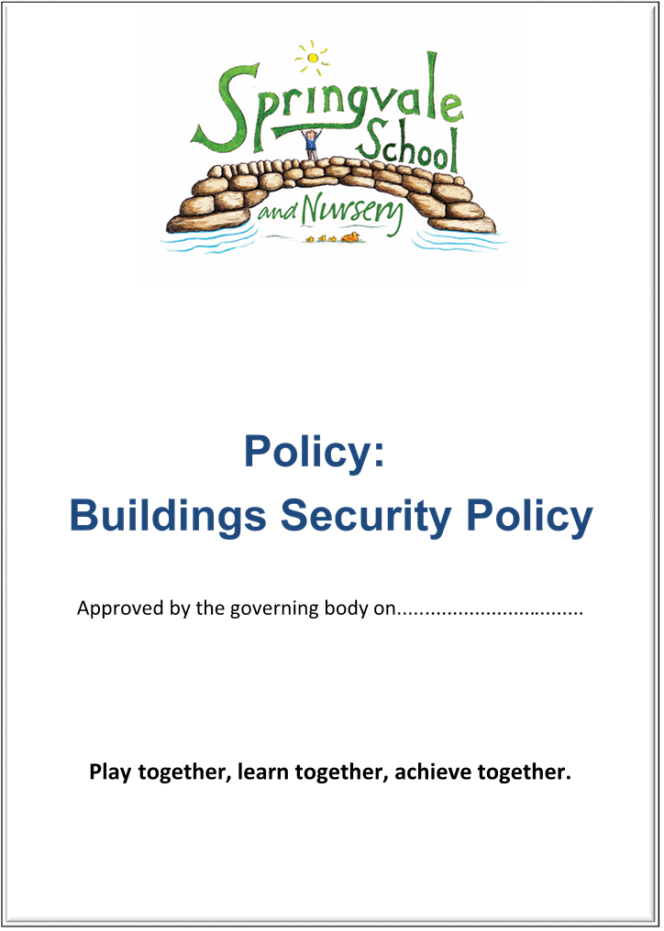
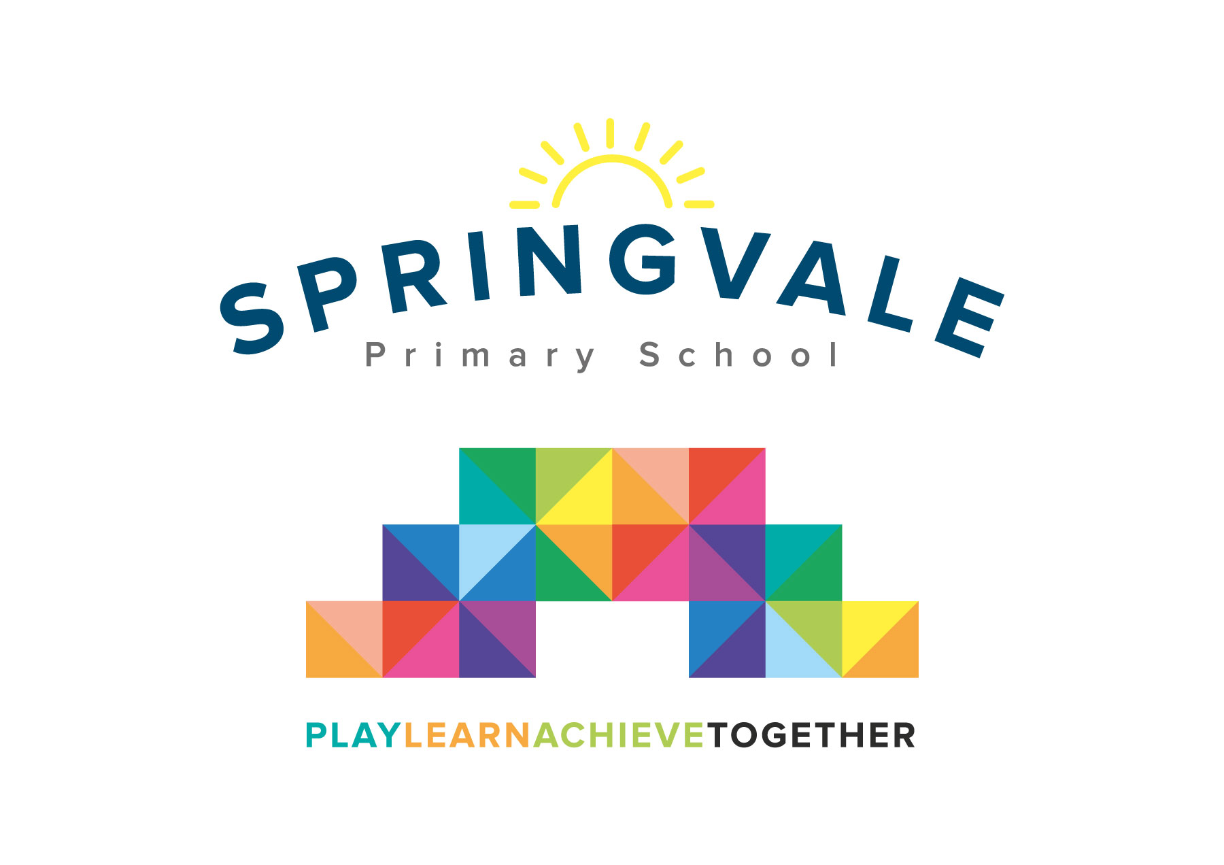
Pupil Premium

SPRINGVALE PRIMARY SCHOOL

Pupil Premium Policy

Introduction

This policy was created after a period of consultation with relevant stakeholders within school. It has been formally adopted by governors and reflects our approach at Springvale Primary School.

Aims and Principles
The policy is underpinned by the central aims of Springvale Primary and values held by the school community:
Aims of the school

- Springvale is committed to promoting high standards of academic achievement for all learners in all subjects.
- As a school we will continue to develop and instil key life skills and values in our pupils.
- We will encourage positive relationships and communications between home, our community and the wider world.

In particular, Springvale School has an inclusive approach to our provision. Our aim is always to involve all our children and stakeholders in all areas of the curriculum and school life. In accordance with our Disability Equality Scheme we recognise that this may mean making special adaptations or arrangements from time to time for children with specific disabilities. We welcome the involvement of disabled adults in all areas of school life.

Background Information
Springvale Primary School is a caring and open school, where parents, children, staff and the wider school community all know that their views and needs will be listened to, in both education and personal areas.

Pupil Premium Policy

Aims

All members of staff and governors accept responsibility for ‘socially disadvantaged’ pupils and are committed to meeting their pastoral, social and academic needs within a caring environment. This is an essential, integral part of the spiritual development of the whole school community.

As with every child in our care, a child who is considered to be ‘socially disadvantaged’ is valued, respected and entitled to develop to his/her full potential, irrespective of need or background.

Rationale of the pupil premium

The pupil premium is a government initiative that targets additional money for pupils from backgrounds who, research shows, can underachieve compared to their peers. The premium is provided in order to support these pupils in reaching their potential. The government have used pupils entitled to Free School Meals (FSM), Looked After Children (LAC) and pupils whose parents are in the armed forces as an indicator for those potentially needing additional support, and have deployed a fixed amount of money to schools per pupil, based on the number of pupils registered for FSM. In making provision for socially disadvantaged pupils, the governors of the school recognise that not all pupils who receive the pupil premium will be socially disadvantaged. This fixed amount of money will increase year on year throughout the term of this current parliament.

The government are not dictating how schools should spend this money, but are clear that schools will need to employ the strategies that they know will support their pupils to increase their attainment, and ‘narrow the gap’ by making good progress in school. Schools will be accountable for narrowing the gap, and there are tools used, such as school performance tables, to show the attainment of pupils who receive the pupil premium compared with their peers.

Provision

In order to meet the above requirements, the governing body and staff of Springvale Primary School will ensure that provision is made which secures the teaching and learning opportunities that meet the needs of all pupils.

As part of the additional provision made for pupils who belong to vulnerable groups, the SLT of the school will ensure that the needs of socially disadvantaged pupils are adequately assessed and addressed in termly data analysis and pupil progress reviews.

The new Universal Free School Meals system does not affect this system and we would still like families who are eligible for FSM to complete an entitlement request to allow the school to access the funds to support your child.

The governors also recognise that not all pupils who are socially disadvantaged are registered or qualify for free school meals. The governors reserve the right to allocate the pupil premium funding to support any pupil or groups of pupils the school has legitimately identified as being socially disadvantaged.

The range of provision

• Facilitating pupils access to education

• Facilitating pupils access to the curriculum

• Additional teaching and learning opportunities

• Alternative support and intervention

Reporting

Tracking now shows the pupils that are eligible for this funding and their progress during each term. Leaders meet regularly with staff about the provision that the pupils receive and what can be done differently or additionally to meet their needs. It will be the responsibility of the headteacher to produce an annual report for the governing body that outlines:

• The progress made by pupils eligible for pupil premium

• An outline of the provision that was made during the academic year

• An evaluation of the cost effectiveness, in terms of the progress made by the pupils receiving a particular provision, when compared with other forms of support.

The governors of Springvale Primary School will ensure that there is an annual statement to the parents outlining how the Pupil Premium funding has been used to support socially disadvantaged pupils. A sensitive version of this report will be shared with all stakeholders through our website. This task will be carried out within the requirements published by the Department for Education.

Success Criteria

The evaluation of this policy is based on how quickly the school has supported socially disadvantaged pupils and their peers. Targets will be identified and evaluated annually.

The success criteria for the Pupil Premium Policy are:

Early intervention and support for all children

The vast majority of children will meet their individual targets

Effective parental pupil school support

Having an effective system for identifying, assessing and monitoring pupils Having a whole-school approach to support this group of pupils throughout their time in school

Create a positive school atmosphere in which pupils’ differences are recognised and valued as full members of the school community, developing confident and independent learners

Appeals

Any appeal in connection with the disposition of the pupil premium funding should be addressed to the headteacher.

