Christmas Songsheet
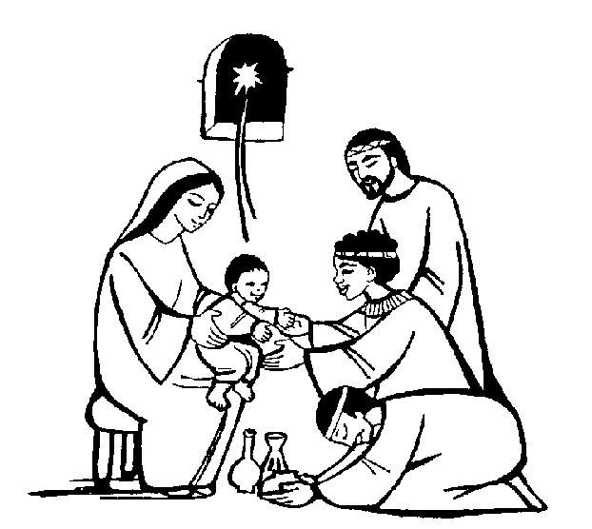
1.Away in a Manger
1. Away in a manger, no crib for a bed,
the little Lord Jesus
laid down his sweet head.
The stars in the bright sky
looked down where he lay,
the little Lord Jesus asleep on the hay

2. The cattle are lowing, the baby awakes,
but little Lord Jesus no crying he makes.
I love you, Lord Jesus;
look down from the sky,
and stay by my side
until morning is nigh.

3. Be near me, Lord Jesus,
I ask thee to stay
close by me for ever, and love me, I pray.
Bless all the dear children
in your tender care and fit us for heaven,
to live with thee there.

2. It was on a starry night
1. It was on a starry night,
When the hills were bright,
Earth lay sleeping, sleeping calm and still.
Then in a cattle shed, in a manger bed
A boy was born, king of all the world *

*Chorus ~ And all the angels sang for him,
The bells of heaven rang for him,
For a boy was born, king of all the world
2. Soon the shepherds came that way,
Where the baby lay
And were kneeling, kneeling by his side,
And their hearts believed again
For the peace of men
For a boy was born, king of all the world *

3. Come and Join the Celebration
Chorus * ~ Come and join the celebration, it’s a very special day. Come and share our jubilation; there’s a new king born today!
1. See the shepherds hurry down to Bethlehem, gaze in wonder at the Son of God who lay before them *
2. Wise men journey, led to worship by a star, kneel in homage, bringing precious gifts from lands afar, so…*
3. ‘God is with us’ ‘round the world the message bring. He is with us, “welcome!” all the bells on earth are peeling…*
4. Jingle Bells
Dashing through the snow
In a one horse open sleigh
O’er the fields we go, laughing all the way.
Bells on bob-tail ring, making spirits bright
O What fun it is to sing a sleighing song tonight.

Chorus : Jingle bells, jingle bells
Jingle all the way
O what fun it is to ride in a one horse open sleigh, O!
Jingle bells, jingle bells
Jingle all the way
O what fun it is to ride in a one horse open sleigh.

5. Rudolf the Red
Rudolph, the red-nosed reindeer
had a very shiny nose.
And if you ever saw him,
you would even say it glows.
All of the other reindeer
used to laugh and call him names.
They never let poor Rudolph
join in any reindeer games.
Then one foggy Christmas Eve
Santa came to say:
"Rudolph with your nose so bright,
won't you guide my sleigh tonight?"
Then all the reindeer loved him
as they shouted out with glee,
Rudolph the red-nosed reindeer,
you'll go down in history!

6. Little Donkey
Little donkey, Little donkey,
On a dusty road
Got to keep on plodding onwards
With your precious load.
Been a long time little donkey
Through the winter's night.
Don't give up now little donkey
Bethlehem's in sight.
Ring out those bells tonight
Bethlehem, Bethlehem.
Follow the star tonight
Bethlehem, Bethlehem.
Little donkey, little donkey
Had a heavy day
Little donkey carry Mary
Safely on her way.
Little donkey, little donkey
Journey's end is near
There are wisemen waiting for a
Sign to bring them here.
Do not falter, little donkey
There's a star ahead
It will guide you, little donkey
To a cattle shed
Ring out those bells tonight . . .

7. Calypso Carol
See him lying in a bed of straw
A draughty stable with an open door
Mary cradling the babe she bore
The prince of glory is his name

* Chorus : O now carry me to Bethlehem
To see the Lord appear to men
Just as poor as was the stable then
The prince of glory when he came.

Star of silver sweep across the skies
Show where Jesus in the manger lies
Shepherds, swiftly from your stupor rise
To see the Saviour of the World…*

Angels sing again the song you sang
Bring God’s glory to the heart of man
Sing that Bethlem’s little baby can
Be salvation to the world…*

8. Jingle Bell Rock
Jingle bell, jingle bell, jingle bell rock
Jingle bells swing and jingle bells ring
Snowin' and blowin' up bushels of fun
Now the jingle hop has begun
Jingle bell, jingle bell, jingle bell rock
Jingle bells chime in jingle bell time
Dancin' and prancin' in Jingle Bell Square
In the frosty air
What a bright time, it's the right time
To rock the night away
Jingle bell time is a swell time
To go glidin' in a one-horse sleigh

Giddy-up jingle horse, pick up your feet
Jingle around the clock
Mix and a-mingle in the jinglin' feet
That's the jingle bell rock
Jingle bell, jingle bell, jingle bell rock
Jingle bell chime in jingle bell time
Dancin' and prancin' in Jingle Bell Square
In the frosty air
What a bright time, it's the right time
To rock the night away
Jingle bell time is a swell time
To go glidin' in a one-horse sleigh

Giddy-up jingle horse, pick up your feet
Jingle around the clock
Mix and a-mingle in the jinglin' feet
That's the jingle bell, That's the jingle bell
That's the jingle bell rock
9. Once in royal Davids city
Once in royal Davids city,
Stood a lowly cattle shed,
Where a mother laid her Baby,
In a manger for His bed:
Mary was that mother mild,
Jesus Christ, her little Child.
He came down to earth from heaven,
Who is God and Lord of all,
And His shelter was a stable,
And His cradle was a stall:
With the poor, and mean, and lowly,
Lived on earth our Saviour holy.
For He is our childhood's pattern;
Day by day, like us, He grew;
He was little, weak, and helpless,
Tears and smiles, like us He knew;
And He careth for our sadness,
And he shareth in our gladness.

And our eyes at last shall see Him,
Through His own redeeming love;
For that Child so dear and gentle,
Is our Lord in heaven above:
And He leads His children on,
To the place where He is gone.

10. O little town of Bethlehem
- O little town of Bethlehem,
How still we see thee lie!
Above thy deep and dreamless sleep
The silent stars go by;
Yet in the dark street shineth
The everlasting Light;
The hopes and fears of all the years
Are met in thee tonight.

2. For Christ is born of Mary,
And fathered all above,
While mortals sleep, the angels keep
Their watch of wondering love.
O morning stars, together
Proclaim the holy birth
And praises sing to God, the King,
And peace to men on earth.
3. How silently, how silently,
The wondrous Gift is given!
So God imparts to human hearts
The blessings of His heaven.
No ear may hear His coming,
But in this world of sin,
Where meek souls will receive Him still,
The dear Christ enters in.
4. O holy Child of Bethlehem,
Descend to us, we pray;
Cast out our sin and enter in,
Be born in us today.
We hear the Christmas angels
The great glad tidings tell:
Oh, come to us, abide with us,
Our Lord Immanuel!

