Springvale Primary School
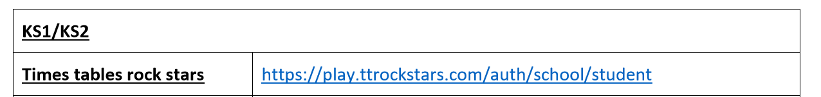
Home learning pack

Twinkl Kids' TV  Twinkl Kids' TV videos offer clear, visual demonstrations on how to use Twinkl's library of science experiments, sensory activities and creative craft resources at home. You'll also find educational video games, such as maths teasers or sorting activities. Parents can also find videos tailored to them at: | https://www.youtube.com/channel/UCOup4ZE0-CHqFQdJpK9CIg
National Geographic Kids  Nat Geo Kids makes it fun to explore your world with weird, wild, and wacky videos! Videos featuring awesome animals, cool science, funny pets, and more, are made just for curious kids like you. So pick a topic you love and start watching today! | https://www.youtube.com/channel/UCXVCgDuD_QCkI7gTKU7-tpg/featured
SciShow Kids  Science SciShow Kids explores all those curious topics that make us ask "why?" Every Tuesday and Thursday, Jessi and her robot rat Squeaks answer your questions and explain fun, complex science concepts for young, curious minds. Whether conducting experiments, researching new questions, or talking with experts, there's always something new to discover with SciShow Kids, no matter what your age | https://www.youtube.com/user/scishowkids/featured
Operation Ouch  Operation Ouch is packed with incredible facts about the human body and fronted by identical twins Dr.Chris and Dr. Xand van Tulleken who experiment and explore their way through the fascinating world of medicine and biology. This channel will de-mistify hospitals for younger viewers; no longer will the hospital be a "scary" place to go as we learn all the exciting things that go on there. Chris and Xand will let the viewer into their exclusive world of medicine and explain the awesome things our bodies can do! | https://www.youtube.com/channel/UCQJDFI9j8UeNoqra37p5OkA/featured
Grammarsaurus | https://www.youtube.com/channel/UCMhWKrdwzFr994ZhwqG4nlA
Practice your times tables easily with the Kool Kidz Times Table Collection. Select one of the times tables you wish to practise and have fun whilst learning! | https://www.youtube.com/playlist?list=PLaSZ7kwwxKqWrWI-I0xs8ugp5fspBZjW7
Learning your times tables while singing along to your favourite songs | https://www.youtube.com/watch?v=9C4EN7mFHCk&list=PLaSZ7kwwxKqXpdLA0hIA9fa8RVmRC32pv
BBC Teach  Offers free classroom resources to schools throughout the UK. Find thousands of free curriculum-linked class clips on BBC Teach to help you deliver lessons - all arranged by subject and age group. | https://www.youtube.com/channel/UC4KN50fal7f45fx2DqG7ttg/playlists?view=50&sort=dd&shelf_id=6

Inclusive anxiety and emotional support for children

https://www.easy-read-online.co.uk/media/53192/advice-on-the-coronavirus-v1.pdf
https://carolgraysocialstories.com/wp-content/uploads/2020/03/Pandemics-and-the-Coronavirus.pdf
https://660919d3-b85b-43c3-a3ad-3de6a9d37099.filesusr.com/ugd/64c685_319c5acf38d34604b537ac9fae37fc80.pdf
https://cdn.shopify.com/s/files/1/0088/6797/1123/files/ChatterPack_-_Developing_an_awareness_of_emotions_and_triggers.pdf?110
https://www.elsa-support.co.uk/wp-content/uploads/2020/03/Coronavirus-story-for-children-1.pdf
https://www.mind.org.uk/information-support/coronavirus-and-your-wellbeing/
https://www.annamathur.com/dealing-with-coronavirus-anxiety/?fbclid=IwAR2Ay4aHehv5KrG4lv0C4ase-xZPocyfR9cfne8KYi3gEu9sqoGZBhb68FY

