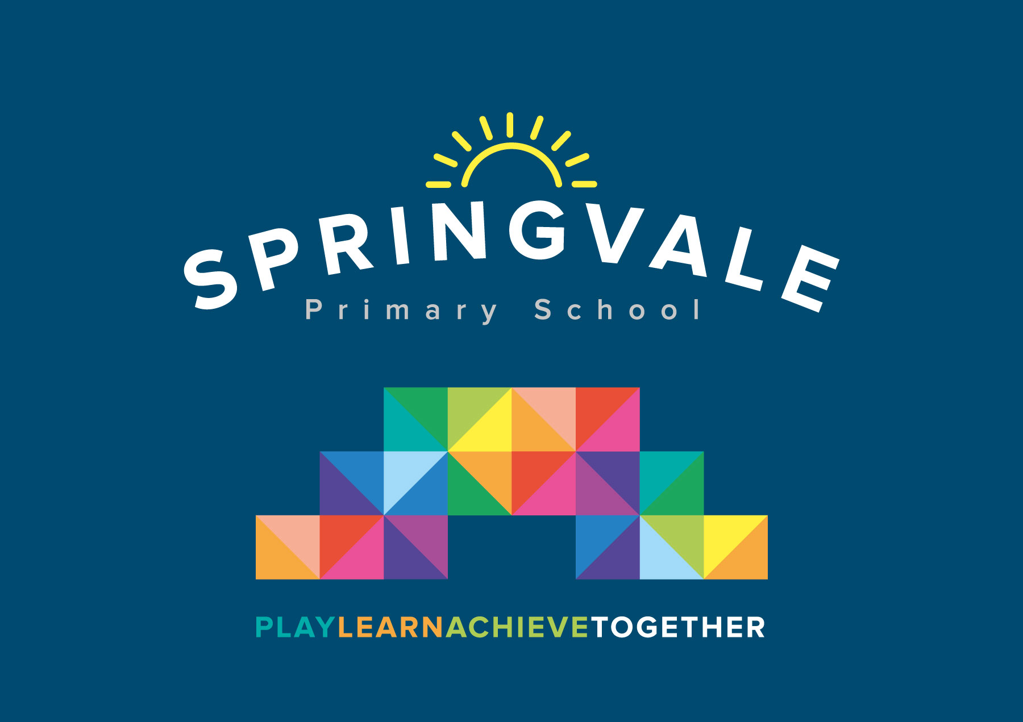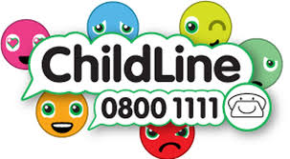
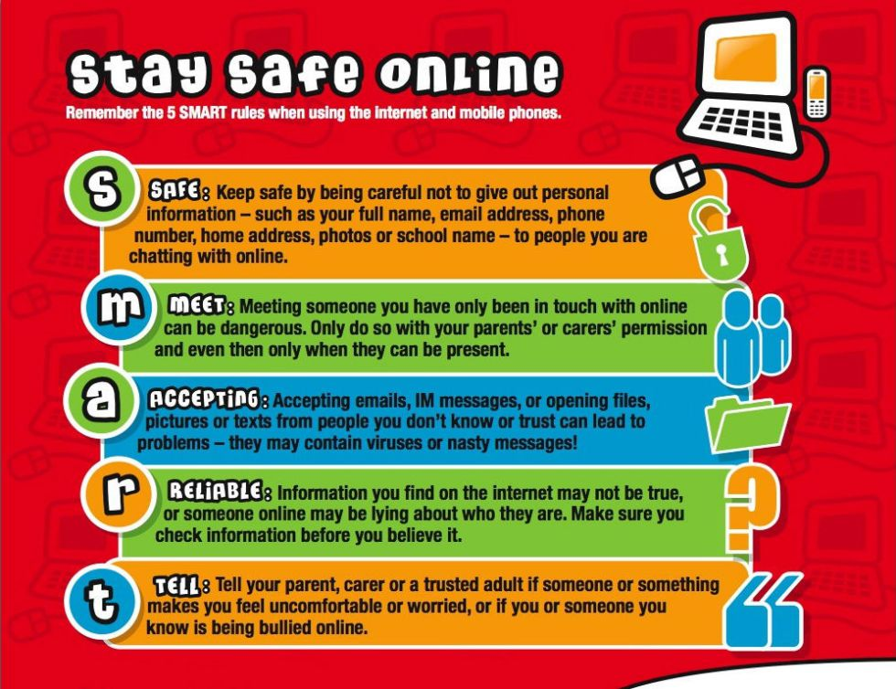

Learning Project WEEK 3 - Viewpoints
Age Range: Y3/4
Weekly Maths Tasks (Aim to do 1 per day) | Weekly Reading Tasks (Aim to do 1 per day)
- Working on Times Table Rockstars - your child will have an individual login to access this (20 mins on SOUND CHECK).  - Play on Hit the Button - focus on number bonds, halves, doubles and times tables.  - Adding and subtract fractions 1/7 + 4/7 = 5/7  - Year 4- adding improper fractions and convert to mixed number fraction 1/5 + 6/5 = 7/5 or 1 2/5  - What 3D shapes can you see around your house? Toiler roll= cylinder, cereal box= cuboid.  - Complete some of the St George’s challenge cards (We haven’t covered all topics in Maths so don’t panic if your child doesn’t understand how to work them out) | - You could share a story together. This could be a chapter book where you read and discuss a chapter a day.  - Listen to your child read and let them discuss what they have read. Encourage them to read with expression and intonation.  - Write a book review. Would you recommend the book to your friends?  - Watch Newsround and discuss what is happening in the wider world.  - Complete the reading comprehension task about St George.
Weekly Spelling Tasks (Aim to do 1 per day) | Weekly Writing Tasks (Aim to do 1 per day)
- Practise the Year 3/4 for Common Exception words.  - Practise your spellings on Spelling Frame (Y3 only)  - Choose 5 Common Exception words. Write a synonym, antonyms, the meaning and an example of how to use the word in a sentence. Can the word be modified?  - Choose 5 Common Exception words and practise spelling them using pyramid words. Write the word in a pyramid, e.g.  s  sp  spe  spel  spell  spelli  spellin  spelling | - Write a letter to a family member telling them all about how their day has been.  - If they were to become a superhero what would their superpower be? Write a character description of them as a superhero. Explain how they save the day.  - Retell a traditional tale from another character’s point of view. E.g Tell the three little pigs from the wolf’s perspective.  - Design an information leaflet that highlights how children can keep safe.  - Write a fact file or biography about St George using facts from the comprehension text (I have included a sheet to use to help with layout)
Learning Project - to be done throughout the week

The project this week aims to provide opportunities for your child to learn more about different viewpoints. Learning may focus on physical viewpoints in terms of what you can see outside of the window at home, what others can see looking into your home and then progress onto personal viewpoints and of others.

- Let’s Wonder:

Draw a picture of themselves and label their drawing with the qualities they have
How do others see them differently? Ask people at home to add to their qualities.
How are they different to other children in different parts of the world?


- Let’s Create:

Complete an observational drawing of what they see outside a window in their house. Then get out into the garden and find natural forms such as stones, leaves, flowers and animals. Complete sketches, showing an awareness of different viewpoints of the same object. Remember to concentrate on tone and shading.

Why not try a drawing tutorial on YouTube or on robbiddulph.com?

- Be Active:

Go for a walk, appreciate the nature around us.
Create an obstacle course in your back garden.
Do laps of your garden- how many laps can you do in 10 minutes?

Recommendation at least 2 hours of exercise a week.


- Time to Talk:

Talk about keeping safe, discuss different ways to keep safe. Basic hygiene rules, road safety, internet safety, water safety, being safe around the home, stranger danger. How do different people view this?


- Understanding Others and Appreciating Differences:

Listen to different pieces of music from around the world, which styles of music do they prefer and why? Music Maybe they could learn a song by heart and perform it.


- Reflect:

Using the England flag template, draw objects that represent England in the white rectangles- Farming, Big Ben, Queen Elizabeth.
Stay Safe, Stay Home.
#TheLearningProjects
An extra task- In the news, we are seeing some amazing people doing small acts of kindness to SAY THANK YOU TO THE NHS.
One person that has touched the heart of the nation is Captain Tom Moore who will be celebrating turning 100 at the end of April.
Why not design a birthday card for him?
Here is the address to send them to-
Captain Tom Moore
C/O Post Office Limited
67 Bedford Road
Marston Moretaine
MK43 0LA

