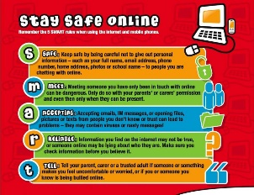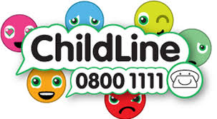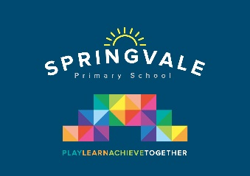

Learning Project WEEK 5 - Environment
Age Range: Y3/4
Weekly Maths Tasks (Aim to do 1 per day) | Weekly Reading Tasks (Aim to do 1 per day)
- Working on Times Table Rockstars - 20 mins on SOUND CHECK- We are monitoring progress on this app.  Please focus on accuracy rather than speed.  - Play on Hit the Button - focus on number bonds, halves, doubles and times tables.  - Practise telling the time. This could be done through this game (scroll down to access the game). Read to the quarter hour and the nearest 5 minutes.  - Year 4- I have included the next White Rose unit- We haven’t done money since Year 3 so have a try if you wish. | - You could share a story together. This could be a chapter book where you read and discuss a chapter a day.  - Listen to your child read and let them discuss what they have read. Encourage them to read with expression and intonation.  - Complete the comprehension tasks on Earth Day (which happened in April, but links with the theme)  - Complete the VE day comprehension- three levels- 1 star would be suitable for most Year 3, 2 stars would be for the higher year 3 readers and most of year 4. The three stars would be aimed at the more confident Year 4 readers
Weekly Spelling Tasks (Aim to do 1 per day) | Weekly Writing Tasks (Aim to do 1 per day)
- Practise the Year 3/4 for Common Exception words.  - Practise your spellings on Spelling Frame (Y3 only)  - Choose 5 Common Exception words. Write a synonym, antonyms, the meaning and an example of how to use the word in a sentence. Can the word be modified?  - Choose 5 Common Exception words and practise spelling them using across and down. Write the word across the page then down the page, e.g  s p e l l i n g  p  e  l  l  i  n  g | - Write a diary entry to a family member telling them all about how their day or week has been.  - Complete a fact file about an endangered animal- a template is included in the pack  - Write a letter to be sent to local schools explaining why children should support local charities if they can and help those who are in need.  - Design a poster that either expresses the importance of recycling, not dropping litter or another UK environmental issue. Can they think of a catchy slogan to accompany their design?
Learning Project - to be done throughout the week.

The project this week aims to provide opportunities for your child to learn more about the environment. Learning may focus on changes to different environments, the impact of humans on environments, climate change etc.

- Let’s Wonder:

What is the weather like around the world? Which countries are most likely to have a snowstorm, torrential rain, heatwaves etc….. Find out about natural disasters such as
forest fires, earthquakes, tsunamis, floods, tornados etc….. How is climate change having
an effect on the weather and natural disasters?

- Let’s Create:

Using recycled materials design and make a recycling mascot to spread the word about the importance and need to recycle. Think about what it is going to look like? Which materials are they going to use? How are they going to join the materials together?
- Design a VE day medal


- Be Active:

Get into the garden and practise throwing and catching skills and keeping control of ball-based equipment like bats and balls.
Recommendation at least 2 hours of exercise a week.
Go Noodle with the family or have a family workout. Fancy a dance? There are lots of dance videos they could try. Dance. Maybe try some Yoga (Cosmic Kids on YouTube is really good and Joe Wicks is doing a daily 30min workout at 9am)

- Time to Talk:

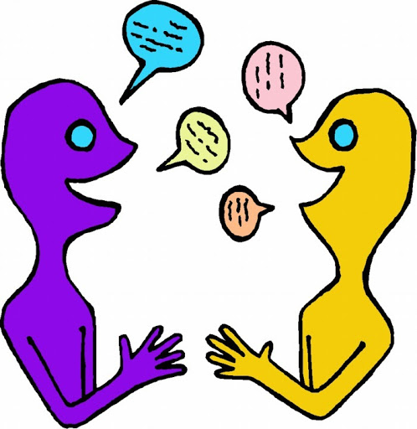
Discuss environmental issues in the UK. Air pollution, climate change, litter, waste, and soil contamination are all examples of human activity that have an impact in the UK. What are the global environmental issues? Various processes that can be said to contribute to the global environmental problems include pollution, global warming, ozone depletion, acid rain, depletion of natural resources, overpopulation, waste disposal and deforestation ... These processes have a highly negative impact on our environment. Decide as a family how they could ‘do their bit’ to look after their environment e.g. you could set up a recycling station in their home; Paper, plastics and glass.

- Understanding Others and Appreciating Differences:

Throughout our lives, culture and experience shapes worldviews, children growing up in the Netherlands, for example, have a much different understanding of the role of water in their lives than their peers in the Sahara Desert. The difference between the abundance and scarcity of water in each of these physical environments affects every aspect of their respective cultures, including the global perceptions they will carry with them throughout their lives. Think about food. How do they think people view food in the UK compared to those living in Ethiopia for example? Research a country where food and water are scarce. Find out about charities that help people in need, Red cross, Christain Aid, Islamic Relief or other charities that are significant to them.

