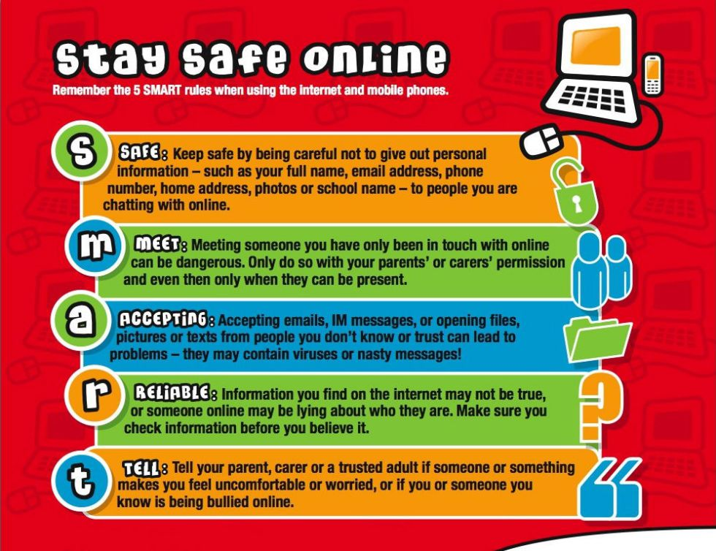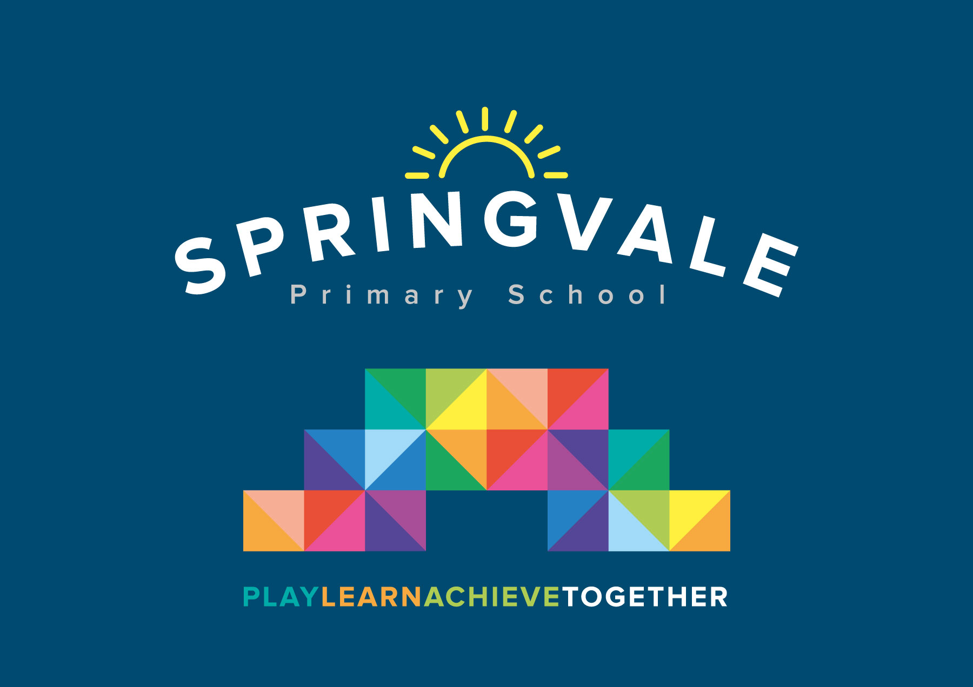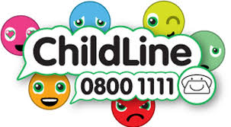

Learning Project WEEK 6 - Food
Age Range: Y3/4
Weekly Maths Tasks (Aim to do 1 per day) | Weekly Reading Tasks (Aim to do 1 per day)
- Working on Times Table Rockstars - your child will have an individual login to access this (20 mins on SOUND CHECK).  - I have also included a paper copy  - Play on Hit the Button - focus on number bonds, halves, doubles and times tables.  - Make a fruit crumble but make sure you weigh out the ingredients correctly  - Year 4- I have attached the maths sheets. We haven’t done time since Year 3 so have a try. | - You could share a story together. This could be a chapter book where you read and discuss a chapter a day.  - Listen to your child read and let them discuss what they have read. Encourage them to read with expression and intonation.  - Watch Newsround and discuss what is happening in the wider world.  - Complete the comprehension tasks on Fairtrade and Palm oil. Like last week  1 star= suitable for Year 3  2 stars= more confident year 3 readers and yr 4  3 stars= more confident year 4 readers.
Weekly Spelling Tasks (Aim to do 1 per day) | Weekly Writing Tasks (Aim to do 1 per day)
- Practise the Year 3/4 for Common Exception words.  - Practise your spellings on Spelling Frame (Y3 only)  - Choose 5 Common Exception words. Write a synonym, antonyms, the meaning and an example of how to use the word in a sentence. Can the word be modified?  - Choose 5 Common Exception words and practise spelling them using bubble letters. Write the word in bubble letters,  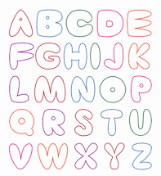  e.g. | - Write a recount to a family member telling them all about how your day or week has been.  - Write a shopping list that ensures their family will eat a balanced diet. Remembering to include exciting adjectives.  - Make something to eat and write a recipe. How to make ……..  Remembering to include a list of ingredients and things they need. Also not forgetting to include headings and subheadings. Then write their set of instructions, remembering to include imperative verbs. (Verbs that command you to do something).  - Write a review about a meal they’ve eaten. Describe what they had to eat. What did they enjoy and why?  - Choose a particular food and write an acrostic poem. Think about where it comes from? What does it look like? What does it taste like? Etc….
Learning Project - to be done throughout the week

The project this week aims to provide opportunities for your child to learn more food. Learning may focus on where different foods originate from, what makes a healthy meal, opportunities to cook etc.

- Let’s Wonder:

What is a balanced diet? Find out about the 5 food groups. Make slides or
posters about what they find out about. Carbohydrates Protein Dairy Fruits and
Vegetables Fats. Where does their food come from? Which foods come from the UK?
What is Fairtrade?
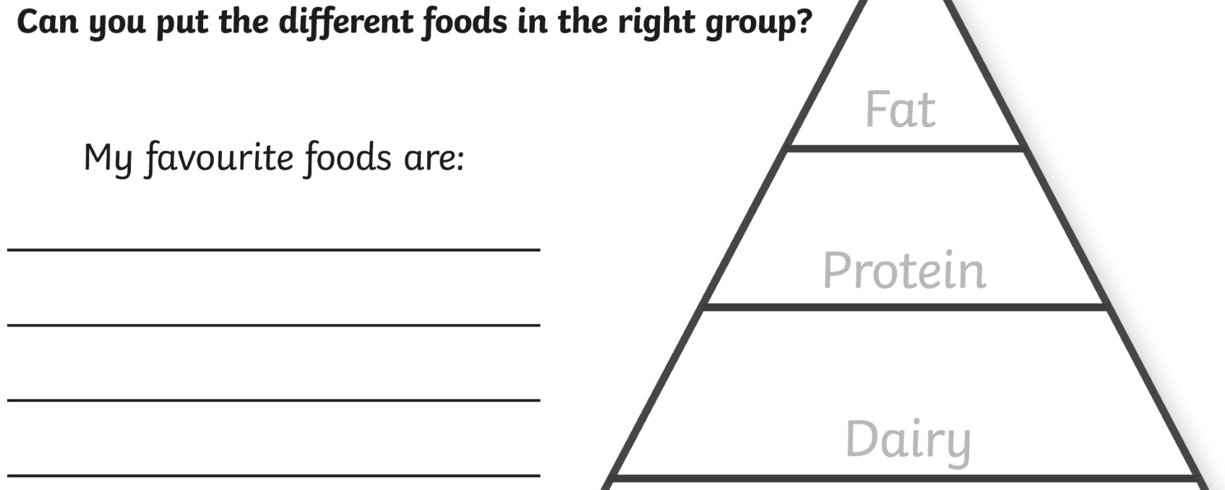
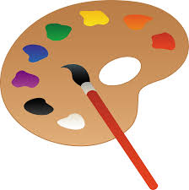

- Let’s Create:

Make repeated pattern prints for decorative purposes using various natural materials, e.g potato printing or create some still life observational sketches of fruit. Look at the artwork of Giuseppe Arcimboldo Maybe recreate some of his paintings with fruit.
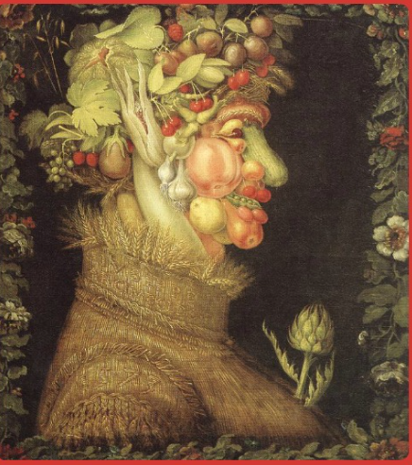

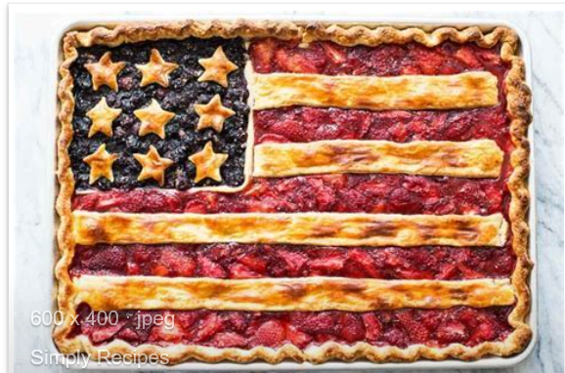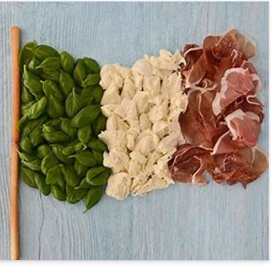 Can you make a flag out of food?

- Be Active:

Food provides us with energy and we need energy to exercise and this keeps us fit. Why not choose a dance from Supermoves?
Go Noodle with the family or have a family workout. Fancy a dance? There are lots of dance videos they could try. Dance. Maybe try some Yoga (Cosmic Kids on YouTube is really good and Joe Wicks is doing a daily 30min workout at 9am)

Recommendation at least 2 hours of exercise a week.

- Time to Talk:

As a family, design a healthy meal plan for the week. Discuss their favourite foods and why they enjoy them? Talk about healthy and unhealthy foods and explain the importance of eating a balanced diet.


- Understanding Others and Appreciating Differences:

Lunch around the world. Look at lunch around the world and investigate how differently people eat in other parts of the world. Find out what a vegetarian is? Vegan? Kosher food?
Halal food?


- Reflect:

Make a meal by combining a variety of ingredients using a range of cooking techniques.
Measure and weigh ingredients appropriately to prepare and cook a range of savoury dishes.

