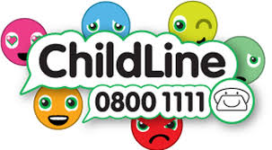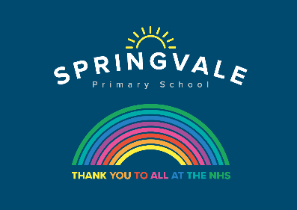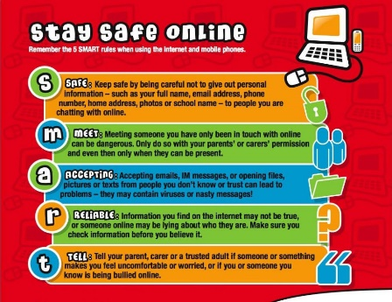

Learning Project WEEK 7 - Celebrations
Age Range: Y3/4
Weekly Maths Tasks (Aim to do 1 per day) | Weekly Reading Tasks (Aim to do 1 per day)
- Working on Times Table Rockstars - your child will have an individual login to access this (20 mins on SOUND CHECK).  - Play on Daily 10- choose a level, a maths focus and then a time limit https://www.topmarks.co.uk/maths-games/daily10  - Practise counting forwards and backwards from any given number in 4s, 8s, 50s and 100s for Y3 and 6s, 7s, 9s, 25s and 1000s for Y4.  - Year 4- Miss Alderson has included some Maths worksheets | - You could share a story together. This could be a chapter book where you read and discuss a chapter a day.  - Listen to your child read and let them discuss what they have read. Encourage them to read with expression and intonation.  - Watch Newsround and discuss what is happening in the wider world.  - Complete the comprehension tasks  *= Year 3  ** = confident Year 3 and Year 4 readers  ***= confident Year 4 readers
Weekly Spelling Tasks (Aim to do 1 per day) | Weekly Writing Tasks (Aim to do 1 per day)
- Practise the Year 3/4 for Common Exception words.  - Practise your spellings on Spelling Frame (Y3 only)  - Choose 5 Common Exception words. Write a synonym, antonyms, the meaning and an example of how to use the word in a sentence. Can the word be modified?  - Choose 5 Common Exception words and practise spelling them using words within words. Write the word and find smaller words within them, e.g. spelling = line, gel, in, etc….  Miss Alderson has added the spellings that Year 4 would be looking at this week if we were in school | - Write a postcard to a family member recounting a celebration that has just taken place.  - Write a set of instructions for ‘How to play the new game?’ Remember to include a list of things they will need. Also not forgetting to include headings and subheadings. Then write their set of instructions, remembering to include imperative verbs. (Verbs that command you to do something). Think about the key rules!  - Write a non-chronological report about a particular celebration/festival they have found out about, using the research sheet to help them.  - Design a card celebrating a religious celebration, remember to include a poem/verse for inside. You could make either an Eid, Easter, Diwali card etc….
Learning Project - to be done throughout the week

This project this week aims to provide opportunities for your child to learn more about celebrations. Learning may focus and different types of celebrations that take place and who may celebrate them. It could look at how people celebrate different events differently in other parts of the world.

- Let’s Wonder:

How are birthdays celebrated around the world? India China America Africa etc.. maybe
there's a particular country they would like to find out about. Create fact files to show the
similarities and differences between them.
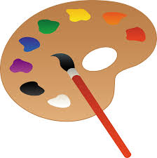
- Let’s Create:

Create a board game that focuses on celebrations. Think about what they can learn from it? Think about how to play the game. Is it going to be a game like Monopoly or Snakes and ladders? Are they going to need a dice? Cards? Characters? etc….
- Create a timeline of celebrations in your family- birthdays, first day at school, Christmas, holidays away with family, Grandparents celebrating VE day 75 years ago.


- Be Active:

Why not have a go at recreating some celebrations scene from some sporting events
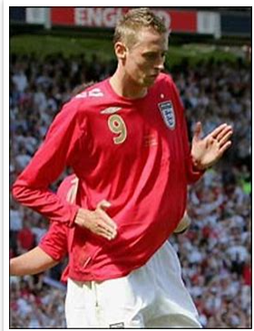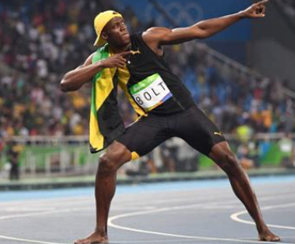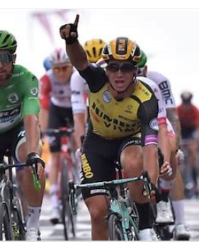

Go Noodle with the family or have a family workout. Fancy a dance? There are lots of dance videos they could try. Dance. Maybe try some Yoga (Cosmic Kids on YouTube is really good and Joe Wicks is doing a daily 30min workout at 9am)

Recommendation at least 2 hours of exercise a week.

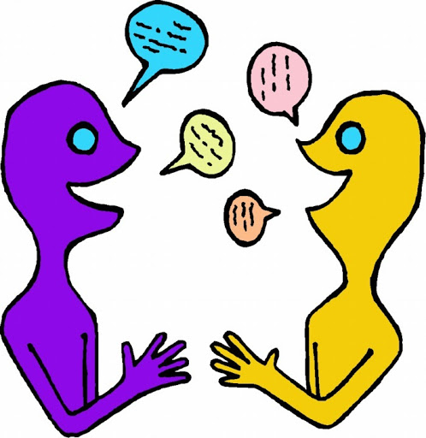
- Time to Talk:

Look through old photos of previous celebrations them and their family have taken part in. What can they remember happened? Why do they and their families celebrate the way they do?


- Understanding Others and Appreciating differences:

How many different types of celebrations are there? Who celebrates Christmas? St Patricks? St George? St David? Easter? Eid? Diwali? Chinese New Year? And how? Which celebrations have they taken part in? What usually happens?

