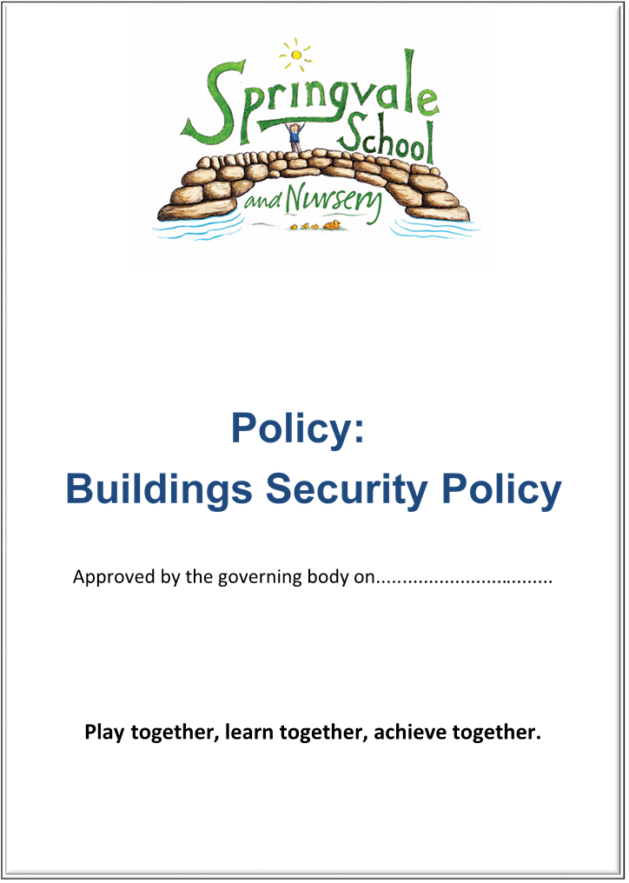
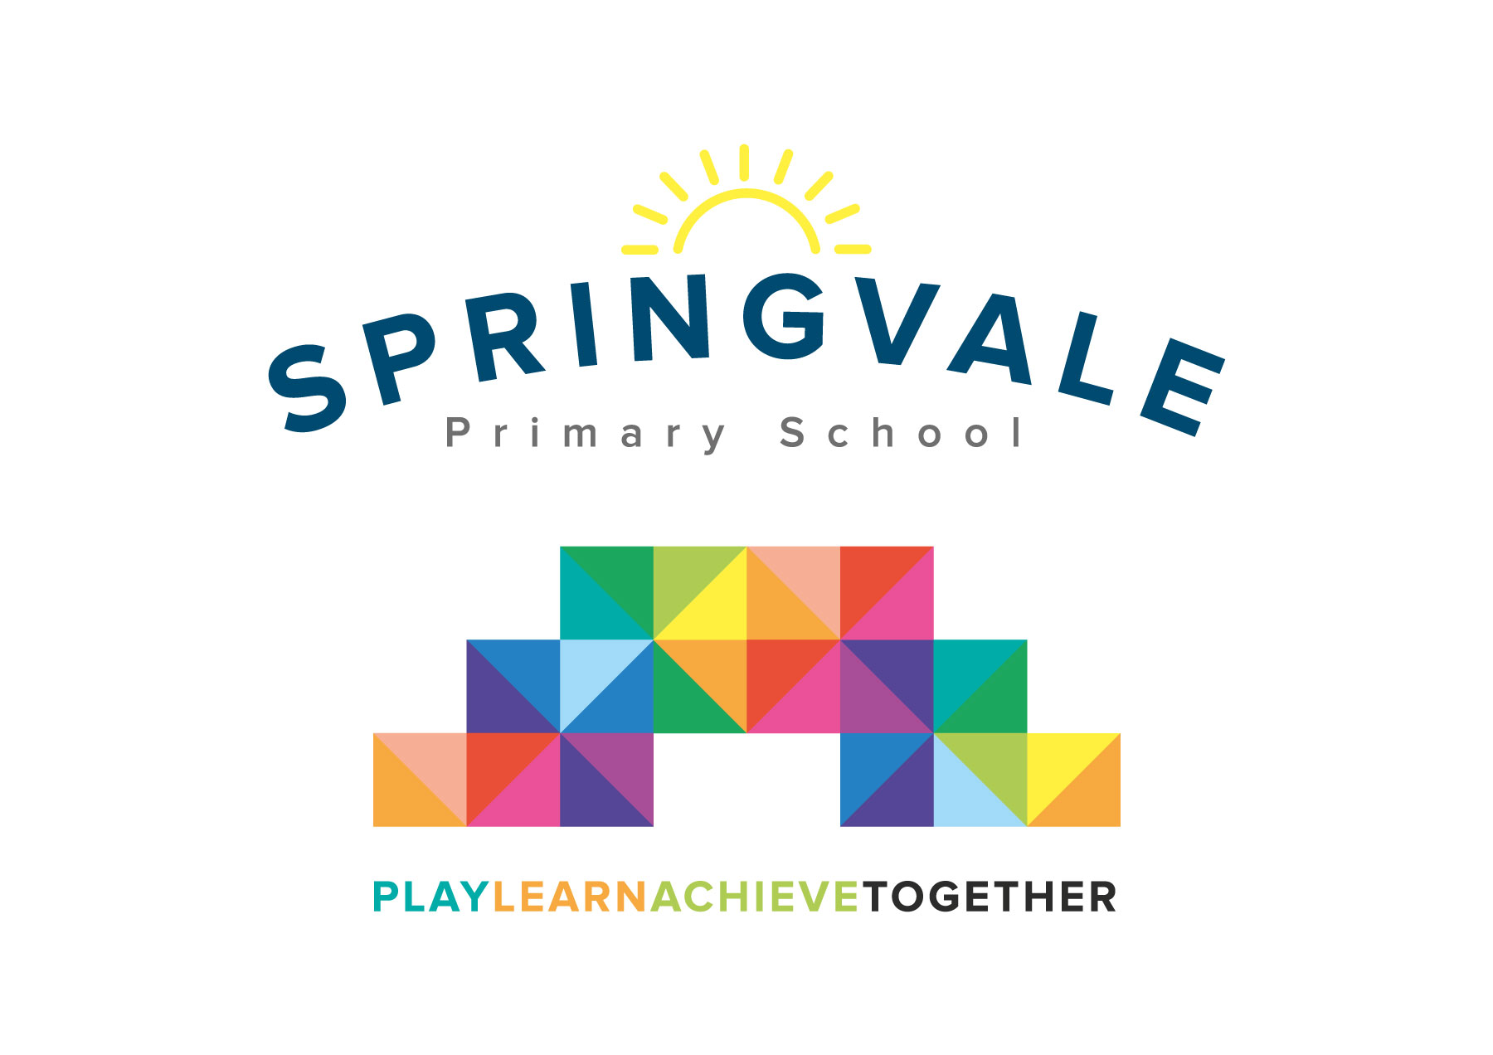
Inclusion
(Providing a balanced and broad curriculum for all pupils)

SPRINGVALE PRIMARY SCHOOL

Inclusion Policy

Introduction

This policy was created after a period of consultation with relevant stakeholders within school. This policy sits alongside our Special Educational Needs and/or Disability (SEND) Offer which follows specific titles and questions that provide parents with a clear insight into all aspects of policy and provision for SEND pupils.

The policy has been formally adopted by governors and reflects our approach at Springvale Primary School.

Aims and Principles
The policy is underpinned by the central aims of Springvale Primary and values held by the school community:
Aims of the school

- Springvale is committed to promoting high standards of academic achievement for all learners in all subjects.
- As a school we will continue to develop and instil key life skills and values in our pupils.
- We will encourage positive relationships and communications between home, our community and the wider world.

In particular, Springvale School has an inclusive approach to our provision. Our aim is always to involve all our children and stakeholders in all areas of the curriculum and school life. In accordance with our Disability Equality Scheme we recognise that this may mean making special adaptations or arrangements from time to time for children with specific disabilities. We welcome the involvement of disabled adults in all areas of school life.

Background Information
Springvale Primary School is a caring and open school, where parents, children, staff and the wider school community all know that their views and needs will be listened to, in both education and personal areas.

Springvale has two policies relating to Inclusion which reflects the school’s determination to ensure that all pupils receive an education which suits their individual needs and talents. Some pupils will have issues which may lead to them being identified as children with Special Education Needs and/or Disabilities (SEND), which is recognise and defined at a national level.

The first of the two policies (‘Inclusion- providing a balanced and broad curriculum for all pupils’) covers all aspects of inclusion and inevitably covers some aspects of SEND provision. The second policy, (Special Education Needs and/or Disabilities) concentrates specifically on SEND issues follows a format specified by the Government. Parents/carers who have a child with SEND issues, or who believe their child may have them, should refer to the Inclusion Policy in the first instance, going on to consult the SEN policy for further information. As always, if you wish to discuss any issues arising from the policies do not hesitate to contact the class teacher or senior leader for advice and assistance.

Rationale of the Policy
In order to fulfil our responsibility to provide a broad and balanced curriculum for all pupils, all staff at Springvale Primary School aim to give every pupil the opportunity to experience success in learning and to achieve to their maximum potential through a flexible, differentiated programme. When planning, all staff have high expectations and provide opportunities for all pupils to achieve their full potential, regardless of gender, disability, social and cultural backgrounds and ethnic groups.

- Staff at Springvale Primary School value pupils of different abilities and support inclusion.
- Within the school, staff and pupils will be constantly involved in the best ways to support all pupils’ needs within the school.
- Within each class, teaching and learning styles and organisation will be flexible to ensure effective learning.
- Grouping to support children with Special Educational Needs will be part of this process.

This policy describes the way we meet the needs of children who experience barriers to their learning, which may impact on pupil progress.

We recognise that pupils learn at different rates and that there are many factors affecting achievement including ability, emotional state, age and maturity. We are particularly aware of the needs of our Key Stage 1 pupils, for whom maturity is a crucial factor in terms of readiness to learn. We believe that many pupils may experience difficulties at some time in their school career which affect their learning and we recognise that these may be long or short term.

At Springvale Primary School we aim to identify these needs as they arise and provide teaching and learning contexts that enable every child to achieve his or her full potential.

The Inclusion Leader is Rhia Fearn
The Inclusion Governor is Claire Throssell

Objectives
- To enable children to move on from us well equipped in the basic skills of literacy, numeracy and social independence to meet the demands of secondary school life and learning.
- Inclusion also recognises the need to maximise the opportunities for children to fulfil their potential in whatever field they display a particular talent be it academic or non-academic.
- To ensure that the progress of all pupils will be continually monitored to identify needs as they arise. Needs will be identified and support provided as early as possible in a child's time with us.
- To establish the early and accurate identification of underachieving /vulnerable pupils including those with additional educational needs/SEND (please see our School Offer for SEND or speak to the class teacher about any concerns that you have about your child’s additional needs).
- To provide full access to the curriculum through differentiated planning and multi-sensory delivery where appropriate, by class teachers, Inclusion Leader, and support staff. (On very rare occasions, the full curriculum may not be offered as a consequence of findings in an Education and Health Care Plan (EHCP)).
- To provide specific input, matched to individual need. This will be provided in addition to differentiated classroom provision for those pupils registered as having SEND.
- To ensure that the progress of pupils with SEND is reviewed regularly to provide the most effective and relevant learning provision.
- To ensure that pupils with SEND will be perceived positively by all members of the school community.
- To ensure SEND provision is positively valued and accessed by staff and parents.
- To ensure that parents/carers are fully involved at every stage in plans to meet their child's needs

Special Facilities and Access Arrangements
- Springvale Primary School is at present housed in a single storey one building, which has wheelchair access to all doors.
- There are shower and laundry facilities in the Foundation Unit.
- There are currently two toilets that are accessible for disabled children or adults.
- Each classroom is equipped with extensive ICT, including an interactive whiteboard, visualiser, computers and a range of handheld technological equipment.
- Acoustic panels in the hall and soft furnishings around the school strongly support children with hearing impairments.
- Several small group rooms are available for use with children.
- External areas include a multi-purpose games area, a football pitch and several environmental areas including a pond, outdoor classroom, wooded area and gardening plots.
- Our PSHCE (Personal, Social, Health, Citizenship Education) programme helps children be aware of and positively value the differences between people as well as the similarities, and to be sensitive to one another's needs.

Provision and support
A range of interventions are used to provide appropriate support, which is mapped out by the Inclusion Leader. Provision maps are written and reviewed termly and are made available to staff.

Additional support for pupils can be provided by Teaching Assistants (TAs). TA time is currently divided as follows:

- Delivering targeted interventions to groups highlighted in termly SEND review meetings.
- Supporting children within Literacy, Numeracy and other lessons as appropriate
- Supporting children with individual needs to meet their IEP targets.

- Children with Statements or EHC Plans are supported as above where this is appropriate to the Statement objectives and provisions. Additional individual help is also timetabled for children with a specific learning need.
- Resources for SEND are purchased as appropriate and are matched to recurring needs throughout the school. Specific individual resources are purchased where this is viable and are used to support other children where this is appropriate.
- Purchasing policies for English, ICT and other curriculum areas reflect the need for resources to include provision for those with SEND.
- Specialist resources are accessed for children with Statements of SEND or EHC Plans through submission to LEA after specialist / Agency / Health Authority advice has been sought.
- Training and non-contact time for the Inclusion Leader are allocated from school budget.

Identification and Assessment Arrangements, and Review Procedures

Children are considered as having SEND through the following criteria:

Foundation Stage
- If teacher assessment / observation show a cause for concern.
- If baseline assessment indicates a significant discrepancy from the class norm.

Key Stage 1 and 2
- If teacher assessments, observations or test data show a cause for concern.
- If pupil progress/SEND review meetings indicate a significant discrepancy from the class norm.

Alternatively if children present with any of the following:

- On entry to the school if they have an EP (educational psychologist) or other recognised agency assessed learning difficulty.
- On entry to the school if there is a Statement of SEND or EHC Plan assessment.
- On entry to the school if previously registered at the SEND support stage by another school or authority.
- At any time if the class teacher has a concern which, after discussion, the Inclusion Leader supports.
- At any time if they need an individually adapted behaviour plan in order to access the curriculum.
- At any time if there is a substantial discrepancy between the pupil's attainment and their capability

Children can be registered at one of the stages of the SEND Code of Practice after discussion with the class teacher and parents.

Children registered at SEND support level will be monitored by all those involved with the child, and will be reviewed at least termly through IEP meetings and reviews. Parents/carers will be invited to discuss and agree all new IEPs. Children with Statements or EHC Plans will also have an annual review to which all those working with the child will be invited and asked to contribute reports.

- Reviews and assessments made by parents/carers, partner schools, social services, health authorities etc. will be used to inform the review process.
- Pupil progress is monitored by the SLT (Senior Leadership Team). Any concerns arising from data analysis are discussed at the SEND review meetings between the Inclusion Leader and the class teacher.
- All children will be working towards agreed targets and these will be discussed at the SEND review meeting. Monitoring of these targets and planning will provide the evidence to agree movement between stages of the SEND Code of Practice. Parents/carers will be informed if any changes to the stage of registration are made.

Arrangements for coordinating SEND provision
- The Inclusion Leader will meet with each class teacher in termly SEND review meetings to discuss and review any SEND concerns in line with the SEND Code of Practice.
- The Inclusion Leader will monitor planning for SEND and is able to support class teachers and learning support assistants with their planning or implementation on request. Targets arising from IEP (Individual Education Plan) meetings and review will be used to support
planning for children with SEND in line with the SEND Code of Practice.
- Class teachers primarily deliver SEND support through differentiated teaching methods. Additional support is accessed through the Inclusion Leader and by trained teaching assistants throughout the school. The support timetable is reviewed as necessary by the Inclusion Leader and the management team in line with current pupil needs, educational initiatives and the budget.
- Support staff, class teachers, the Inclusion Leader and outside agencies liaise and share developments in order to inform reviews and forward planning.

Admission Arrangements
- Children with special educational needs are considered for admission to the school on exactly the same basis as children without special educational needs.
- Where children have attended Nursery prior to starting school, there will be close liaison between the Inclusion Leader and the Nursery Teacher to ensure continuity of provision.
- There is one reception class (FS2). Children identified, prior to joining our school, as having SEND will be closely monitored to ensure a balance of both provision and opportunity.
- Home visits and visits to child care settings take place in advance of the school year and any particular needs are discussed during these sessions. In this way we aim to effectively accommodate children with needs from their first day with us.
- Admission to FS2 is on a part-time basis for the first few days. These arrangements are flexible to cater for individual needs.
- Prior to starting school, parents/carers of children with a current Statement of SEND or EHCP, or one pending, will be invited to discuss the provision that can be made to meet their identified needs.

Links with other schools/Transfer arrangements
- FS2 staff meet with staff from other nursery schools and day care centres prior to pupils starting school. SEND concerns will be brought to the attention of the Inclusion Leader after this meeting. Where necessary the Inclusion Leader will arrange a further meeting.
- Class teachers of children joining from other schools will receive information from the previous school; if there is a SEND situation the class teacher (or the Inclusion Leader if relevant) will telephone to further discuss the child's needs. Children transferring from Springvale Primary to new schools will have a Special Needs File which gives details of SEND and provision. The class teacher or Inclusion Leader will discuss these children with other schools or visit on request.

Special Provision
While there is no specialist SEND unit in Springvale School, training is undertaken by relevant staff when needs arise. Examples of this include:
- Literacy Support
- Additional Literacy Support Training
- Early Literacy Support Training
- Toe-by-Toe training
- ‘Team Teach’
- Big Maths
- Social Stories to support Autism
- Communication training
- Lego Therapy
- Music Therapy
- Intensive interaction

Arrangements for providing access for pupils with SEND to a balanced and broadly based curriculum
- The School Offer for SEND outlines all of the access arrangements set out by the school for children with SEND.
- Schemes of work and policies for each area of the curriculum are in place and are differentiated to include appropriate learning outcomes for all pupils.
- Long term planning through topic structures is in place and areas of the curriculum are planned throughout the school to include continuous and blocked units of work. From this, class teachers plan a mid-term forecast which details learning outcomes for all pupils with differentiated learning outcomes and activities identified for children with SEND.
- Differentiation takes a variety of forms within teacher planning. Learning intentions are always made explicit and then activities may be adapted, or planned separately as appropriate. Alternative methods of responding or recording may also be planned for where this is appropriate.
- TA support hours are planned to meet the needs of individual pupils through in class support and structured intervention programmes.
- Children with sensory or mobility impairments or a specific learning difficulty will access the curriculum through specialist resources such as ICT where this is appropriate.

The School's Arrangements for SEND In-Service Training
- The Inclusion Leader attends regular cluster / authority meetings to update and revise developments in Special Educational Needs and Disabilities.
- SEND pupils are targeted each year through the school's long term goals and the School Development Plan. In-service training and individual professional development is arranged matched to these targets.
- In-house SEND training is provided through staff meetings by the Inclusion Leader.
- All staff have access to professional development opportunities and are able to apply for SEND training where a need is identified and relevant.
- Support staff are encouraged to extend their own professional development and the management team will ensure ‘tailor-made’ training where this is appropriate.

The use made of teachers and facilities from outside the school, including support services
- The educational psychologist visits the school regularly (according to timetable), following discussion with the Inclusion Leader as to the purpose of each visit.
- BMBC’s Inclusion Services are able to attend school to provide advice, share resources and provide in-service training.
- Specialist advice is requested where we do not have the necessary in-house expertise - for example, in relation to children with autistic-spectrum disorders, sensory impairment or severe emotional and behavioural difficulties.
- Teachers from Barnsley Education Specialist Support Team can support school in working with children wherever necessary. Class teachers plan alongside these advisors who can sometimes contribute to IEP targets.
- The Inclusion Leader liaises frequently with a number of other outside agencies, for example:

    - Social Services
    - Education Welfare Service
    - School Nurse
    - Community Paediatrician
    - Speech/Occupational Therapy
    - Physiotherapy

Arrangements for partnership with parents/carers
- Staff and parents/carers will work together to support pupils with SEND.
- An appointment will be made for the class teacher to meet all parents whose children are being registered as having SEND. The Inclusion Leader will be invited to this meeting if either the class teacher or the parent thinks this is appropriate.
- At review meetings with parents/carers we try to always make sure that the child's strengths as well as weaknesses are discussed. Where we make suggestions as to how parents/carers can help at home, these are specific and achievable. It is intended that all parents go away from the meeting clear about the action to be taken and the way in which outcomes will be monitored and reviewed.
- IEP targets will include targets to work towards at home, and parents/carers are always invited to contribute their views to the review process. All IEPs and reviews will be copied and given to parents during or after meetings.
- Parent’s evenings provide regular opportunities to discuss concerns and progress. Parents/carers are able to make other appointments on request.
- Regular communication between school and home will ensure that concerns are promptly acted on. Where this has not happened, however, parents/carers are able to make a complaint by contacting the Headteacher or, if this fails to resolve the issues, the Governing Body. Our complaints procedure, available from the school office, sets out the steps in making a complaint in more detail.
- All information about how SEND children are supported at Springvale Primary School is included in the School Offer for SEND, which is accessible via the school website.

Links with Health and Social Services, Educational Welfare Services and any Voluntary Organisations
- Health service professionals are regularly consulted by the school. Concerns are initially brought to the attention of the school nurse by the Inclusion Leader, and referrals will be made as appropriate.
- Social Services and the Education Welfare Service will be accessed through the visiting education welfare officer as appropriate. Class teachers will alert the Headteacher if there is a concern they would like discussed.
- There are many voluntary organisations supporting SEN. The LEA maintains an up to date list. Parents will be given details of these groups on request or as appropriate. Information sent from organisations will be posted on the parents' notice board.

Evaluating the effectiveness of the School's Inclusion Policy

- The Inclusion Leader will provide information to the governing body as to the number of pupils identified as having inclusion at each stage, at the end of each term. The number of pupils transferring to or from each stage will be noted.
- Inclusion is a standing item on the headteacher’s report for school led governing body meetings and is an agenda item at the LA full governing body meetings.
- The Inclusion Leader will meet with the Inclusion Governor to discuss current matters. The Inclusion Governor leads governor monitoring of all matters relating this policy.
- Whole school monitoring and evaluation procedures will include sampling of work and observations. Outcomes pertinent to SEND provision and planning will be taken forward by the whole staff and used to build upon successful practice.
- The progress of all SEND children is monitored on a termly basis and any matters arising are addressed in Pupil Progress Meetings. Strategies are then identified to address these.
- The school continually monitors the children in school who have significant confidence and ability in any of a wide range of academic and non-academic activities.

