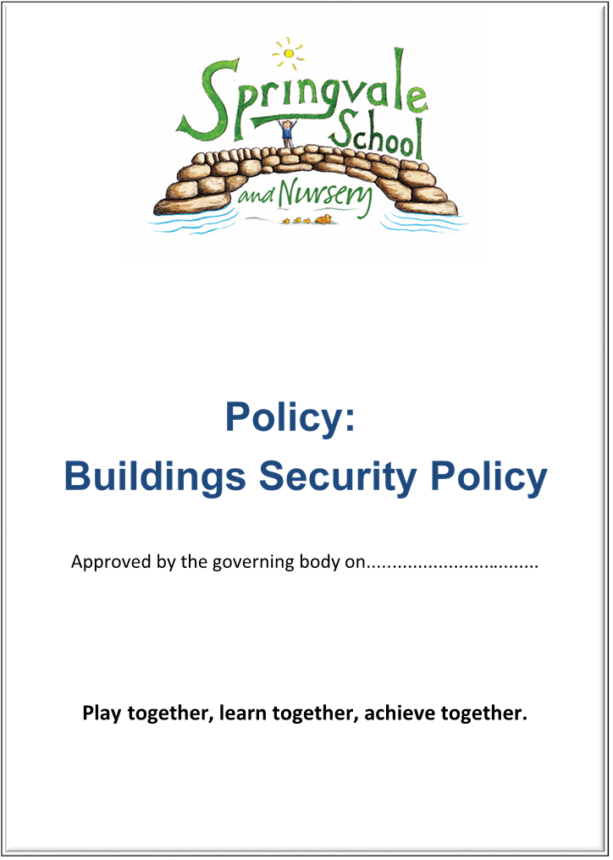
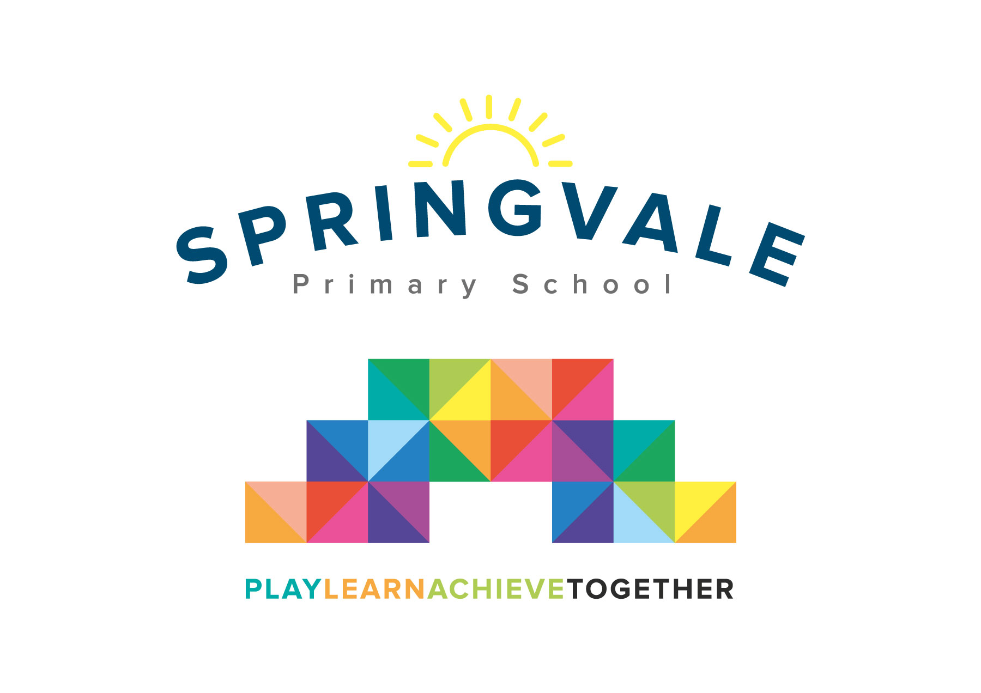
School Offer for Special Educational Needs and/or Disabilities (SEND) Pupils

SPRINGVALE PRIMARY SCHOOL

School Offer for SEND pupils

Introduction

This policy was created after a period of consultation with relevant stakeholders within school. This policy sits alongside our Inclusion Policy but follows specific titles and questions that provide parents with a clear insight into all aspects of policy and provision for SEND pupils. Parents should also refer to the overarching Inclusion Policy and address any questions or concerns to our SEND Leader.

The policy has been formally adopted by governors and reflects our approach at Springvale Primary School.

Aims and Principles
The policy is underpinned by the central aims of Springvale Primary and values held by the school community:
Aims of the school

- Springvale is committed to promoting high standards of academic achievement for all learners in all subjects.
- As a school we will continue to develop and instil key life skills and values in our pupils.
- We will encourage positive relationships and communications between home, our community and the wider world.

In particular, Springvale School has an inclusive approach to our provision. Our aim is always to involve all our children and stakeholders in all areas of the curriculum and school life. In accordance with our Disability Equality Scheme we recognise that this may mean making special adaptations or arrangements from time to time for children with specific disabilities. We welcome the involvement of disabled adults in all areas of school life.

Background Information
Springvale Primary School is a caring and open school, where parents, children, staff and the wider school community all know that their views and needs will be listened to, in both education and personal areas.

Springvale has two policies relating to Inclusion which reflects the school’s determination to ensure that all pupils receive an education which suits their individual needs and talents. Some pupils will have issues which may lead to them being identified as children with Special Education Needs and/or Disabilities (SEND), which is recognise and defined at a national level.

The first of the two policies (‘Inclusion- providing a balanced and broad curriculum for all pupils’) covers all aspects of inclusion and inevitably covers some aspects of SEND provision. The second policy, (Special Education Needs and/or Disabilities) concentrates specifically on SEND issues follows a format specified by the Government. Parents/carers who have a child with SEND issues, or who believe their child may have them, should refer to the Inclusion Policy in the first instance, going on to consult the SEN policy for further information. As always, if you wish to discuss any issues arising from the policies do not hesitate to contact the class teacher or senior leader for advice and assistance.

School Offer for Pupils with Special Educational Needs and/or Disabilities (SEND)

What is a Special Educational Need or Disability?
A child or young person has SEND if they have a learning difficulty or disability which calls for special educational provision to be made for them. A child of compulsory school age or a young person has a learning difficulty or disability if they:
(a) have a significantly greater difficulty in learning than the majority of others of the same age; or
(b) have a disability which prevents or hinders them from making use of educational facilities of a kind generally provided for others of the same age in mainstream schools.
‘A child under compulsory school age has special educational needs if they fall within the definition at (a) or (b) above or would do so if special educational provision was not made for them (Clause 20 Children and Families Act 2014)’ (SEND Code of Practice 0 – 25, 2014, p94)

What should I do if I think my child has SEND?
Following the SEND Code of Practice, Springvale Primary uses a graduated approach when meeting the needs of children with SEND. Up to 20% of children and young people have special educational needs at some stage in their lives; only around 2% have special educational needs which are of a severe and complex nature. For many children, simple changes to the way that the curriculum is delivered can make a significant impact on removing the barriers to their learning. If a parent or carer feels that their child may have SEND needs they should:
- In the first instance make an appointment to speak to your child's class teacher.
- The teacher might feel that it would be helpful to have the SENDCo, the specialist member of staff in school on such issues, attend the meeting also.
- Springvale Primary closely monitors all of its children with special needs and at the meeting we may feel that we do need to put in place some strategies and interventions to try and remove your child's barriers to learning.
- Some children will need something which is additional to and different from that which is normally provided for all children.
- If a child requires this type of support the school will monitor them according to the SEND Code of Practice 2015. You will be kept informed of the additional support that your child is receiving. This could mean that the class teacher may be using different strategies to help your child to learn, or perhaps your child will be receiving some additional support in a small group alongside other children with similar needs.

Approach to the teaching of children/young people with SEND
In order to fulfil our responsibility to provide a broad and balanced curriculum for all pupils, all staff at Springvale Primary School aim to give every pupil the opportunity to experience success in learning and to achieve their maximum potential through a flexible, differentiated programme. When planning, all staff have high expectations and provide opportunities for all pupils to achieve their full potential, regardless of gender, disability, social and cultural backgrounds and ethnic groups.
Springvale Primary operate a graduated approach to meet the needs of SEND pupils. Starting with quality first teaching in the classroom, all classes plan clear differentiation for various groups of children. Where children need extra support, above and beyond the teaching in the classroom, group intervention and 1:1 support may be given (in line with the Code of Practice).

How will we be kept informed of our child’s progress?
- Individual Educational Plan meetings with the class teacher
- Specially arranged meetings with the class teacher/SENDCo
- Annual Review- For children who have an EHCP (Educational Health Care Plan)
- TAF (Team Around the Family)/EHA (Early Help Assessments) Meetings- this is a supportive meeting for families of children with SEND or safeguarding needs which may be attended by other professionals including colleagues from health, welfare or social services.
- The small group work will be carefully targeted to address your child's needs and his/her progress will be closely monitored and evaluated.
- At this point you may be able to support your child e.g. extra reading practice, or providing opportunities to practice new skills at home that have been taught in class.
- Sometimes the support in addition to the classroom curriculum differentiation is sufficient to mean that your child no longer has barriers to their learning and they start to make progress. However, for some children this may not be enough and the School, with your agreement, will make the decision to increase the level of support provided.
- If required the School may involve some external professionals or agencies to provide us with more specialist advice and guidance in order to remove barriers to learning. This external support might be from an Educational Psychologist; Speech and Language Therapist; Occupational / Physiotherapist; Specialist Advisory Teacher; or a medical professional. If your child's needs are wide ranging or more complex, then it may involve several of these people who will need to work in a co-ordinated way.
- As more people become involved in helping the School to meet your child's needs, your child's class teacher or the SENDCo, or headteacher in school may decide an EHA meeting is required. Once established, the TAF will help the school to organise a meeting where everyone involved, (including yourself), can sit down together and discuss the best way forward to help the School help your child to make progress.
- The School may decide to draw up an Individual Education Plan (IEP). This is a personalised plan for pupils with a recognised SEND issue to ensure that they receive tailored provision to meet their precise needs. This will record the additional more specialist strategies and interventions that will be required to help remove the barriers to your child's learning.
- Only a very small percentage of children require support of an additional nature beyond this. If this is the case, then the SENDCo may discuss with you the possibility of asking the Local Authority to undertake a statutory assessment of your child's needs. If this is considered appropriate, then the School will collect together all your child's information and evidence of all the carefully evaluated additional strategies and interventions that have been put place and with your permission send it off to the Local Authority for them to consider the information at a panel meeting and make a decision whether or not to carry out a statutory assessment of your child's needs. Whilst this is taking place the School will continue to meet your child's needs with the support that is already in place.
- Once the Local Authority receives a request to consider whether to make an Educational Health Care Plan (EHCP) assessment or not, a legal timescale begins. The process of statutory assessment is carefully bound by the legislation and guidance within the SEND Code of Practice. The SENDCO will be able to explain the process and timescales to you or alternatively you would find this in the SEND Code of Practice. If the decision is made to go ahead with a statutory assessment then the Local Authority will signpost you to guidance and support that will assist you through the process for example from SENDIASS (Special Educational Needs and Disabilities Information Advice and Support Service).
Curriculum and learning environment adaptations for children/young people with SEND
Within each class, teaching and learning styles and organisation will be flexible to ensure effective learning. Grouping to support children with Special Educational Needs will be part of this process. Reasonable adjustments can be made to the learning environment, for example by providing children with additional specialist resources where appropriate. We work closely with external agencies to ensure that our provision closely meets the needs of children and young people with SEND.
Our day-to-day teaching includes resources and strategies to support children and young people with Dyslexia, Autism, Communication difficulties, Visual Impairments and Hearing Impairments.

Springvale Primary School is at present housed in one building, which has wheelchair access to all doors. There are shower and laundry facilities in the Foundation Unit. There are currently two toilets that are accessible for disabled children or adults. Our classrooms provide good acoustic conditions so that the effects of hearing difficulties are minimised. Our Personal, Health, Social and Citizenship Education (PHSCE) programme helps children be aware of and positively value the differences between people as well as the similarities, and to be sensitive to one another's needs. Our school has been accredited with the Communication Friendly School Award, which means that every classroom makes communication as easy, effective and enjoyable as possible. We provide an education where everyone can talk, listen, understand and take part while supporting children’s learning and social and emotional developments too. Our communication friendly classrooms are great for supporting everyone’s communication skills and usually include features which will also be particularly beneficial for children with Speech, Language and Communication Needs (SLCN).

Additional learning support available for children/young people with SEND
The SENDCo will meet with each class teacher in termly SEN review meetings, to discuss and review any SEND concerns in line with the Code of Practice.
Class teachers primarily deliver SEN support through differentiated teaching methods.

SEND Register
The register provides an updated record of all pupils receiving additional SEN support so that:
- Progress and achievements of pupils with SEND can be more closely monitored.
- There is an overview of the range and level of need across the school.
- School provision reflects and is responsive to current profile of need.
- Close monitoring of this register also provides evidence to show impact of the school provision for pupils with additional needs.
Once identified as requiring additional SEND support, pupils will receive a planned package of support to remove barriers to learning and put in effective special educational provision. This will be managed through a four part cycle of assessment, planning, intervention and review. This cycle is known as the Graduated Response and follows the model described in the SEN Code of Practice. It will enable a growing understanding of the pupils’ needs and the nature of support they need to make good progress and secure positive outcomes. Depending on the need of each pupil, successive cycles will draw on more detailed approaches, more frequent review and more specialist expertise.
Where progress has been limited, further analysis and assessments will be made to ensure the provision offered matches the nature and level of needs. Where adaptations are required the SENDCO and class teacher will discuss these and make adjustments to the provisions. If may be decided that further investigation is required by the school SENDCO in identifying specific difficulties whereby in-school assessments will be used.
If not already involved and with the agreement of parents, the SENDCO will make a referral to an external specialist agency. An EHA may also be raised by the SENDCO, especially where an assessment for an EHCP is requested.
All forms of intervention begin with an entry assessment and end with an exit assessment allowing for direct comparison, thus enabling the SENDCO to measure the impact of interventions on the progress of children undertaking the intervention.

Arrangements for assessing and reviewing the progress made towards the outcomes identified for children/young people with SEND.
The School has a rigorous programme for assessing children's learning. Some assessment takes place at the end of specific pieces of work to inform teacher's planning of the children's next steps in learning. Also, on-going assessments take place on a daily/regular basis to ensure that the opportunities presented to children are appropriate to meet need and aid their learning and development. The same systems and procedures are in place for children with special educational needs. In some instances additional assessments may be appropriate for children with special educational needs in order to provide additional information to determine their strengths and areas for development.
- The SENDCO/class teacher will be happy to discuss any additional assessments used, the results achieved and the implications for future learning. However, it is felt that something more specialised is required then the relevant service could be contacted to discuss this.
- The School sets aspirational targets for all its children including those with special educational needs.
We recognise the importance of early identification and aim to ensure that robust measures are in place to highlight children who are falling behind or who are facing difficulties with any aspect of learning or social development at the earliest opportunity.
This process of early identification is supported by:
- Review of skills and attainment when pupils join the school, taking into account information from any previous settings or agencies as appropriate.
- When children start in F2 they will all take the WellComm Assessment - A Speech and Language Toolkit for screening and intervention in the Early Years.
- Termly tracking of all pupils to monitor rates of progress and attainment.
- Concerns raised directly by parents or other agencies.
As well as progress in core subject areas, progress in other areas will also be considered such as social development and communication skills.
The needs of all individuals and groups will be met by:
- Setting suitable learning challenges within a broad and balanced curriculum, for all children.
- Responding to pupils’ diverse learning needs.
- Overcoming potential barriers to learning and assessment for individuals and groups of pupils.
In determining whether a pupil may have SEND, consideration will also be given to other factors which may be affecting pupils’ progress and achievement including:
- Their attendance and punctuality
- Their health and welfare
- Having English as an Additional Language (EAL)
- Being in receipt of Pupil Premium Grant
- Being a Looked after Child (LAC)
- Being a child of a serviceman/woman
- Family circumstances
- Economic disadvantages
Springvale Primary School acknowledges that consideration of these factors will be particularly important when a child is displaying challenging behaviour or becoming isolated and withdrawn. Such behaviours can often mask an unmet need and further assessments will be undertaken to determine any underlying factors affecting behaviour which may not be SEND.
Before deciding that a pupil requires additional send support the SENDCO and class teacher will review current arrangements to meet the child’s needs within daily class teaching and consider any further modifications and adaptations that should be put in place to support good progress.
The school will use the graduated response as laid out in the SEND Code of Practice 0 – 25 (2014) and Equality Act 2010 as follows:
Using teachers’ assessments through Target Tracker and other appropriate assessments and discussions with parents, the SENDCO and class teachers will meet termly (or half termly if deemed necessary), to discuss the provision of needs of the pupils in their class at all levels. Consideration will be given to the academic achievement of each pupil, the progress made and the mental and emotional resilience demonstrated by each pupil, including the behaviour exhibited in school and reported behaviours from home.

How effective is the school’s provision for children with Special Educational Needs?
Springvale Primary has a robust policy for special educational needs. The policy is implemented by all members of staff and its effectiveness is monitored and evaluated by the Governing Body on an annual basis. The SENDCO feeds back to the SEN Governor on a termly basis about general information on the progress of children, quality of provision, information from parental, children's and teacher’s questionnaires comments and data are all discussed. This helps us to ensure that we make the necessary developments to ensure we have used our best endeavours to minimise the gaps in our provision for children with SEND.
What support is available for children / young people with SEND?
  - Differentiated first quality teaching
  - Small group work and 1:1 support is available
  - Booster groups
  - Individualised support programmes e.g. physio, speech and language
  - Targeted Teaching Assistant support running specific programmes of need e.g. Read Write Ink, Jump Ahead, Dyslexia Programmes, Maths Programmes, Lego Therapy and Music interaction.
Extra-curricular activities available for children/young people with SEND
We encourage all children in school to attend extra-curricular and after school activities. The SENDCo monitors the amount of SEND children who attend extra-curricular clubs on a termly basis, and repots these findings to the SEN Governor. Together the Head Teacher, SENDCo and SEN Governor continue to improve the provision provided, so that it is fully inclusive to all children who attend our school.

Support available for children/young people with SEND
- Lego Therapy
- The Big A
- Early Literacy support
- Sensory support
- Music Interaction
- Social Stories
- Read, Write, Ink – Phonics Programmes
- Specifically tailored 1:1 Programmes
- Lifeskills programmes
- Jump Ahead – focussing on fine and gross motor skills
- Makaton
- Speech and Language programmes
- Now and Then boards/Visual Timetables etc
- In rare cases an individual personalised curriculum may be required and we would always seek advice of outside agencies to support with this. Some children may require interventions of a 1/1 nature for very short periods of time. Again these are overseen by the class teacher and progress is carefully monitored.
- The Head teacher/SENDCO is responsible for the allocation of 1/1 / group interventions support timetable for the School. This information is detailed within the School's Provision Map.
- Visual cues are clearly displayed in some classrooms and communal areas where needed in order to facilitate easier access for our children who require a communication friendly environment.
- Visual timetables are clearly displayed in classrooms where needed.
- We are a Communication Friendly School.
How do we secure staff expertise in supporting and working with children who have SEND?
- Support from external agencies up-skilling staff.
- Bespoke training e.g. Makaton, Speech and Language, Dyslexia, Memory Retention work, Lego Therapy Training, Special Friends training etc. by sourcing appropriate to meet the needs of our children.

- Continuous in-house training e.g. up-skilling new and experienced staff through visits to other schools, staff meetings and designated inset days.
- Support from other experienced SENDCO’s to improve practices in school.
- Specialist TA’s/HLTA’s leading specific areas of SEND Training to up-skill other TA’s
- Through Performance Management of both Teachers and Teaching Assistants we identify CPD requirements of all staff.
- Through employing specialist staff to work with our SEND children.
What arrangements do we have for supporting and improving the emotional and social development of children / young people with SEND?
  - We value parents/carers and they are at the heart of decision making in regards to SEND children.
  - Links/referrals with external agencies if required.
  - In-house: Class teacher/TA Support, Behaviour Support Groups, PHSE Materials along with other individualised programmes as and when required.
  - Use of EHA/TAF meetings and individualised support plans.
  - Running Lego Therapy programmes, along with social stories to support children with emotional, social and mental health issues.

Arrangements for supporting and improving the emotional and social development of children/young people with SEND
- We value parent partnerships and they are at the heart of decision making in regards to SEND children.
- Links with external agencies if required.
- In-house: Class teacher/TA Support, Behaviour Support Groups, SEAL Materials along with other individualised programmes are used as and when required.
Use of EHA and individualised support plans.

Appendix of Terms

Acronym Definition
SEND Special Education Needs
SENDCo Special Educational Needs Co-Ordinator
TAF Team Around the Family
EHA Early Help Assessment
IEP Individual Education Plan
EHCP Education and Health Care Plan
SLCN Speech, Language and Communication Needs
PHSCE Personal Health, Social and Citizenship Education

