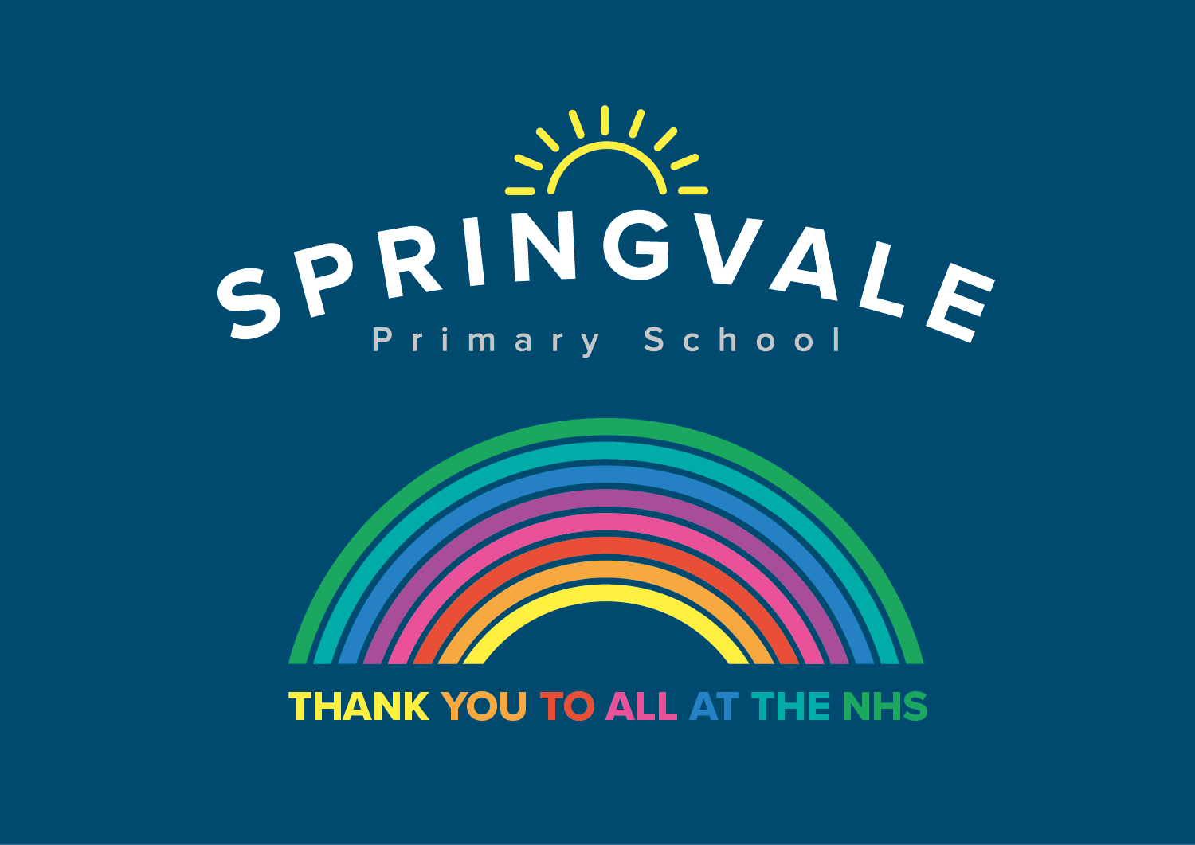

PSHE Year 6 Body Development and Relationship Education

In this unit we will look at relationships and appropriate touch.
We will look at how our bodies change- especially at puberty.
We will discuss why living things need to reproduce & look in detail at the human life cycle, comparing it to other animals.
We will research rites of passage in different cultures and look at STDs.

Descriptions of Sessions

Title | Description
Relationships | In Y6 we will continue to look at healthy and unhealthy relationships and will provide information on how to seek help if they feel worried or scared about a particular relationship they have with someone. This module also includes informative lessons and animations on puberty and conception.  Think about all the different relationships that chn have/will have with other people, leading to a discussion about marriage. Research marriage customs in different cultures. Chn return to timelines & predict hopes & expectations for their future lives.
Puberty | Look at the physical changes that take place during puberty. Some are seen easily, e.g. growing taller & broader, hair around genitals & under arms, etc. Also discuss menstruation & wet dreams & rites of passage in different cultures on reaching puberty.  Look at the emotional changes in puberty. Use drama to act out typical scenarios involving parents & teenagers; look at the different viewpoints & discuss how compromise can ease situations. Look at the meaning of friendships & where help can be found.
Conception | Changes at puberty prepare our bodies to have chn of our own. Look in more detail at the stages of human fertilisation & pregnancy & learn how important it is for mother-to-be to look after her health. Look at baby growth in utero & explain function of umbilical cord.  Watch a video of a birth & discuss other forms of delivery such as Caesarean or forceps deliveries. Discuss how the parents’ lives will now change. Research birth rites of passage in different cultures.
Sexual Health | Have the discussion about contraceptives as a way of preventing an unwanted pregnancy, but also explain that they can help protect against STI/Ds.  Discuss one STD in more detail – HIV/Aids. Ensure chn understand diff between having the virus & the syndrome. Watch a video by chn living with an HIV mother & discuss stigma involved with HIV/Aids. Look at stats & discuss Memory Books & World Aids Day.

Children are given a safe place to ask questions anonymously via a question box.

