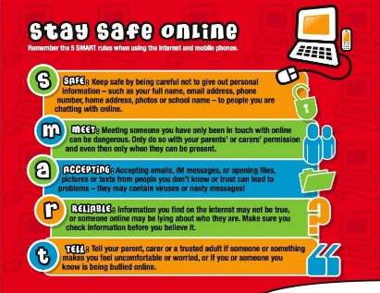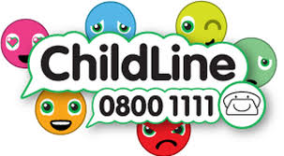
Learning Project WEEK 9 – Sport
Age Range: Y3/4
Weekly Maths Tasks (Aim to do 1 per day) | Weekly Reading Tasks (Aim to do 1 per day)
- Working on Times Table Rockstars - your child will have an individual login to access this (20 mins on SOUND CHECK).  - Get your child to watch this video explaining coordinates and how to plot them using the x-axis first, then the y-axis.  - Set up a treasure hunt in your home/garden. Ensure your child knows where the origin (0,0) is and ask them to take 4 steps to the right and 7 steps forward to find the ‘treasure’ at (4,7).  - Ask your child to play Alien Attack using the first quadrant. Can they describe the positions of the alien spaceships? Then encourage them to play ‘Hit the Coordinate’ to practise plotting coordinates on a grid.  - Can you solve the mystery of the sabotaged bob sleigh track and/or the mystery of the missing sacks on sports day? Work through each clue to find the answer! | - Encourage your child to read for enjoyment- perhaps in the garden for a change.  - Listen to these BBC children’s sport podcasts. Or your child can look through newspapers/ magazines and list all of the sporting vocabulary they find.  - Research and read online with your child about The Olympics. Which sport/s would they like to try? Why? Write 10 facts about The Olympics.  - Complete the comprehension about the women’s world cup.  1 star= Year 3 readers  2 stars= Confident Year 3 readers/Year 4  3 stars = confident Year 4 readers
Weekly Spelling Tasks (Aim to do 1 per day) | - Weekly Writing Tasks (Aim to do 1 per day)
- Practise the Year 3/4 for Common Exception words.  - Practise your spellings on Spelling Frame (Y3 only)  - Year 4 week 2 spellings for Summer 2 have been included in the pack.  - Practise spelling these words: myth, gym, Egypt, pyramid, mystery. Can your child identify the spelling rule? (The ‘ɪ’ sound spelt ‘y’ elsewhere than at the end of words).  - Alphabetical order: List each letter of the alphabet and ask your child to think of a sport related word that corresponds with each letter. | - Visit the Literacy Shed for this wonderful resource on The Catch (Once you click on the video link make sure you scroll down to the correct video). Or, your child could write their very own celebration song.  - Ask your child to choose a sports person they admire. Get them to write a list of questions they would like to ask them. They could answer in role as their hero. Ensure your child uses a range of question words.  - Your child could devise their very own sport, including rules, equipment needed and a scoring system. Why not test the sport out?  - Encourage your child to continue this story starter (click down arrow then on right of page) and write their own Underwater Olympics story using this picture as a stimulus.
Learning Project - to be done throughout the week

The project this week aims to provide opportunities for your child to learn more about sports and games. Learning may focus on the history of sport, sporting-heroes, physical challenges and performance.

- Let’s Wonder:
Our Sport Heroes- How many famous sports people can your child name? Ask them to choose a sports person and research online about them. Can they find out how and when they started their career, or any other interesting facts about them? Encourage your child to create a timeline that details all of the achievements of their sporting hero.

- Let’s Create:

Tissue Paper Sports Logo - Ask your child to use scrunched up tissue and paint to recreate the logo for their favourite sport team or design and create their own sport logo, perhaps for their school team. Your child could sketch this with pencils as an alternative.


- Be Active:
Super Movers! - Encourage your child to take part in this football themed Super Movers! There are two levels - Super Movers are a great way to keep active and have fun! Try Go Noodle and dance along to one of their routines - there’s plenty to choose from and the whole family can join in! Remember to tweet a video of their workout. Your child could design a poster encouraging others to take part in sporting activities. Ask them how they would persuade others to join in. What type of words could they use?

Recommendation at least 2 hours of exercise a week.

Family time
- Sharing Sport Interests - Encourage your child to ask different family members about their favourite sports and any sports they took part in growing up - were they a part of any clubs? Did they take part in any competitions? Did they win any trophies? They might find out something new about their family members! Following this, can your child use the information to write a newspaper report recounting one the memorable events? They could include quotes from the interview.

Although last week’s theme was ‘Under the sea’ there is an online event on facebook for World Ocean day on Monday 8th June for anyone who fancies it: https://www.facebook.com/events/479707706275164/permalink/629025811343352/

Family time- Have a chill out evening after your superb efforts with home learning and watch a film about sports
Space Jam (U certificate)
The Mighty Ducks (PG certificate)
Cool Runnings (PG certificate)
The Big Green (PG certificate)
Stay safe. We miss you.

