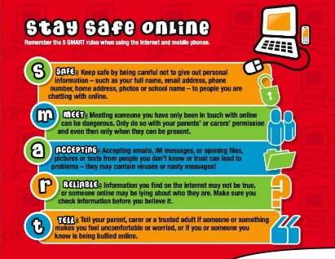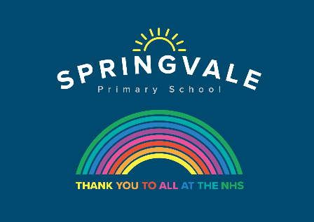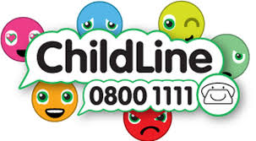
Learning Project WEEK 11 – Famous & Significant People
Age Range: Y3/4
Weekly Maths Tasks (Aim to do 1 per day) | Weekly Reading Tasks (Aim to do 1 per day)
- Working on Times Table Rockstars - your child will have an individual login to access this (20 mins on SOUND CHECK). Please note year 4 MUST do a sound check this week.  - Watch this addition video and this subtraction video, which revise the column method. Generate calculations to practise at home.  - Challenge your child to use the Subtraction Grids to see how many calculations they can solve correctly in 2 minutes. Or try this calculation game.  - Ask your child to think about these questions: What calculations can you create using the numbers 127, 111, 200, 28 and 65? Will you use subtraction, addition or both? Can you find the inverse to the calculations you write?  - Get your child to revise using all four operations by playing this game. They make a target number using the different operations.  - Complete the mystery of the super snack. | - Task your child with reading something unusual in an unusual place e.g. a cookbook in the bath. How many unusual places can your child read in this week?  - Visit Ducksters and encourage your child to choose a person to read about. Ask them to create a fact file on their chosen person using facts learnt.  - Ask your child to read a magazine or newspaper article about a famous person. Ask them to write a diary entry from the viewpoint of that person.  - Read through this book about famous artists together. Encourage your child to choose one of the artists and create their own inspired painting.  - With your child, take a look at this information all about Neil Armstrong, the first man to walk on the moon. Complete the quiz and test your knowledge!  - Complete the comprehension about David Walliams and/or Rosa Parks.  1 star= Year 3 readers  2 stars= Confident Year 3 readers/Year 4  3 stars = confident Year 4 readers
Weekly Spelling Tasks (Aim to do 1 per day) | - Weekly Writing Tasks (Aim to do 1 per day)
- Practise your spellings on Spelling Frame (Y3 only)  - Year 4 week 4 spellings for Summer 2 have been included in the pack.  - Your child can choose a person that is significant to them and mindmap all of the words that they associate with this individual e.g. inspirational, heroic, intelligent, courageous.  - Practise spelling these words: information, adoration, sensation, preparation, admiration. Your child can list other words ending in ‘tion’.  - Puzzle fun. Choose 5 Common Exception words and create a word search containing these spelling words. Who can find the words?  - A-Z fun. Ask your child to list a famous or significant person that begins with each letter of the alphabet. | - Visit the Literacy Shed for this wonderful resource on The Clocktower or take part in a writing masterclass using your authorfy login from last week.  - Tell your child to imagine that they are famous. What would they be famous for? Can they write a diary entry recounting the day’s events in role?  - Ask your child to find out when the NHS began. Who was the founder? Encourage them to compare the NHS then and now. Can they represent information on a timeline or in an information booklet?  - All famous people should earn £1,000,000 per year. Does your child agree/disagree? Ask them to have and write a discussion on this statement.  - Ask your child to use the words FAMOUS PEOPLE to write an acrostic poem about significant people in history.
Learning Project - to be done throughout the week
The project this week aims to provide opportunities for your child to learn more about famous or significant people. Learning may focus on past or present inventors, explorers or scientists and how they influence society today.

Let’s Wonder:
Famous Fact Find - Find out about one or more Famous British People here. Ask your child to decide how they would like to present the information they have discovered. This could be a slide show, a poster or an information report about them. Can your child create a true or false quiz about their chosen person and test it out on the family during a games night?


Let’s Create:
Healthcare Heroes - As the NHS plays such a significant role in our lives, ask your child to represent our amazing NHS staff with their own piece of artwork. This could be a painting, collage or even a collectable stamp of a famous medic e.g Florence Nightingale, Mary Seacole or Aneurin Bevan. Remember to tweet a photo of their artwork.
Sophia Barnacle
- Sophia was a British inventor who, in 1907, invented the Helter-skelter. Try using junk box material to make your own helter-skelter or marble run.
To find out more about building your own marble run click here


Be Active:
Sport Superstar - Watch an interview with Rod Ellingworth, a famous, British cyclist. Then go for your own bike ride as part of your daily exercise. Don’t forget to wear your helmet. No bike? Then take a walk and look out for any cyclists you see.
Recommendation at least 2 hours of exercise a week.
FAITH
Religious Role Models - Ask your child to find out about significant religious people, like Jesus, Moses, Muhammed (pbuh), Guru Nanak or someone else who is important to your family. What do they notice about these people? What is similar about them? What is different? Help! Record the similarities and differences in a table format or make a Religious Role Model mini-book.

. Family time
As a family, discuss the famous people that may have had an impact on their lives and the choices they have made about the jobs they have chosen. Talk about who has inspired them and why. Your child can create a family tree that illustrates inspirations and choices.

Family time- Have a chill out evening after your superb efforts with home learning and watch a film based on a famous or significant person:
The Greatest Showman (PG)
The Prince of Egypt (U)
Pocahontas (U)
Ruby Bridges (PG) Recommend that parents watch this first, I haven’t seen it but there are apparently scenes of racial harassment that could be disturbing for younger children.)

Stay safe. We miss you.
@SpringvalePS

