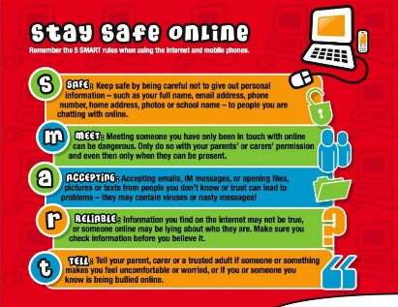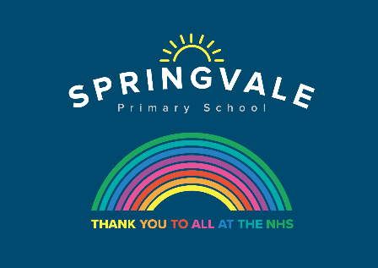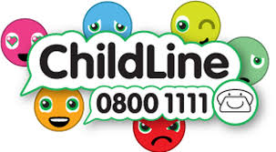
Learning Project WEEK 12 – Around the world
Age Range: Y3/4
Weekly Maths Tasks (Aim to do 1 per day) | Weekly Reading Tasks (Aim to do 1 per day)
- Your child can try to find real life arrays -this could be eggs in a tray, candles in a row, etc. Once found, get your child to write the calculation for that array. Can they find the fact family? (E.g. 3x4 = 12, 4x3=12, 12÷3 = 4 & 12 ÷ 4=3).  - Choosing a times table of choice, ask your child to write a rap/song to help them remember the multiplication facts linked to this time table. Can they include the corresponding division facts in their rap/song too?  - Get your child to make a multiplication flower for a times table of their choice like the one here.  - Ask your child to think about the products that they use at home and how far these have travelled. Food, clothing, toys and electrical items often carry ‘Made in…’ labels. Calculate distances travelled and order from those made closest to home to those made furthest away.  Encourage your child to explore different currencies of money used around the world. How do these compare to pounds? E.g £1= $1.25.  - Complete the mystery at the swimming baths game. | - Share a story together, perhaps a story from another culture? Ask your child to identify any countries, cultures or food that are referenced in the story.  - Visit Ducksters and let your child choose a region to learn about. Ask them to identify major cities, rivers and information on its landscape.  - Can your child design a book cover for a well-known myth e.g. Romulus and Remus? Or can they write an alternative ending instead?  - Visit Story Nory and let your child choose a story from around the world to listen to. Can they summarise the main events by drawing a comic strip?  - Look at the world flags poster attached together. How many flags does your child recognise? Ask your child to choose one of the countries and read online about their culture, cuisine, popular sport and significant/famous people from this country.  - Complete the comprehension about mythical stories from different cultures.  1 star= Year 3 readers  2 stars= Confident Year 3 readers/Year 4  3 stars = confident Year 4 readers
Weekly Spelling Tasks (Aim t o do 1 per day) | - Weekly Writing Tasks (Aim to do 1 per day)
- Practise your spellings on Spelling Frame (Y3 only)  - Year 4 week 5 spellings for Summer 2 have been included in the pack.  - Your child can learn to spell the continents of the world. Practise writing them using pencils, pens, chalk, sticks, typing, etc.  - Practise spelling these words: sadly, completely, usually, finally, comically. Can your child identify the spelling rule for adding the ‘ly’ suffix?  - Can your child create their very own ‘Around the World’ crossword puzzle? Help them write clues and a family member can complete it.  - Trace it. Choose 5 Common Exception words and trace around each word. What does your child notice about the shape of each word?  Ask your child to list adjectives and place names that begin with the same letter e.g. fascinating France, sweltering Sri Lanka, exquisite England. Can they put these into a list poem?  - A-Z fun. Ask your child to list a famous or significant person that begins with each letter of the alphabet. | - Visit the Literacy Shed for this wonderful resource on The Blackhat. Or your child could design a new island for people to visit by creating a detailed map from a bird’s eye view.  - Ask your child to write a set of instructions explaining how to make an African mask. Remind them to include: equipment, headings, imperative verbs (bossy words), adverbs (e.g. carefully, slowly ) and a handy hint.  - Discuss a holiday that your child has been on or a place they’ve visited. Get them to design a postcard and write about what they did there.  - Get your child to listen to some Anansi stories. Ask them to write their own story featuring Anansi. What is she going to teach them? Encourage them to create their own book with a front and back cover and illustrations.  - After the reading task, your child can create an information report on their chosen country and organise their paragraphs using these headings: culture, cuisine, popular sport and significant/famous people.
Learning Project - to be done throughout the week
The project this week aims to provide opportunities for your child to learn more about countries and cities around the world. Learning may focus on different cultures and traditions, famous landmarks, food and clothing.

Let’s Wonder:
Virtual Explorer - What are the continents of the world? Where are they located? What languages are spoken in these continents? Ask your child to use Google Maps to explore a continent of their choice. Can they create a continent fact file or choose a particular country they are interested in and create an information guide including the weather, tourist locations, landmarks, weather, traditional music, food, flags. Remember to tweet a photo of their fact file or information guide

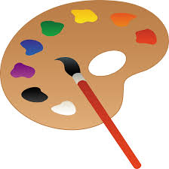
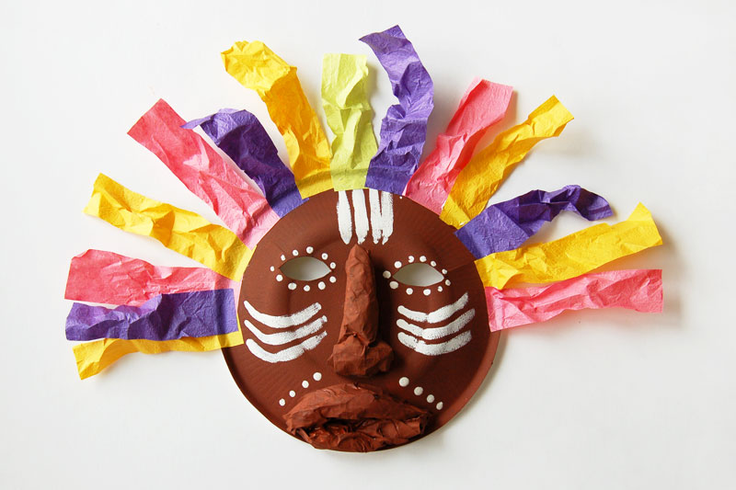
Let’s Create:
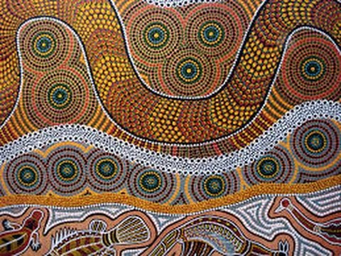
Mask Making - Ask your child to use paper or cardboard and a range of materials around the home to design and create their own African mask. Can they find out their importance to African culture by watching this clip?
Aboriginal Art – Have a go at some aboriginal art using cotton
buds to paint the distinctive dots in a pattern on paper or a stone.
Check out this video for help: aboriginal art

Be Active:

- Dance Around the World - Use SafeYoutube to dance along to some different cultural dances from around the world, such as the Brazilian Samba, the traditional Diwali stick dance or the Spanish Flamenco. Your child can design a cultural costume for their favourite dance and label it with suitable materials. Why not record a video to share with your school’s Twitter? Encourage your child to watch the recording back and evaluate their dance.
Recommendation at least 2 hours of exercise a week.

Music
This is not linked to our topic this week but is an exciting opportunity for any musicians out there. Barnsley Music Services are putting together a special music concert, if you play an instrument or sing you can get involved, learn the track and play or sing along, or if you just like to listen to music you can watch the concert on Friday at 1.30. Check out this link for more details: https://www.barnsleymusichub.com/key-stage-two-music-festival-online

Family time
- Speak the Language - Encourage your child to discuss with their family the links they and their family have to the wider world. Find out places family members have visited on holiday, work/business links or simply countries they would like to visit in the future. Have a go at learning some simple phrases in different languages from around the world and write the phrases using the colours of the flag for that country. You could visit the Mrs Mandarin website here.
- If you haven’t checked out the Edmodo app yet, it’s really good for simple daily practise of a new language.

Family time- Have a chill out evening after your superb efforts with home learning and watch a film set in a different country or culture:
Moana (PG)
Rio (U)
Mulan (animated: U, live action: 12A)
My neighbour Totoro (U)

Stay safe. We miss you.
@SpringvalePS

