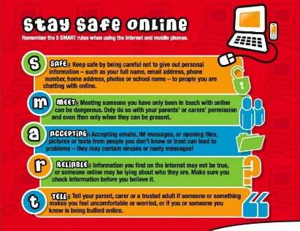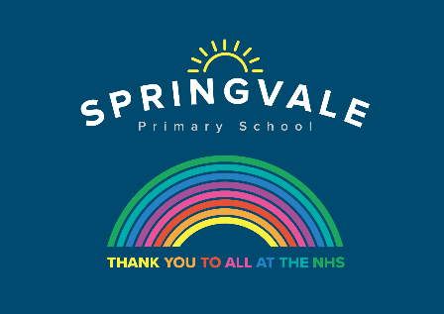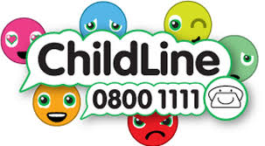
Learning Project WEEK 13 – Music
Age Range: Y3/4
Weekly Maths Tasks (Aim to do 1 per day) | Weekly Reading Tasks (Aim to do 1 per day)
- Working on Times Table Rockstars - your child will have an individual login to access this (20 mins on SOUND CHECK).  - Encourage your child to watch this video about angles and learn the names of different angles such as right angles, obtuse and acute angles.  - Ask your child to become a shape scavenger! How many examples of different 2D and 3D shapes can they find around the home/garden? Can they create a tally and sort the shapes they find based on their properties? e.g. number of sides/edges, number of pairs of parallel lines.  - Ask your child to write their name in capital letters and see how many angles they can see in each letter. How many right angles? How many acute and obtuse angles? Repeat for other family names.  - Last week your child wrote a times table song. Ask your child to rehearse their song but this time incorporate a beat using a musical instrument (see below).  - Have a go at the mystery at the Springfall Carnival maths game. | - Look with your child at the PowerPoint ‘the history of musical styles through the 20th century’. Read through the information for each musical style and find a song to listen to. Ask your child to identify their favourite music styles giving reasons for their choice.  - Ask your child to find the lyrics to their favourite song and highlight some creative words used, finding out the meaning of new words.  - Visit Audible and let your child choose a book to listen to. Ask them to write a review when they have finished (free audio books available).  - Your child can listen to BBC School Radio music episodes here. These episodes are based on Treasure Island and your child will learn new songs.  - Complete the comprehension about Gustav Holst and/or Sergei Rachmaninoff  1 star= Year 3 readers  2 stars= Confident Year 3 readers/Year 4  3 stars = confident Year 4 readers
Weekly Spelling Tasks (Aim t o do 1 per day) | - Weekly Writing Tasks (Aim to do 1 per day)
- Practise your spellings on Spelling Frame (Y3 only)  - Year 4 week 6 spellings for Summer 2 have been included in the pack.  - Ask your child to learn to spell the names of an instrument from each of the instrument families (strings, woodwind, brass, keyboards, and percussion).  - Ask your child to unscramble these musical words: empot, demloy, epslu, narhmoy & rrecsttuu.  - Memory. Write as many of your spellings down from memory as you can. How many did you recall? Practise any you have missed. | - Visit the Literacy Shed for this wonderful resource on Once in a Lifetime or take part in a writing masterclass.  - Listen to the piece of music called Peter and the Wolf, written by Prokofiev. Whilst listening, encourage your child to list any words that come to mind e.g elation, cheerfulness. They could also draw a picture of what they think the song represents.  - Now read the story. Ask your child to write their own story that would be great told through music or draw a story map to represent this tale. Can they include speech too?  - Your child can make a mini-book about the instrument families. Include: names of instruments within that family, famous musicians who use them, country of origin and labelled illustrations.  - Invent a new instrument. Ask your child to write a fact file about their instrument or design an advert for when the instrument goes on sale.
Learning Project - to be done throughout the week
The project this week aims to provide opportunities for your child to learn more about music. Learning may focus on famous musicians, listening to and performing music and exploring a range of music genres and instruments.

Let’s Wonder:
Lean On Me - Encourage your child to listen to Lean On Me, a Soul/Gospel song by Bill Withers. Do they like it? What instruments can they hear? Can they clap a rhythm? Learn to sing the lyrics and have a go at performing the song. Perhaps your child would like to research this famous artist in more detail and listen to more of his songs, creating an artist profile complete with portrait sketch. Perhaps they could perform the song to a family member via Facetime (with adult supervision)?
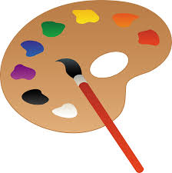
Let’s Create:
Musical Makes - Ask your child to try creating their own music instrument. They could make their own pan flute using straws, a cereal box guitar, or some tin can drums. Encourage them to plan their design first, source materials from around the house, write the steps to make the product and then evaluate it afterwards. Or they could research Kandinsky and create their own instrument art inspired by his work whilst listening to different genres of music.
Making Instruments
- You will need a jar/bottle, some water and a pencil. Try tapping the side of an empty container with a pencil. What type of sound does it make? Partially fill the container with water, tap the container again. Has the sound changed? Try filling the container with different amounts of water. Can you play a tune? Look here.
- Now try making a straw oboe. All you need is a drinking straw and some scissors. Cut the end of the straw into an arrow shape and blow gently. Once you get a duck type sound try altering the length of the straw. What do you notice?
For more ideas take a look at the full resources here


Be Active:
- Feel the Beat - Why not ask your child to have a go at moving their body to different genres of music. As you change between Rock, Jazz, Hip Hop, Heavy Metal and Classical music, how does the way they move their body change? Have a dance together to the beat of the music! Recommendation at least 2 hours of exercise a week.

- MUSIC
Visit https://www.bbc.co.uk/teach/ten-pieces for lots of different pieces of music to listen to and learn about.
Visit https://www.classicsforkids.com/ for learning and games about different types of instruments and music.

- Family Time
Listen Together - Encourage your child to ask each family member what their favourite song is. Play the song aloud and listen together. Spend some time as a family discussing what genre of music the songs belong to and how each piece of music makes you feel. Which genres of music were the most popular? Can your child represent their results in a bar chart? They could ask family members to rank their favourite genres of music first.

Musical Movie Time - Allow your child to choose an age-appropriate musical to watch. Andrew Lloyd Webber is now posting filmed versions of his shows on his Youtube channel The Shows Must Go On! each week! Discuss the story behind the musical and ask your child to step into the shoes of different characters and imagine how they are feeling. Which is your child’s favourite song from the film/show and why? Can they create a billboard poster advertising the show? Or perhaps design a ticket?
Stay safe. We miss you.
@SpringvalePS

