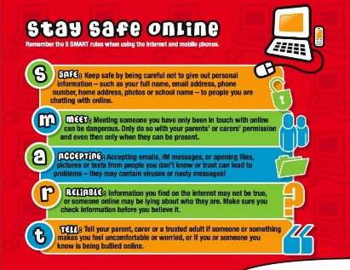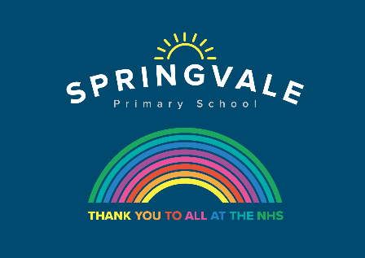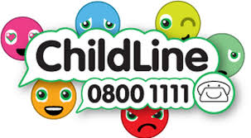
Learning Project WEEK 14 – Space
Age Range: Y3/4
Weekly Maths Tasks (Aim to do 1 per day) | Weekly Reading Tasks (Aim to do 1 per day)
- Working on Times Table Rockstars - your child will have an individual login to access this (20 mins on SOUND CHECK).  - Give your child an A4 piece of paper and mark out a rectangle 12cm by 24cm. They are designing a vegetable patch and need to include the following areas: A carrot zone with a perimeter of 32cm, a pea zone with an area of 12cm squared, a strawberry zone with an area of 20cm squared and a perimeter of 18cm.  - Following on from yesterday, your child can design 3 more zones of their choice but there must be a difference of at least 2cm between each of the areas.  - ‘Conquer the Area’. You will need: square paper or draw a square grid, 2 different colour pencils and 2 dice. Roll the dice and multiply the two numbers together. Whoever rolled the dice draws this area on the square grid with their pencil. Fill up the whole page - whoever has taken up the most space wins.  - Visit this website for more space-themed activities.  - Have a go at the space maths challenge cards and the maths mosaic sheets. | - Encourage your child to recreate space and read a story e.g. under dark bed sheets with a torch or even in the garden under the stars (with supervision).  - Encourage your child to explore the surface of Mars on the Curiosity Rover here. What did they notice? What was most surprising?  - Task your child with creating their own Book Bingo. See here for inspiration.Can they complete the game over the next week?  - Complete the comprehension about mars and/or Apollo 13  1 star= Year 3 readers  2 stars= Confident Year 3 readers/Year 4  3 stars = confident Year 4 readers  - Have a go at the mystery of the stolen space food English game.
Weekly Spelling Tasks (Aim t o do 1 per day) | - Weekly Writing Tasks (Aim to do 1 per day)
- Practise your spellings on Spelling Frame (Y3 only)  - Task your child with creating their very own space themed word bank e.g orbit, solar, comet. They can refer to this for some of their writing tasks.  - Practise spelling these words: division, invasion, confusion, decision, collision, television. Ask your child to list synonyms for each word (words with the same meaning).  - Learn to spell the names of all the planets in our solar system. Put them in alphabetical order and then order of size.  - Flash writing. Choose 5 Common Exception words and go into a darkened room with a torch and write them in the air with the torch light.  - Using the word bank from Wednesday, ask your child to create their very own space-themed word search. A family member could complete it. | - Visit the Literacy Shed for this wonderful resource on Broken: Rock, Paper, Scissors. Or your child can write a response to this: If I met an alien, I would… Your child could record their responses in a list to form a list poem and then perform it.  - Ask your child to write a diary entry about what it would be like on a Space Station. What do they miss about life on Earth? More inspiration here.  - Encourage your child to create a travel brochure for a planet of their choice or to promote space tourism in general. Make sure they include information about travel times, accomodation, food and things to do and see. If you have access to a PC, this could be done on Word or Google Docs.  - Ask your child to write a story about a character who went into space for the day. Ask them to think about which time openers (e.g. Later that day,) they could use and how they could build suspense to engage the reader.  - Create an information poster about Neil Armstrong. Remind your child to use labels and captions. What diagrams could they include?
Learning Project - to be done throughout the week
The project this week aims to provide opportunities for your child to learn more about space. Learning may focus on our Solar System, the Sun and the Moon. It could look at life in outer space from the view of an astronaut and travelling through space.

Let’s Wonder:
- Our Solar System- Encourage your child to think about what they already know about space and create a mind map. Can they name the planets in our solar system? Can they remember them in order or create their own mnemonic to help them? Ask your child to research the characteristics of the planets e.g What is it made of? What size is it? How close to the Sun is it? Temperature? Can they create a fact file, PowerPoint or Google Slide presentation on a planet of their choice? These facts about Mars or these facts about space may be a good starting point.
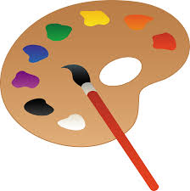
Let’s Create:
Blast off!- Ask your child to design a new spacesuit suitable for an astronaut. They will need to consider which materials would be most suitable, comfort for the astronauts and the temperature in space. Encourage them to design a logo for the spacesuit too. Perhaps they could make this using materials from around the home? Share your designs on twitter.
Design your own planet!
Can you design your own planet, think about what it will look like, what features it will have, use the attached sheet if you need support.


Be Active:
- Astronaut Aerobics- Astronauts have to be fit and agile for their missions to space. Ask your child to design an obstacle course in your garden or home space and put your agility to the test! Can you find your pulse and count your heart rate before and after exercising? Recommendation at least 2 hours of exercise a week.

- Out of this World- Ask your child if space travel was made more accessible and they could go on holiday to space, would they like to be the first space tourist? Can they think of arguments for and against being the first space tourist? Is it unethical for millionaires to spend their money on space tourism or should they spend all their money on reducing poverty? Ask them to prepare a speech about this discussion point.

One Giant Leap for Mankind - Ask your child to find out about Neil Armstrong. Who was he and what challenges did he have to overcome during his life? Can they write a biography or create a piece of drama about Neil Armstrong’s life and achievements?

Science
Mission X – Jump Training
- Stronger bones help astronauts stay safer while performing all of their assigned tasks – whether in a space vehicle, on the moon, Mars, or once back on Earth.
- Your bones become stronger when you do exercises that support your weight, such as running or jumping. Train like an astronaut by skipping on the spot for 60 seconds without stopping. Rest for 30 seconds. Repeat three times. Vary and extend by adding jumping jacks, travelling forward and by increasing length of time. You can find out more here.
Sign up and access all of the Mission X resources here.

Family time- Have a chill out evening after your superb efforts with home learning and watch a film set in space
Wall-e (U)
Zathura (PG)
Space Chimps (U)
Fly me to the moon (U)
Stay safe. We miss you.
@SpringvalePS

