


Sample Submission Guideline for Mass Spectrometry (Novogene AMEA)
Last updated: March 2025

**For Internal Use.

This sample submission guideline is for customers in the Asia Pacific and Middle East region (AMEA), excluding mainland China. For any questions, please contact the APM team.

Content
Tissue Weight Reference 2
- Sample Requirement for Metabolomics 3
- Sample Preparation for Metabolomics 4
  - Human and Animal Tissue 4
  - Plant Samples 5
  - Plasma/ Serum 7
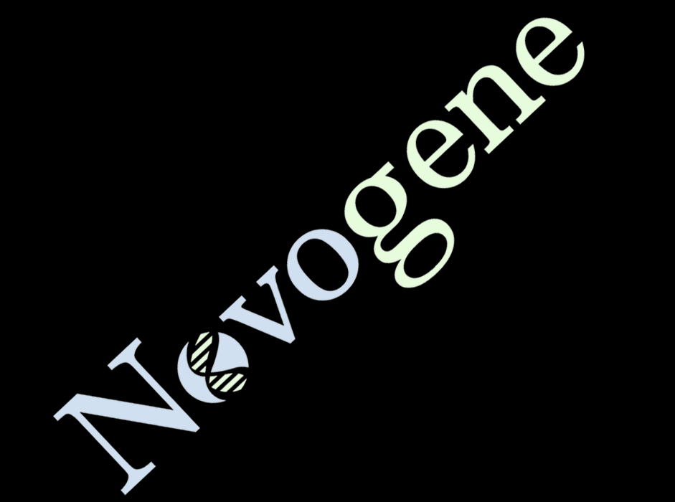
  - Feces and Intestinal Content 9
  - Saliva 9
  - Urine 10
  - Tears 10
  - Microbe Samples 11
  - Cell Samples 12
- Metabolites Extraction Method for Untargeted Metabolomics 13
- Sample Requirement for Quantitative Proteomics Services 15
- Sample Requirement for Post-Translational Modification Proteomic (PTM) . 17 Services
- Sample Preparation for Proteomics products 18
  - Animal Tissues Samples 18
  - Cell Samples 19
  - Solution Samples 20
  - Plant/ Tissue Samples 22
  - Microbial Samples 22
  - Protein Solutions 22


Tissue Weight Reference

Tissue Reference Size | Name | Weight
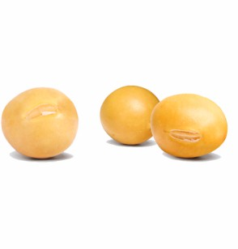 | Soybean | 100 mg/ seed
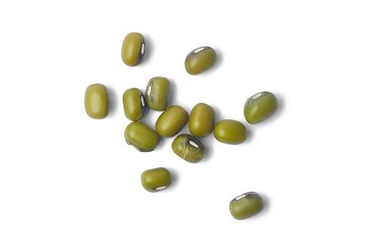 | Mung bean | 50 mg/ seed
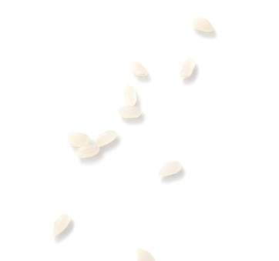 | Rice | 10 mg/ seed

Sample Requirement for Metabolomics
- The Singapore lab will start accepting these sample types for untargeted metabolomics product from April 1st, 2025.


- For Lipidomics product, only China lab will accept samples. Contact the Logistics team for shipment suggestions.

Sample type* Untargeted metabolomics/ Lipidomics
Human & Animal tissue 200 mg
Plant tissue 500 mg
Plasma/Serum 200 μL
Feces/Intestinal contents 200 mg
Saliva 200 μL
Urine 200 μL

Note:
* Please use 1.5 mL centrifuge tubes for sample collection.

Only the China lab will accept the sample types listed below. Please check with APM before communicating with the customer. Contact the Logistics team for shipment suggestions.

Sample type Untargeted metabolomics/ Lipidomics
Amniotic fluid/Bile/Tear, etc. 200 μL
Supernatant/Fermentation broth 2 mL
Microbial thallus 100 μL
Microbial solution 2 mL
Culture medium 200 mg
Cell* ≥107

Note:
* Please ensure the cell count can meet the requirement.

Sample Preparation for Metabolomics

Human & Animal Tissue

Preparation Steps
Human Tissue: When collecting samples from human patients, generally only a small biopsy is obtained. It is recommended to snap-frozen these samples as soon as possible.


To minimize tissue contamination, as much blood as possible should be removed from the samples. This can be achieved by rinsing with deionized water.

Animal Tissue: For large tissue samples, it is advisable to subdivide and aliquot them to minimize freeze-thaw cycles. In the case of rodents, tissue removal should be performed after exsanguination to minimize the presence of blood in the tissue.

- Select specific regions according to the experimental design and place 200 mg/sample into centrifuge tubes.
- Properly label the tubes, then quickly freeze them in liquid nitrogen for at least 15 minutes.
- Store the samples at -80°C and ship them with sufficient dry ice.

Notes
- For biological replicates, try to keep the sampling location as consistent as possible.
- Be aware of possible contaminant signals resulting from the collection of tissue samples, such as those from anesthetic, surgical instrument cleaning solutions, or tube-related contaminants.
- Tissues should be collected on ice to minimize further metabolism. The samples should either be processed immediately upon collection or be snap-frozen and stored at −80 °C to avoid any further loss of unstable metabolites.
- Collect the tissue into a suitable container and then subdivide it into labeled tubes/containers. If the tissue samples are large, it is recommended to cut them into small pieces for freezing and storage. Small pieces of tissue will freeze more rapidly, and separate aliquots will minimize or eliminate freeze-thaw cycles. If sub-aliquoting the sample is not possible, keep the number of freeze-thaw cycles to the absolute minimum.

References
Want E J, Masson P, Michopoulos F, et al. Global metabolic profiling of animal and human tissues via UPLC-MS[J]. Nature Protocols, 2012, 8(1):17-32.

Plant Samples

Leaves, Stems, Flowers

      - Preparation Steps
- Take a whole leaf, stem, or flower and wrap it in aluminum foil.
- Label the wrapped sample and quickly freeze it in liquid nitrogen for at least 15 minutes.
- After removing from liquid nitrogen, quickly place the sample into a self-sealing bag (one bag per group) and include a label paper inside the bag to indicate the sample information.
- Quickly store the sample at -80 °C.

- Use sufficient dry ice for transport.

Notes
- When collecting leaf samples, it is best to do so during the midday when there is good lighting.
- According to the experimental design, maintain sample consistency when collecting samples, especially within the same group of samples (color, degree of aging, leaf vein proportion, lighting, position, etc.).
- Since marker pen markings on aluminum foil tend to fade, it is recommended to also include a label sheet inside the self-sealing bag.

Roots

      - Preparation Steps
- Take the entire plant root and quickly rinse off the soil with 1 x PBS.
- According to the specific experimental design, take specific parts of the plant roots and place 500mg/sample into centrifuge tubes.
- Label the sample and immediately freeze it in liquid nitrogen for at least 15 minutes.
- Quickly store in a -80 °C freezer. Use sufficient dry ice during transport.

Notes
- Wash with PBS as quickly as possible.
- Since root tissues are particularly fragile and will turn mushy when squeezed, it is recommended to store them in centrifuge tubes rather than wrapping them in aluminum foil.

Fruits, Seeds

      - Preparation Steps
- For juicy and large fruits (e.g., tomatoes, watermelons, apples), cut them into uniform, suitable small pieces (approximately 500 mg per sample) with a sharp knife. Divide the pieces into 1.5 mL centrifuge tubes. After labeling, quickly freeze the samples in liquid nitrogen for at least 15 minutes.
- For small particle seeds (e.g., Arabidopsis seeds, grain seeds), mix the seeds from the same group first and then divide them into 1.5 mL centrifuge tubes (approximately 500 mg per sample). After labeling, quickly freeze the samples in liquid nitrogen for at least 15 minutes.

- For the entire fruits (e.g., whole grapes), pack the fruit in a 50 mL centrifuge tube or a self-sealing bag. Label the container (including sample information if using a self-sealing bag), and quickly freeze the fruit in liquid nitrogen for at least 15 minutes.

Notes
- Maintaining uniformity in sampling juicy fruits (such as the proportion of tomato skins, flesh, pulp, and seeds) is challenging. It is strongly recommended to grind and freeze-dry the entire fruit, then weigh and package the powder.
- It is not recommended to wrap it with aluminum foil.

References
De Vos R C, Moco S, Lommen A, et al. Untargeted large-scale plant metabolomics using liquid chromatography coupled to mass spectrometry. [J]. Nature Protocols, 2007,2(4):778-791.
Kim H K, Choi Y H, Verpoorte R. NMR-based metabolomic analysis of plants[J]. Nature Protocols,2010,5(3):536

Plasma/Serum

Preparation Steps for Plasma
It is recommended to use heparin sodium anticoagulant tubes to collect whole blood and perform plasma separation as soon as possible. Centrifuge at 3000 rpm, 4°C for 10 minutes. Take the upper layer and aliquot 0.2 mL per tube into 1.5 mL centrifuge tubes. After labeling the tubes, freeze them in liquid nitrogen for 15 minutes and store them at -80°C. Use sufficient dry ice during transport.

Preparation Steps for Serum

Collect blood using a vacuum blood collection tube and let it stand at 37°C (or room temperature) for an hour for coagulation and stratification. Then, centrifuge at 3000 rpm for 5 minutes. Take the supernatant and transfer it to a clean centrifuge tube. Centrifuge at 12000 rpm at 4°C for 10 minutes (or perform only one centrifugation to complete the sampling). Collect the supernatant and aliquot into 1.5 mL centrifuge tubes, 0.2 mL per tube. After labeling, freeze in liquid nitrogen for 15 minutes and store at -80°C. Transport with sufficient dry ice.

Notes

Animal Samples
Ensure animals fast and are deprived of water for at least 10 hours before sampling.

Clinical Samples:
Maintain a light diet for 3 days before sampling.
Fast from food and water after 8:00 PM on the evening before sampling.
The sample processing process should be as consistent as possible, including sample placement time, centrifugation time, etc.

- If alcohol is used for disinfection during blood collection, please wipe the area dry and wait for the alcohol to completely evaporate before taking the sample.

Blood Collection Tube Selection:
Plasma: It is recommended to use heparin sodium anticoagulant tube (green cap). Sodium citrate anticoagulant (blue or black cap) and EDTA anticoagulant (purple cap) can interfere with metabolites and cause matrix effects. However, the interference of EDTA anticoagulant can be eliminated by desalinization. If using EDTA tubes, please note this in advance.

Serum: Please use a vacuum blood collection tube (red cap) without anticoagulant during blood collection.

- It is recommended to collect as many samples as possible and aliquot them into 1.5 mL centrifuge tubes for freezing. Be sure to avoid repeated freeze-thaw cycles.

- Serum reference yield: 30% to 50% (e.g., 1 mL of whole blood can yield approximately 0.3 to 0.5 mL of serum). Plasma reference yield: approximately 50% (e.g., 1 mL of whole blood can yield approximately 0.5 mL of plasma).


- If hemolysis is observed in the sample, please refer to the color chart below. If the sample color matches the last two categories, hemolysis is severe, and the sample is unsuitable for further metabolomics analysis. In such cases, the sample needs to be recollected.

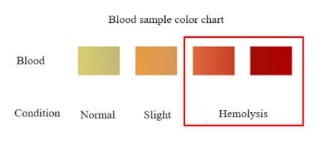

References
BarriT, Dragsted L O. UPLC-ESI-QTOF/MS and multivariate data analysis for blood plasma and serum metabolomics: effect of experimental artefacts and anticoagulant[J]. Analytica Chimica Acta, 2013, 768(1):118-128.

Feces/Intestinal Contents

Preparation Steps for Plasma
After collecting fresh feces or intestinal contents, aliquot 200 mg per tube, immediately freeze in liquid nitrogen for 15 minutes, and store at -80 °C. Use sufficient dry ice during transport.

Notes

Due to the abundance of microorganisms in feces and intestinal contents, their metabolic rate is very fast. Therefore, repeated freeze-thaw cycles can significantly impact metabolic levels. After sample collection, it is recommended to pack and freeze the samples at 250mg/tube.

References
Wu J, An Y, Yao J, et al. An optimized sample preparation method for NMR-based faecal metabonomic analysis[J]. Analyst, 2010, 135(5):1023-30.

Saliva

Preparation Steps
Sample collection should be done between 9:30 AM and 11:30 AM. After rinsing the mouth with saline, expectorate saliva into a sterile sputum cup (keep on ice). Avoid coughing up sputum.
Collect enough samples in a short time. Centrifuge at 4°C, 2000g for 10 minutes. Collect the supernatant, then filter through a 0.22μm filter membrane for sterilization (filtration is optional). Aliquot into 2-3 tubes, freeze in liquid nitrogen for 15 minutes, and store at -80°C. Transport with sufficient dry ice.

Notes
- Refrain from smoking, drinking, and eating for at least 1 hour before sampling. Do not brush your teeth prior to sampling.
- It is recommended to collect as many samples as possible and pack them in 1.5mL centrifuge tubes for freezing. Avoid repeated freeze-thaw cycles.

References
Bertram, H. C., Eggers, N., & Eller, N. Potential of Human Saliva for Nuclear Magnetic Resonance-Based Metabolomics and for Health-Related Biomarker Identification[J].
Analytical Chemistry, 2009, 81(21), 9188–9193.

Urine

Preparation Steps
Midstream urine (clinical) or 1-hour morning urine (animal) was centrifuged at 3000rpm, 4 °C for 10 minutes. Clear urine was collected and divided into centrifuge tubes with 500 μL per tube.
After labeling, freeze in liquid nitrogen for 15 minutes and store at -80 °C. Use sufficient dry ice during transport.

Notes

- If the output of animal's 1-hour urine is insufficient, it can be collected in multiple times. For 24-hour urine collection, please use a metabolic cage equipped with a low-temperature device and add sodium azide (0.05-0.1% w/v).
- Sodium azide is a preservative and bactericide, but it is toxic. Please handle with extreme caution.

References
Want E J, Wilson I D, Gika H, et al. Global metabolic profiling procedures for urine using UPLC-MS.[J]. Nature Protocols, 2010, 5(6):1005-1018.

Tears

Preparation Steps
Collect samples between 9:00-12:00 in the morning. Ask the subject to look upward. Using the prepared Schirmer strip, place the curved end into the conjunctival sac at the outer 1/3 of the eyelid, and let the other end hang outside the eye. Instruct the subject to gently close their eyes. The collection time is 5 minutes. Removed strips and placed in a 1.5 mL centrifuge tube and froze in liquid nitrogen for 15 minutes and store at -80 °C. Use sufficient dry ice during transport.

Notes
Collect no more than one tear sample per eye per day.

References
Pieragostino D, D'Alessandro M, di Ioia M, et al. Unraveling the molecular repertoire of tears as a source of biomarkers: beyond ocular diseases[J]. Proteomics–Clinical Applications, 2015, 9(1-2): 169-186.
Chen L, Zhou L, Chan E C Y, et al. Characterization of the human tear metabolome by LC–MS/MS[J]. Journal of proteome research, 2011, 10(10): 4876-4882.

Microbe Samples

Preparation Steps for Microbial Thallus
Collect microbial thallus using centrifugation (ensuring consistent volume after centrifugation), rinse 2-3 times quickly with pre-chilled PBS, and centrifuge for 5 minutes at 4 °C, 5000rpm after each wash. Completely discard the supernatant, collect the bacterial cells in a 1.5 mL centrifuge tube (Cryogenic Vials), and immediately freeze in liquid nitrogen for 15 minutes and store at - 80 °C. Use sufficient dry ice during transport.

Preparation Steps for Microbial Liquid Culture Medium

After mixing the cultured microbial liquid, take more than 5mL of culture, and centrifuge at 3000rpm, 4 °C for 10 minutes. Collect all the supernatant and immediately freeze in liquid nitrogen for 15 minutes. Store at -80 °C. Use sufficient dry ice during transport.

Preparation Steps for Solid Culture Medium
Cut the culture medium into square pieces with a blade. Immediately freeze the pieces in liquid nitrogen for 15 minutes, and store at -80 °C. Use sufficient dry ice during transport.

Notes
- Microbial metabolism is very fast, so all steps need to be completed as soon as possible.
- The number of bacterial cells should be consistent among different samples.
- Generally, an OD600 between 0.6 and 0.8 indicates that the bacteria are in logarithmic growth phase, with an empirical concentration of 10^8 cells/mL, which needs to be confirmed based on specific circumstances.

References
Winder C L, Dunn W B, Schuler S, et al. Global metabolic profiling of Escherichia coli cultures: an evaluation of methods for quenching and extraction of intracellular metabolites[J].
Analytical Chemistry, 2008, 80(8):2939-48.
MarcinowskaR, TryggJ, Wolf-WatzH,etal. Optimization of a sample preparation method for the metabolomic analysis of clinically relevant bacteria [J]. Journal of Microbiological Methods, 2011,87(1):24-31.
Bertrand S., Azzollini A., SchumppO.,et al. Multi-well fungal co-culture for de novo metabolite-induction in time-series studies based on untargeted metabolomics[ J]. Mol. BioSyst. 2014; 10:2289–2298.

Cell Samples

Preparation Steps for Cell

Suspension Cell Samples:
Centrifuge to collect the suspended cells, quickly wash 2-3 times with pre-chilled PBS at 4°C, 1000g for 1 minute. Discard the supernatant and collect the cell pellet (50μL) in a 1.5mL centrifuge tube. Freeze in liquid nitrogen for 15 minutes, store at -80°C, and transport with sufficient dry ice.

Adherent Cell Samples:

Remove the old medium from the cultured cells and wash 2-3 times with pre-chilled PBS. Discard the supernatant, then add 0.5mL trypsin for digestion. After digestion, wash the cells 2-3 times with pre-cooled PBS to stop trypsin activity. Transfer the cells into a centrifuge tube, centrifuge at 4°C, 1000g for 1 minute. Discard the supernatant, and collect the cells in a
1.5mL centrifuge tube. Freeze in liquid nitrogen for 15 minutes, store at -80°C, and transport with sufficient dry ice. (For setting up replicate wells, use trypsin digestion for cell counting.)

Note:
Cell count results for each sample are necessary.

Preparation Steps for Cell Culture medium
Remove the old culture medium and quickly wash 2-3 times with pre-chilled PBS. Then, add serum-free medium to continue culturing for a period of time. Based on the experimental design or cell condition, select an appropriate time to aspirate more than 5 mL of culture medium from adherent cells. Centrifuge at 1000g, 4°C for 1 minute, collect all the supernatant, freeze in liquid nitrogen for 15 minutes, store at -80°C, and transport with sufficient dry ice.

Notes
- Try to ensure that the number of cells collected for each sample should be as consistent as possible, and the entire process should be completed as quickly as possible.
- The type of culture medium affects the types of metabolites, and it is necessary to ensure that the type of culture medium is consistent during the cell culture process.
- To study extracellular metabolism, please use serum-free culture medium while ensuring cell viability.

References
Sellick C A, Hansen R, Stephens G M, et al. Metabolite extraction from suspension cultured mammalian cells for global metabolite profiling[J]. Nature Protocol, 2011, 6(8):1241-9.
Yuan M, Breitkopf S B, Yang X, et al. A positive/negative ion-switching, targeted mass spectrometry-based metabolomics platform for bodily fluids, cells, and fresh and fixed tissue[J]. Nature Protocols, 2012, 7(5):872-81.

Metabolites Extraction Method for Untargeted Metabolomics

Tissue sample

Tissues (100mg) were individually grounded with liquid nitrogen and the homogenate was resuspended with prechilled 80% methanol (500μL) by well vortex. The samples were incubated on ice for 5 mins and then were centrifuged at 15,000 g, 4°C for 20 min. A portion of supernatant was diluted to final concentration containing 53% methanol by LC-MS grade water. The samples were subsequently transferred to fresh Eppendorf tubes and then were centrifuged at 15000 g, 4°C for 20 min. Finally, the supernatant was injected into the LC-MS/MS system analysis. [1]

Liquid sample
The samples (100μL) were placed in the Eppendorf tubes and resuspended with prechilled methanol (400μL) by well vortex. Then the samples were incubated on ice for 5 mins and centrifuged at 15,000 g, 4°C for 20 min. Some of supernatant was diluted to final concentration containing 53% methanol by LC-MS grade water. The sample were subsequently transferred to a fresh Eppendorf tube and then were centrifuged at 15000 g, 4°C for 20 min. Finally, the
supernatant was injected into the LC-MS/MS system analysis. ^{[2-3]}

Cell or bacteria sample
The samples were placed in the EP tubes and resuspended with prechilled 80% methanol by well vortex. Then the samples were melted on ice and whirled for 30 seconds. After the sonification for 6 mins, they were centrifuged at 5,000 rpm, 4°C for 1 min. The supernatant was freeze-dried and dissolved with 10% methanol. Finally, the solution was injected into the LC-MS/MS system
analysis ^{[4-5]}.

Cell or bacteria culture medium sample
The samples (1 mL) were freeze-dried and resuspended with prechilled 80% methanol by well vortex. Then the samples were incubated on ice for 5 mins and centrifuged at 15,000 g, 4°C for 15 mins. Some of supernatant was diluted to final concentration containing 53% methanol by LC-MS grade water. The samples were subsequently transferred to a fresh Eppendorf tube and then were centrifuged at 15000 g, 4°C for 15 min. Finally, the supernatant was injected into the LC-MS/MS system analysis.

Reference
- Want E J , Masson P , Michopoulos F , et al. Global metabolic profiling of animal and human tissues via UPLC-MS[J]. Nature Protocols, 2012, 8(1):17-32.
- Want E J , O"Maille G , Smith C A , et al. Solvent-Dependent Metabolite Distribution, Clustering, and Protein Extraction for Serum Profiling with Mass Spectrometry[J]. Analytical Chemistry, 2006, 78(3):743-752.
- BarriT ,Dragsted L O . UPLC-ESI-QTOF/MS and multivariate data analysis for blood plasma and serum metabolomics: effect of experimental artefacts and anticoagulant[J]. Analytica Chimica Acta, 2013, 768(1):118-128.
- Sellick C A, Hansen R, Stephens G M, et al. Metabolite extraction from suspension cultured mammalian cells for global metabolite profiling[J]. Nature Protocol, 2011, 6(8):1241-9.

- Yuan M, Breitkopf S B, Yang X, et al. A positive/negative ion-switching, targeted mass spectrometry-based metabolomics platform for bodily fluids, cells, and fresh and fixed tissue[J]. Nature Protocols, 2012, 7(5):872.

Sample Requirement for Quantitative Proteomics Services


The Singapore lab will start accepting these sample types for Deep/ Rapid DIA products from April 1st, 2025.

Sample Type |  | Deep / Rapid DIA
Animal Tissue* | General tissues (brain, heart, liver, spleen, lung, kidney, muscle, etc.) | 10 mg
 | Hard tissues (cartilage, hair, etc.) | 200 mg
Cells** | Suspension/adherent cultured cells | 2×106  (10 μL cell pellet)
Serum/ Plasma | No high-abundant protein depletion procedure | 5 μL
 | High-abundant protein depletion from human blood by kit | 10 μL
Body Fluids*** | Cerebrospinal fluid/semen/ Follicular Fluid | 500 μL
 | Urine | 10 mL
 | Saliva/tear | 500 μL
 | Breast milk | 10 μL

Note:
* It is recommended that customers provide samples according to the above quantities to ensure the smooth execution of the project. If the submitted sample quantity is lower than the recommended amount, an inquiry evaluation is required, and customers need to be informed of the associated risks.

** Please ensure the cell count can meet the requirement.

*** Body fluid samples generally have low protein content, so it is recommended to avoid dilution and send us the undiluted samples whenever possible.

Please refer to below table for protein samples.

Sample Type |  | Deep / Rapid DIA
Extracted protein sample* (Solvent buffer reagent components must be provided) | Non-detergent containing protein sample (Optimal buffer with 6M Urea, preferred protein concentration ≥ 0.5 μg/μL) | 100 μg
 | Detergent containing protein sample (including SDS, triton X-100, NP40, CHAPS, etc.) | 200 μg

Note:
* When the sample type is a protein solution or protein powder, SDS-PAGE gel image and protein quantification results must be provided to confirm the protein extraction efficiency. If the buffer contains detergents or the protein concentration is below 0.5 µg/µL, protein purification/ concentration is necessary. This process may result in protein loss, so a significantly larger sample amount is required.

Only China lab will accept the sample types listed below. Please refer to price list for logistics cost.

Sample Type |  | Deep / Rapid DIA
Plant Tissue* | Soft tissues (leaves and flowers of woody plants, herbaceous  plants, algae, ferns, etc.) | 100 mg
 | Hard tissues (tree roots, bark, branches, etc.) | 1 g
 | Fruit pulp | 2 g
 | Seeds | 100 mg
 | Pollen | 50 μL
Microorganisms* | Common bacteria | 30 mg or 30 μL pellet
 | Fungal mycelium | 50 mg or 50 μL pellet


Note:
* It is recommended that customers provide samples according to the above quantities to ensure the smooth execution of
the project. If the submitted sample quantity is lower than the recommended amount, an inquiry evaluation is required, and customers need to be informed of the associated risks.

Sample Requirement for Post-Translational Modification Proteomic (PTM) Services


Only China lab will accept the sample types listed below. Please refer to price list for logistics cost.

Sample Type* |  | Phosphorylation | Acetylation/  Ubiquitination | N-/O- Glycosylation**
Animal Tissues | General tissues (brain, heart, liver,  spleen, lung, kidney, muscle, etc.) | 100 mg | 1 g | 100 mg (only take  human, mouse, rat)
 | Hard tissues (cartilage, hair, etc.) | 2 g | 10 g | 2 g (only take human,  mouse, rat)
Plant Tissues | Soft tissues (leaves and flowers of woody plants, herbaceous plants,  algae, ferns, etc.) | 500 mg | 10 g | 500 mg
 | Hard tissues (tree roots, bark,  branches, etc.) | 10 g | 50 g | 10 g
 | Fruit pulp | 20 g | 100 g | 20 g
 | Seeds | 4 g | 20 g | 4 g
 | Pollen | 400 μL | 2 mL | 400 μL
Microbes | Common bacteria, fungal cells | 200 mg or 200 μL  pellet | 1 g or 1 mL pellet | /
Cells | Suspension/adherent cultured cells (it is crucial to meet the  required cell pellet volume) | 1×107  (50 μL pellet) | 1×108  (500 μL pellet) | 1×107  (50 μL pellet) (only take human, mouse, rat)
Fluids | Serum/Plasma (No high abundant  protein depletion procedure) | 50 μL | 500 μL | 50 μL
 | Saliva /Tear | 2 mL | 5 mL | 2 mL

Note:
* It is recommended that customers provide samples according to the above quantities to ensure the smooth execution of the project. If the submitted sample quantity is lower than the recommended amount, an inquiry evaluation is required, and customers need to be informed of the associated risks.
** Only human, mouse, rat, and plants samples are applicable for glycosylation service.

Sample Preparation

Animal Tissue Samples

General Animal Tissues (Brain, Heart, Liver, Spleen, Lung, Kidney, Muscle, etc.)
- Collect the tissue and rinse the sample with pre-cold saline or PBS to remove remaining blood.

- Cut the sample into 0.5 cm width or ~100 mg pieces and put into Eppendorf tubes. Label the tube clearly with sample name, species, and tissue type.
- Flash freezes the sample with liquid nitrogen for at least 5 min, store at -80°C, and avoid repeated freeze-thaw cycles.

Mollusks (Schistosoma, Trichina)
- Collect the sample and rinse with pre-cold PBS to remove contaminants. Label sample name, species, tissue type clearly.
- Flash freezes the sample with liquid nitrogen for at least 5 min, store at -80°C, and avoid repeated freeze-thaw cycles.

Hard Animal Tissues (Cartilage, Hair, etc.)
- Collect the tissue and rinse with pre-cold PBS to remove debris.
- Label sample name, species, tissue type clearly.
- Flash freezes the sample with liquid nitrogen for at least 5 min, store at -80°C, and avoid repeated freeze-thaw cycles.

Cell Samples

Suspension cells
- Centrifuge the sample at 400-1000 g for 5-10 minutes to collect the suspended cells. Discard the supernatant.
- Wash the cells 2-3 times with pre-cold PBS. After each wash, centrifuge and discard the supernatant.
- Transfer the collected cells into a 1.5 mL centrifuge tube. It is recommended to prepare at least 2-3 tubes per sample, with each tube containing more than 50 μL of cell pellets.

- Record the total cell volume, flash freeze the tubes in liquid nitrogen, and store them at - 80°C.

Adherent cells
- Discard the culture medium, wash the adherent cells 3 times with pre-cold PBS.
- Put the culture dish on ice, add 0.5 mL lysis buffer (6 M Urea, 0.1 M TEAB), shake the dish gently.
- Scrape the dish with cell scraper, then transfer cell lysate from the culture dish to a 1.5 mL centrifuge tube.
- It is recommended to prepare at least 2-3 tubes per sample, with each tube containing more than 50 μL of cell pellets.
- Record the total cell volume, flash freeze the tubes in liquid nitrogen, and store them at - 80°C.

Note:
  - Add a protease inhibitor (if applicable, Roche, Cat. No: 5892791001) to the lysis buffer before use. If the samples are used for phosphorylation detection, add phosphatase inhibitor (Roche, Cat. No: 4906845001) to the lysis buffer.
  - If the recommended lysis buffer is not available, customers can follow the subculturing protocol for adherent cell by using trypsin to detach the adherent cells. Please wash the trypsin treated cells 2-3 times with pre-cold PBS solution before sending out the samples.

Solution Samples

Serum/Plasma

Plasma
  - Collect blood using an EDTA anticoagulant tube (purple cap). Gently invert the tube 8-10 times, then centrifuge the tube at 4°C, 800 g for 10 minutes.
  - Transfer upper layer plasma into a 1.5 mL centrifuge tube with a pipette, immediately add protease inhibitor and mix well (if applicable). Flash freezes the tube in liquid nitrogen, and store at -80°C.


Serum
  - Collect blood using a centrifuge tube (without anticoagulant) or vacuum blood collection tube (without anticoagulant, red cap).
  - Place the tube at 4°C for 15-30 minutes to facilitate coagulation and separation.
  - Centrifuge the tube at 800 g, 4℃ for 10 minutes.
  - Use a pipette to transfer the serum to a 1.5 mL centrifuge tube, immediately add protease inhibitor and mix well (if applicable). Flash freezes the tube in liquid nitrogen, and store at - 80°C.
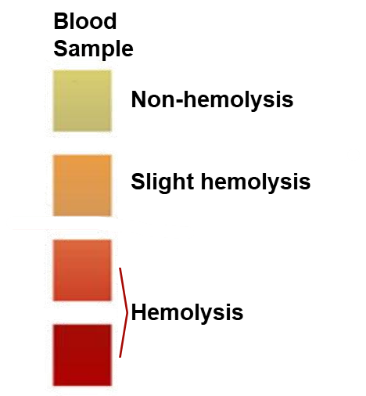

Note:
- Hemolysis must be avoided during serum/plasma sample preparation.
- Recommended solutions for avoiding hemolysis: have a trained phlebotomist perform the blood collection; gently mix the sample; shake up and down more than ten times; avoid drawing blood when the patient is taking special medications.
- If high abundant protein depletion or exosomes preparation are applied to further plasma sample preparation, customers MUST NOT use heparin as anticoagulant. EDTA or other anticoagulants can be used.

- Serum yield is approximately 30~50% (e.g., 0.3-0.5 mL of serum yield from 1 mL of whole blood typically). Plasma yield is approximately 50% (e.g., 0.5 mL of plasma yield from 1 mL of whole blood typically).

Saliva
- Fasting for at least 2 hours before sampling is required. The best time for sampling is between 9 AM and 12 PM. Expectorate saliva into a sterile sputum cup (keep it on ice). Do not cough up sputum, and collect a sufficient sample within a short period.

- Centrifuge the samples at 1000g – 2000g for 5 minutes. Transfer supernatant to 1.5 mL centrifuge tube, flash freeze in liquid nitrogen, and store at -80℃.

Tears
- Use a capillary micro-pipette to collect the sample into centrifuge tube.
- Centrifuge at 8000 -14000g at 4°C for 5 minutes.
- Transfer supernatant to 1.5 mL centrifuge tubes, flash freeze in liquid nitrogen, and store at - 80 ℃.

Urine
- Study participants need to control diet before collection. It’s better to collect the urine samples within 1 hour after the study participants waking up.
- Collect "fresh" mid/late-morning urine samples from study participants, avoid bacteria contamination and keep the sample in 4℃ for short-term preservation (DO NOT exceed 8 hours).
- Centrifuge at 3000g 4℃ for 15 minutes to remove cell and cell debris. Flash freezes in liquid nitrogen, and store at -80℃. Ship the samples with dry ice.

Breast milk
Collect breast milk into a centrifuge tube, flash freeze in liquid nitrogen, and store at -80℃.

Cerebrospinal fluid/ synovial fluid/ lymph fluid/ ascitic fluid/ pleural fluid/etc.
- Collect the fluids and place it on ice. Avoid blood contamination when collecting the samples.
- Centrifuge at 2000g, 4℃ for 10-15 minutes to remove cell and cell debris.
- Transfer the supernatant into centrifuge tubes, flash freeze in liquid nitrogen, and store at - 80℃. Ship the samples with dry ice.

Plant Tissue Samples

Soft plant tissues (leaves, flowers, fruits, seeds, roots, bark, ferns, etc.)
- Collect the tissue and rinse the sample with pre-cold saline or PBS to remove debris.
- Label sample name, species, tissue type clearly. Flash freezes the sample with liquid nitrogen for at least 5 min, store at -80°C, and avoid repeated freeze-thaw cycles.

Pollen

- Collect pollen during the flowering period. Examine the collected sample under a microscope to remove impurities, then transfer to centrifuge tubes.
- Label the tube clearly and flash freeze in liquid nitrogen, store at -80°C.

Algae
- Use an appropriate centrifugation force based on the type of algae to separate the algae while ensuring cell integrity.
- Wash with PBS 2-3 times, flash freeze the tubes with liquid nitrogen, and store at -80°C.

Microbial Samples

- Collect microbial cells pellet using centrifugation and discard the supernatant. Then wash the pellet with pre-cold PBS, avoid proteins contamination from culture medium.
- Centrifuge the microbial cell at 5000g, 4℃ for 5 min after each wash procedure, discard the supernatant.
- Collect the bacterial pellet in 1.5 mL cryovials, record the microbial volume, flash freeze the tubes in liquid nitrogen, and store at -80°C.

Protein Solution

Please provide the required information, including SDS-PAGE electrophoresis image, the protein extraction method and solution composition. An optimal lysis buffer could be 6M Urea with 0.1-1% SDS and a buffer solution (e.g.,100mM PBS or Tris-HCl). Ensure the protein concentration is above 0.5 µg/µL.

If customers plan to use other buffers, please consult us in advance regarding their suitability and fill out the Sample Information Form with the buffer composition.


www.novogene.com/amea-en/ marketing_amea@novogeneait.sg

© 2025 Novogene Co., Ltd. All Rights Reserved.
Information and speciﬁcations are subject to change at any time without notice. Please contact your Novogene representative.
March 2025

