RTL-Matched LUT-Based Adaptive Bit-Loading Controller
for Calibrated Bidirectional OFDM/DMT Wireline Transceivers
[Author Name(s)]
[Department and Institution], [City], [Country] | [Corresponding author e-mail]
Draft status: technical content and currently verified MATLAB/ModelSim/E2E results are included. Author details, Quartus synthesis/PNR data, and measured bidirectional-wireline calibration results remain to be inserted before submission.

Abstract
This paper presents an RTL-matched adaptive bit-loading controller for a calibrated bidirectional orthogonal frequency-division multiplexing/discrete multitone (OFDM/DMT) wireline transceiver. In each transceiver, the per-subcarrier signal-to-noise ratio (SNR) measured by the local receiver is used to generate the quadrature-amplitude-modulation (QAM) allocation of the co-located transmitter, under a symmetric or calibrated bidirectional-link assumption. The controller replaces direct complementary-error-function evaluation and division with a 32-entry, 5-bit-address exponential lookup table, shift operations, QAM-dependent constants, and cross-multiplied comparisons. Independent margins are updated for 4-, 16-, 64-, and 256-QAM, while an offline-calibrated fixed correction is applied only in the final allocation pass to recover the conservative rate loss of the LUT approximation. For a 512-point DMT system with 255 active subcarriers and a target BER of 10^-4, the proposed Q16 implementation allocates 998 bits per OFDM symbol and achieves 36.159 Gb/s. The analytical BER is 3.68x10^-5 and the end-to-end waveform BER is 3.67x10^-5 under ideal synchronization and perfect one-tap frequency-domain equalization. ModelSim reproduces the 248 margin updates and the complete 255-entry allocation map.
Keywords: adaptive bit loading; bidirectional transceiver; discrete multitone; fixed-point RTL; lookup table; OFDM; QAM allocation.

1. Introduction
Discrete multitone (DMT), which is the real-valued implementation of orthogonal frequency-division multiplexing (OFDM), divides a frequency-selective wireline channel into nearly orthogonal narrowband subchannels. This enables the modulation order of each tone to be selected according to its signal-to-noise ratio (SNR), assigning more bits to strong tones and fewer bits, or no bits, to weak tones. Classical loading algorithms provide effective bit and power allocation for spectrally shaped channels [1]-[4], and recent high-speed DMT receivers have demonstrated that bit and power loading remains an important mechanism for exploiting wideband electrical channels with deep frequency notches [5], [6].
Many loading methods are first evaluated in floating-point software, where exact or high-accuracy bit-error-rate (BER) expressions, iterative searches, and divisions can be used without a strict implementation cost. A direct hardware mapping is less attractive. Exact square-QAM BER evaluation contains a complementary error function, and average-error or target-BER checks introduce divisions. A coarse LUT can remove these operations, but its quantization and fitted exponential form may overestimate BER near the decision boundaries. The resulting conservative thresholds reduce the number of loaded bits and create a non-negligible rate loss.
A second system-level question is where the loading engine should be placed in a bidirectional transceiver. Sending a full per-tone SNR profile to an external host, executing the allocation in software, and returning a map to the physical layer adds software and register-transfer latency. This paper instead considers a local-adaptation architecture: each bidirectional transceiver integrates an RX, a TX, and the proposed loading engine. The local RX estimates the incoming SNR profile, and the engine uses a calibrated bidirectional relation to construct the outgoing-link SNR estimate and the local TX allocation.
The use of an incoming-link SNR to adapt the co-located outgoing transmitter has an experimental precedent in full-duplex visible-light communication. Zhang et al. reported fully overlapping forward- and reverse-link SNR traces when identical visible-light hardware was used, and a largely stable offset that could be calibrated when different front ends were used [7]. This result does not prove universal SNR equality in electrical wireline links; rather, it supports the feasibility of local RX-to-TX adaptation when the two directions are sufficiently symmetric or explicitly calibrated.
The main contributions of this work are as follows:
1) A calibrated bidirectional local-adaptation model is defined in which each RX supplies the SNR profile used by the co-located TX allocation engine, while residual directional mismatch is explicitly separated from the nominal controller model.
2) A hardware-oriented BER estimator uses a 32-entry exponential LUT with a 5-bit address, QAM-dependent constants, fixed-point multiplication, and binary shifts instead of direct erfc evaluation.
3) A QAM-dependent margin controller uses transmitted-bit-weighted BER stopping and cross-multiplied average-error comparisons, thereby eliminating runtime division.
4) A fixed QAM-dependent correction, scaled by alpha=0.8 and applied only during the final allocation pass, recovers most of the LUT-induced rate loss while maintaining BER headroom. The design is verified by an RTL-matched Q16 MATLAB model, ModelSim, and end-to-end OFDM waveform simulation.

2. Bidirectional Local-Adaptation System Model

2.1 Local RX-to-TX adaptation architecture
Figure 1 shows the considered link. TRX-A and TRX-B each contain a transmitter, a receiver, a local SNR-profile memory, and one instance of the proposed bit-loading engine. RX-A measures the B-to-A subcarrier SNR profile. After bidirectional calibration, engine A interprets this profile as an estimate of the A-to-B SNR and generates the QAM map used by TX-A. TRX-B performs the symmetric operation.
(1)
(2)
Here, γ-hat denotes an SNR measured by the local receiver, γ-tilde is the outgoing-link SNR estimate supplied to the loading engine, and C_A,k and C_B,k are optional calibration terms. The calibration may be a constant offset when the directional difference is dominated by stable gain mismatch, or a per-subcarrier profile when the two analog front ends have different frequency responses. The symmetric baseline used in the present RTL-matched evaluation sets both calibration terms to zero.
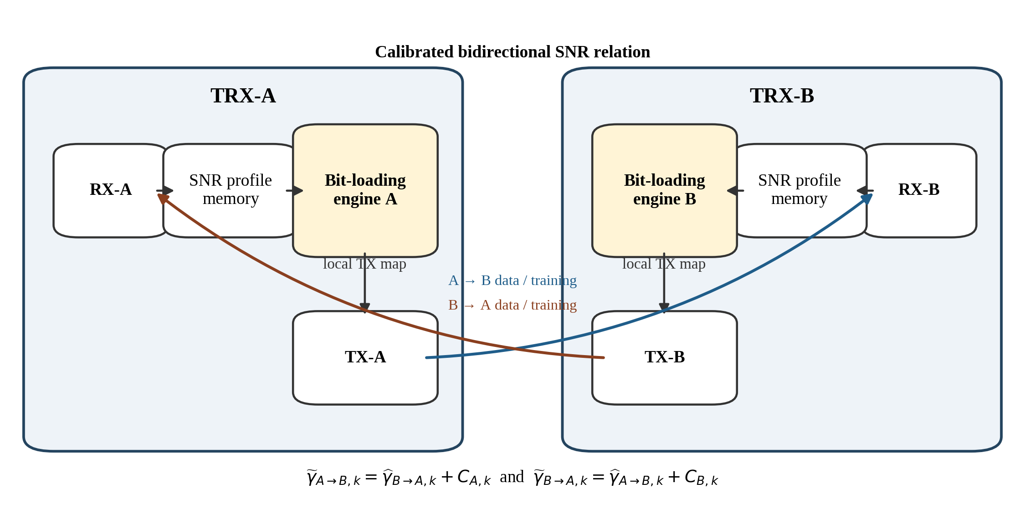
Fig. 1. Bidirectional on-chip local-adaptation architecture. Each local RX supplies a calibrated SNR profile to the co-located TX allocation engine.
Changing the TX allocation also requires the peer RX to use the same demapping profile. Therefore, the generated map and its activation time must be conveyed through link-control signaling or a training/retraining protocol. The present work implements and verifies the arithmetic allocation core and its 255-entry output stream; a complete standardized profile-exchange protocol is outside the claimed controller scope.

2.2 SNR acquisition and reciprocity scope
During initialization or retraining, a known training sequence or preamble can be used by the receiver to estimate the channel and noise power of each tone. The resulting per-subcarrier SNR profile is stored locally before the controller starts. In the present evaluation, the SNR estimator is modeled as a preceding PHY block: the channel and noise model directly generates the Q16 SNR inputs used by MATLAB and ModelSim. Consequently, the reported hardware results validate the loading operation after SNR acquisition, not an RTL implementation of the preamble detector or SNR estimator.
Reciprocal channel response alone does not guarantee equal directional SNR. Transmit swing, transmitter noise, receiver noise figure, analog gain, data-converter quantization, and implementation loss can differ between directions. After calibration, the actual outgoing-link SNR is written as
(3)
where ε_A,k represents residual calibration error, time variation, or unmodeled directional hardware mismatch. The nominal results in this paper use ε_A,k=0. Thus, the bidirectional interpretation is a calibrated baseline and not a claim that all wireline links have intrinsically identical forward and reverse SNR.

3. Proposed RTL-Matched Bit-Loading Controller

3.1 Exact reference and system BER metric
For square M-QAM with Gray labeling, the analytical BER reference used for offline evaluation is
(4)
The controller supports M in {4,16,64,256}, corresponding to b_M in {2,4,6,8} transmitted bits per active tone. Because the modulation orders carry different numbers of bits, the system BER is evaluated using a transmitted-bit-weighted metric rather than an unweighted average across tones:
(5)
The target is P_b,target=10^-4. The exact expression in (4) is used only for floating-point reference and end-to-end consistency checks; it is not evaluated in the runtime RTL path.

3.2 5-bit LUT/shift BER approximation
The hardware estimator approximates the QAM BER by a fitted exponential form. For each QAM order M, define Y_M=K_M gamma, split Y_M into integer and fractional parts, and approximate the fractional exponential with a 32-entry LUT:
(6)
The LUT stores L[q]=floor(2^(-q/32)·2^16)/2^16 for q=0,...,31. The integer exponential is implemented by a right shift. Table 1 lists the fitted constants used by both MATLAB and RTL.
Table 1 QAM-specific controller constants
QAM order M | Bits/tone | K_M | C_M | Base threshold (dB)
4 | 2 | 0.7213 | 0.5000 | 6
16 | 4 | 0.1443 | 0.3750 | 12
64 | 6 | 0.0305 | 0.2916 | 18
256 | 8 | 0.0085 | 0.2343 | 24

Figure 2 summarizes the processing sequence. The SNR and BER values are represented in unsigned Q16 format. The LUT address therefore requires only five fractional bits, and the remaining datapath consists primarily of fixed multipliers, adders, counters, comparators, and shifts.
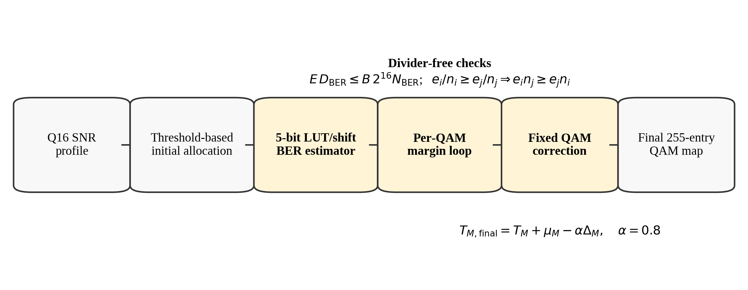
Fig. 2. Proposed RTL-matched controller flow.
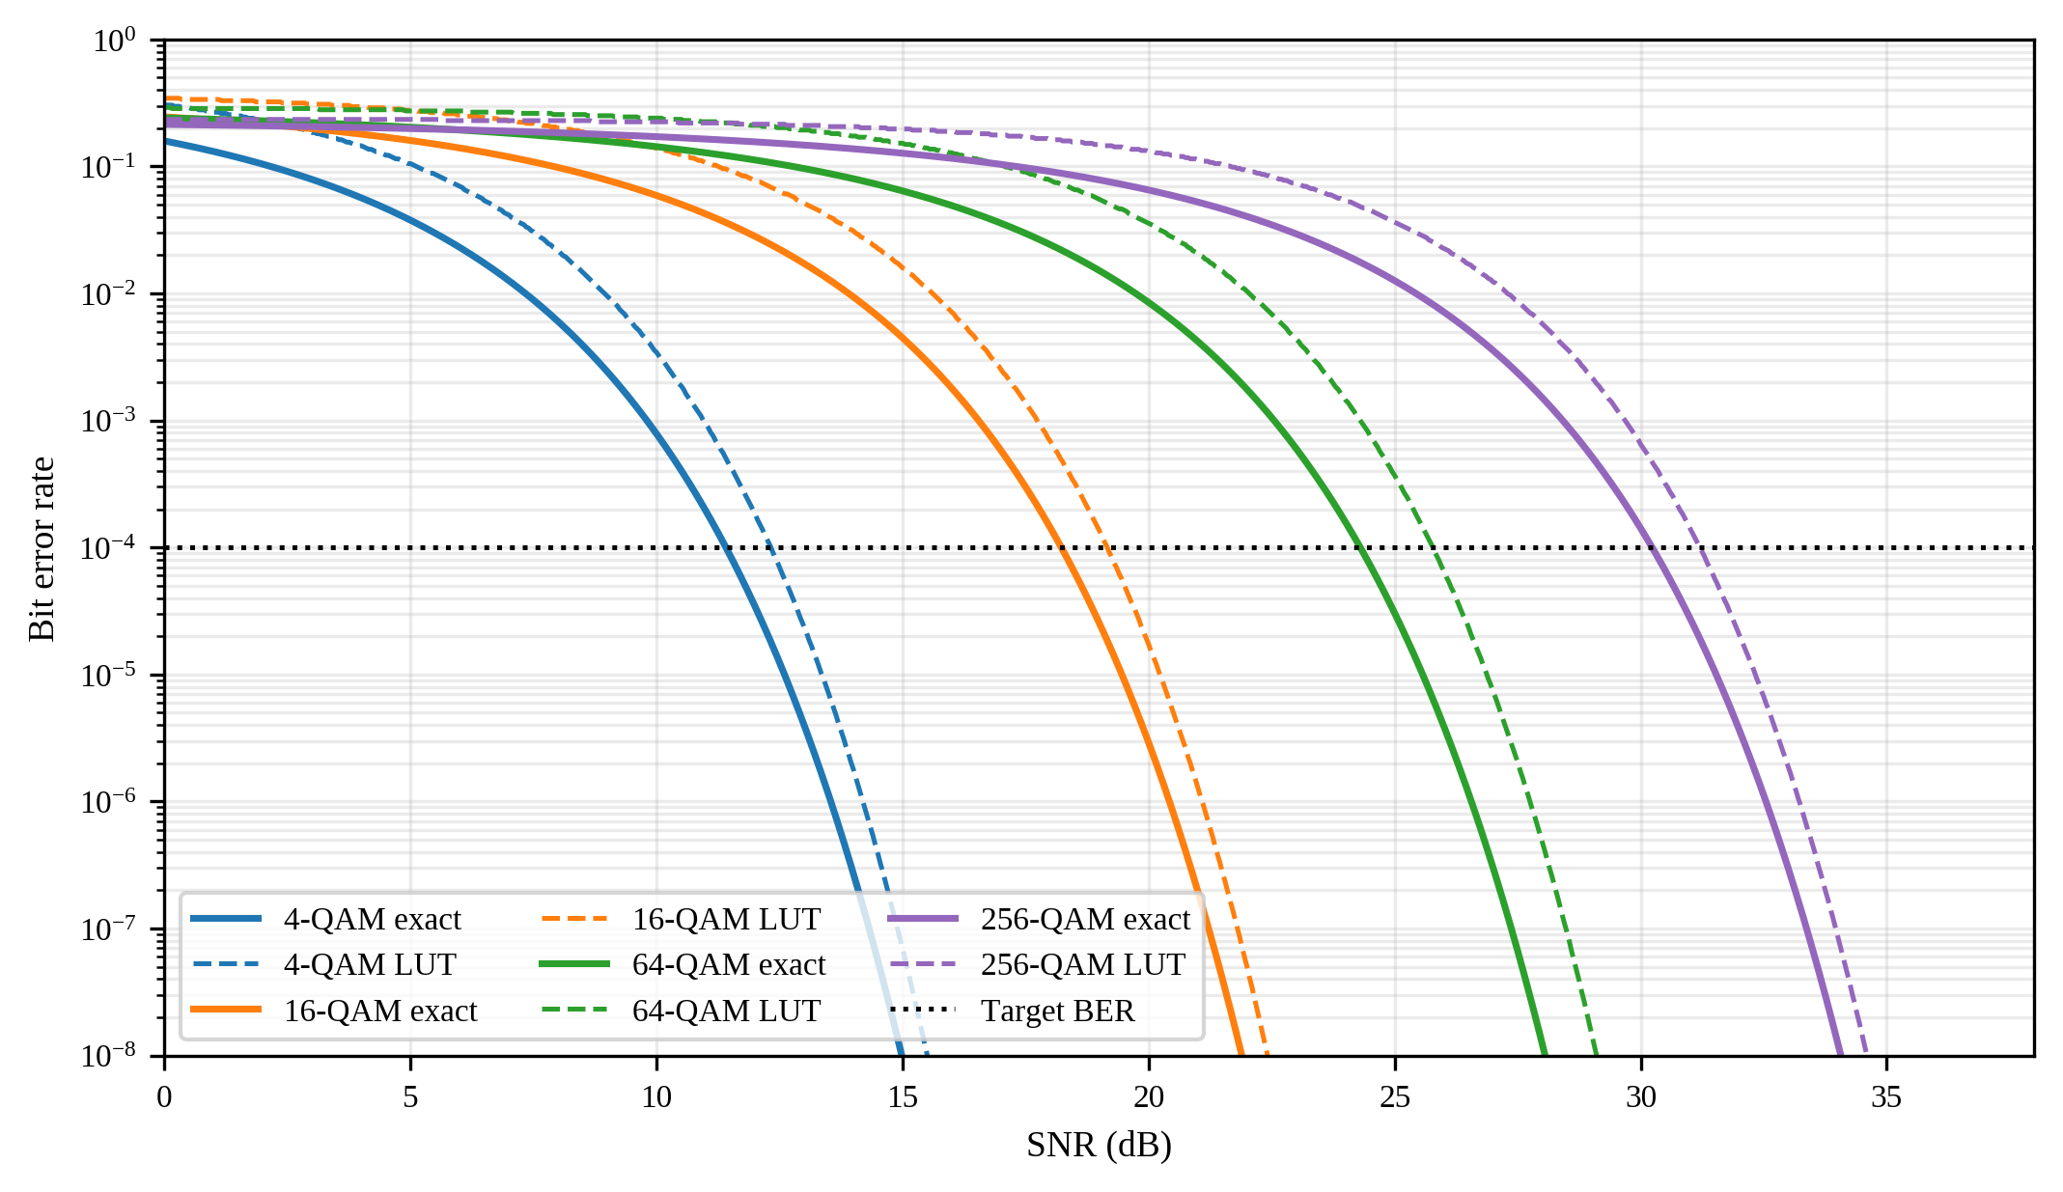
Fig. 3. Analytical square-QAM BER and the 32-entry LUT/shift approximation. The LUT is intentionally conservative near several target-BER crossings.

3.3 Independent QAM-margin update
The initial allocation selects the highest QAM order whose threshold is satisfied. A separate non-negative margin mu_M is maintained for each QAM order. During each iteration, all tones are reclassified with thresholds T_M+mu_M and their Q16 LUT errors are accumulated. Let E denote the transmitted-bit-weighted Q16 error sum and B the total number of loaded bits. With the target represented by the integer fraction N_BER/D_BER=1/10000, the stop condition is evaluated without division:
(7)
If the target is not satisfied, the controller increases one QAM-specific margin by 0.1 dB. The selected tier is the populated QAM class with the largest average estimated BER. For error sum e_i and tone count n_i, pairwise averages are compared as
(8)
Equation (8) removes the divider from the tier-selection path. Pairwise winners are compared in a small tree, and the winning margin is incremented. The loop continues until (7) is satisfied or the configured iteration limit is reached.

3.4 QAM-dependent fixed correction
Although the LUT estimator is inexpensive, its target-BER crossing can occur at a higher SNR than the exact reference, which shifts the QAM cut lines upward and reduces throughput. This bias is calibrated offline. For each QAM order, the exact and LUT SNR crossings at the target BER are found on a 0.01-dB grid, and the non-negative difference is
(9)
The proposed final threshold is
(10)
Only 80% of the fitted crossing difference is used to preserve headroom for fixed-point quantization, SNR-estimation error, and residual link mismatch. Importantly, the correction is disabled during the margin-search loop and enabled only in the final allocation pass. Applying it inside the loop would increase the estimated BER, cause the margin controller to add the same offset again, and largely cancel the intended rate recovery.

3.5 RTL organization
The RTL contains a pipelined per-tone datapath, QAM-specific accumulators and counters, a divider-free comparison tree, a margin-update finite-state machine, and a final corrected allocation pass. The final map is streamed as 255 QAM-tier entries. The correction constants are Q16 dB parameters, so enabling correction adds only QAM-dependent constant selection and threshold addition/subtraction rather than a second BER engine. This organization maintains identical arithmetic rules in the RTL-matched MATLAB model and ModelSim testbench.

4. Evaluation Methodology

4.1 System and channel configuration
The evaluated DMT link uses a 20-Gsample/s sampling rate, a 512-point FFT/IFFT, a 40-sample cyclic prefix, and 255 positive-frequency data subcarriers. The channel response is reconstructed from a supplied pole-residue description. The SNR model includes an 8-bit DAC, an 8-bit ADC, thermal noise, converter quantization noise, and a 4-dB implementation loss. The controller receives the resulting SNR values in both dB-Q16 and linear-Q16 form.
Table 2 Evaluation parameters
Parameter | Value
Sampling rate F_s | 20 GHz
FFT/IFFT size N_FFT | 512
Cyclic-prefix length N_CP | 40 samples
Active positive-frequency tones | 255
Supported constellations | 4-, 16-, 64-, and 256-QAM
Target BER | 1x10^-4
Base thresholds | 6, 12, 18, and 24 dB
Margin step | 0.1 dB (Q16 value 6554)
Fixed correction scale alpha | 0.8
DAC/ADC resolution in SNR model | 8 bits / 8 bits
Implementation loss | 4 dB

For an allocation b_k, the net rate including cyclic-prefix overhead is
(11)

4.2 Compared controllers
Four cases are compared. Exact independent uses the analytical BER reference with QAM-specific margins and serves as a high-accuracy controller reference, not as a proof of globally optimal loading. LUT global uses one common margin for all QAM orders. LUT independent uses the proposed QAM-specific margin rule without correction. Proposed LUT+corr. adds the final QAM-dependent correction in (10). All LUT cases use the same Q16 inputs, constants, and cross-multiplied rules as the RTL.

4.3 Verification levels
Three verification levels are used. First, the RTL-matched MATLAB model executes the exact Q16 quantization, LUT, shifts, integer comparisons, margin updates, and final allocation rules. Second, the Q16 SNR memories are exported to a ModelSim testbench, which checks the update count, QAM population, total loaded bits, and every entry of the output stream. Third, an end-to-end waveform simulation performs QAM mapping, Hermitian-symmetric IFFT, cyclic-prefix insertion, channel filtering, additive noise, FFT, one-tap frequency-domain equalization, and Gray-QAM demapping. The waveform result assumes ideal synchronization, a cyclic prefix sufficient for the modeled channel, and perfect one-tap equalizer coefficients; it therefore validates the controller-level BER model rather than a complete nonideal PHY implementation.

5. Results and Discussion

5.1 Rate-BER trade-off
Table 3 Rate and BER comparison
Controller | Net rate (Gb/s) | Analytical BER | E2E waveform BER
Exact independent reference | 36.812 | 4.88x10^-5 | 5.02x10^-5
Q16 LUT + global margin | 32.681 | 9.42x10^-6 | 1.06x10^-5
Q16 LUT + independent margins | 32.826 | 7.88x10^-6 | 9.05x10^-6
Proposed Q16 LUT + fixed correction | 36.159 | 3.68x10^-5 | 3.67x10^-5

The uncorrected LUT controllers are substantially more conservative than the exact reference. Independent margins improve the global-margin result only slightly because the dominant loss comes from the LUT crossing bias. The fixed correction increases the rate from 32.826 to 36.159 Gb/s, a 10.2% recovery relative to the uncorrected independent controller. The remaining gap to the 36.812-Gb/s exact independent reference is 0.653 Gb/s, or 1.8%. The proposed operating point remains well below the 10^-4 BER target.
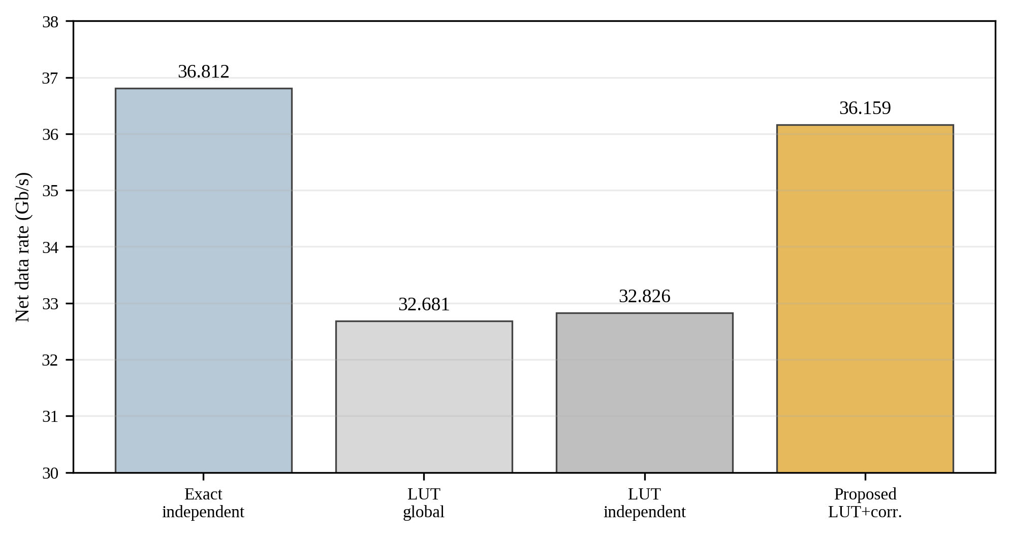
Fig. 4. Net data-rate comparison for the evaluated channel.
The analytical and directly counted waveform BER values agree closely for all four cases, as shown in Fig. 5. In the proposed case, 3.68x10^-5 analytically predicted BER corresponds to 3.67x10^-5 in the end-to-end waveform simulation. This agreement supports the use of the controller-level bit-weighted BER metric under the stated ideal synchronization and equalization assumptions.
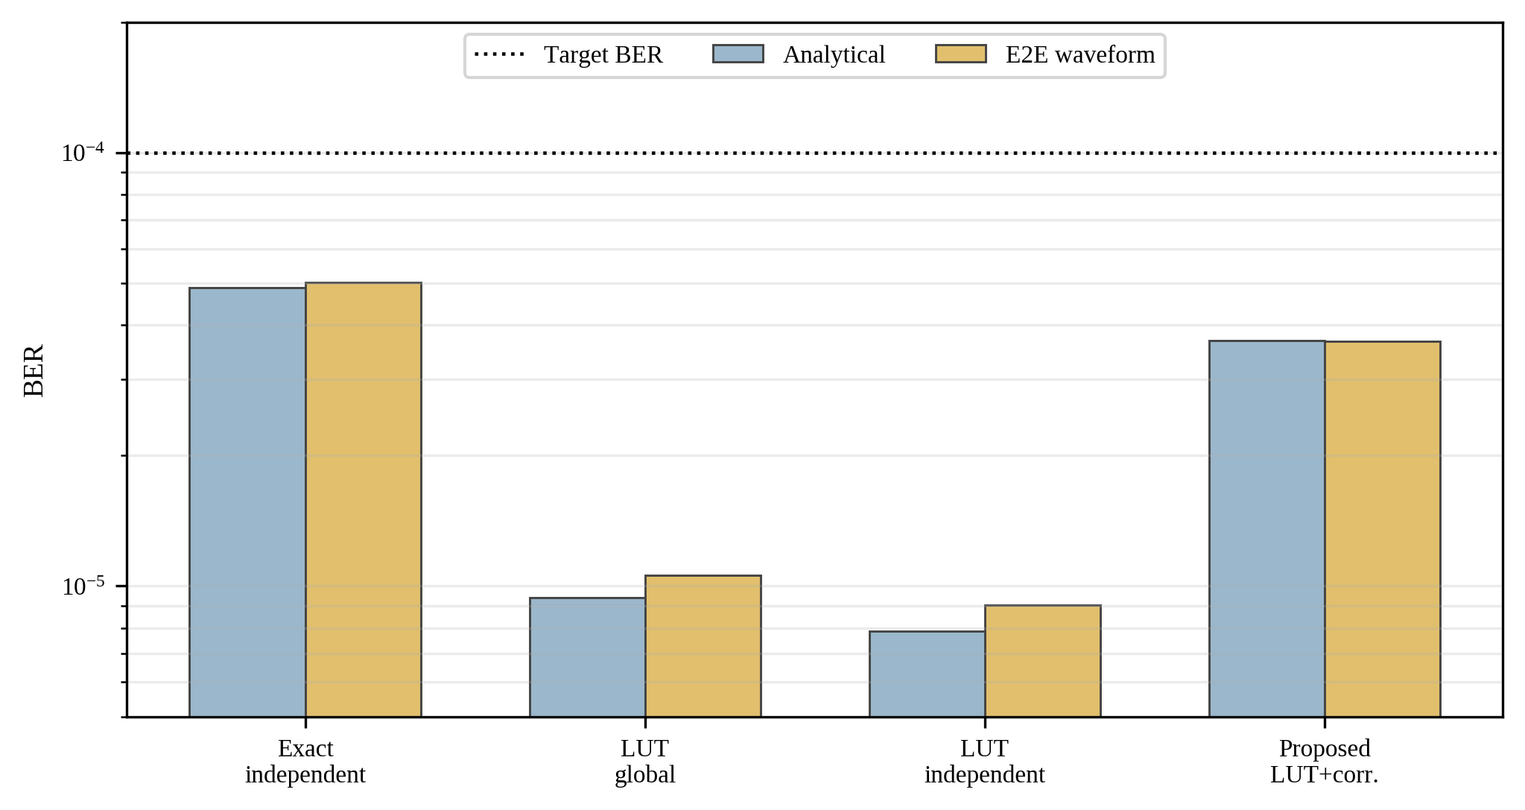
Fig. 5. Analytical and end-to-end waveform BER. All cases remain below the 10^-4 target.

5.2 RTL-matched allocation and ModelSim agreement
The RTL-matched margin loop terminates after 248 updates. The final corrected map contains 78 4-QAM tones, 76 16-QAM tones, 79 64-QAM tones, 8 256-QAM tones, and 14 unused tones. This allocation carries
(12)
which produces 36.1594 Gb/s through (11). ModelSim reproduces the update count, all five population counts, the 998-bit total, and the complete 255-entry final stream. Figure 6 shows the map composition.
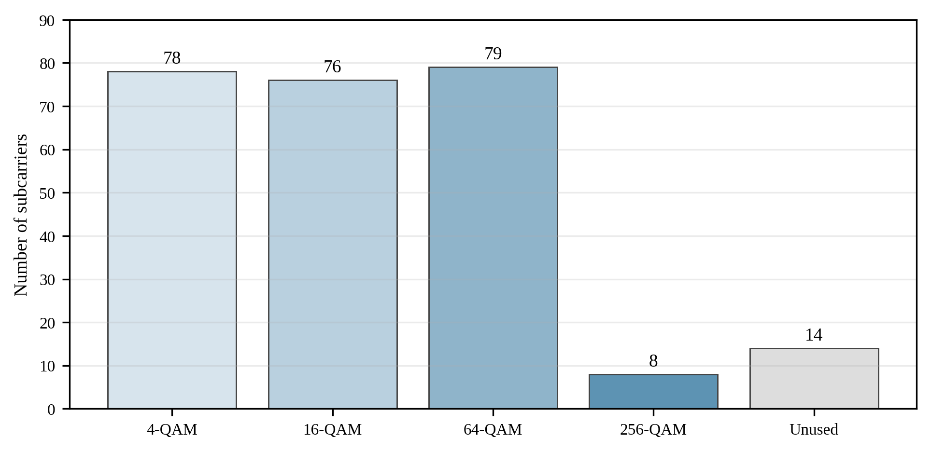
Fig. 6. QAM population of the proposed final allocation.

5.3 Bidirectional interpretation and limitations
The numerical results above characterize one controller instance driven by a calibrated per-tone SNR profile. In a symmetric two-TRX system, the same engine is instantiated at both ends, with RX-A driving TX-A adaptation and RX-B driving TX-B adaptation. The VLC measurements in [7] demonstrate that this local use of an incoming SNR can be practical when directional responses overlap or differ by a stable calibratable offset. However, the present results do not include a measured electrical forward/reverse calibration experiment, nor do they quantify BER degradation under nonzero residual ε_A,k and ε_B,k. These are deployment-level validation tasks rather than completed claims of this paper draft.
Similarly, the current implementation evidence establishes RTL functional equivalence but does not yet include final FPGA or ASIC power, performance, and area. Table 4 separates completed and pending validation to avoid overstating the result.
Table 4 Validation status
Item | Status | Evidence / required completion
Floating-point analytical reference | Completed | Exact-QAM BER re-evaluation
RTL-matched Q16 MATLAB | Completed | Same LUT, shifts, constants, and cross multiplication
ModelSim functional verification | Completed | 248 updates and matching 255-entry map
End-to-end OFDM waveform verification | Completed | Ideal synchronization and perfect one-tap FDE
Quartus synthesis / timing / resource use | TBD | Insert device, Fmax, ALMs/LUTs, registers, DSPs, and power
Measured bidirectional wireline calibration | TBD | Measure forward/reverse SNR and residual per-tone mismatch
Multi-channel fixed-alpha robustness | TBD | Verify alpha=0.8 over additional channel profiles

6. Conclusion
An RTL-matched LUT-based adaptive bit-loading controller has been presented for calibrated bidirectional OFDM/DMT wireline transceivers. The architecture places one engine in each TRX and uses the SNR profile measured by the local RX to determine the QAM allocation of the co-located TX, subject to a symmetric or calibrated directional-link assumption. The controller removes runtime erfc evaluation and division through a 32-entry exponential LUT, shifts, QAM-dependent constants, transmitted-bit-weighted accumulation, and cross-multiplied comparisons. Independent QAM margins enforce the BER target, while an offline-calibrated correction is applied only in the final pass to recover conservative LUT rate loss.
For the evaluated 512-point DMT link, the Q16 RTL-consistent controller loads 998 bits per symbol and achieves 36.159 Gb/s with an analytical BER of 3.68x10^-5 and an end-to-end waveform BER of 3.67x10^-5. ModelSim matches the 248 update iterations and the complete final map. The current evidence therefore supports the arithmetic architecture and controller-level BER/rate claims. Final publication claims on implementation efficiency and practical bidirectional robustness require the pending Quartus synthesis results, additional channel profiles, and measured forward/reverse SNR calibration.

References
[1] P. S. Chow, J. M. Cioffi, and J. A. C. Bingham, “A practical discrete multitone transceiver loading algorithm for data transmission over spectrally shaped channels,” IEEE Trans. Commun., vol. 43, nos. 2-4, pp. 773-775, Feb.-Apr. 1995, doi: 10.1109/26.380108.
[2] R. F. H. Fischer and J. B. Huber, “A new loading algorithm for discrete multitone transmission,” in Proc. IEEE Global Telecommunications Conf. (GLOBECOM), vol. 1, 1996, pp. 724-728, doi: 10.1109/GLOCOM.1996.594456.
[3] J. Campello, “Practical bit loading for DMT,” in Proc. IEEE Int. Conf. Communications (ICC), vol. 2, 1999, pp. 801-805, doi: 10.1109/ICC.1999.765384.
[4] R. V. Sonalkar, “Bit- and power-allocation algorithm for symmetric operation of DMT-based DSL modems,” IEEE Trans. Commun., vol. 50, no. 6, pp. 902-906, Jun. 2002.
[5] G. Kim et al., “A 161-mW 56-Gb/s ADC-based discrete multitone wireline receiver data-path in 14-nm FinFET,” IEEE J. Solid-State Circuits, vol. 55, no. 1, pp. 38-48, Jan. 2020, doi: 10.1109/JSSC.2019.2938414.
[6] J. Lee et al., “A 112-Gb/s discrete multitone wireline receiver datapath with time-interleaved time-based ADC in 5-nm FinFET,” IEEE J. Solid-State Circuits, vol. 61, no. 1, pp. 8-19, Jan. 2026, doi: 10.1109/JSSC.2025.3618188.
[7] J. Zhang, X. Zhang, and G. Wu, “Dancing with light: Predictive in-frame rate selection for visible light networks,” in Proc. IEEE Conf. Computer Communications (INFOCOM), 2015, pp. 2434-2442, doi: 10.1109/INFOCOM.2015.7218632.
AUTHOR CHECKLIST - REMOVE BEFORE SUBMISSION
□ Fill author names, affiliations, corresponding author, funding, and acknowledgments.
□ Insert the final Quartus target device and synthesis/PNR table; do not claim low area or high Fmax before these data are available.
□ Confirm whether alpha=0.8 remains fixed after the multi-channel test set; update Abstract, (10), Table 2, and Results together if changed.
□ Add the actual bidirectional calibration experiment or keep the current calibrated-link assumption and limitation wording.
□ Replace schematic figures with journal-quality vector artwork if required by the submission portal.
□ Check Electronics Letters word/page limits and transfer the content into the current journal template.

