Medical Wean/End of Life Management – email 5/10/2023

- Place PIV, consider placement of PICC line if needed 2. Start continuous care with RN 3. 30 minutes prior to planned extubation provide IVP comfort medications a. Morphine IVP i. Additional boluses of morphine q5 minutes prn (suggested stating dose 5- 10mg, at discretion of physician) b. Ativan IVP i. Additional boluses of ativan q5 minutes prn (suggested starting dose 1-2mg, at discretion of physician) C secretion control d. Atropine 1% ophthalmic drops 1-2 gtts q5 minutes prn Terminal Wean a. Place patient on a SBT with CPAP 5 PS 14-16. Continue the same level of FIO2 b. Decrease PS by 2 every 5 minutes until a level of 6-8 is reached c. If during the weaning process, if patient exhibits signs of distress, give additional doses of morphine / Ativan as needed to ensure comfort d. Once patient is on CAP 5 PS 6-8 and appears comfortable, then decrease the F102 by 20% every few minutes to a goal of room air or < 2 liters e. If patient remains comfortable, proceed with disconnecting the ventilator and provide 02 via mask
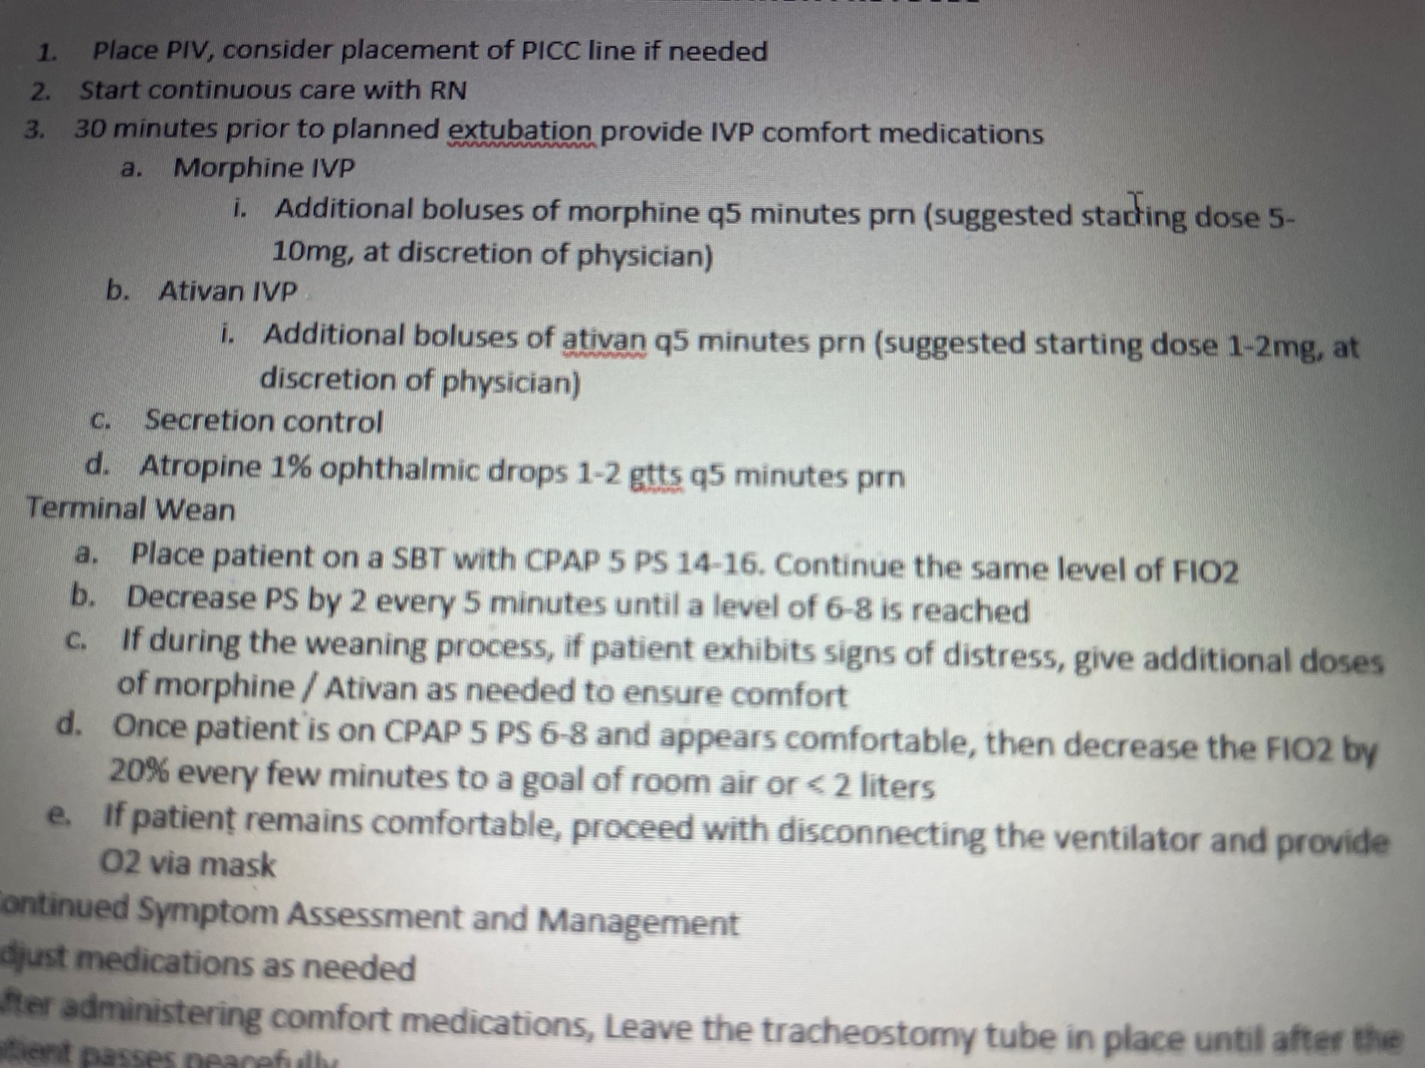
I spoke to the assistant chief of GPCC over Palliative Care Dr Ma today about this. He was as surprised as I was about the lack of support. I’ve found them to be very useful in these types of circumstances and will come to the department to speak with the family and place orders to help in any way they can. He will speak to his team to see if there are any observations on their side and will also re emphasize this with their team. He wondered what modality you used to contact the inpatient palliative team. I’m attaching a screenshot of how to connect with them. On amcom it’s palliative medicine. And the instructions are to connect with their SBC Palliative team via cortext. I’ve found that once I send a cortext to this team within 5 minutes there’s an answer with a follow up phone call. He wonders if you connected via operator or another modality and accidentally got routed to the Home Care Palliative/Hospice physician who is not hospital based. Either way I’m glad you brought it up and he would like the info with details when you find it. They’re very proud of their program out here since it’s the only Palliative medicine program in the region with fellowship trained and credentialed palliative physicians dedicated to the inpatient space. They are here to support us so please let me know if there are any further issues.

Alp Arkun, MD, FACEP
Assistant Area Medical Director
Hospital Based Services
SCPMG San Bernardino County

