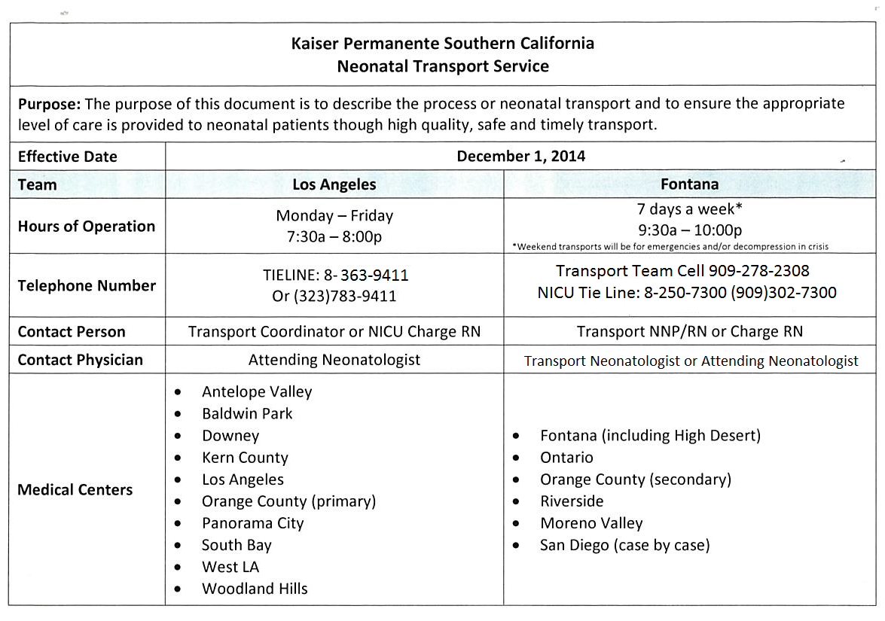

Fontana Regional Neonatal Transport
Team Members: Dr. Lizette C. Sistoza
Sunjeeve P. Weerashinge, NNP
Celia A. Elias, NNP
Ralph E. Funk, RN
Caroline F. Spoerl, RN
