SBC ED / RADIOLOGY DOWNTIME WORKFLOW
During downtime, please use the Radiology Downtime Order Form
Reading Coverage:
- Code Stroke CT and Ultrasound exams will be read by Teleradiology.
- Findings can be viewed on the Teleradiology Website. https://miti-imisweb5.appl.kp.org/telerad/tr_applogin.php 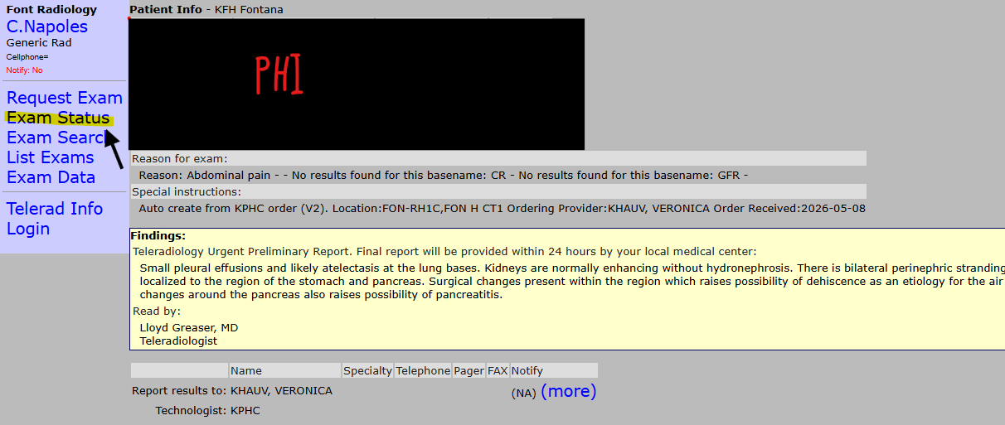
STAT Exams:
- OnRad will read STAT CT/MR studies.
- Faxed reports will be sent directly to Fontana and Ontario locations.
Contingency Plan:
- If OnRad is down/delayed or not receiving images, Teleradiology support will be activated to assist with CT and MR readings as needed.

Imaging Graveyard Operations Support
Graveyard System Admin – Kwasi Ntim
📞 909-302-4112
Operations Manager – Cecilia Napoles
Contact via Microsoft Teams
CT:
Ontario CT — 909-724-5302
Fontana CT — 909-302-4019

MRI:
Ontario MRI — 909-724-5304
Fontana MRI — 909-302-4351
X-RAY:
Fontana Hospital XR — 909-302-4164
Ontario XR — 909-724-527
ULTRASOUND:
Fontana US — 909-302-7652
Ontario US — 909-724-5320
LINKS:
http://imiscid.kp.org/ -- LINK TO PROVIDER INTELLISPACE
https://passwordexpress.kp.org/ - PASSWORD RESET

QUESTIONS:
- If I cannot view results in Teleradiology?
Support is available:
Teleradiology Support:
562-658-3095 (8+137+3095)

- If I cannot access Teleradiology?
- Request Access:
https://idm.kp.org or 1-866-529-0933

- If reports are not being faxed by OnRad:
Contact OnRad: 951-786-0801 or Imaging Graveyard System Admin

