**DATABASE SET UP – TUYEN PHAM 915591991**

1. Tuyen Pham – tuh39709
2. Website title: American Dream
3. The content of your home page:

This is the place to help Vietnamese people to achieve American dream, which include studying, traveling and living in the USA. In fact, this web page will introduce to Vietnamese people some university in 52 states of America that allows international students to study there and some law to achieve an immirgrant visa.

Non-immigrant visa includes F1, B1/B2, H1B, J1.

* F1 visa is for those wishing to study in the USA.
* B1/B2 visa is for those wishing to have a business trip or a vacation in the USA.
* H1B visa is required for those coming to the United States to perform services in a re-arranged professional job.
* J1 visa is used for foreign visitors to come to the US in order to participate in the exchange program.

Immigrant visa: a person who wishes to immigrate to the United States must have a petition approved by the U.S. Citizenship and Immigration Services (USCIS) before applying for an immigrant visa.

1. Table design of three tables.
   * Table design of user_role

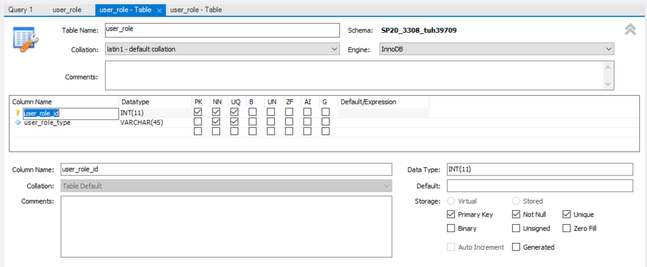

* + Table design of web_user plus the “foreign keys” tab

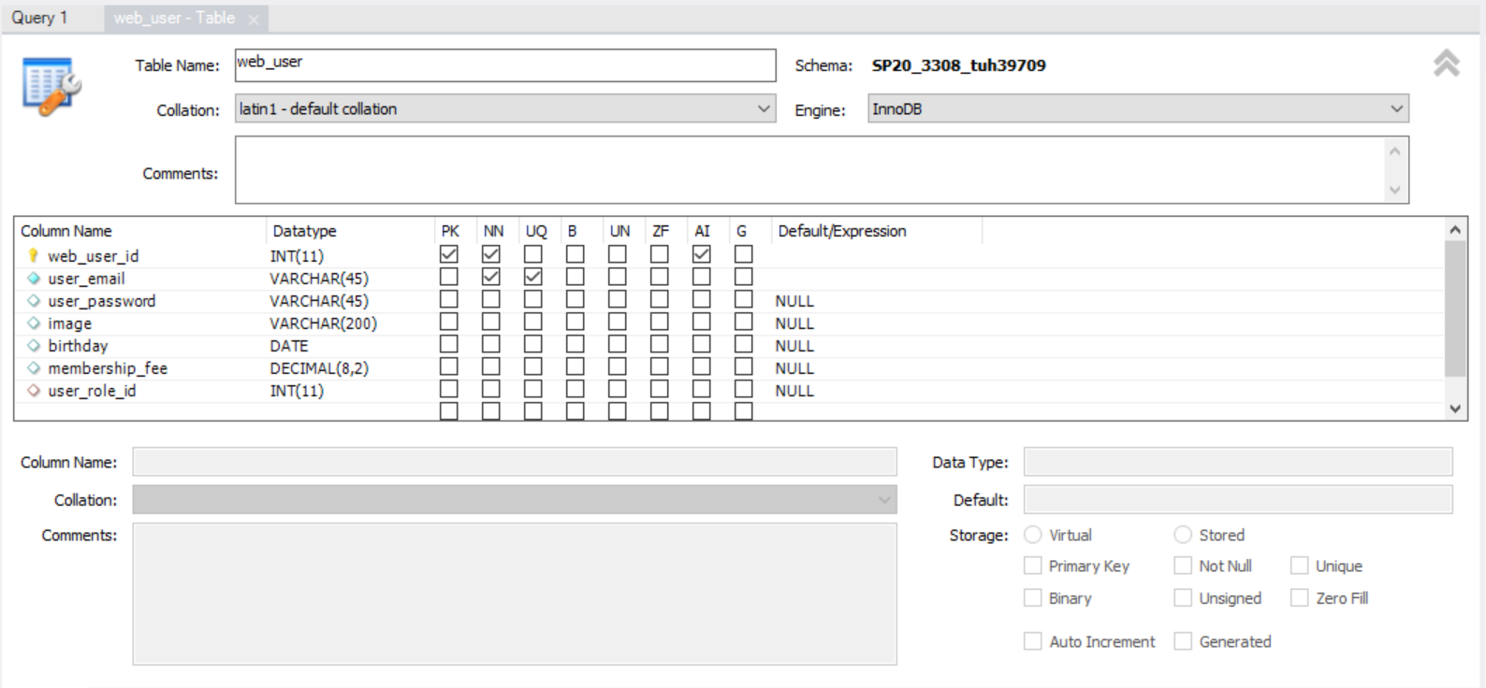

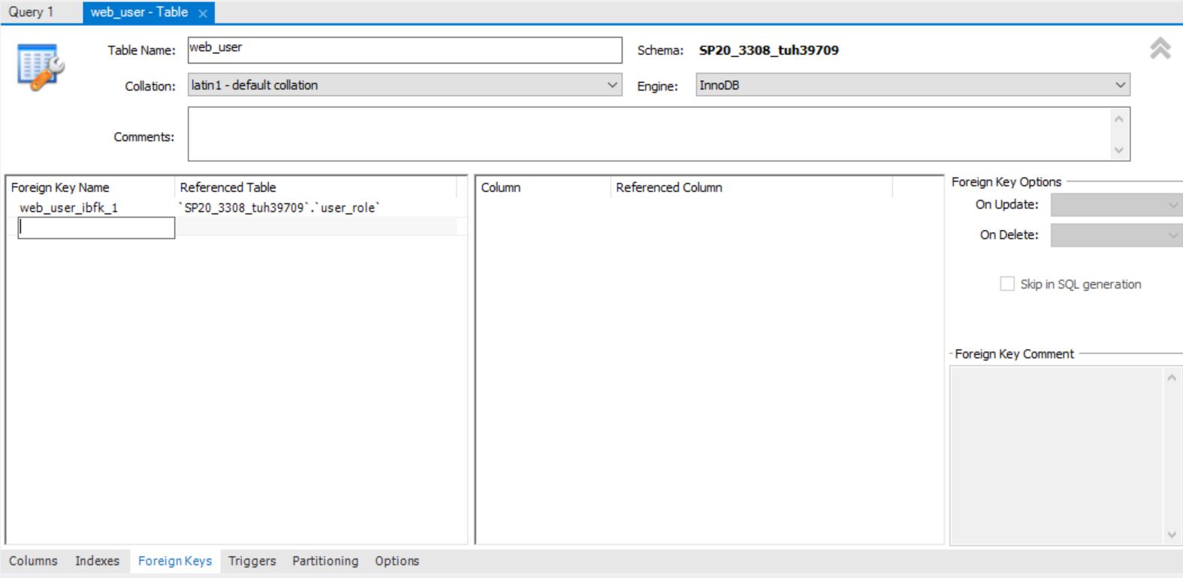

* + Table design of your “other” table plus the foreign keys”

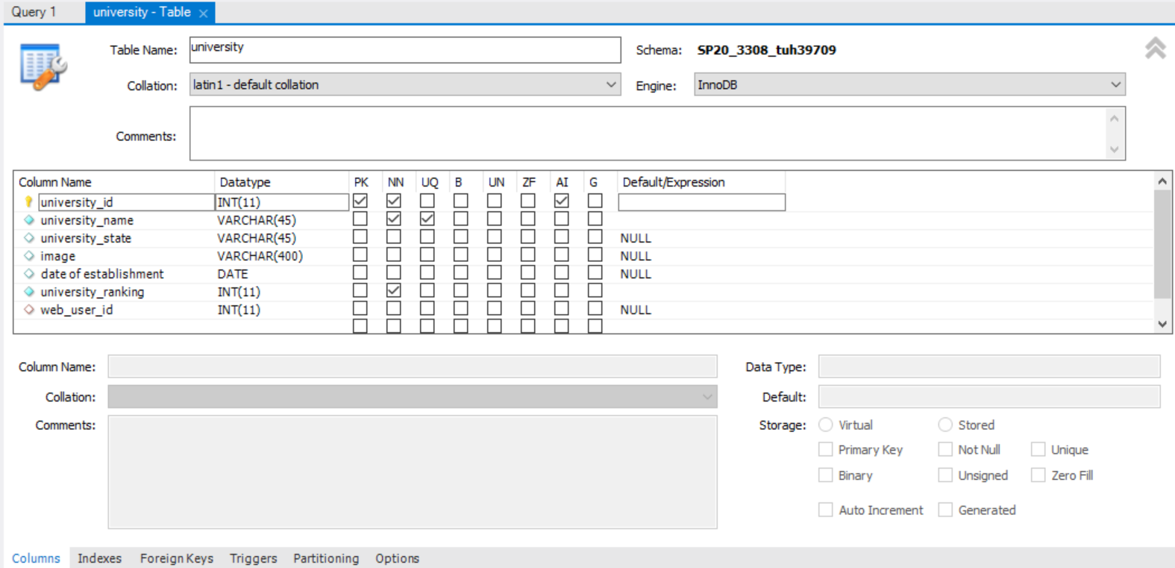

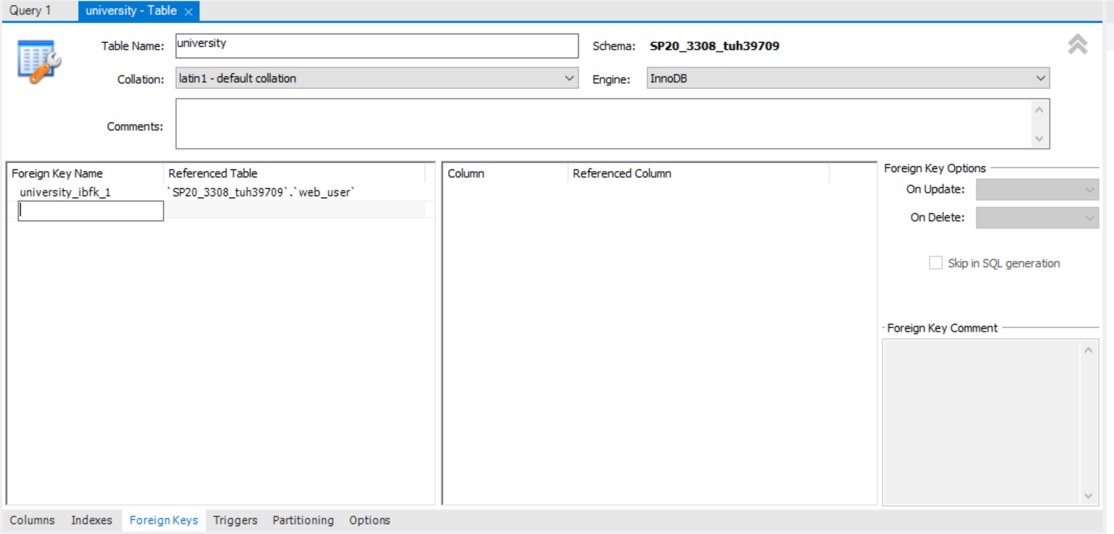

1. Screen captures of the selected statement above.
   * 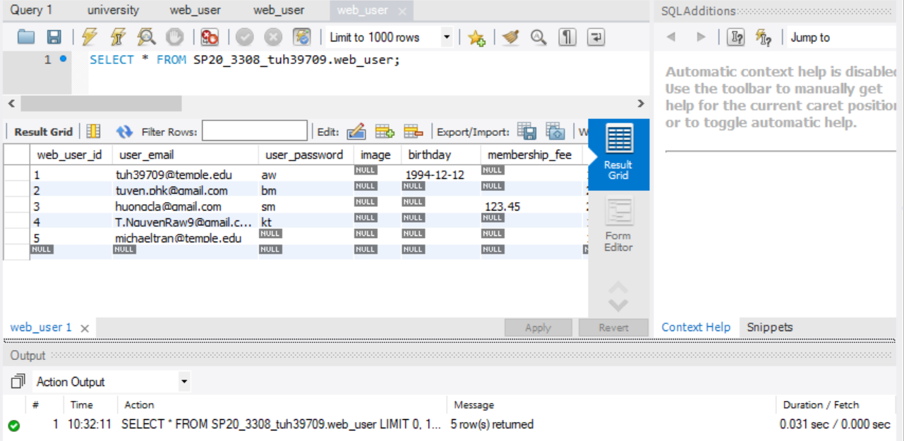Run a SELECT statement that lists all the columns of all the records of your “other” table, selecting out each column and presenting them in an order that you think users would like to view the data.

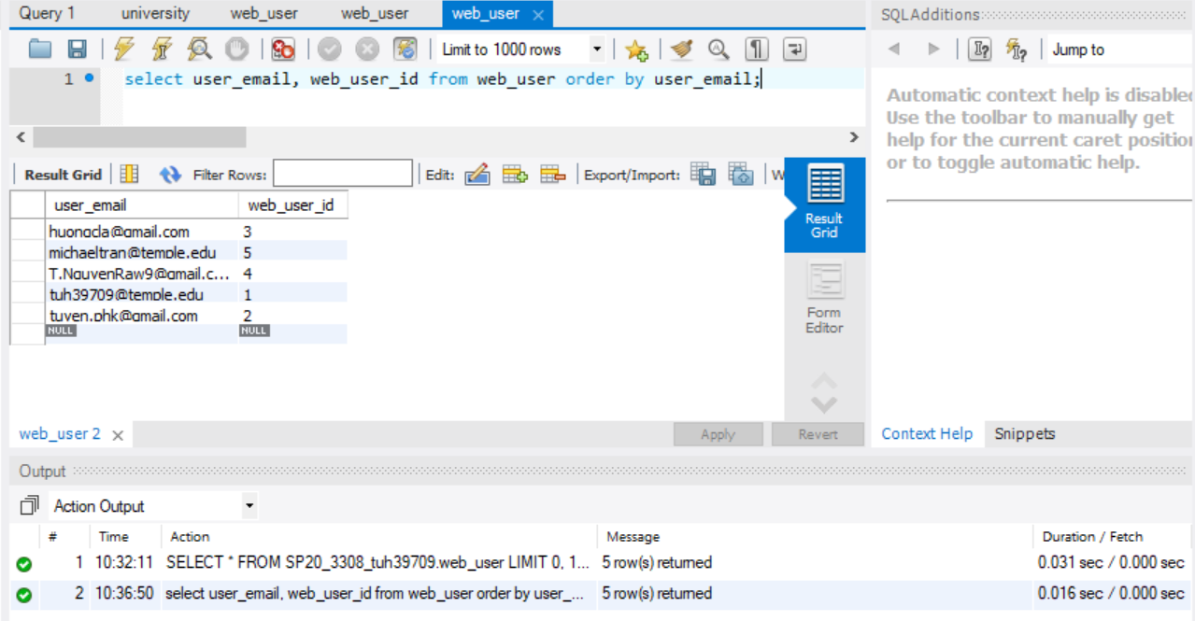

* + The SELECT statement above but adding a WHERE clause so that you see some of the records but not all.

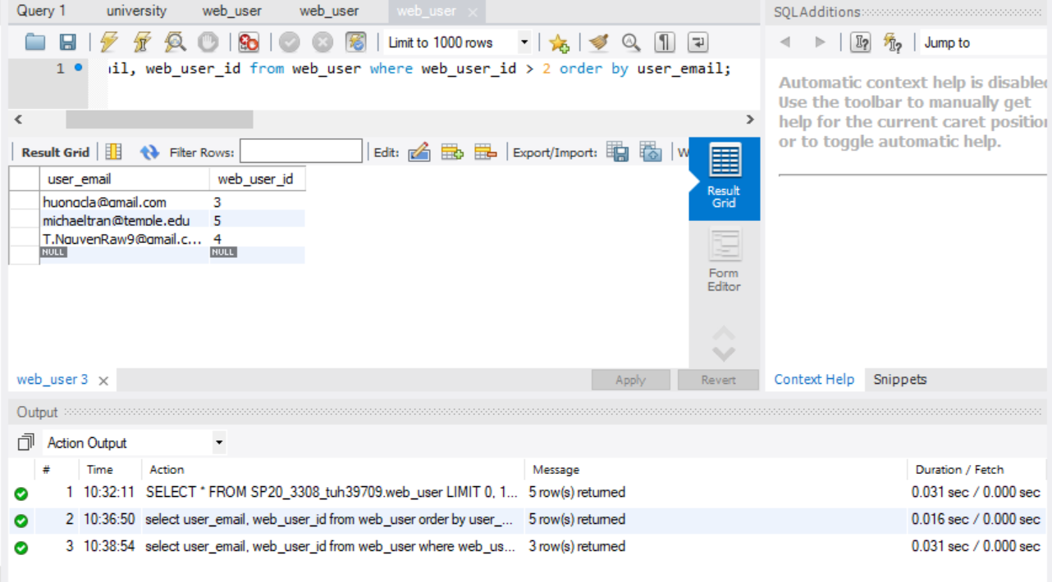

* + A SELECT statement that shows all the records from the web_user table joined with the user_role table.

