**Neighborhood of London and New York**

**Clustered Venues of Greenwich and Kensington**

1. **Introduction**

New York city and London are two big cities in the world. They are very similar that they can offer architecture, culture, entertainment and food. In this project, it will provide a small portion of statistic data of these two cities such as number of neighbors, total restaurants in each city and number of restaurants in location of each city. In fact, the project will explore neighborhoods of London and compare that with neighborhoods of New York.

1. **Business Problem**

Travel tour guide recommends a list of famous cities such as Greenwich, South Kensington, Bankside, Belgravia, Bloomsbury to visit in United Kingdom. After exploring the neighbor of London, the project will further analysis on the venues of Greenwich and Kensington. By category of venues in these two locations, one can decide which one will be the good place for opening a new business.

1. **Data Description**
2. I used ‘List of areas of London’ on Wikipedia (<https://en.wikipedia.org/wiki/List_of_areas_of_London> ) page to scrape the locations. Boroughs, postal Code and the associated Grid Ref data of London and create a panda data frame. In addition, I used Grid Ref on the same page to scrape the latitude and longitude of each location and create another data frame. Finally, I merge two data frames using one common Grit Ref column. Here is the result:

**Locations, Latitude and Longitude of London**

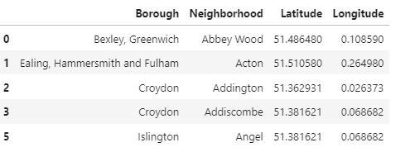

**Locations, Latitude and Longitude of Network (using existing project data)**

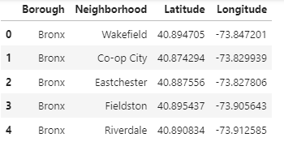

1. Statistical data of the number of restaurants of each location in London was retrieved from ‘Office for National Statistic.’

**Total number of restaurants in London and New York (2018)**

London: 18110

New York: 26697

**Total number of restaurants by each city in London (2018)**

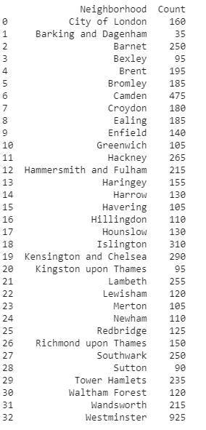

**Total number of restaurants by each city in New York (2018)**



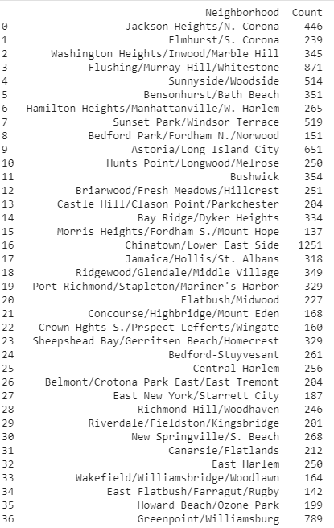

**……**

What can see from the above data is that London has 32 boroughs while New York has 5 boroughs.

1. **Methodology**
2. **Single Neighborhood** Greenwich and Kensington

* Greenwich

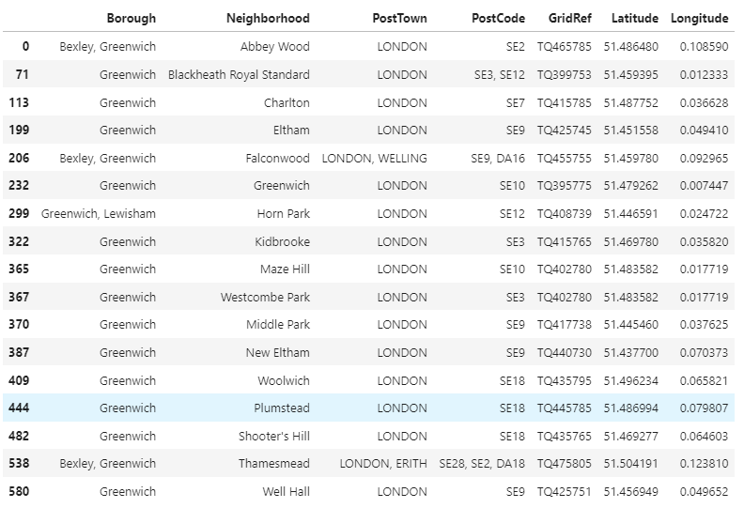

* Kensington

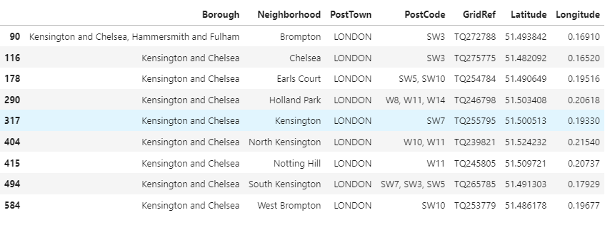

1. The **Foursquare** data is used to explore venues in Greenwich and Kensington.

* Greenwich

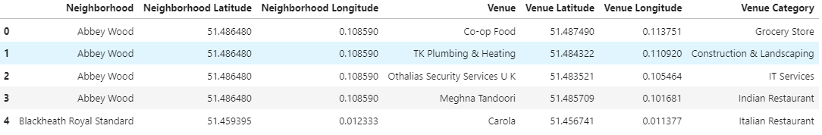

* Kensington

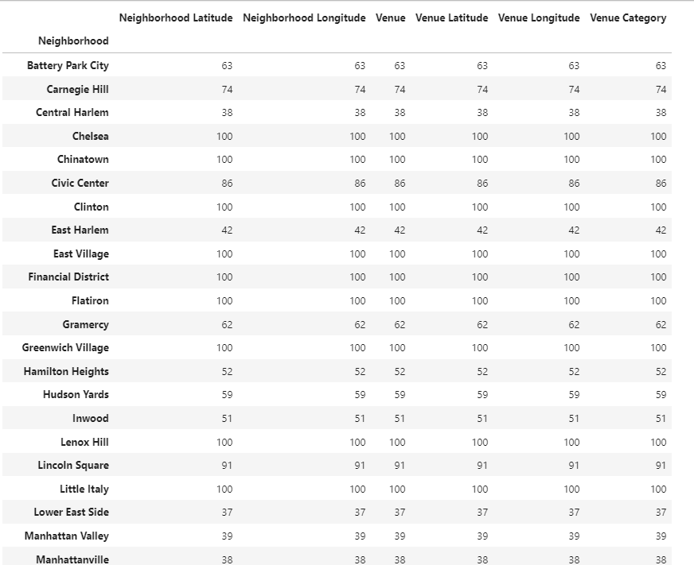

1. The **venues** data is further to Analyze each neighborhood.

* Greenwich

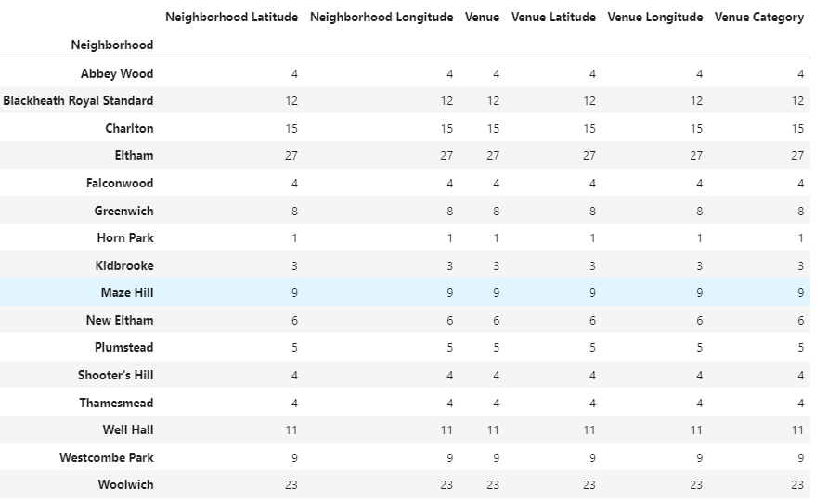

* Kensington

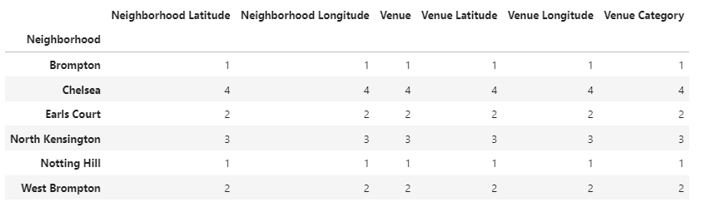

1. **Cluster neighborhood (k-means)**

* Greenwich

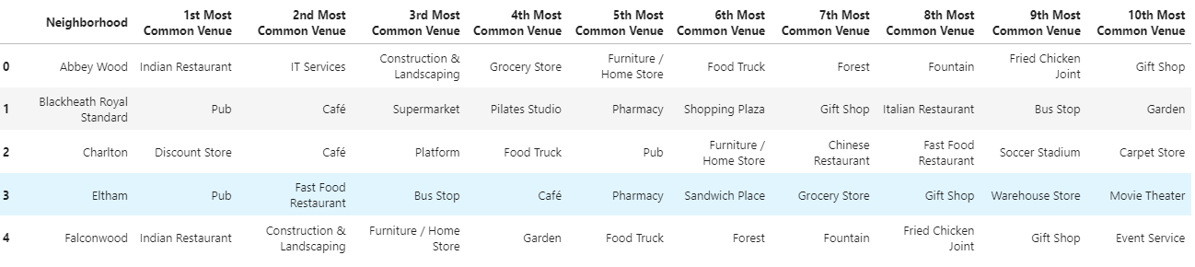

* Kensington

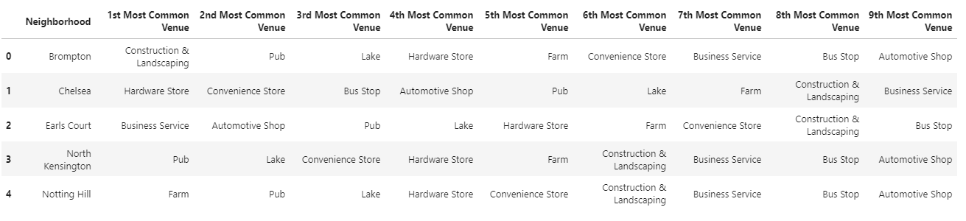

1. Examine clusters to determine which place is the best to open a restaurant.

* Based on the results of Cluster neighborhood (k-means) of Greenwich

and Kensington, there are 5 clusters and Greenwich and 2 clusters of Kensington.

* For Greenwich:

Cluster 1: the most common venue is sport like gym, park, sport, soccer field, park.

Cluster 2: the most common venue is Indian restaurant.

Cluster 3: the most common venue is Indian restaurant and Grocery Store.

Cluster 4: the most common venue is Indian restaurant.

Cluster 5: the most common venue is platform.

* For Kensington:

Cluster 1: the most common venue is hardware store.

Cluster 2: the most common venue is fast food restaurant.

1. **Conclusion**

This project I represent a small portion of statistic data of two big cities in the world which would help travelers to have on overview of these two cities. In addition, I also used a method of clustering to group areas of Greenwich and Kensington which are the two famous places which should be visited when traveling to United Kingdom to see which place the best is to open a new business. Based on the above data, in my opinion, Kensington should be a place to consider for a new business.