EDUCATION IN New Zealand

Kim Van Nguyen – 68569443

Lianyin Liu – 17899438

Swapna Josmi Sam – 74281128

Ancy John – 52770710

Contents

1. Introduction 2

2. Data sources 3

3. Target 4

4. Difficulties 4

5. Techniques 5

6. Outcomes 6

7. Conclusion 6

8. References 6

# Introduction

Right to education is one of the fundamental human rights, in many of the nations. The cultural aspects of a nation mainly depend on its quality of Education. Education is the key to empower a human being and to make him independent. Governments take responsibility of education for its human resources. This is a major step towards progress of the nation. The pathway to reach peace, human well-being and economic growth. are smoother when people are educated. It is the country’s will to improve and spread education to everyone. In this 21st century of advanced technology, countries liaise and support each other, enabling easy access of education. Education is one of the issues that countries work together for the betterment. Hence, education is one of government’s big concern.

The New Zealand education system entitles free education and free enrolment for every child between 5 and 19 years of age. The whole system is separated as 3 different levels. Primary, secondary and Tertiary levels. This project is an attempt to wrangling, analysing and visualizing of the dataset.

Major focus is on the wrangling part of the data. We collected 4 data-sets from 4 different sources and used R programming to do the wrangling on these data. We used R and Julia to join these data- sets and to visualize it.

Our final data model organizes elements of all these data-set to extract information regarding:

* Education Enrolment
* Employment vs unemployment
* Government expenditure
* School list in New Zealand

Techniques used to get data:

* Github to share work
* Google map API

# Data sources

After doing research on sources of education dataset, we decided to use these four sources that we believe they are true, transparent and reliable.

1. World Bank (<https://databank.worldbank.org/>)

World Bank is an organization that is combined of five international institutions that aims for ending poverty and boost prosperity. It serves in non--profit sector, so its data is believed to be unbiased and non-driven by money. Further, World Bank is a well-known world institution that has been operating over many decades and has good reputation for its works. It relies on its data to work towards its goals. Not only itself but also many countries and other experts in the world also rely on this data. Therefore, the data should be correct and reliable. In this source, we used “Labour and Unemployment Rate” data.

1. United Nations (<http://data.un.org/>)

United Nations is a non-for-profit international organization. It works toward non-financial goals including human rights, so it should have data about education around the world. It is made up of more than 100 countries in the world. Therefore, it has less chance of having manipulated data. It has a history of more than 70 years and is also well-known for its profession and good impact to the change of the world, so we trust its data. It has many offices around the world and large number of staffs, so it has the ability to collect large data in many countries. We obtained “Enrolment” data from this source.

1. UNESCO Institute for Statistics (UIS) (<http://data.uis.unesco.org/>)

The UIS is an “official and trusted source of internationally comparable data on education, science, culture and communication” (UNESCO Institute of Statistics, 2019). The organization collects data from trustworthy statistics providers such as national statistical offices, line ministries and other statistical organizations. The data is used to produce reports by large organizations such as UN, World Bank, UNICEF, etc. to work towards development goals especially in the field of education. Additionally, many global indices cannot be calculated without UIS data such as Human Development Index and the World Competitiveness Index (UNESCO Institute of Statistics, 2019). This is where we obtained “Government Expenditure” data.

1. New Zealand government’s data website (<https://catalogue.data.govt.nz/>). The website provides public API to access the data. The data source which we were after had an API setup and we accessed the data via a web API. Data.govt.nz is a New Zealand’s All-of-Government service with technical development led by Government Information Services and content production led by Stats NZ (About Data.govt.nz, 2019). It is a warehouse of data released by New Zealand Government organisations. The data is offered to the public for free. Public sector agencies such as Central Government, Local Government, Crown Research Institutes and the Tertiary sector also use this data source. This source was chosen for our project also because it provides more details about education circumstances in New Zealand which is suitable for our New Zealand schools analysis. Based on the reasons above, we think that this is the most reliable, true and informative New Zealand data source compared with other sources. We obtained New Zealand schools “School_list” from this source.

# Target

[what **target** you chose, what is the **intended use of the data]**

Our first target is to see where New Zealand ranks compared with other countries in the world in regard to each category: government expenditure, enrolment, labour and unemployment rate. By knowing these, New Zealand government can know its status compared with the world to improve its policy in improving enrolment, labour and unemployment rate. For this target, we would need to clean up the data, arrange all datasets to be in the same structure (Countries in the first column and Years spread into columns).

Our second target is to create a model which is a combination of New Zealand data from all 4 datasets (Expenditure, Enrolment, Labour and Unemployment). This is a relational data which shows just New Zealand information so we can compare the change over time of the country’s expenditure, enrolment, labour and unemployment. There will be plotting for visualisation. Based on the outcomes, we can conclude that whether one variable has influence on the other or not, so policy makers can consider this for future policy adjustments. We let variable “Year” in the first column as observation so observations for later years can be added. To achieve this target, we would need to have all datasets to be wrangled, then select New Zealand data and join.

For the third target, as we are focusing on New Zealand education, we want to know about the primary and secondary education, number of students enrolled and student enrolment based on origin and school details in New Zealand. The intention was to compare which region of NZ has a greater number of schools and number of students of each origin based on region. This means that we can compare the students count whether they are Maori, European, Asian or International students and reach to a conclusion that which students (Origin) acquiring education in NZ are more in number.

# Difficulties

[what difficulties you had to overcome to wrangle the data sources into the target data model]

In wrangling process, there are many difficulties we have been through. First difficulty is that there are many useless variables which makes data messy. For example, the “Sources” columns showing the sources of data which is irrelevant to our analysis, and the years that are too old and inapplicable for our analysis. So, we have to delete the irrelevant variables that are not useful such as years before 2000. “Government Expenditure” dataset has many old years, so it is tricky to delete them correctly and not accidently delete needed columns.

The second difficulty is that every dataset is in different structures. The variables in a dataset were recorded as observations instead of variables. Two datasets have the variables in one column called “Series” which makes the country name and year repeated many times. The other dataset also has “Year” in one column which also makes the country name repeated. To tackle this problem, we have to spread the variables of “Series” column, choose one variable useful for our model then spread the “Year” column.

Third difficulty is that values were recorded in different formats. One dataset has quotation marks before and after value but there are no quotation marks in another dataset. So, we have to delete all quotation marks in values that have.

Fourth difficulty is that not all years are available which makes the output incomplete. To interpret the results, we would have to choose an interval of year to see the trend over a long time so we will not be influenced much by the missing years.

Plotting for the relational data (New Zealand joined data) is difficult because each column has different range of value. For example, the unit range of Labour Force is from 2,000,000 to 3,000,000 but Total Unemployment range is from 3 to 7. We also have different type of value such as Government Expenditure’s value is different from number of students enrolled in primary education. However, our target is to see if the expenditure affects number of enrolments and other variables, so we still have to plot but in separate graphs.

Using API to extract data and to create a dataframe was little difficult. The resultant dataframe had columns with different number of rows which throwed error and was due to the null values in the data. Therefore, we handled the null values by giving if else statement. Thereby, we created a dataframe without any error. Another, issue faced was the API Key which had not required access to perform which was solved by enabling Geolocate and providing billing.

# Techniques

[what techniques you did use]

Github was used to share our works and track changes to the code.

* In our project, we used 2 languages to do wrangling and plotting: R and Julia. Our CSV formatted files were downloaded from the data sources and imported into Jupyter notebook using *read_csv* function. We used *tidyverse* library for all the wrangling. Other libraries we also used are *readxl*, *visdat*, *ggplot2*, and *dplyr*.
* In wrangling process, first we choose the columns that are relevant and useful for our target by using *select* function. Then we used *rename* function for columns’ names. We used *vis_miss()* function to see missing values in the data. We filled missing value with “no data” using *is.na* function. We *spread* the variables and again *select* the variables that are useful for us. We used *arrange* function to sort data as preference. Lastly, we drew boxplots and scatter plots with lines using *boxplot* and *ggplot* function respectively.
* For New Zealand schools’ enrolment, we accessed the data via a web API from data.govt.nz. This data source had an API setup. A GET request is submitted within the URL with each parameter separated by an ampersand. We then parse the content returned from the server as text using the content function. Our required data is stored inside the ‘records’ list in the main list. Required data is fetched and provided as columns of a dataframe. Null values were handled by providing “Data unknown” to Regional_Council. Also removed the ‘NA’ values from Latitude and Longitude columns by using the *drop.na* function. We used *ggmap* package is used for spatial visualisation which aligns with *ggplot*. *‘get_map’* queries Google maps server for the map of New Zealand using personal API key. One of our requirements was to plot the top five regions which has a greater number of schools. We have used the *group_by* function to group the school list based on Regional_Council. We took the mean of Latitude and Longitude and count of schools in each region to form a table using *summarise* function. The five points were plotted on NZ map using *ggplot.* Second requirement was to create a table with the counts of International Students, Maori Students, Asian student, European students and Total Students in each region of New Zealand and use the *mutate function* to find the proportion of these students from the total number of students. The proportion of these different students based on origin in each region was plotted using the *barplot* to find which type of students are more in each region of New Zealand.

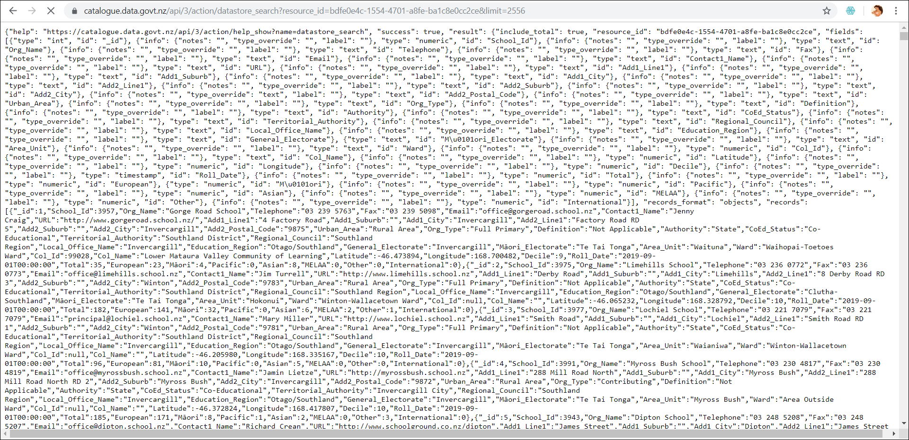*Figure 5.1: The original data in JSON format which is accessed via web API*

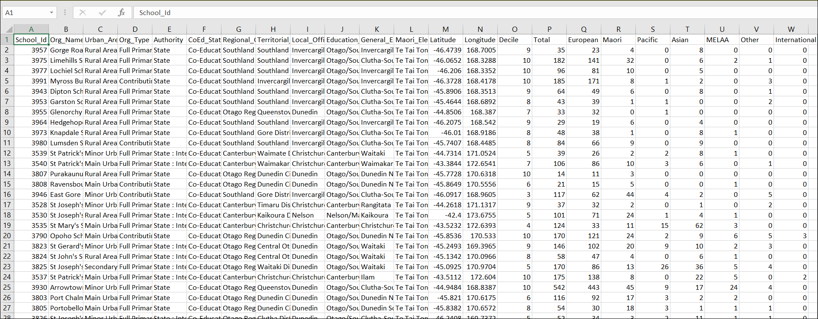

*Figure 5.2: The wrangled data in a dataframe.*

# Exploratory Analysis & Outcomes

[what you managed to achieve and what you failed to do]

* Education Enrollment data

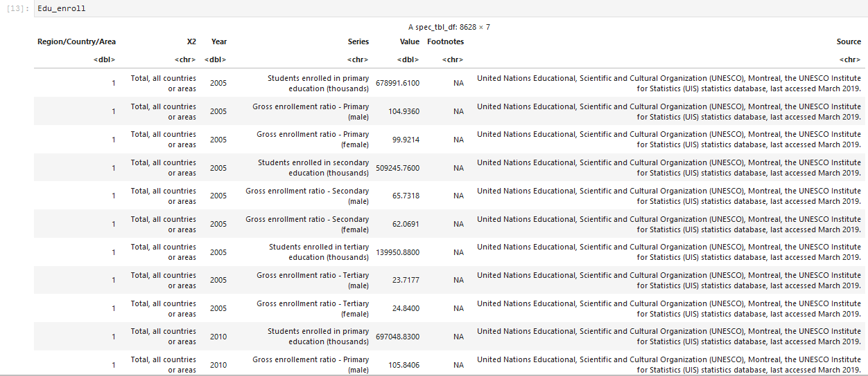

Original data

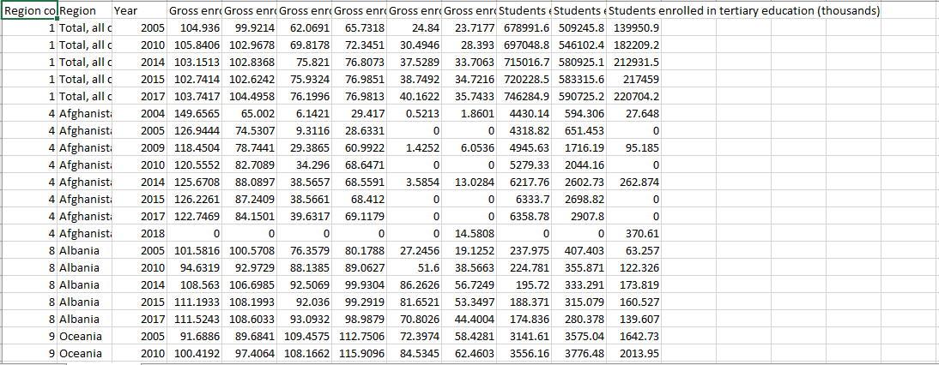

Wrangled output csv

* Labour Unemployment data

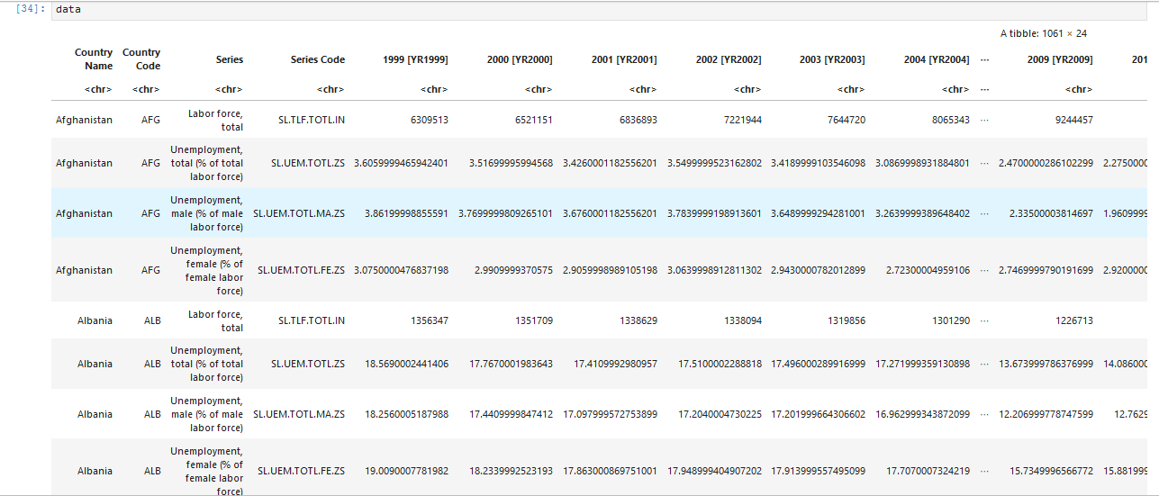

Original data

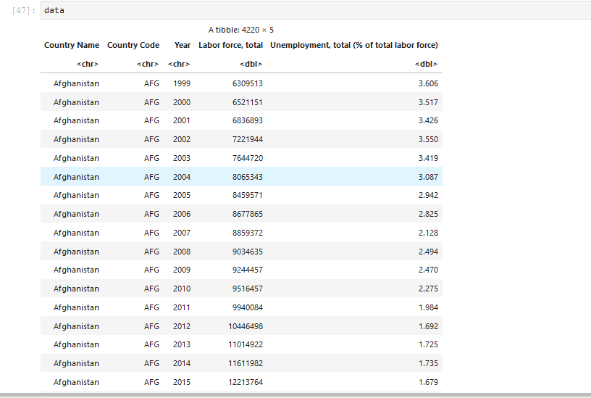

Wrangled data

* **School List Data:** One of our requirements was to plot the top five regions which has a greater number of schools. We have used the *group_by* function to group the school list based on Regional_Council. We took the mean of Latitude and Longitude and count of schools in each region to form a table using *summarise* function. The five points were plotted on NZ map using *ggplot.*

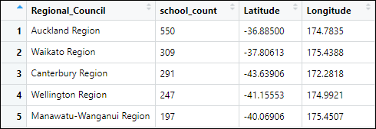

*Table 6.1: Table showing the top five regions in New Zealand with a greater number of schools.*

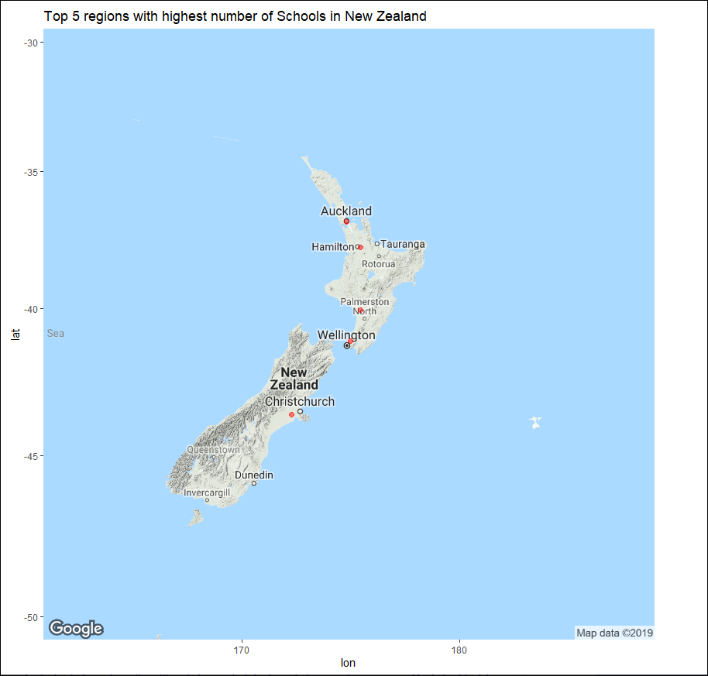

*Figure 6.1: Figure showing the top five regions in New Zealand with a greater number of schools.*

It is clear from the table and graph that Auckland has a greater number of school when compared to other regions which tells that Auckland provides better education opportunity to students.

* Second requirement was to create a table with the counts of International Students, Maori Students, Asian student, European students and Total Students in each region of New Zealand and use the *mutate function* to find the proportion of these students from the total number of students. The proportion of these different students based on origin in each region was plotted using the *barplot* to find which type of students are more in each region of New Zealand.

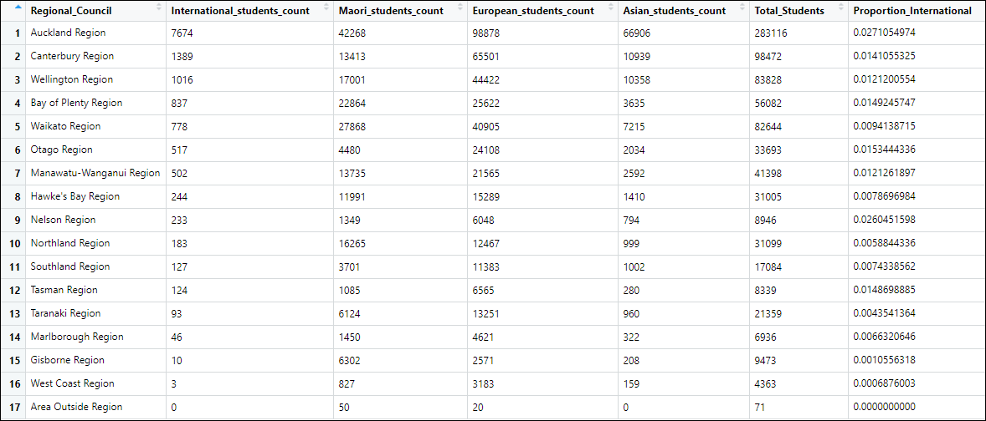

*Table 6.2: Table showing the student distribution based on origins in different regions of New Zealand.*

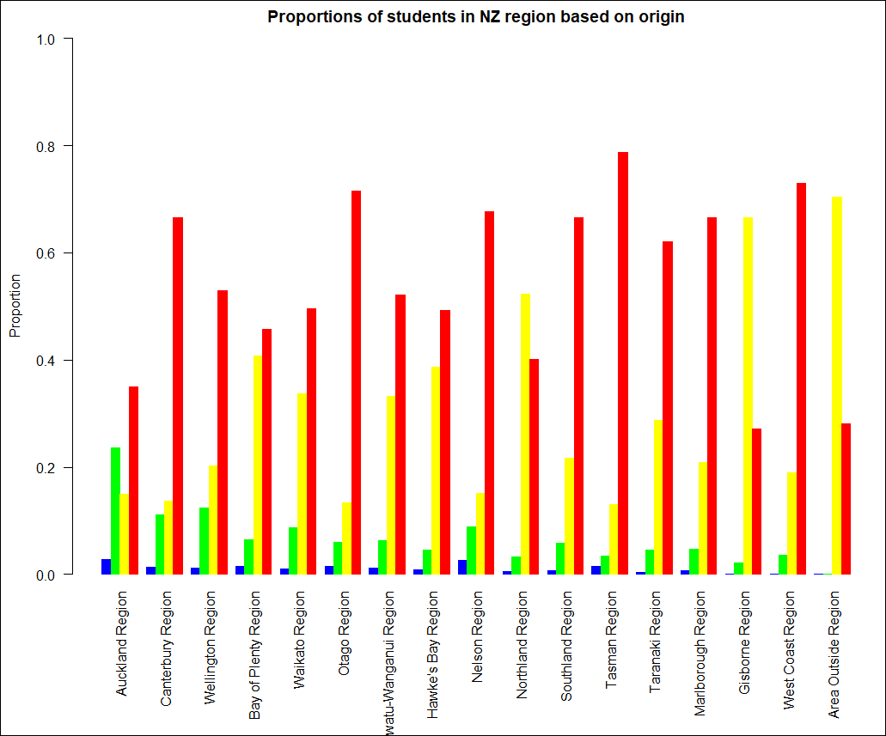

*Figure 6.2: Figure showing the student proportion in each region based on their origin.*

From the graph it is clear that European student have a greater proportion when compared to the others in most of the regions.

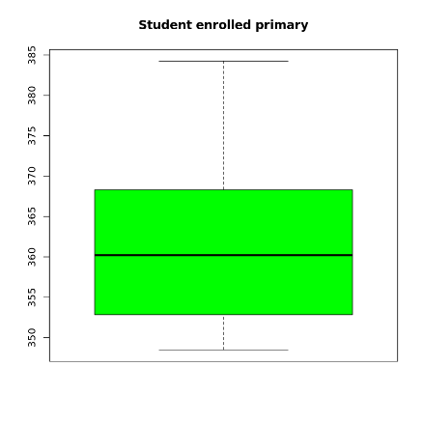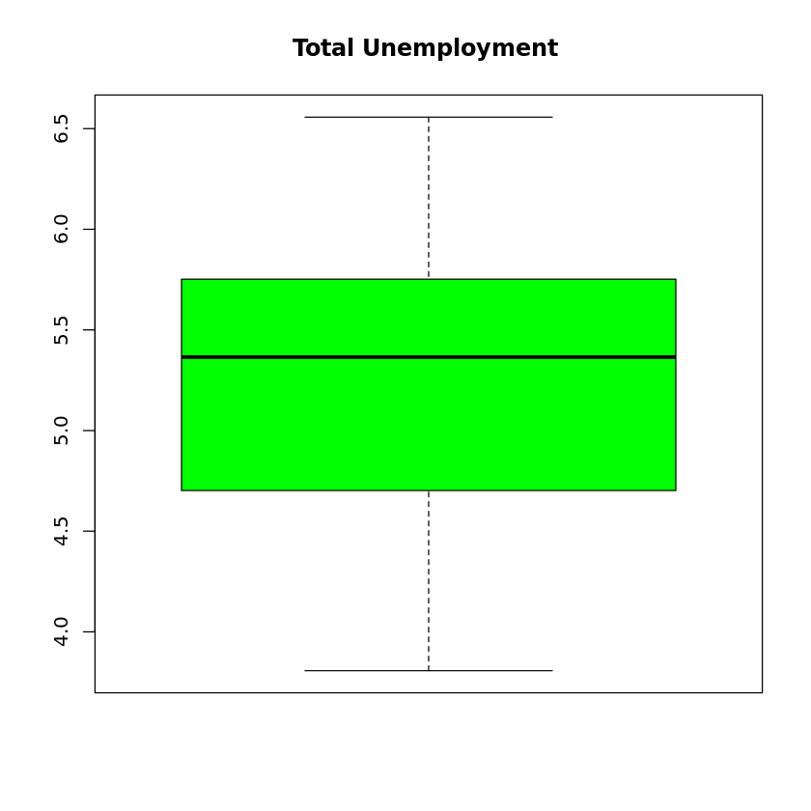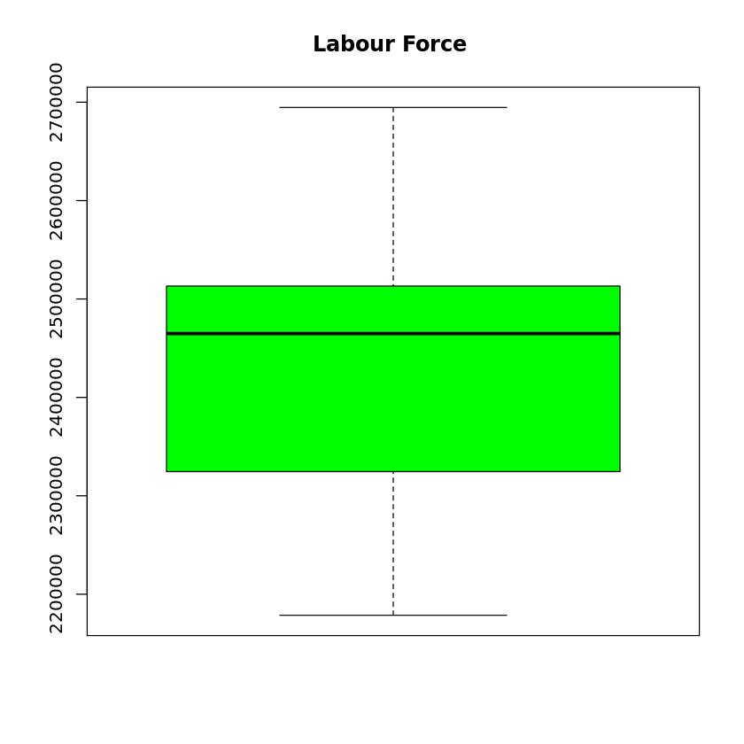

*Figure 6.3: box plot of the final joint data*

The first plot shows that the median of student enrolled in primary median is 360, the minimal is under 350 and maximal is over 380.

The second plot shows that the median of unemployment in New Zealand is between 5.0 and 5.5, the minimal is under 4.0 and maximal is over 6.5

The third plot shows that the median of labour force between 2400000 and 2500000, the minimal is under 2200000 and maximal is roughly 2700000.

There is no outlier in the boxplots.

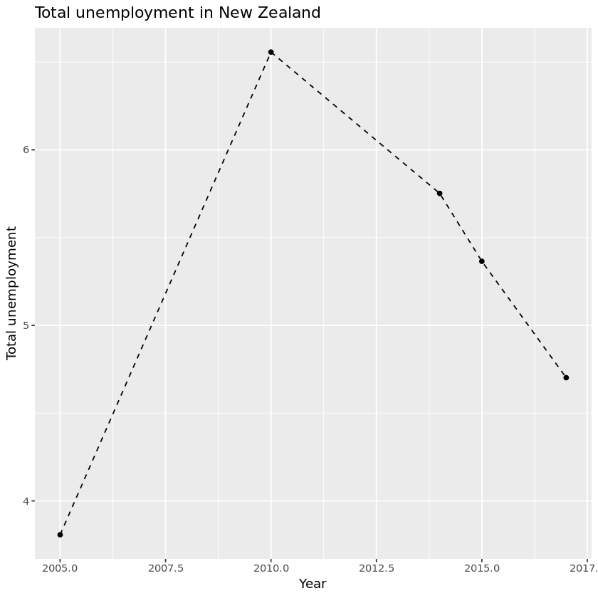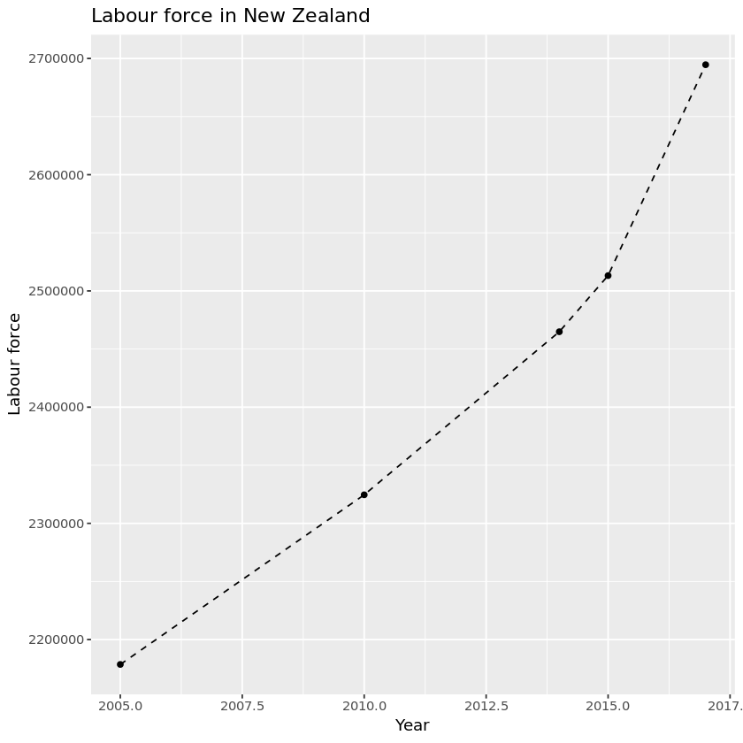

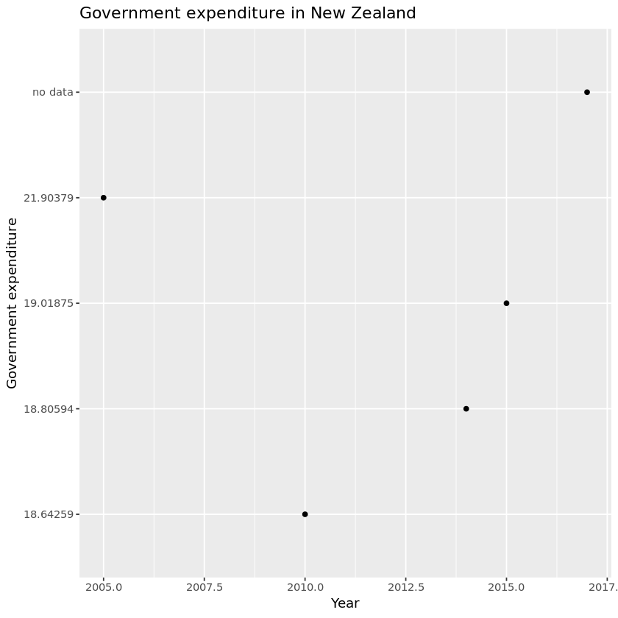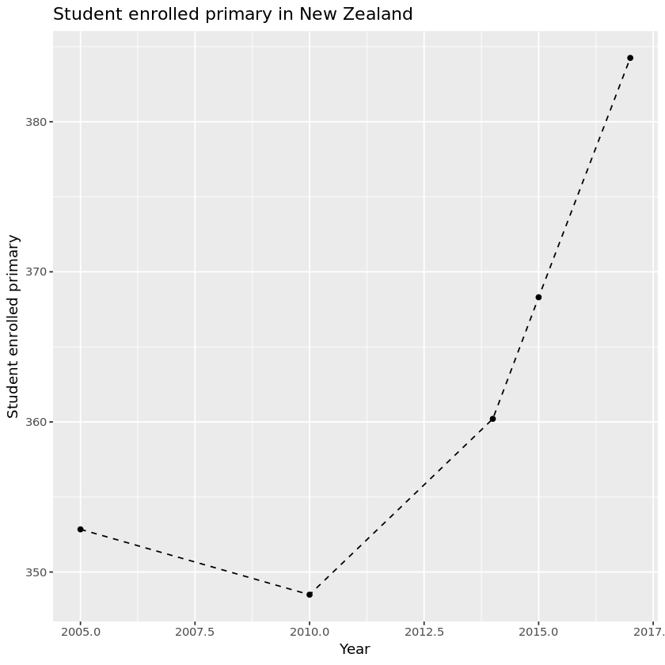

*Figure 6.4: Time series trend of the final joint data*

From the time series plot we can see that the unemployment rate in New Zealand rises sharply from 2005 to 2010 and goes down until 2017.

The labour force in New Zealand increases from 2005 to 2017 sharper and sharper.

The student enrollment in primary in New Zealand goes down from 2005 to 2010, then increases rapidly.

The Government expenditure in primary in New Zealand goes down sharply from 2005 to 2010, then increases rapidly

The final data model

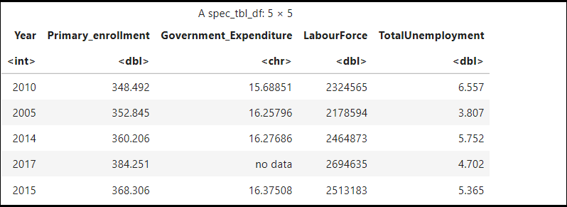

**Julia part**

We used Julia programming language in some part, for joining and plotting of the data. We have joined the education enrolment and labour unemployment data frames for this.

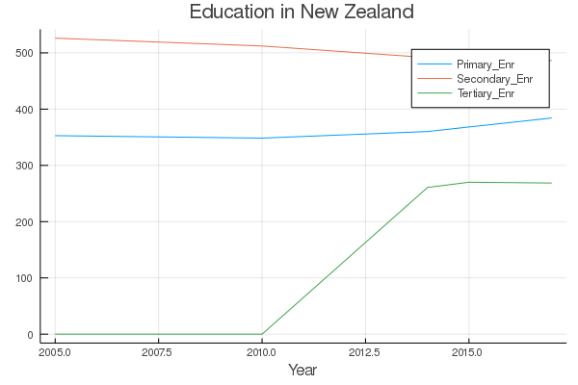 The first plot is the education enrolment in three different levels, primary, secondary and tertiary. We have maximum enrolment at the secondary level. Enrolment in the primary and tertiary levels are showing improvement over the years. One difficulty found in this plot is the missing information. Since there is no data until 2010 for the tertiary level the value is assigned to zero.

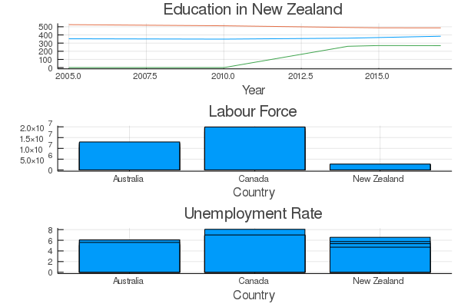

In the combined plot above, we did a comparison of Labour force and the un-employment rate of New Zealand with that of Australia and Canada. Labour force is the least in New Zealand compared to the others. Yet, the unemployment rate in New Zealand is higher than that of Australia.

# Conclusions

After the analysis, we can see that Government Expenditure on education does not affect enrolment or labour or unemployment rate. There are many aspects that can influence those rates. This analysis is limited to the data we have.

The group project helped us understand how to deal with the wrangling of a messy data, and its further analysis &visualization. Now we have answers to some interesting questions and are in a position to do follow-up and deep dive analysis.

# References

Data.govt.nz. 2019. *About.* Retrieved from <https://www.data.govt.nz/about/about-data-govt-nz/>

Reddy, C. n.d. *Why Education is Important? Top 13 Reasons.* Retrieved from<https://content.wisestep.com/education-important-top-reasons/>

UNESCO Institute of Statistics. 2019. *About Us | UNESCO UIS.* Retrieved from <http://uis.unesco.org/en/about-us>

UNESCO Institute of Statistics. 2019. *Data to Transform Lives.* Retrieved from <http://uis.unesco.org/en/data-transform-lives>

World Bank. 2019. *About the World Bank.* Retrieved from <https://www.worldbank.org/en/about>

<https://www.rdocumentation.org/packages/ggmap/versions/3.0.0/topics/get_map>

https://catalogue.data.govt.nz/api/3/action/datastore_search?resource_id=bdfe0e4c-1554-4701-a8fe-ba1c8e0cc2ce&limit=2556