# Manual Sequence Optimizer

## Install Python / Pycharm

1. **Install Anaconda:**

* Visit the official Anaconda website: <https://www.anaconda.com/download>
* Download the installer for your operating system (Windows, macOS, or Linux).
* Run the installer and follow the on-screen instructions.

2. **Verify Anaconda Installation:**

* Open a new command prompt or terminal.
* Type **conda --version** to verify that Anaconda has been installed successfully.

3. **Install PyCharm:**

* Visit the official PyCharm website: <https://www.jetbrains.com/pycharm/download>
* Scroll down to download the Community (free) version.
* Run the PyCharm installer and follow the on-screen instructions.
* Create a desktop shortcut if needed.

4. **Run PyCharm:**

* Launch PyCharm from the desktop shortcut or by searching for it in your applications menu.

## Open project in Pycharm

**Next step is to set up an interpreter and install the packages from the requirements**

**Choose settings**

**Pycharm automatically says Install requirements to fix your packages**



**Then open the file run_sequence_optimizer.py by double clicking in the navigator on the let in Pycharm and check the run configuration:**

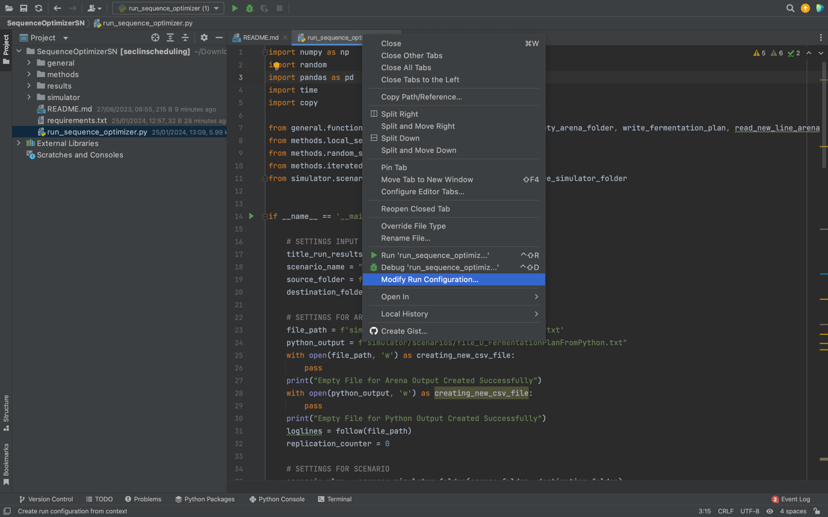

**Check that you see the right interpreter:**

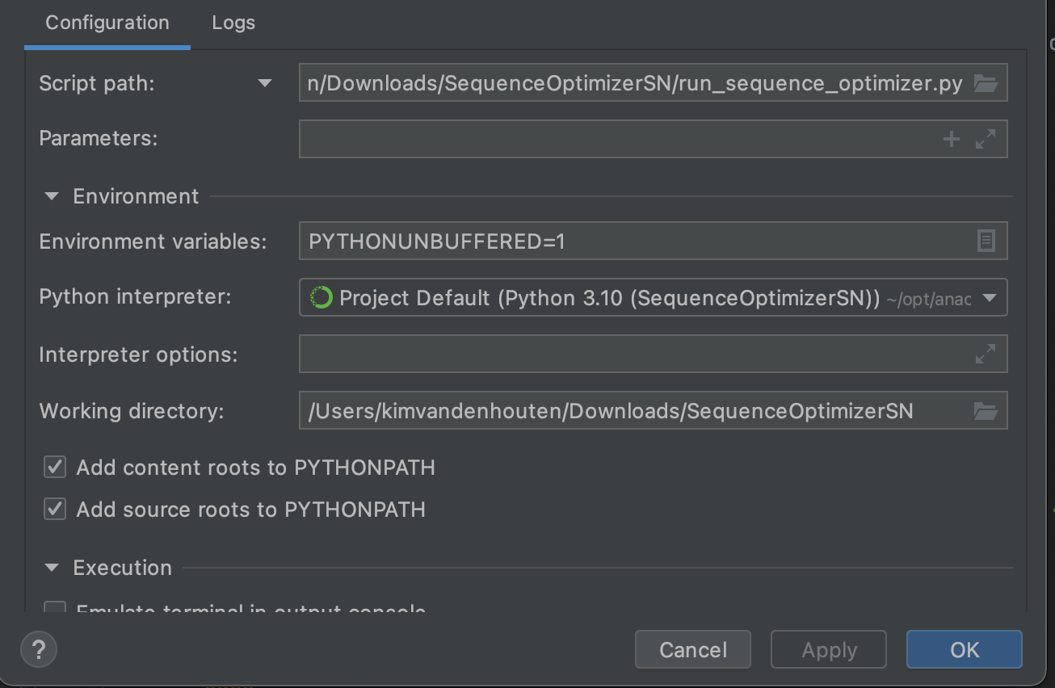

**Now you should be able to run this script by clicking RUN**

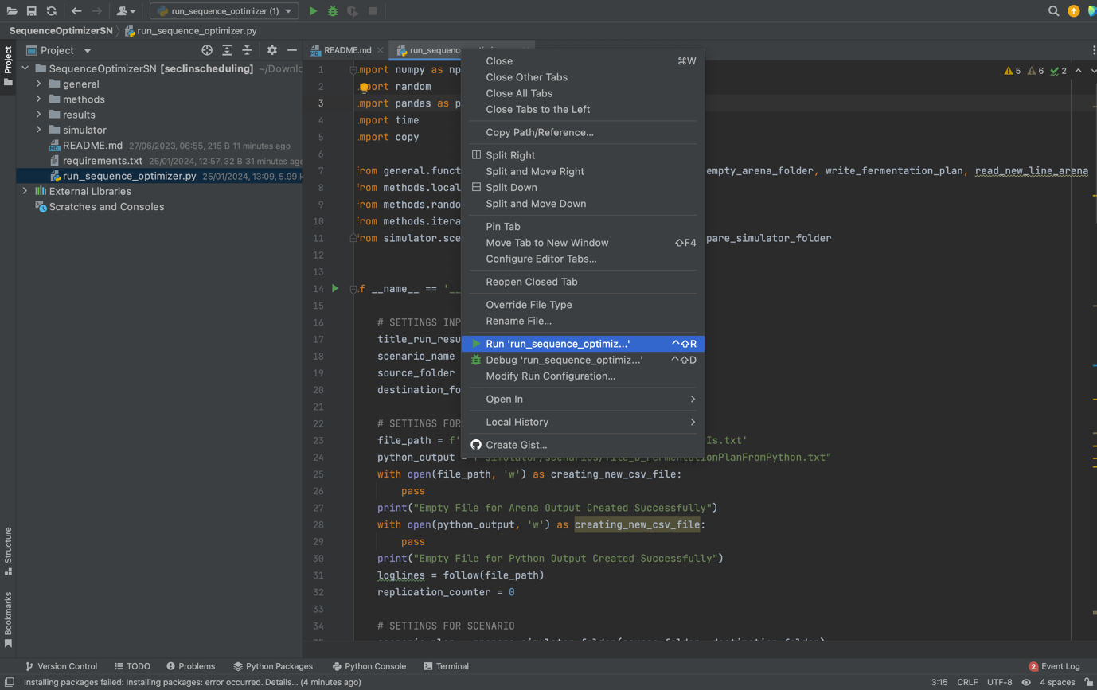

**Of course, you might want to change some settings:**

**E.g., change the name of the scenario folder, make sure this scenario folder is in the folder scenarios (see e.g. As-Is)**

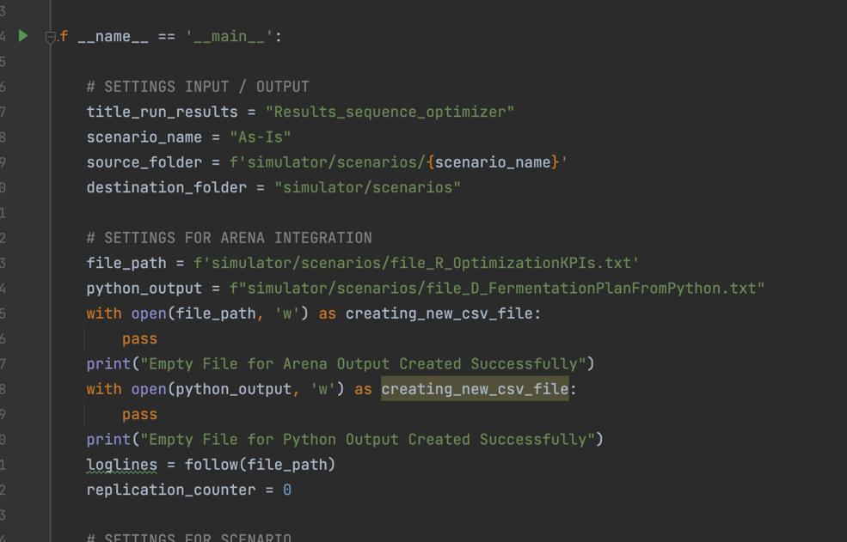

**You could also change the budget (nr of replications) of the algorithm if you scroll down. During testing, I would recommend setting the budget to 10.**

**After you press “RUN”, this is the moment that you should start playing Arena.**

**So, open the model that is also in the folder simulator/scenarios. Make sure it has enough replications and that it is in Python mode (i.e. that it writes replication results to file_R_OptimizationKPIs.txt)**

**First, you will see that all input files from the scenario were copied:**

**Check- n Arena that the replications are going (and that it does not get stuck after 1 replication). After 10 replications you should obtain the KPIs from the best sequence (printed), and find the optimized sequence in the folder results/fermentation_sequence**