FYP Working Log

Energy Efficiency of Agentic Software Engineering - CPU Follow-up to Fernandez et al. 2025
Kim Wanjari

Single working log: environment/setup, raw data, graphs & calculations, and inferences. Not a polished report - a running record of exploratory work testing/extending claims from Fernandez et al. on CPU-only hardware.

1. Environment & Setup
Machine: Lenovo IdeaPad Flex 5 14IAU7, Intel i7 (12 logical cores), no discrete GPU - confirmed via lspci
OS: Ubuntu 24.04.4, hostname fyp-rig
Energy measurement: Intel RAPL, package-0 domain (/sys/class/powercap/intel-rapl:0/energy_uj), sampled immediately before/after each run
Inference tool: llama.cpp (built from source), models in GGUF format
Model (Experiments 1-2): Llama-3.2-1B-Instruct, Q4_K_M quantization
Pre-flight (every session): CPU governor pinned to "performance" via cpupower; Wi-Fi and background updates disabled; laptop kept plugged in (avoids battery-throttling confound)
Project structure: ~/fyp/fernandez-cpu-followup/ - llama.cpp/, models/, scripts/ (preflight.sh, sweep.sh, sweep_decode_strat.sh, sweep_speculative_decode.sh), results/<experiment-name>/
Standardized task: "Write a function to sort a list of numbers using bubble sort." - identical core instruction at every input length; only non-task-altering background padding grows, avoiding the confound of longer inputs also being functionally different tasks

Key debugging fixes (reusable, worth remembering):
- Interactive hang: llama-cli defaults into an interactive chat wrapper for instruct models. Fixed with -st (single-turn).
- Empty log files: llama-cli writes its live display directly to the tty, bypassing stdout even when redirected. Fixed by wrapping every run in `script` (pseudo-terminal capture), stripping ANSI codes afterward.
- Real throughput format: this build's actual summary line is [ Prompt: X t/s | Generation: Y t/s ] - not the older llama_perf_context_print format found via web search.
- Real token counts: obtained via llama-tokenize --show-count (run outside the timed window), not the CLI's own output. Subtracts the auto-added BOS token. Raw-text counts undercount vs. the model's true internal count by the chat template's role-header overhead (~34 tokens, roughly constant across runs, not chased further).
- -n is a ceiling, not a guarantee: -st mode can stop generation early on a natural end-of-turn token - confirmed directly at output=512 (actual: 364/422/450 tokens). All analysis below uses ACTUAL measured token counts, never nominal request values.

2. Raw Data - Experiment 1 (Prefill/Decode Scaling)

2.1 Run A - Initial Sweep (21 runs)
3 input settings (nominal 128/512/2048) x 3 repeats; 4 output settings (nominal 8/64/256/512) x 3 repeats. Single pre-run CPU frequency snapshot only (no continuous sampling in this run).

sweep | input_actual | output_actual | run | energy_J | wall_s | cpu_freq_khz
input | 128 | 64 | 1 | 155.4606 | 8.008 | 429232
input | 128 | 64 | 2 | 158.7099 | 8.0076 | 2070638
input | 128 | 64 | 3 | 153.6186 | 8.0076 | 1405103
input | 512 | 64 | 1 | 241.2782 | 10.0089 | 400000
input | 512 | 64 | 2 | 236.564 | 10.0089 | 400000
input | 512 | 64 | 3 | 240.6012 | 10.0092 | 467728
input | 1693 | 64 | 1 | 502.5105 | 28.0274 | 3794211
input | 1693 | 64 | 2 | 481.142 | 28.0292 | 400000
input | 1693 | 64 | 3 | 480.8938 | 28.0285 | 400000
output | 422 | 13 | 1 | 183.1692 | 8.0071 | 756307
output | 422 | 13 | 2 | 180.1374 | 8.0076 | 400000
output | 422 | 13 | 3 | 179.6586 | 8.0076 | 400000
output | 422 | 69 | 1 | 221.3901 | 10.0091 | 1127194
output | 422 | 68 | 2 | 229.3739 | 12.0112 | 1063071
output | 422 | 68 | 3 | 220.7311 | 10.01 | 400000
output | 422 | 260 | 1 | 355.9769 | 20.0184 | 400000
output | 422 | 261 | 2 | 360.6898 | 20.0189 | 1214477
output | 422 | 261 | 3 | 356.8552 | 20.0186 | 400000
output | 422 | 347 | 1 | 489.2908 | 28.026 | 400000
output | 422 | 453 | 2 | 505.6204 | 30.0293 | 2591485
output | 422 | 304 | 3 | 398.5772 | 22.0195 | 614051

2.2 Run B - Expanded Sweep with Timeseries (33 runs)
5 input settings (nominal 128/256/512/1024/2048) x 3 repeats; 6 output settings (nominal 8/32/64/128/256/512) x 3 repeats. Continuous RAPL + CPU frequency sampling (~1Hz) throughout every run, consolidated separately in timeseries.csv per experiment (not reproduced in full here - see figures below for derived plots).

sweep | input_actual | output_actual | run | energy_J | wall_s | cpu_freq_khz
input | 104 | 69 | 1 | 152.0562 | 7.0482 | 400000
input | 104 | 69 | 2 | 150.8309 | 7.0496 | 1356693
input | 104 | 69 | 3 | 153.7281 | 7.0501 | 3213147
input | 211 | 69 | 1 | 183.8467 | 8.0574 | 400000
input | 211 | 68 | 2 | 184.2282 | 8.0582 | 3458390
input | 211 | 68 | 3 | 182.6025 | 8.0579 | 400000
input | 422 | 68 | 1 | 238.9317 | 10.0711 | 560811
input | 422 | 69 | 2 | 236.2654 | 10.0722 | 400000
input | 422 | 68 | 3 | 243.8039 | 10.0719 | 3516452
input | 846 | 68 | 1 | 354.3238 | 14.0973 | 400000
input | 846 | 69 | 2 | 324.2488 | 14.1058 | 400000
input | 846 | 69 | 3 | 302.1225 | 16.1435 | 400000
input | 1693 | 68 | 1 | 470.9298 | 27.2486 | 830203
input | 1693 | 69 | 2 | 478.0927 | 28.2597 | 915099
input | 1693 | 68 | 3 | 475.2503 | 27.2506 | 1540665
output | 422 | 13 | 1 | 184.6772 | 8.0562 | 960431
output | 422 | 13 | 2 | 175.4261 | 8.0616 | 1180309
output | 422 | 13 | 3 | 179.5017 | 8.0581 | 1086093
output | 422 | 37 | 1 | 202.3694 | 9.0676 | 1170476
output | 422 | 37 | 2 | 200.697 | 9.0692 | 400000
output | 422 | 37 | 3 | 200.5372 | 9.0675 | 400000
output | 422 | 68 | 1 | 213.4837 | 10.0808 | 400000
output | 422 | 69 | 2 | 219.6995 | 10.0793 | 400000
output | 422 | 68 | 3 | 213.536 | 10.0793 | 2696573
output | 422 | 133 | 1 | 264.6818 | 13.1077 | 625707
output | 422 | 133 | 2 | 265 | 13.1073 | 400000
output | 422 | 133 | 3 | 268.7468 | 14.1166 | 400000
output | 422 | 260 | 1 | 357.2878 | 19.1675 | 400000
output | 422 | 260 | 2 | 363.9014 | 20.1765 | 1404768
output | 422 | 260 | 3 | 358.6415 | 20.1781 | 400000
output | 422 | 364 | 1 | 448.7783 | 25.219 | 1175098
output | 422 | 422 | 2 | 486.1695 | 28.2503 | 1811188
output | 422 | 450 | 3 | 518.7787 | 30.2717 | 969959

2.3 Experiment 2 - Decoding Strategy Comparison (24 runs: 128-token and 256-token output)
Fixed input (~422 actual tokens), varying sampling strategy: greedy (temp=0), temperature sampling, top-p (nucleus), top-k. 3 repeats each. First run used a 128-token output budget; NONE of the 12 runs reached a return statement (all cut off mid-implementation, universally, regardless of strategy) - an insufficient-budget finding in its own right, not a strategy effect. Re-run with a 256-token budget, where 10/12 runs completed. Both datasets kept and compared below. Strategy flags were also corrected between runs: llama.cpp's default sampler chain has top_k=40 and top_p=0.95 active in the background regardless of other settings, so each condition below explicitly disables the filters it isn't testing (--top-k 0, --top-p 1.0, --min-p 0.0 as appropriate) for genuine isolation. Beam search unavailable in this build's CLI, excluded.

strategy | output budget | run | energy_J | wall_s | reached return?
greedy | 128 | 1 | 310.88 | 13.0926 | No
greedy | 128 | 2 | 309.753 | 13.0951 | No
greedy | 128 | 3 | 310.9029 | 13.0938 | No
temperature | 128 | 1 | 315.6813 | 13.0985 | No
temperature | 128 | 2 | 273.7739 | 14.1138 | No
temperature | 128 | 3 | 276.9856 | 14.1167 | No
top_p | 128 | 1 | 277.0144 | 14.1161 | No
top_p | 128 | 2 | 274.6285 | 14.1153 | No
top_p | 128 | 3 | 272.8208 | 14.1184 | No
top_k | 128 | 1 | 273.7179 | 14.116 | No
top_k | 128 | 2 | 276.865 | 14.1155 | No
top_k | 128 | 3 | 274.8893 | 14.1187 | No
greedy | 256 | 1 | 446.6294 | 18.1289 | Yes
greedy | 256 | 2 | 446.3054 | 18.1337 | Yes
greedy | 256 | 3 | 448.6585 | 18.1332 | Yes
temperature | 256 | 1 | 385.7003 | 20.167 | Yes
temperature | 256 | 2 | 372.3329 | 20.174 | Yes
temperature | 256 | 3 | 369.2884 | 20.178 | No
top_p | 256 | 1 | 367.5491 | 20.1748 | Yes
top_p | 256 | 2 | 370.2086 | 20.1784 | Yes
top_p | 256 | 3 | 368.3637 | 20.1756 | Yes
top_k | 256 | 1 | 367.2429 | 20.1758 | Yes
top_k | 256 | 2 | 377.1157 | 21.1871 | Yes
top_k | 256 | 3 | 369.7955 | 20.1757 | No

3. Graphs & Calculations

3.1 Energy Scaling - Run A
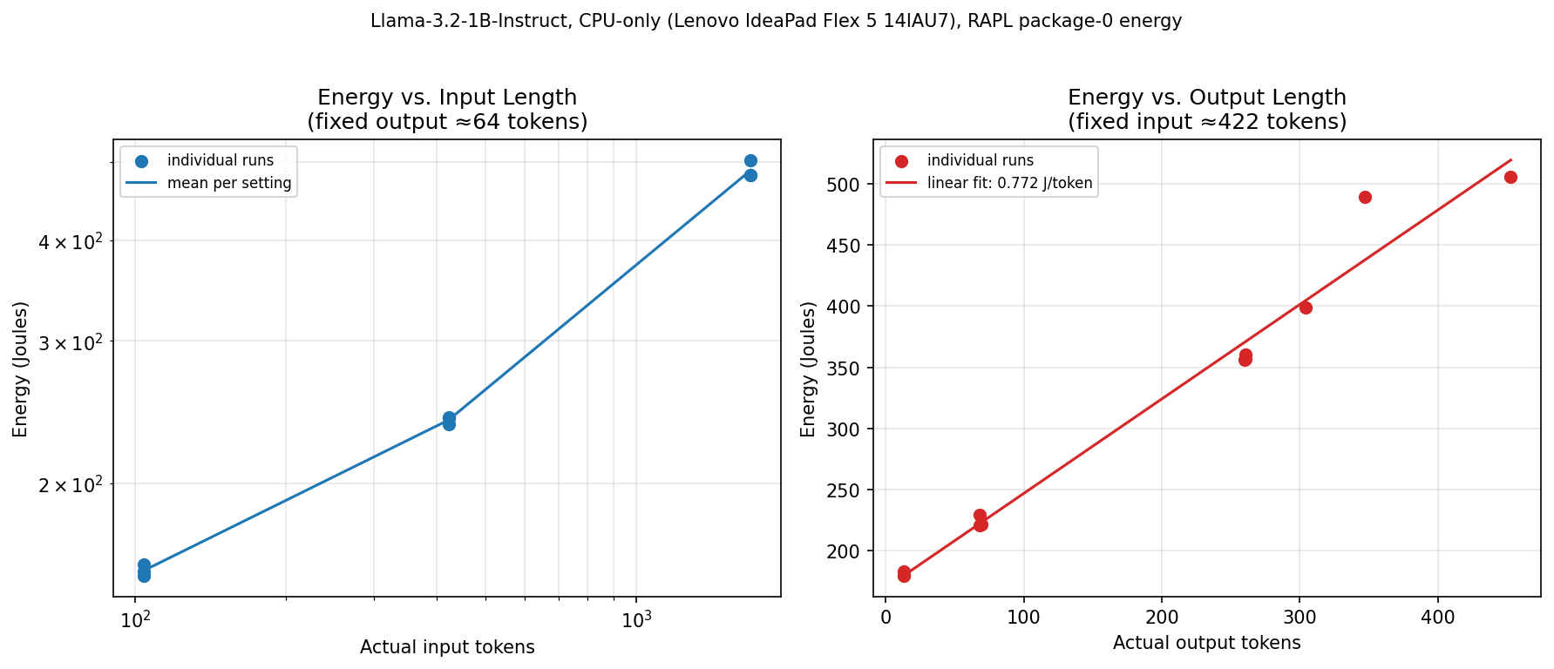
Energy vs. input length (log-log, left) and output length with linear fit (right), Run A (21 runs).

Input scaling: 104→422 actual tokens: energy x1.54 (input x4.06); 422→1693: energy x2.04 (input x4.01) - sub-linear steepening toward linear.
Output scaling: linear regression on actual output tokens: 0.772 J/token, R²=0.978.

3.2 Energy Scaling - Run B (expanded)
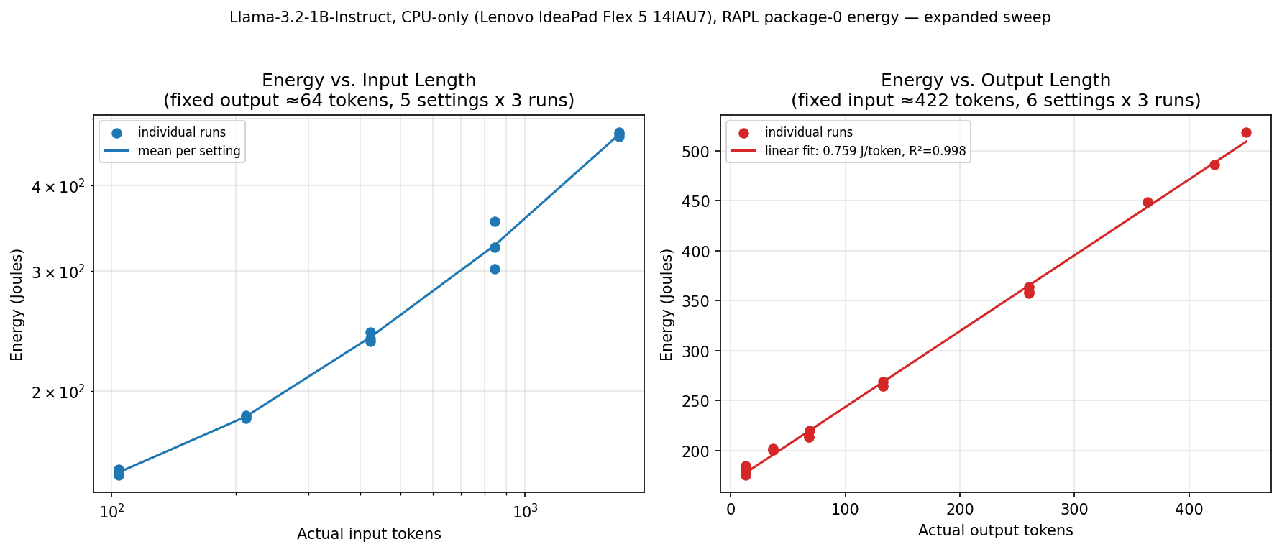
Energy vs. input length (5 settings, left) and output length with linear fit (6 settings, right), Run B (33 runs).

Input scaling: 104→211: x1.21 (input x2.03); 211→422: x1.31 (x2.00); 422→846: x1.36 (x2.00); 846→1693: x1.45 (x2.00) - monotonic steepening, now visible across 4 ratios instead of 2.
Output scaling: linear regression on all 18 runs (actual tokens): 0.759 J/token, R²=0.998.
Prefill marginal cost: linear fit across the full input range: 0.200 J/token, R²=0.985.
Decode/prefill ratio: 0.759 / 0.200 ≈ 3.8x - decode costs roughly 3.8x more energy per token than prefill on this CPU/model, confirming the paper's qualitative claim quantitatively.

3.3 Decode's Share of Total Energy, by Output Length
Using the Run B regression (energy ≈ 0.759×output_tokens + 167.7):

Actual output tokens | Measured avg energy (J) | Predicted decode energy (J) | Decode % of total
13 | 179.9 | 9.9 | 5.5%
37 | 201.2 | 28.1 | 14.0%
68 | 215.6 | 51.9 | 24.1%
133 | 266.1 | 100.9 | 37.9%
260 | 359.9 | 197.3 | 54.8%
412 | 484.6 | 312.7 | 64.5%

Confirms the paper's claim that decode dominates energy except for very short generations: decode is only 5.5% of total at 13 output tokens (classification-length), climbing to 64.5% by 412 tokens. Crossover to decode-majority falls between 133 and 260 output tokens on this hardware/model.

3.4 CPU Frequency Instability
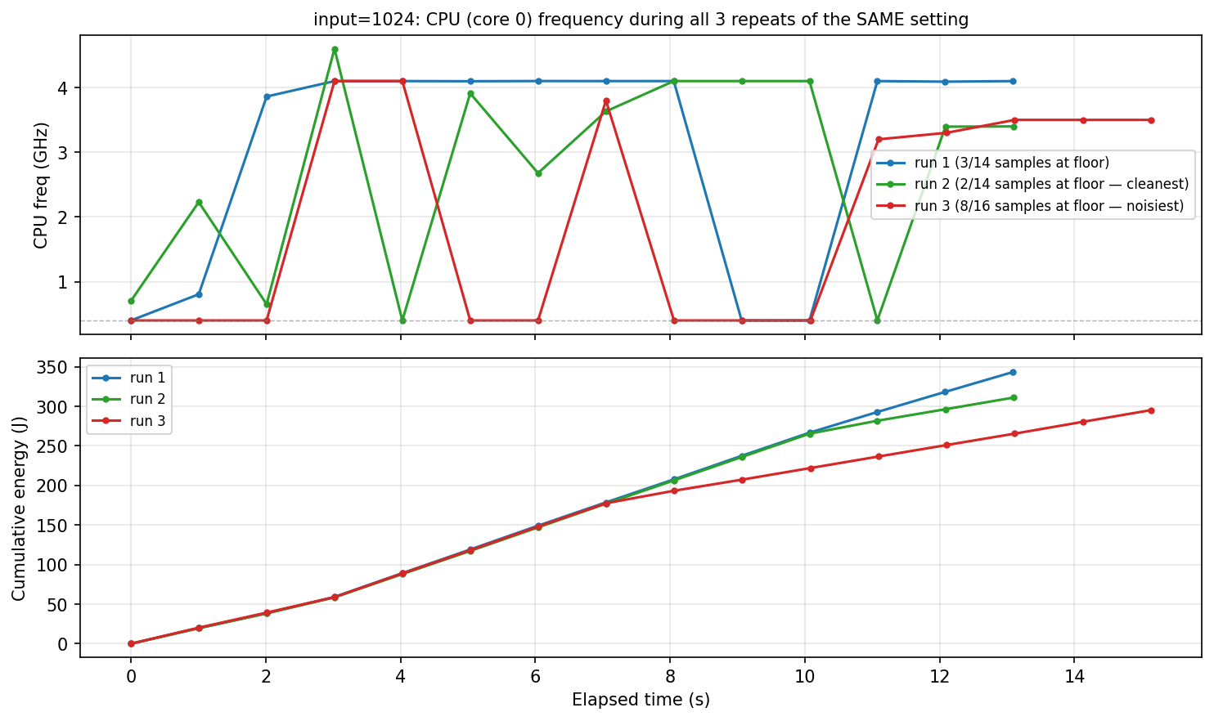
CPU (core 0) frequency and cumulative energy over time, all 3 repeats of the input=1024 setting. All oscillate between the 400MHz floor and ~4.1-4.7GHz throughout generation. Run 3 (red) spends a sustained ~3-4s stretch at the floor the others don't, visible directly in its flatter cumulative energy line - a genuine per-run difference, not sampling noise.

Across the input=1024 setting specifically: run 1 spent 3/14 one-second samples at the floor, run 2 spent 2/14 (cleanest), run 3 spent 8/16 (noisiest) - directly explaining why this setting alone showed 16% run-to-run spread vs. 1-4% everywhere else.

3.5 Decoding Strategy Comparison (Experiment 2)
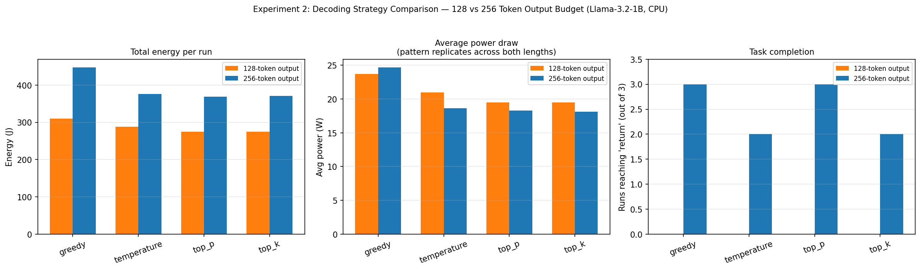
Total energy, average power draw, and task completion (runs reaching a return statement, out of 3) across four decoding strategies, compared at two output budgets (128 vs. 256 tokens), fixed 422 input tokens, Llama-3.2-1B, CPU.

strategy | 128-tok avg energy(J) | 128-tok avg power(W) | 128-tok completed | 256-tok avg energy(J) | 256-tok avg power(W) | 256-tok completed
greedy | 310.5 | 23.71 | 0/3 | 447.2 | 24.66 | 3/3
temperature | 288.8 | 20.96 | 0/3 | 375.8 | 18.63 | 2/3
top_p | 274.8 | 19.47 | 0/3 | 368.7 | 18.27 | 3/3
top_k | 275.2 | 19.49 | 0/3 | 371.4 | 18.1 | 2/3

128-token budget was universally insufficient. All 12 runs, across all 4 strategies, were cut off mid-implementation with no return statement - confirmed by manually inspecting every log, not just the heuristic check. This is a budget problem, not a strategy effect: at this length, the comparison was really measuring "energy to generate a fixed-length partial prefix," not "energy per completed task."
256-token budget mostly resolved it. 10 of 12 runs reached a return statement with genuinely correct, executable bubble sort code (manually verified for greedy_run1 - full implementation with early-exit optimization). The 2 that didn't (temperature_run3, top_k_run3) were extremely close, correct logic through the final comparison, cut off one line before the return.
The counter-intuitive power-draw finding replicates. Greedy drew the most average power at BOTH output lengths (23.71W then 24.66W) while temperature/top-p/top-k clustered together and lower in both cases (~18-21W). Two independent runs showing the same pattern is meaningfully stronger evidence than the original single n=3 comparison - this is no longer just a preliminary flag.
Greedy also completed most reliably. 3/3 at 256 tokens, tied with top-p, while temperature and top-k only reached 2/3. Combined with the power finding, greedy is both the most power-hungry AND (together with top-p) the most reliable at actually finishing the task within a fixed budget - a real, practically-relevant tradeoff for anyone choosing a decoding strategy for a token-budgeted agentic step.

4. Inferences
1. Decode costs ~3.8x more energy per token than prefill. Direct quantitative confirmation of the paper's claim, measured specifically for CPU-only inference (which the paper doesn't cover).
2. The decode marginal cost is stable across two independent sweeps. 0.772 J/token (Run A) vs 0.759 J/token (Run B) - within 2% despite being run separately with different settings. Suggests a genuine, reproducible property of this model/quantization/hardware combination.
3. Open question - does the paper's sub-linear prefill regime transfer to CPU at all? The paper attributes sub-linear-then-linear prefill scaling to GPU accelerator under-utilization at short sequences - a batching/parallelism effect. A single straight line already explains the CPU prefill data well (R²=0.985 across the full range), raising a real question: is the observed steepening genuine curvature, or just a constant fixed overhead being diluted as input grows on top of an already-linear cost? CPU inference has no batch-saturation dynamic the way GPU serving does, so the GPU-specific mechanism may simply not apply here. Distinguishing the two would need isolating prefill from decode energy per run, which whole-process RAPL cannot currently do.
4. The model naturally stops well short of a large token budget for a bounded task. output=512 (nominal) produced actual generations of 364/422/450 - never 512, never matching each other. Naive "energy per max-token-budget" estimates would systematically overestimate real cost for a well-specified task; measuring actual completion length (not nominal request) was essential, and is expected to matter again in Phase 2 agentic-loop work.
5. CPU frequency shows sustained, multi-second throttling dips, not just single-sample noise. Consistent with classic Intel power-budget cycling (short-term boost above a sustained power limit, followed by forced clock-down) - possibly compounding with thread migration across cores (only cpu0 is sampled). Identical repeated workloads can receive measurably different treatment from the CPU's own power management between runs - a real, only partially-controlled source of variance, and an argument for keeping RUNS at 3+ rather than trusting single measurements.
6. Sampling strategy affects power draw, not just theoretical compute cost - and this replicates. Greedy decoding drew the most average power at both a 128-token and a 256-token output budget (23.71W then 24.66W), while temperature/top-p/top-k consistently clustered lower (~18-21W) in both independent experiments. Two separate confirmations makes this a stronger finding than a single n=3 comparison - the opposite of the naive expectation that greedy (no sampling-distribution computation) should be cheapest. Mechanism still unclear: average CPU frequency doesn't cleanly explain it (greedy's average frequency was not consistently highest), so this may relate to execution pattern (branch prediction, cache behavior) rather than a straightforward FLOPs-based story.
7. A too-small output budget silently invalidates a strategy comparison. At 128 output tokens, 0 of 12 runs across all 4 strategies reached a return statement - every comparison was really measuring "energy for a fixed-length partial prefix," not task completion, and this was invisible without manually checking the generated text (the energy numbers alone looked perfectly reasonable). At 256 tokens, 10/12 completed. Worth checking actual output content, not just aggregate stats, before trusting any energy-per-task comparison - and worth budgeting output length generously for Phase 2 agentic-loop experiments, where under-provisioning a step's token budget could silently produce the same problem.

Status: Experiment 1 (prefill/decode scaling) complete across two sweeps. Experiment 2 (decoding strategy) complete across two output-budget conditions (128 and 256 tokens, 24 runs total) - the power-draw finding now replicates independently and is no longer just preliminary; also surfaced and resolved a real output-budget-too-small problem along the way. Experiment 3 (speculative decoding) script built; standard-mode path confirmed working in a smoke test, but the full sweep crashed the terminal partway through for reasons not yet fully diagnosed (memory and system suspend both ruled out) - deferred for now, to be retried inside tmux for session resilience. Open items: confirm/rule out the multi-core frequency-sampling hypothesis; resolve the sub-linear-regime open question if time allows; investigate the mechanism behind the greedy power-draw finding.

