1. Experiment 1 - Prefill/Decode Scaling
1.1 Raw Data - Run A (21 runs; 3 input settings x 3 repeats, 4 output settings x 3 repeats)
sweep | input_req | output_req | run | energy (J) | wall time (s)
input | 128 | 64 | 1 | 155.4606 | 8.008
input | 128 | 64 | 2 | 158.7099 | 8.0076
input | 128 | 64 | 3 | 153.6186 | 8.0076
input | 512 | 64 | 1 | 241.2782 | 10.0089
input | 512 | 64 | 2 | 236.564 | 10.0089
input | 512 | 64 | 3 | 240.6012 | 10.0092
input | 2048 | 64 | 1 | 502.5105 | 28.0274
input | 2048 | 64 | 2 | 481.142 | 28.0292
input | 2048 | 64 | 3 | 480.8938 | 28.0285
output | 512 | 8 | 1 | 183.1692 | 8.0071
output | 512 | 8 | 2 | 180.1374 | 8.0076
output | 512 | 8 | 3 | 179.6586 | 8.0076
output | 512 | 64 | 1 | 221.3901 | 10.0091
output | 512 | 64 | 2 | 229.3739 | 12.0112
output | 512 | 64 | 3 | 220.7311 | 10.01
output | 512 | 256 | 1 | 355.9769 | 20.0184
output | 512 | 256 | 2 | 360.6898 | 20.0189
output | 512 | 256 | 3 | 356.8552 | 20.0186
output | 512 | 512 | 1 | 489.2908 | 28.026
output | 512 | 512 | 2 | 505.6204 | 30.0293
output | 512 | 512 | 3 | 398.5772 | 22.0195

1.2 Raw Data - Run B (33 runs; 5 input settings x 3 repeats, 6 output settings x 3 repeats)
sweep | input_req | output_req | run | energy (J) | wall time (s)
input | 128 | 64 | 1 | 152.0562 | 7.0482
input | 128 | 64 | 2 | 150.8309 | 7.0496
input | 128 | 64 | 3 | 153.7281 | 7.0501
input | 256 | 64 | 1 | 183.8467 | 8.0574
input | 256 | 64 | 2 | 184.2282 | 8.0582
input | 256 | 64 | 3 | 182.6025 | 8.0579
input | 512 | 64 | 1 | 238.9317 | 10.0711
input | 512 | 64 | 2 | 236.2654 | 10.0722
input | 512 | 64 | 3 | 243.8039 | 10.0719
input | 1024 | 64 | 1 | 354.3238 | 14.0973
input | 1024 | 64 | 2 | 324.2488 | 14.1058
input | 1024 | 64 | 3 | 302.1225 | 16.1435
input | 2048 | 64 | 1 | 470.9298 | 27.2486
input | 2048 | 64 | 2 | 478.0927 | 28.2597
input | 2048 | 64 | 3 | 475.2503 | 27.2506
output | 512 | 8 | 1 | 184.6772 | 8.0562
output | 512 | 8 | 2 | 175.4261 | 8.0616
output | 512 | 8 | 3 | 179.5017 | 8.0581
output | 512 | 32 | 1 | 202.3694 | 9.0676
output | 512 | 32 | 2 | 200.697 | 9.0692
output | 512 | 32 | 3 | 200.5372 | 9.0675
output | 512 | 64 | 1 | 213.4837 | 10.0808
output | 512 | 64 | 2 | 219.6995 | 10.0793
output | 512 | 64 | 3 | 213.536 | 10.0793
output | 512 | 128 | 1 | 264.6818 | 13.1077
output | 512 | 128 | 2 | 265 | 13.1073
output | 512 | 128 | 3 | 268.7468 | 14.1166
output | 512 | 256 | 1 | 357.2878 | 19.1675
output | 512 | 256 | 2 | 363.9014 | 20.1765
output | 512 | 256 | 3 | 358.6415 | 20.1781
output | 512 | 512 | 1 | 448.7783 | 25.219
output | 512 | 512 | 2 | 486.1695 | 28.2503
output | 512 | 512 | 3 | 518.7787 | 30.2717

1.3 Regression Statistics and Constant Overhead
 | slope (J/token) | intercept - constant overhead (J) | R-squared
Run A, output sweep (decode) | 0.7716 | 169.83 | 0.9778
Run B, output sweep (decode) | 0.7591 | 167.74 | 0.9978
Run B, input sweep (prefill) | 0.2000 | 144.39 | 0.9850

 | value
Decode marginal cost, Run A | 0.7716 J/token
Decode marginal cost, Run B | 0.7591 J/token
Prefill marginal cost, Run B | 0.2000 J/token
Decode / Prefill ratio | 3.80

1.4 Decode Share of Total Energy vs. Output Length (Run B)
actual output tokens | measured avg energy (J) | predicted decode energy (J) | decode % of total
13 | 179.9 | 9.9 | 5.5%
37 | 201.2 | 28.1 | 14.0%
68 | 215.6 | 51.9 | 24.1%
133 | 266.1 | 100.9 | 37.9%
260 | 359.9 | 197.3 | 54.8%
412 | 484.6 | 312.7 | 64.5%

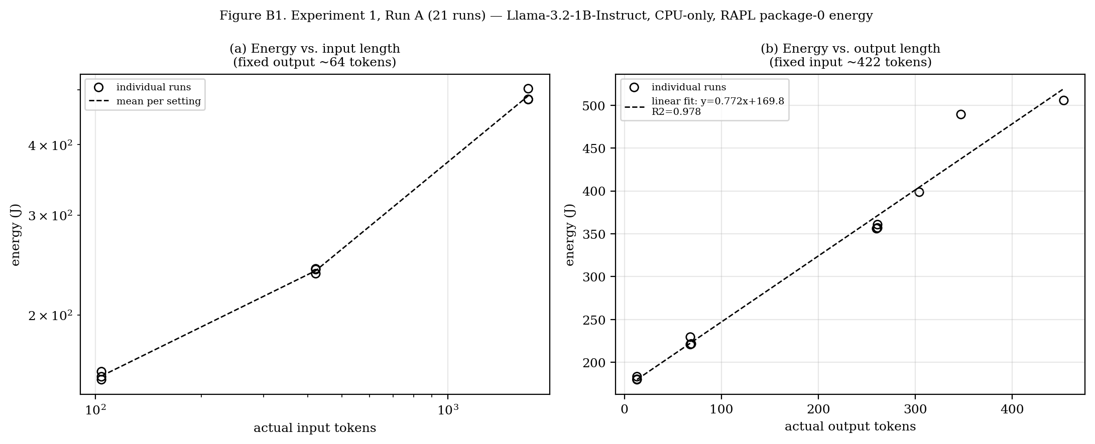
Figure B1. Energy vs. input length (a, log-log) and output length with linear fit (b), Run A (21 runs).

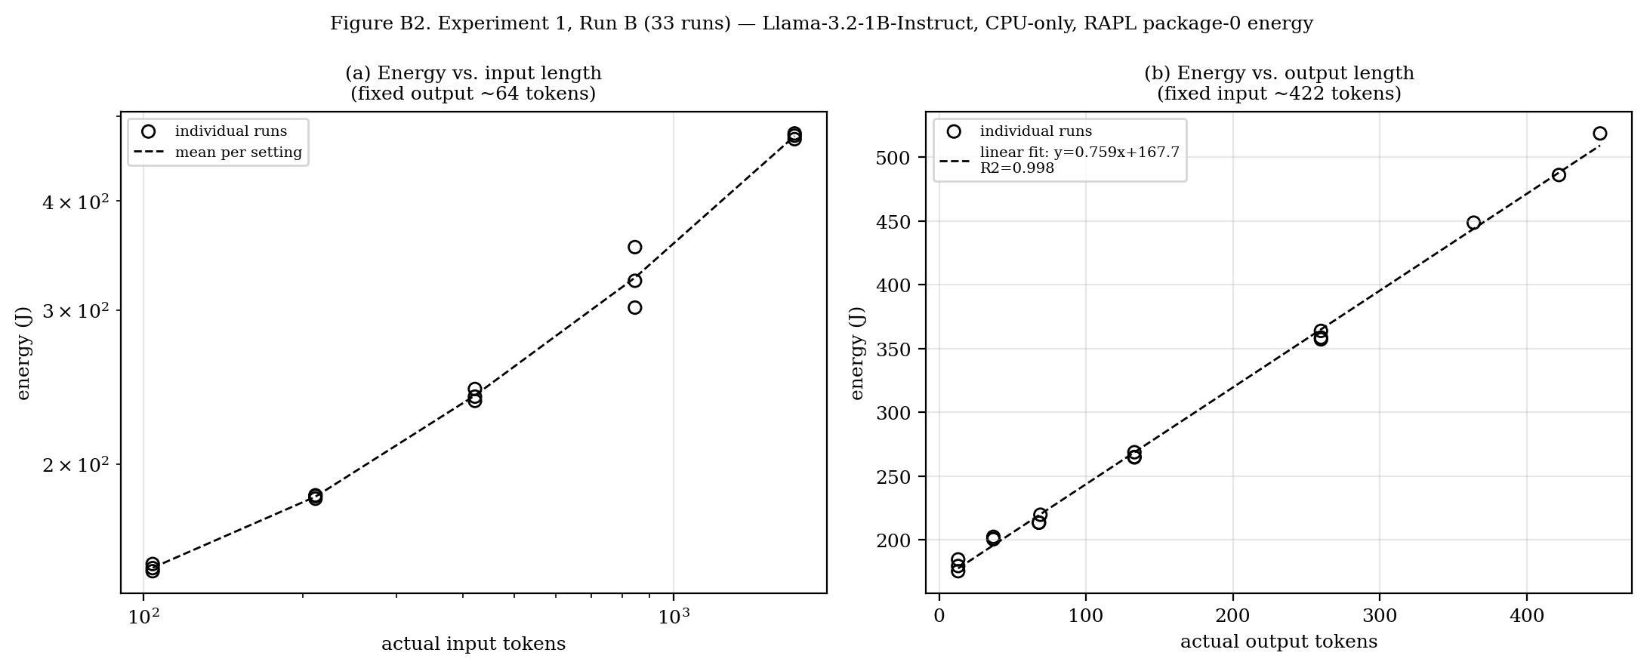
Figure B2. Energy vs. input length (a, log-log) and output length with linear fit (b), Run B (33 runs).

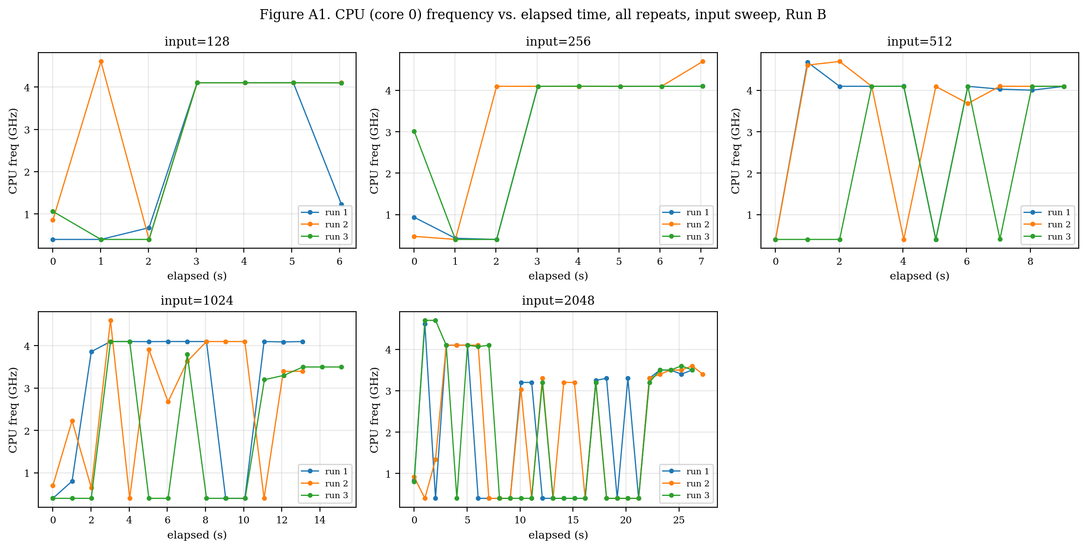
Figure A1. CPU (core 0) frequency vs. elapsed time, all repeats, input sweep, Run B.

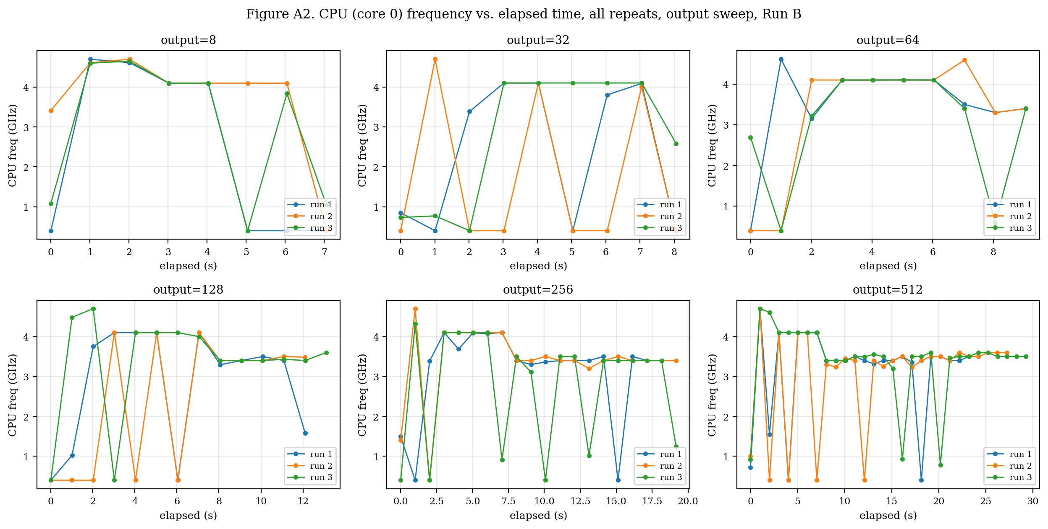
Figure A2. CPU (core 0) frequency vs. elapsed time, all repeats, output sweep, Run B.

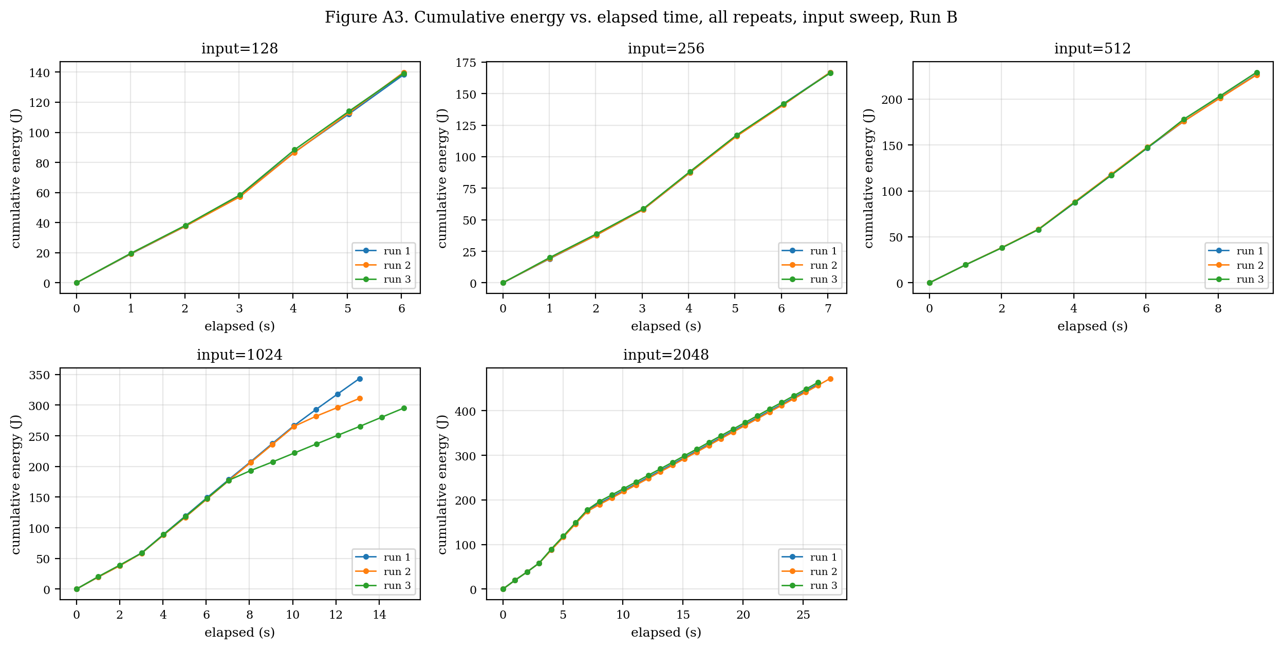
Figure A3. Cumulative energy vs. elapsed time, all repeats, input sweep, Run B.

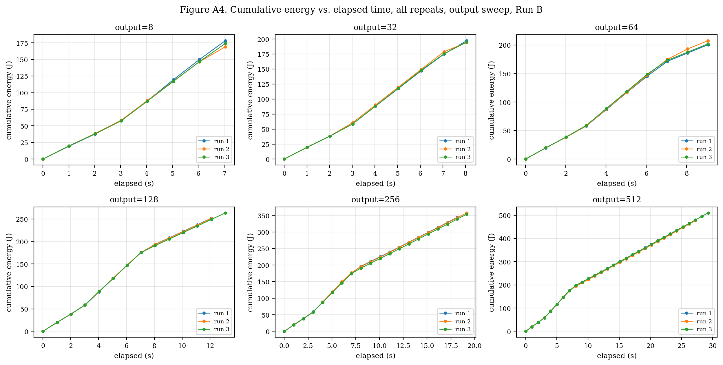
Figure A4. Cumulative energy vs. elapsed time, all repeats, output sweep, Run B.

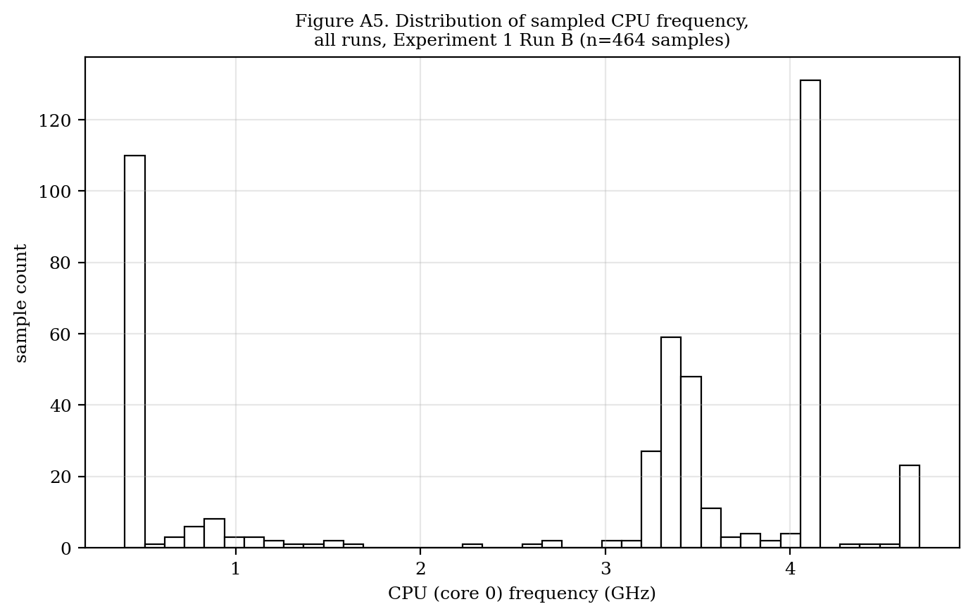
Figure A5. Distribution of sampled CPU (core 0) frequency, all runs and settings, Run B (n = 464 samples).

2. Experiment 2 - Decoding Strategy Comparison
Fixed input (~422 actual tokens). Two output-budget conditions tested: 128 tokens and 256 tokens. Strategies: greedy (temp=0), temperature (temp=0.8), top-p / nucleus (temp=0.8, top-p=0.9), top-k (temp=0.8, top-k=40). Sampler defaults (top-k=40, top-p=0.95) explicitly disabled in conditions not testing them. 3 repeats per strategy per condition.
2.1 Raw Data (24 runs)
strategy | output budget | run | energy (J) | wall time (s) | reached return?
greedy | 128 | 1 | 310.88 | 13.0926 | No
greedy | 128 | 2 | 309.753 | 13.0951 | No
greedy | 128 | 3 | 310.9029 | 13.0938 | No
temperature | 128 | 1 | 315.6813 | 13.0985 | No
temperature | 128 | 2 | 273.7739 | 14.1138 | No
temperature | 128 | 3 | 276.9856 | 14.1167 | No
top_p | 128 | 1 | 277.0144 | 14.1161 | No
top_p | 128 | 2 | 274.6285 | 14.1153 | No
top_p | 128 | 3 | 272.8208 | 14.1184 | No
top_k | 128 | 1 | 273.7179 | 14.116 | No
top_k | 128 | 2 | 276.865 | 14.1155 | No
top_k | 128 | 3 | 274.8893 | 14.1187 | No
greedy | 256 | 1 | 446.6294 | 18.1289 | Yes
greedy | 256 | 2 | 446.3054 | 18.1337 | Yes
greedy | 256 | 3 | 448.6585 | 18.1332 | Yes
temperature | 256 | 1 | 385.7003 | 20.167 | Yes
temperature | 256 | 2 | 372.3329 | 20.174 | Yes
temperature | 256 | 3 | 369.2884 | 20.178 | No
top_p | 256 | 1 | 367.5491 | 20.1748 | Yes
top_p | 256 | 2 | 370.2086 | 20.1784 | Yes
top_p | 256 | 3 | 368.3637 | 20.1756 | Yes
top_k | 256 | 1 | 367.2429 | 20.1758 | Yes
top_k | 256 | 2 | 377.1157 | 21.1871 | Yes
top_k | 256 | 3 | 369.7955 | 20.1757 | No

2.2 Summary Statistics by Strategy and Output Budget
strategy | 128-tok avg energy (J) | 128-tok avg power (W) | 128-tok completed | 256-tok avg energy (J) | 256-tok avg power (W) | 256-tok completed
greedy | 310.5 | 23.71 | 0/3 | 447.2 | 24.66 | 3/3
temperature | 288.8 | 20.96 | 0/3 | 375.8 | 18.63 | 2/3
top_p | 274.8 | 19.47 | 0/3 | 368.7 | 18.27 | 3/3
top_k | 275.2 | 19.49 | 0/3 | 371.4 | 18.10 | 2/3

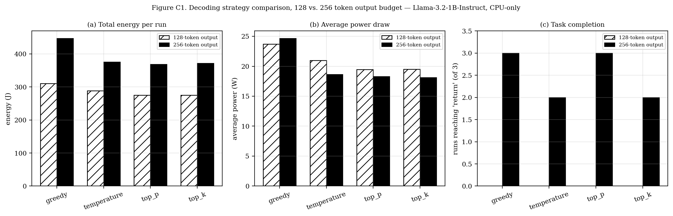
Figure C1. Total energy (a), average power draw (b), and task completion (c) by decoding strategy, at 128- and 256-token output budgets.

