Week 5 - Multi-Model CPU Inference Sweep: Llama-3.2-1B vs. Llama-3.2-3B
Lenovo IdeaPad Flex 5 (Intel i7, no GPU), llama.cpp, RAPL package-0, governor = performance. Both models Q4_K_M. Same bubble-sort task and padding as week 3. Colour key used throughout: blue = Llama-3.2-1B, orange = Llama-3.2-3B.

1. Experiment 1 - Prefill/Decode Scaling
Input sweep: 8 input settings (nominal 128-2048), output fixed at 64. Output sweep: 8 output settings (nominal 8-512), input fixed at 512 nominal (422 actual). 5 repeats each, 80 runs per model. Token counts are actual counts from llama-tokenize.

1.1 Raw Data - Llama-3.2-1B (80 runs; 8 input settings x 5 repeats, 8 output settings x 5 repeats)
sweep | input_req | output_req | run | input_act | output_act | energy (J) | wall time (s)
input | 128 | 64 | 1 | 104 | 64 | 108.0142 | 5.0362
input | 128 | 64 | 2 | 104 | 64 | 109.3231 | 5.0373
input | 128 | 64 | 3 | 104 | 64 | 108.6582 | 5.0364
input | 128 | 64 | 4 | 104 | 64 | 109.6378 | 5.0370
input | 128 | 64 | 5 | 104 | 64 | 107.9470 | 5.0370
input | 256 | 64 | 1 | 211 | 64 | 133.4521 | 6.0436
input | 256 | 64 | 2 | 211 | 64 | 133.4425 | 6.0429
input | 256 | 64 | 3 | 211 | 64 | 134.4983 | 6.0442
input | 256 | 64 | 4 | 211 | 64 | 138.4836 | 6.0434
input | 256 | 64 | 5 | 211 | 64 | 134.9169 | 6.0432
input | 384 | 64 | 1 | 316 | 64 | 159.5390 | 7.0511
input | 384 | 64 | 2 | 316 | 64 | 158.3169 | 7.0517
input | 384 | 64 | 3 | 316 | 64 | 227.1931 | 8.0583
input | 384 | 64 | 4 | 316 | 64 | 159.2254 | 7.0521
input | 384 | 64 | 5 | 316 | 64 | 182.3507 | 7.0493
input | 512 | 64 | 1 | 422 | 64 | 189.5060 | 8.0580
input | 512 | 64 | 2 | 422 | 64 | 189.1917 | 8.0586
input | 512 | 64 | 3 | 422 | 64 | 187.4116 | 8.0587
input | 512 | 64 | 4 | 422 | 64 | 189.4417 | 8.0587
input | 512 | 64 | 5 | 422 | 64 | 186.4796 | 8.0591
input | 768 | 64 | 1 | 635 | 64 | 242.0843 | 10.0730
input | 768 | 64 | 2 | 635 | 64 | 240.5207 | 10.0730
input | 768 | 64 | 3 | 635 | 64 | 243.3050 | 10.0726
input | 768 | 64 | 4 | 635 | 64 | 241.4410 | 10.0727
input | 768 | 64 | 5 | 635 | 64 | 240.8602 | 10.0717
input | 1024 | 64 | 1 | 846 | 64 | 296.4441 | 12.0867
input | 1024 | 64 | 2 | 846 | 64 | 295.3553 | 12.0877
input | 1024 | 64 | 3 | 846 | 64 | 299.9649 | 12.0867
input | 1024 | 64 | 4 | 846 | 64 | 300.0059 | 12.0882
input | 1024 | 64 | 5 | 846 | 64 | 297.0829 | 12.0862
input | 1536 | 64 | 1 | 1270 | 64 | 413.0787 | 16.1130
input | 1536 | 64 | 2 | 1270 | 64 | 414.6260 | 16.1144
input | 1536 | 64 | 3 | 1270 | 64 | 418.9730 | 17.1214
input | 1536 | 64 | 4 | 1270 | 64 | 420.6832 | 17.1239
input | 1536 | 64 | 5 | 1270 | 64 | 416.3194 | 16.1159
input | 2048 | 64 | 1 | 1693 | 64 | 444.9435 | 24.2146
input | 2048 | 64 | 2 | 1693 | 64 | 533.7962 | 21.1525
input | 2048 | 64 | 3 | 1693 | 64 | 437.8675 | 24.2162
input | 2048 | 64 | 4 | 1693 | 64 | 531.7066 | 21.1562
input | 2048 | 64 | 5 | 1693 | 64 | 427.7830 | 24.2215
output | 512 | 8 | 1 | 422 | 8 | 135.4383 | 6.0450
output | 512 | 8 | 2 | 422 | 8 | 134.0891 | 6.0447
output | 512 | 8 | 3 | 422 | 8 | 134.6323 | 6.0444
output | 512 | 8 | 4 | 422 | 8 | 135.0559 | 6.0443
output | 512 | 8 | 5 | 422 | 8 | 134.6977 | 6.0447
output | 512 | 16 | 1 | 422 | 16 | 141.9386 | 6.0433
output | 512 | 16 | 2 | 422 | 16 | 148.7177 | 6.0435
output | 512 | 16 | 3 | 422 | 16 | 142.4727 | 6.0449
output | 512 | 16 | 4 | 422 | 16 | 140.4783 | 6.0444
output | 512 | 16 | 5 | 422 | 16 | 140.3987 | 6.0441
output | 512 | 32 | 1 | 422 | 32 | 157.3117 | 7.0525
output | 512 | 32 | 2 | 422 | 32 | 157.1257 | 7.0517
output | 512 | 32 | 3 | 422 | 32 | 157.3858 | 7.0518
output | 512 | 32 | 4 | 422 | 32 | 158.3855 | 7.0515
output | 512 | 32 | 5 | 422 | 32 | 157.1618 | 7.0525
output | 512 | 64 | 1 | 422 | 64 | 185.2362 | 8.0591
output | 512 | 64 | 2 | 422 | 64 | 187.9490 | 8.0606
output | 512 | 64 | 3 | 422 | 64 | 186.6243 | 8.0594
output | 512 | 64 | 4 | 422 | 64 | 189.2774 | 8.0587
output | 512 | 64 | 5 | 422 | 64 | 191.7706 | 8.0590
output | 512 | 128 | 1 | 422 | 128 | 246.8380 | 11.0811
output | 512 | 128 | 2 | 422 | 128 | 244.4306 | 10.0744
output | 512 | 128 | 3 | 422 | 128 | 251.8710 | 11.0835
output | 512 | 128 | 4 | 422 | 128 | 248.1654 | 11.0807
output | 512 | 128 | 5 | 422 | 128 | 244.9533 | 10.0744
output | 512 | 256 | 1 | 422 | 255 | 370.0512 | 16.1179
output | 512 | 256 | 2 | 422 | 256 | 368.9563 | 16.1171
output | 512 | 256 | 3 | 422 | 256 | 362.5388 | 15.1121
output | 512 | 256 | 4 | 422 | 255 | 359.8073 | 15.1131
output | 512 | 256 | 5 | 422 | 256 | 360.8550 | 15.1128
output | 512 | 384 | 1 | 422 | 374 | 489.6272 | 21.1548
output | 512 | 384 | 2 | 422 | 384 | 521.4772 | 21.1529
output | 512 | 384 | 3 | 422 | 372 | 440.1889 | 22.1838
output | 512 | 384 | 4 | 422 | 332 | 440.6789 | 19.1393
output | 512 | 384 | 5 | 422 | 384 | 470.1552 | 21.1646
output | 512 | 512 | 1 | 422 | 377 | 408.7015 | 22.1933
output | 512 | 512 | 2 | 422 | 466 | 552.7350 | 25.1953
output | 512 | 512 | 3 | 422 | 418 | 449.7062 | 25.2199
output | 512 | 512 | 4 | 422 | 342 | 445.3741 | 19.1396
output | 512 | 512 | 5 | 422 | 404 | 436.4271 | 23.2029

1.2 Raw Data - Llama-3.2-3B (80 runs; 8 input settings x 5 repeats, 8 output settings x 5 repeats)
sweep | input_req | output_req | run | input_act | output_act | energy (J) | wall time (s)
input | 128 | 64 | 1 | 104 | 64 | 257.6380 | 12.0890
input | 128 | 64 | 2 | 104 | 64 | 271.2884 | 12.0848
input | 128 | 64 | 3 | 104 | 64 | 268.8840 | 12.0861
input | 128 | 64 | 4 | 104 | 64 | 274.8280 | 12.0859
input | 128 | 64 | 5 | 104 | 64 | 269.1631 | 12.0855
input | 256 | 64 | 1 | 211 | 64 | 344.7943 | 14.0992
input | 256 | 64 | 2 | 211 | 64 | 342.5864 | 14.1000
input | 256 | 64 | 3 | 211 | 64 | 325.1277 | 15.1177
input | 256 | 64 | 4 | 211 | 64 | 306.7349 | 15.1244
input | 256 | 64 | 5 | 211 | 64 | 346.7899 | 14.1011
input | 384 | 64 | 1 | 316 | 64 | 369.0186 | 19.1596
input | 384 | 64 | 2 | 316 | 64 | 421.2633 | 17.1216
input | 384 | 64 | 3 | 316 | 64 | 367.4803 | 19.1629
input | 384 | 64 | 4 | 316 | 64 | 416.7025 | 18.1324
input | 384 | 64 | 5 | 316 | 64 | 361.7618 | 19.1665
input | 512 | 64 | 1 | 422 | 64 | 477.4546 | 20.1534
input | 512 | 64 | 2 | 422 | 64 | 412.1954 | 23.2047
input | 512 | 64 | 3 | 422 | 64 | 477.7523 | 21.1636
input | 512 | 64 | 4 | 422 | 64 | 410.2151 | 22.1947
input | 512 | 64 | 5 | 422 | 64 | 452.2038 | 21.1711
input | 768 | 64 | 1 | 635 | 64 | 527.7439 | 30.2790
input | 768 | 64 | 2 | 635 | 64 | 585.3596 | 28.2367
input | 768 | 64 | 3 | 635 | 64 | 539.6098 | 31.2824
input | 768 | 64 | 4 | 635 | 64 | 590.2274 | 28.2347
input | 768 | 64 | 5 | 635 | 64 | 529.8584 | 30.2763
input | 1024 | 64 | 1 | 846 | 64 | 698.4790 | 36.3130
input | 1024 | 64 | 2 | 846 | 64 | 647.0879 | 38.3515
input | 1024 | 64 | 3 | 846 | 64 | 712.2832 | 35.3030
input | 1024 | 64 | 4 | 846 | 64 | 644.6312 | 38.3552
input | 1024 | 64 | 5 | 846 | 64 | 696.4837 | 36.3185
input | 1536 | 64 | 1 | 1270 | 64 | 878.7827 | 53.5036
input | 1536 | 64 | 2 | 1270 | 64 | 941.1180 | 51.4644
input | 1536 | 64 | 3 | 1270 | 64 | 885.2123 | 54.5117
input | 1536 | 64 | 4 | 1270 | 64 | 949.0722 | 51.4620
input | 1536 | 64 | 5 | 1270 | 64 | 895.0362 | 54.5228
input | 2048 | 64 | 1 | 1693 | 64 | 1114.8925 | 69.6579
input | 2048 | 64 | 2 | 1693 | 64 | 1115.2926 | 69.6700
input | 2048 | 64 | 3 | 1693 | 64 | 1110.0405 | 68.6567
input | 2048 | 64 | 4 | 1693 | 64 | 1136.8086 | 70.6787
input | 2048 | 64 | 5 | 1693 | 64 | 1106.1424 | 68.6595
output | 512 | 8 | 1 | 422 | 8 | 319.5044 | 16.1368
output | 512 | 8 | 2 | 422 | 8 | 317.6353 | 16.1400
output | 512 | 8 | 3 | 422 | 8 | 317.6971 | 16.1398
output | 512 | 8 | 4 | 422 | 7 | 319.6239 | 16.1412
output | 512 | 8 | 5 | 422 | 7 | 361.2643 | 14.1011
output | 512 | 16 | 1 | 422 | 16 | 330.0079 | 17.1497
output | 512 | 16 | 2 | 422 | 16 | 332.4723 | 17.1519
output | 512 | 16 | 3 | 422 | 16 | 332.0801 | 17.1471
output | 512 | 16 | 4 | 422 | 16 | 377.4067 | 16.1192
output | 512 | 16 | 5 | 422 | 16 | 333.7820 | 17.1502
output | 512 | 32 | 1 | 422 | 32 | 357.7424 | 19.1675
output | 512 | 32 | 2 | 422 | 32 | 396.2902 | 17.1353
output | 512 | 32 | 3 | 422 | 32 | 357.6894 | 19.1702
output | 512 | 32 | 4 | 422 | 32 | 359.3537 | 19.1687
output | 512 | 32 | 5 | 422 | 32 | 409.3707 | 17.1290
output | 512 | 64 | 1 | 422 | 64 | 406.6967 | 22.1993
output | 512 | 64 | 2 | 422 | 64 | 411.8858 | 22.2040
output | 512 | 64 | 3 | 422 | 64 | 410.6463 | 22.1995
output | 512 | 64 | 4 | 422 | 64 | 409.1680 | 22.2010
output | 512 | 64 | 5 | 422 | 64 | 410.9397 | 22.2007
output | 512 | 128 | 1 | 422 | 128 | 579.6755 | 29.2449
output | 512 | 128 | 2 | 422 | 128 | 535.5847 | 30.2749
output | 512 | 128 | 3 | 422 | 128 | 530.2861 | 30.2765
output | 512 | 128 | 4 | 422 | 128 | 531.9500 | 30.2765
output | 512 | 128 | 5 | 422 | 128 | 522.5658 | 31.2844
output | 512 | 256 | 1 | 422 | 255 | 772.5694 | 46.4186
output | 512 | 256 | 2 | 422 | 256 | 769.5917 | 46.4235
output | 512 | 256 | 3 | 422 | 256 | 774.4793 | 46.4226
output | 512 | 256 | 4 | 422 | 255 | 770.9011 | 46.4244
output | 512 | 256 | 5 | 422 | 256 | 787.8601 | 47.4430
output | 512 | 384 | 1 | 422 | 384 | 1021.2249 | 63.5849
output | 512 | 384 | 2 | 422 | 384 | 1017.2600 | 62.5772
output | 512 | 384 | 3 | 422 | 384 | 1038.6481 | 64.6093
output | 512 | 384 | 4 | 422 | 369 | 1000.0764 | 61.5685
output | 512 | 384 | 5 | 422 | 384 | 1025.7042 | 63.5862
output | 512 | 512 | 1 | 422 | 454 | 1167.4752 | 72.6729
output | 512 | 512 | 2 | 422 | 510 | 1292.6368 | 81.7566
output | 512 | 512 | 3 | 422 | 461 | 1179.4868 | 73.6800
output | 512 | 512 | 4 | 422 | 448 | 1139.2692 | 70.6510
output | 512 | 512 | 5 | 422 | 453 | 1164.1813 | 72.6714

1.3 Regression Statistics and Constant Overhead
 | slope (J/token) | intercept - constant overhead (J) | R-squared
Llama-3.2-1B, output sweep (decode) | 0.8747 | 131.42 | 0.9817
Llama-3.2-1B, input sweep (prefill) | 0.2378 | 91.72 | 0.9674
Llama-3.2-3B, output sweep (decode) | 1.8801 | 305.20 | 0.9969
Llama-3.2-3B, input sweep (prefill) | 0.5364 | 218.38 | 0.9925
Week 3 reference: Llama-3.2-1B, Run B decode | 0.7591 | 167.74 | 0.9978
Week 3 reference: Llama-3.2-1B, Run B prefill | 0.2000 | 144.39 | 0.9850

 | Llama-3.2-1B | Llama-3.2-3B | 3B / 1B
Decode marginal cost | 0.8747 J/token | 1.8801 J/token | 2.15x
Prefill marginal cost | 0.2378 J/token | 0.5364 J/token | 2.26x
Decode / Prefill ratio | 3.68 | 3.50 | -
Constant overhead (decode-fit intercept) | 131.4 J | 305.2 J | 2.32x
Model file size (Q4_K_M) | 771 MB | 1.9 GB | 2.5x
Slopes are fitted on actual token counts across all 40 runs of each sweep. Week 3 rows are from fyp_print_data (5 input / 6 output settings, 3 repeats) and are shown for continuity only.

1.4 Decode Share of Total Energy vs. Output Length
output_req | 1B actual output | 1B measured avg (J) | 1B predicted decode (J) | 1B decode % | 3B actual output | 3B measured avg (J) | 3B predicted decode (J) | 3B decode %
8 | 8.0 | 134.8 | 7.0 | 5.2% | 7.6 | 327.1 | 14.3 | 4.4%
16 | 16.0 | 142.8 | 14.0 | 9.8% | 16.0 | 341.1 | 30.1 | 8.8%
32 | 32.0 | 157.5 | 28.0 | 17.8% | 32.0 | 376.1 | 60.2 | 16.0%
64 | 64.0 | 188.2 | 56.0 | 29.8% | 64.0 | 409.9 | 120.3 | 29.4%
128 | 128.0 | 247.3 | 112.0 | 45.3% | 128.0 | 540.0 | 240.6 | 44.6%
256 | 255.6 | 364.4 | 223.6 | 61.3% | 255.6 | 775.1 | 480.5 | 62.0%
384 | 369.2 | 472.4 | 323.0 | 68.4% | 381.0 | 1020.6 | 716.3 | 70.2%
512 | 401.4 | 458.6 | 351.1 | 76.6% | 465.2 | 1188.6 | 874.6 | 73.6%
Predicted decode energy = decode slope x actual output tokens (mean of 5 runs). At the 384 and 512 budgets the models stop early, so actual output is below the request.

1.5 Inter-Model Comparison per Setting (means of 5 runs)
sweep | setting | 1B energy (J) | 3B energy (J) | 3B / 1B energy | 1B avg power (W) | 3B avg power (W) | 1B decode (tok/s) | 3B decode (tok/s) | 1B prefill (tok/s) | 3B prefill (tok/s)
input | in 128 | 108.7 | 268.4 | 2.47x | 21.6 | 22.2 | 27.0 | 10.6 | 117.8 | 40.5
input | in 256 | 135.0 | 333.2 | 2.47x | 22.3 | 23.0 | 25.6 | 9.9 | 118.7 | 41.1
input | in 384 | 177.3 | 387.2 | 2.18x | 24.3 | 21.0 | 25.6 | 9.4 | 114.0 | 38.5
input | in 512 | 188.4 | 446.0 | 2.37x | 23.4 | 20.8 | 25.6 | 8.9 | 116.2 | 38.2
input | in 768 | 241.6 | 554.6 | 2.29x | 24.0 | 18.8 | 24.6 | 7.9 | 116.1 | 35.0
input | in 1024 | 297.8 | 679.8 | 2.28x | 24.6 | 18.5 | 23.3 | 7.4 | 113.3 | 34.3
input | in 1536 | 416.7 | 909.8 | 2.18x | 25.2 | 17.2 | 19.7 | 6.6 | 110.8 | 31.8
input | in 2048 | 475.2 | 1116.6 | 2.35x | 20.9 | 16.1 | 16.3 | 6.1 | 98.5 | 30.4
output | out 8 | 134.8 | 327.1 | 2.43x | 22.3 | 20.9 | 25.7 | 8.8 | 117.0 | 36.2
output | out 16 | 142.8 | 341.1 | 2.39x | 23.6 | 20.2 | 25.7 | 8.9 | 115.8 | 36.0
output | out 32 | 157.5 | 376.1 | 2.39x | 22.3 | 20.6 | 25.8 | 8.9 | 115.8 | 37.1
output | out 64 | 188.2 | 409.9 | 2.18x | 23.3 | 18.5 | 25.3 | 8.8 | 116.1 | 35.1
output | out 128 | 247.3 | 540.0 | 2.18x | 23.2 | 17.9 | 24.9 | 8.3 | 116.9 | 35.8
output | out 256 | 364.4 | 775.1 | 2.13x | 23.5 | 16.6 | 25.6 | 8.1 | 116.6 | 35.1
output | out 384 | 472.4 | 1020.6 | 2.16x | 22.6 | 16.2 | 24.1 | 8.0 | 117.5 | 34.6
output | out 512 | 458.6 | 1188.6 | 2.59x | 20.1 | 16.0 | 23.1 | 7.9 | 117.4 | 35.0
Average power = energy / wall time per run. Decode and prefill speeds are llama-cli's own reported throughput.
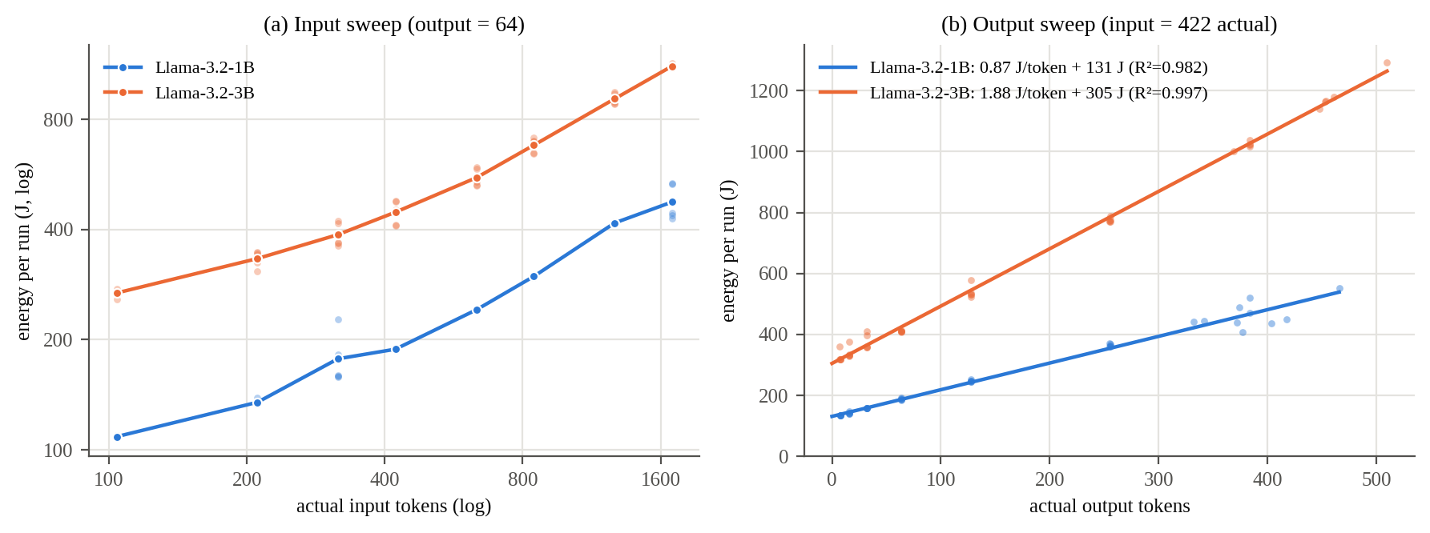
Figure B1. Energy vs. input length (a, log-log) and output length with linear fit (b), both models (80 runs each). Faint dots are individual runs, solid markers are means.
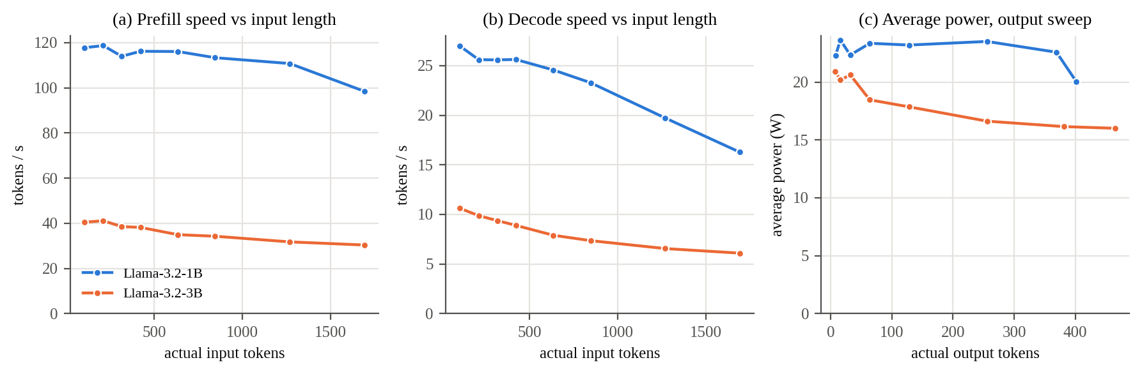
Figure B2. Prefill speed (a) and decode speed (b) vs. input length, and average power draw across the output sweep (c), both models.
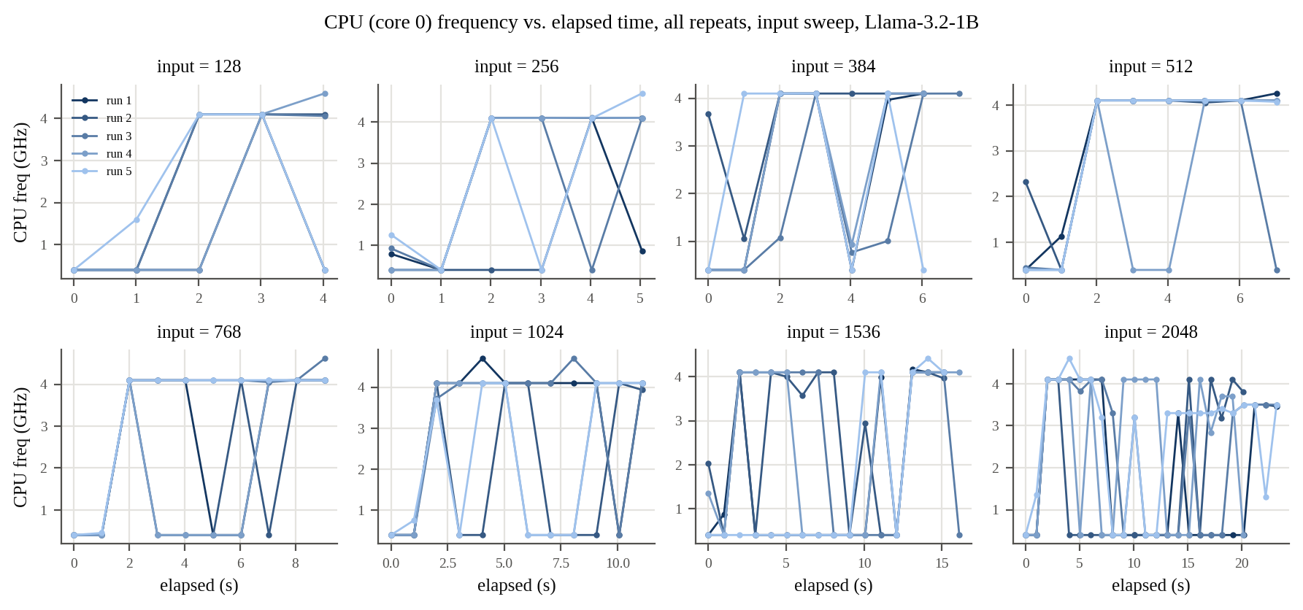
Figure A1. CPU (core 0) frequency vs. elapsed time, all repeats, input sweep, Llama-3.2-1B.
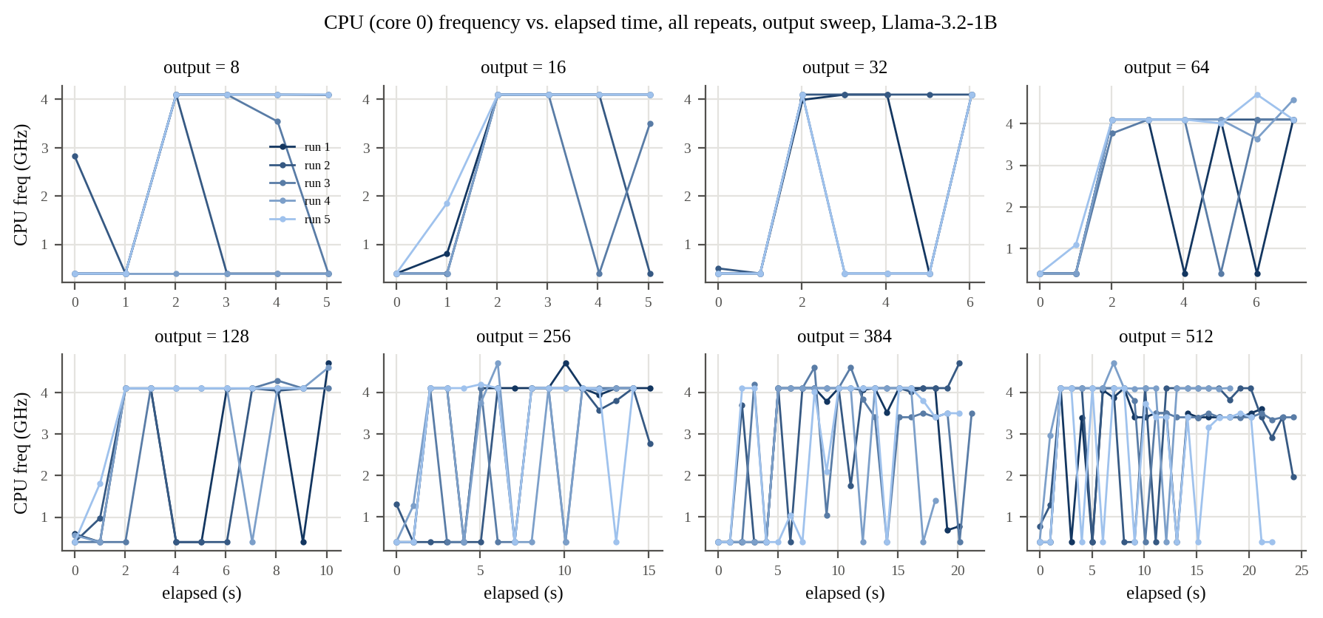
Figure A2. CPU (core 0) frequency vs. elapsed time, all repeats, output sweep, Llama-3.2-1B.
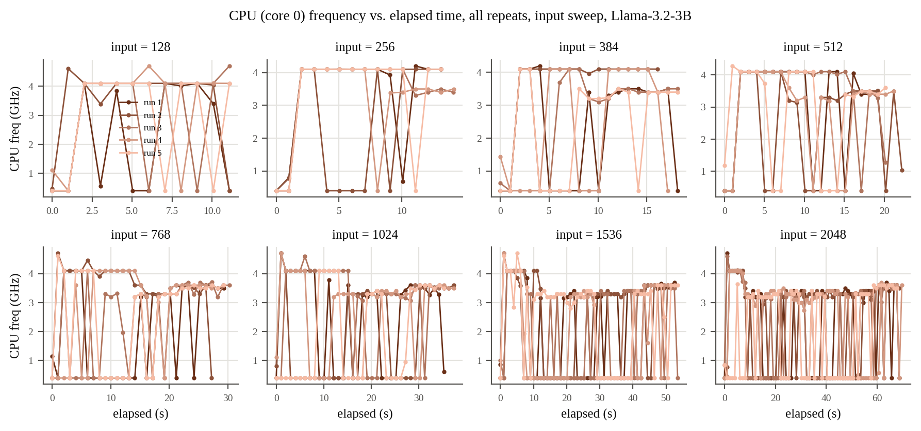
Figure A3. CPU (core 0) frequency vs. elapsed time, all repeats, input sweep, Llama-3.2-3B.
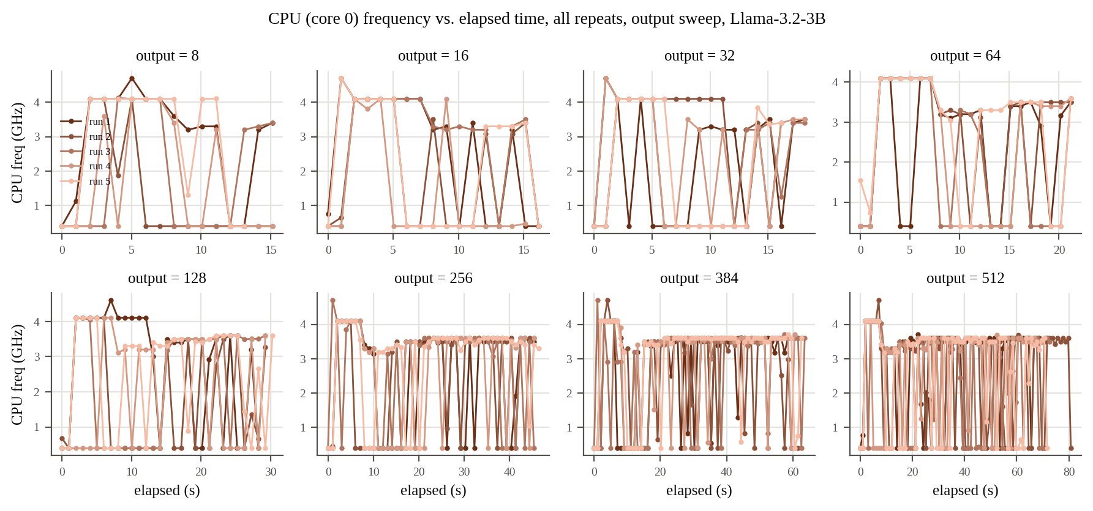
Figure A4. CPU (core 0) frequency vs. elapsed time, all repeats, output sweep, Llama-3.2-3B.
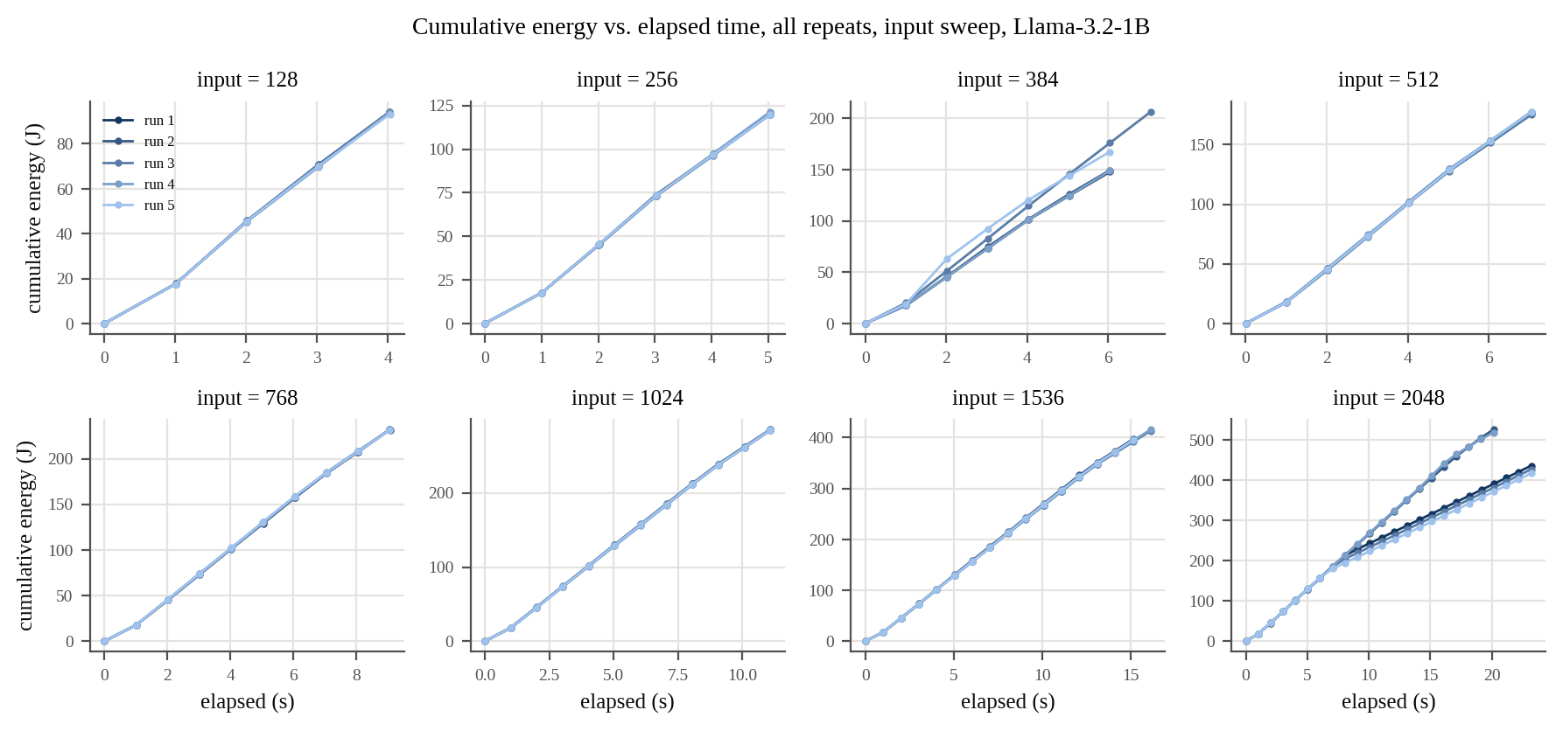
Figure A5. Cumulative energy vs. elapsed time, all repeats, input sweep, Llama-3.2-1B.
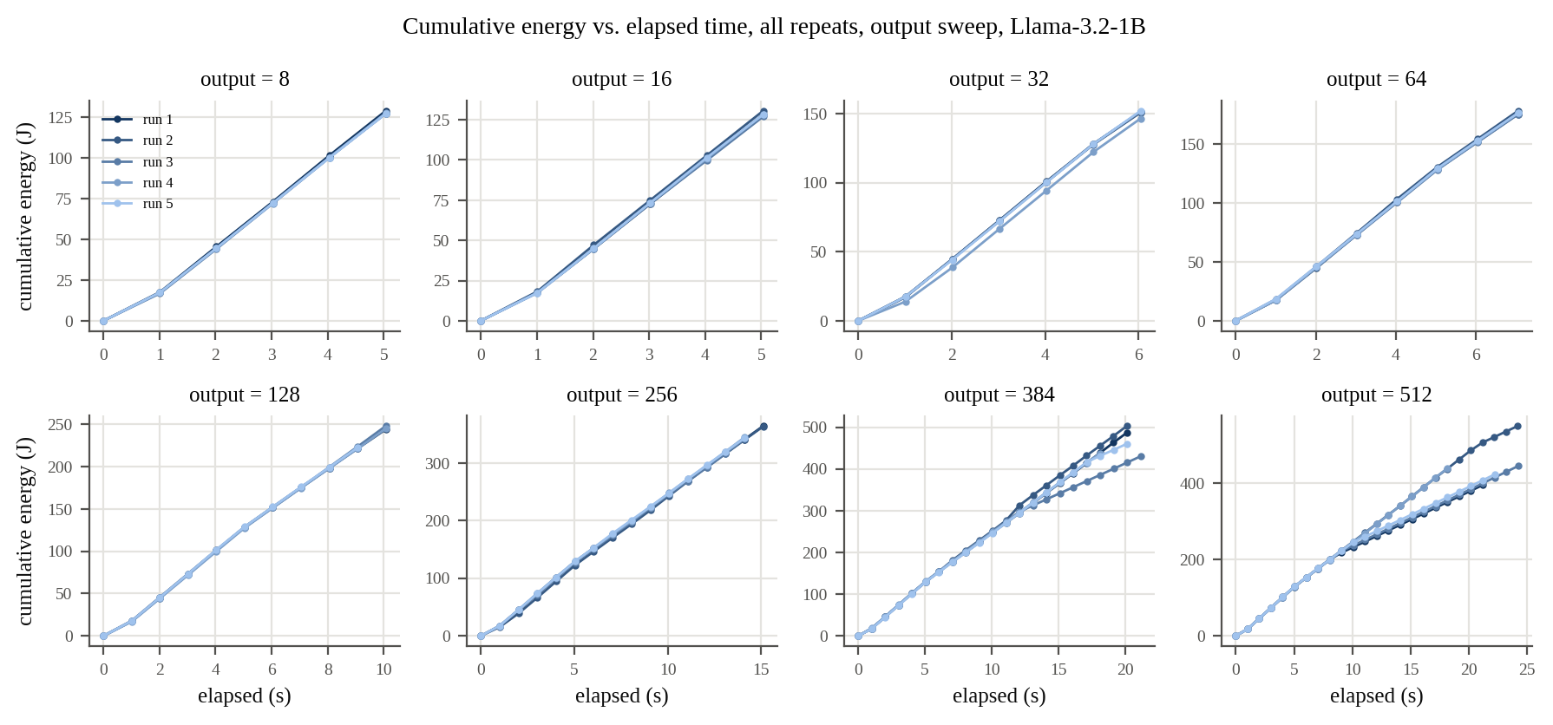
Figure A6. Cumulative energy vs. elapsed time, all repeats, output sweep, Llama-3.2-1B.
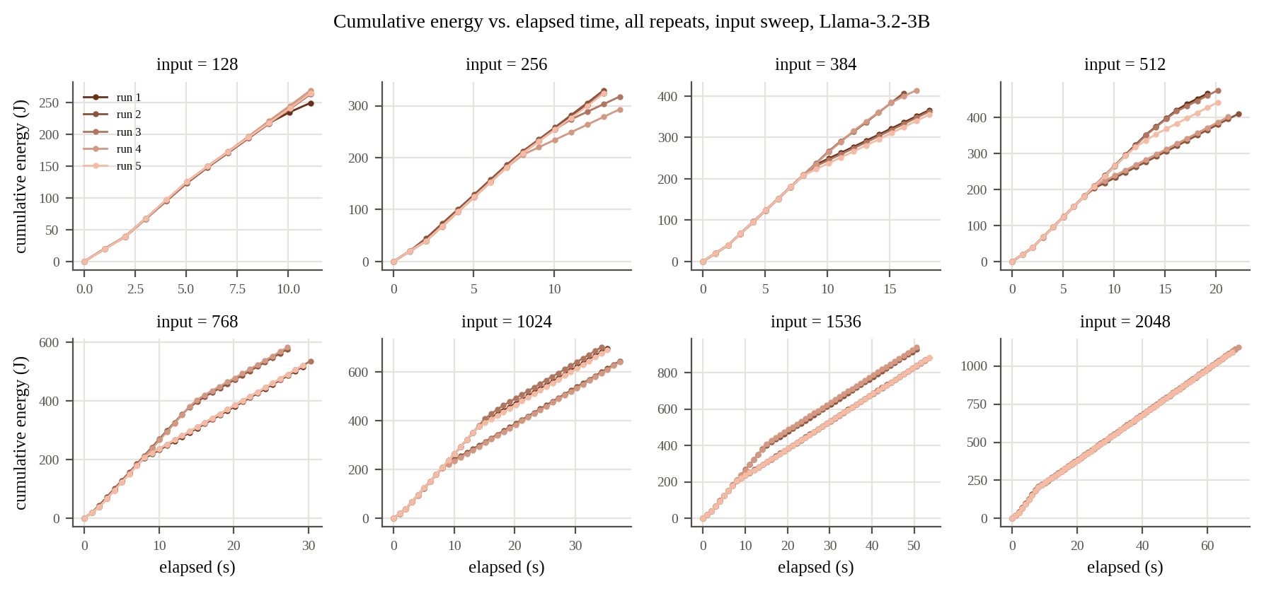
Figure A7. Cumulative energy vs. elapsed time, all repeats, input sweep, Llama-3.2-3B.
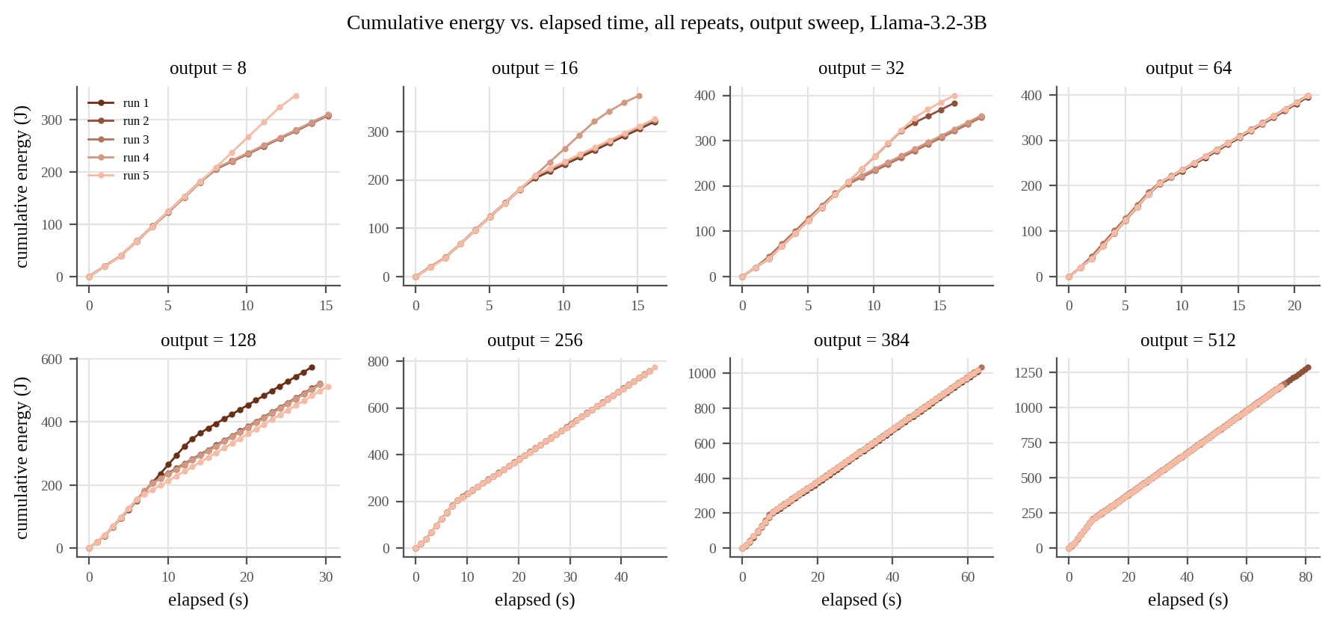
Figure A8. Cumulative energy vs. elapsed time, all repeats, output sweep, Llama-3.2-3B.
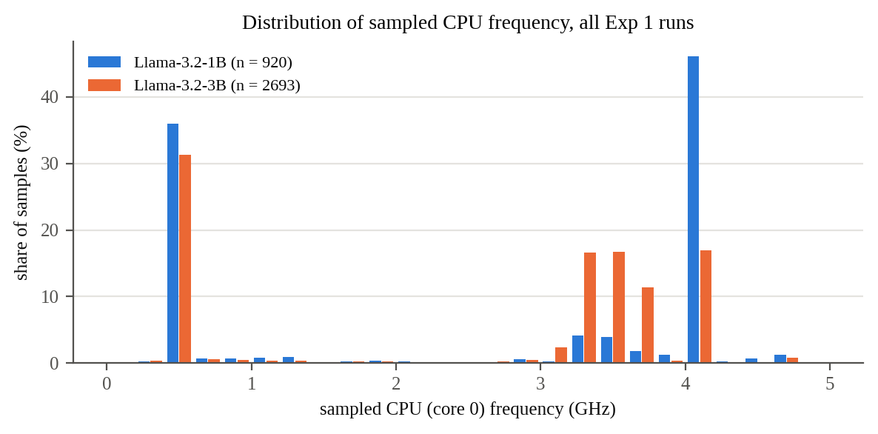
Figure A9. Distribution of sampled CPU (core 0) frequency as a share of samples, all Exp 1 runs and settings (n = 920 samples for 1B, 2693 for 3B).

2. Experiment 2 - Decoding Strategy Comparison
Fixed input (422 actual tokens), 256-token output budget. Strategies: greedy (temp=0), temperature (temp=0.8), top-p / nucleus (temp=0.8, top-p=0.9), top-k (temp=0.8, top-k=40). Sampler defaults explicitly disabled in conditions not testing them. 5 repeats per strategy per model.

2.1 Raw Data (40 runs)
model | strategy | run | output tokens | energy (J) | wall time (s) | avg power (W) | working fn (harness) | working fn (re-scored)
Llama-3.2-1B | greedy | 1 | 256 | 364.2850 | 15.1039 | 24.12 | No | Yes
Llama-3.2-1B | greedy | 2 | 256 | 368.0686 | 16.1137 | 22.84 | No | Yes
Llama-3.2-1B | greedy | 3 | 256 | 369.4711 | 16.1152 | 22.93 | No | Yes
Llama-3.2-1B | greedy | 4 | 256 | 383.6973 | 16.1136 | 23.81 | No | Yes
Llama-3.2-1B | greedy | 5 | 256 | 373.6014 | 16.1142 | 23.18 | No | Yes
Llama-3.2-1B | temperature | 1 | 256 | 373.1240 | 16.1142 | 23.15 | No | Yes
Llama-3.2-1B | temperature | 2 | 256 | 422.0635 | 16.1118 | 26.20 | Yes | Yes
Llama-3.2-1B | temperature | 3 | 256 | 367.4245 | 16.1157 | 22.80 | Yes | Yes
Llama-3.2-1B | temperature | 4 | 256 | 369.1231 | 16.1162 | 22.90 | No | Yes
Llama-3.2-1B | temperature | 5 | 256 | 379.1009 | 16.1154 | 23.52 | No | Yes
Llama-3.2-1B | top_p | 1 | 255 | 371.3917 | 16.1179 | 23.04 | Yes | Yes
Llama-3.2-1B | top_p | 2 | 256 | 369.9975 | 16.1168 | 22.96 | No | Yes
Llama-3.2-1B | top_p | 3 | 256 | 368.1913 | 16.1148 | 22.85 | Yes | Yes
Llama-3.2-1B | top_p | 4 | 256 | 364.6174 | 15.1099 | 24.13 | Yes | Yes
Llama-3.2-1B | top_p | 5 | 256 | 377.2487 | 16.1160 | 23.41 | No | Yes
Llama-3.2-1B | top_k | 1 | 256 | 368.5588 | 16.1158 | 22.87 | Yes | Yes
Llama-3.2-1B | top_k | 2 | 256 | 371.6624 | 16.1153 | 23.06 | Yes | Yes
Llama-3.2-1B | top_k | 3 | 255 | 364.0262 | 15.1104 | 24.09 | Yes | Yes
Llama-3.2-1B | top_k | 4 | 256 | 369.4202 | 16.1162 | 22.92 | No | No
Llama-3.2-1B | top_k | 5 | 256 | 364.4463 | 15.1079 | 24.12 | No | Yes
Llama-3.2-3B | greedy | 1 | 256 | 864.0828 | 43.3355 | 19.94 | No | Yes
Llama-3.2-3B | greedy | 2 | 256 | 838.2815 | 43.3549 | 19.34 | No | Yes
Llama-3.2-3B | greedy | 3 | 256 | 841.4908 | 44.3665 | 18.97 | No | Yes
Llama-3.2-3B | greedy | 4 | 256 | 845.4413 | 44.3654 | 19.06 | No | Yes
Llama-3.2-3B | greedy | 5 | 256 | 836.8921 | 44.3704 | 18.86 | No | Yes
Llama-3.2-3B | temperature | 1 | 256 | 833.1965 | 44.3691 | 18.78 | No | Yes
Llama-3.2-3B | temperature | 2 | 256 | 819.8143 | 45.3866 | 18.06 | Yes | Yes
Llama-3.2-3B | temperature | 3 | 256 | 845.5659 | 45.3809 | 18.63 | Yes | Yes
Llama-3.2-3B | temperature | 4 | 256 | 832.1597 | 44.3749 | 18.75 | Yes | Yes
Llama-3.2-3B | temperature | 5 | 255 | 831.5987 | 44.3717 | 18.74 | No | No
Llama-3.2-3B | top_p | 1 | 256 | 773.8200 | 46.4188 | 16.67 | No | No
Llama-3.2-3B | top_p | 2 | 256 | 853.9860 | 44.3690 | 19.25 | No | Yes
Llama-3.2-3B | top_p | 3 | 256 | 818.6498 | 45.3898 | 18.04 | No | No
Llama-3.2-3B | top_p | 4 | 256 | 828.8241 | 44.3689 | 18.68 | Yes | Yes
Llama-3.2-3B | top_p | 5 | 256 | 811.3112 | 45.3911 | 17.87 | No | Yes
Llama-3.2-3B | top_k | 1 | 256 | 811.3129 | 44.3842 | 18.28 | Yes | Yes
Llama-3.2-3B | top_k | 2 | 256 | 769.1924 | 46.4121 | 16.57 | Yes | Yes
Llama-3.2-3B | top_k | 3 | 256 | 841.3791 | 44.3689 | 18.96 | Yes | Yes
Llama-3.2-3B | top_k | 4 | 256 | 769.7257 | 46.4148 | 16.58 | No | No
Llama-3.2-3B | top_k | 5 | 256 | 842.1445 | 44.3689 | 18.98 | Yes | Yes
"Working function" replaces week 3's "reached return?": the generated code is extracted and the function must correctly sort 7 test lists. "Harness" is the check recorded during the run (scripts from commit 7d8b567, unchanged through eed365e), which fails any output cut off mid example-usage line even when the function above it is complete. "Re-scored" is scripts/rescore_code.py on the saved outputs (results/*/all_models_rescored.csv, column passes_tests_v2): it drops the unparseable trailing lines first, so a function that is itself cut off still fails. Summaries and Figure C1 use the re-scored column.

2.2 Summary Statistics by Strategy and Model
strategy | 1B avg energy (J) | 1B avg power (W) | 1B working (harness / re-scored) | 3B avg energy (J) | 3B avg power (W) | 3B working (harness / re-scored) | 3B / 1B energy
greedy | 371.8 ± 7.4 | 23.38 | 0 / 5 of 5 | 845.2 ± 11.0 | 19.23 | 0 / 5 of 5 | 2.27x
temperature | 382.2 ± 22.8 | 23.72 | 2 / 5 of 5 | 832.5 ± 9.1 | 18.59 | 3 / 4 of 5 | 2.18x
top_p | 370.3 ± 4.6 | 23.28 | 3 / 5 of 5 | 817.3 ± 29.2 | 18.10 | 1 / 3 of 5 | 2.21x
top_k | 367.6 ± 3.3 | 23.41 | 3 / 4 of 5 | 806.8 ± 36.2 | 17.88 | 4 / 4 of 5 | 2.19x
± is the standard deviation across the 5 runs. Every run of both models used the full 256-token budget.
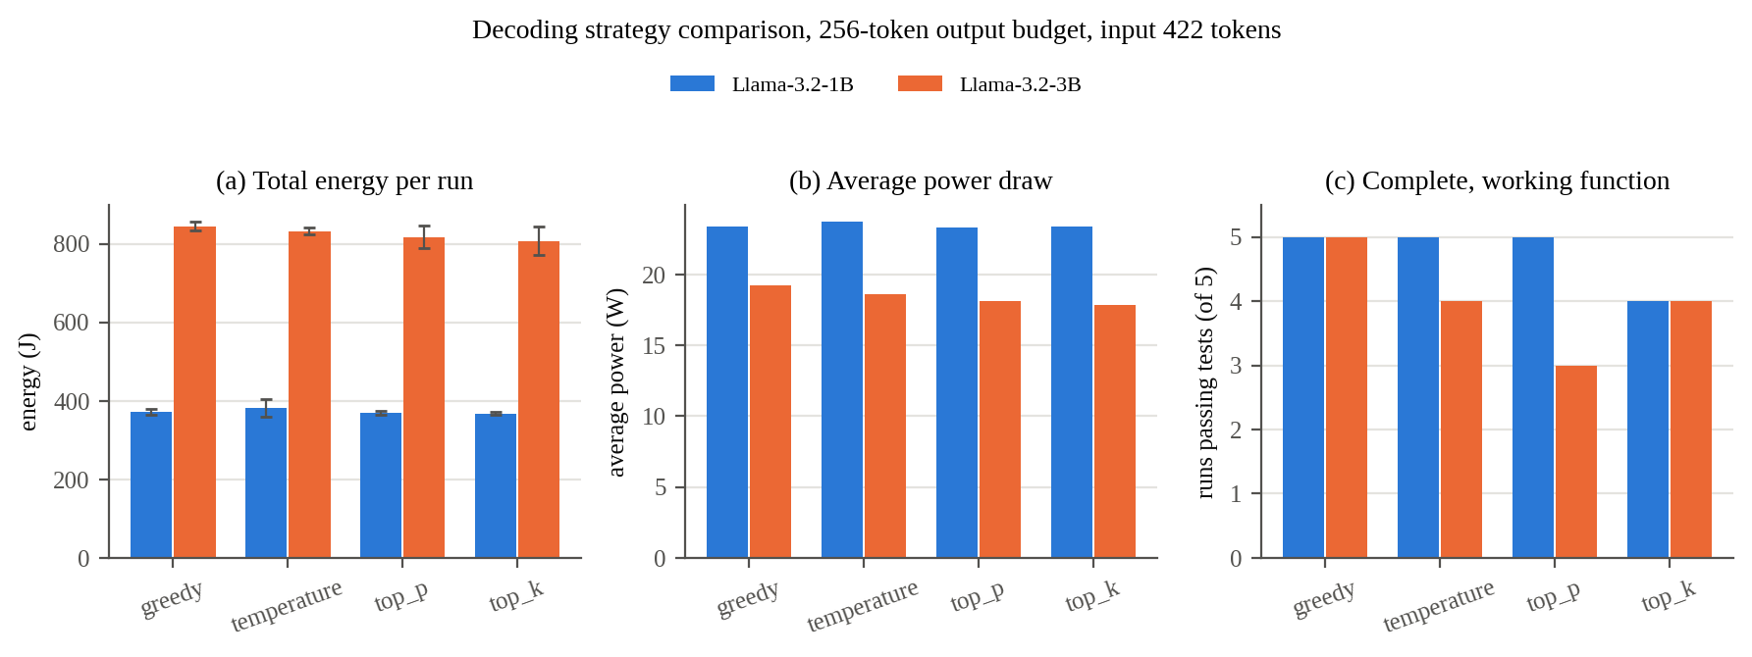
Figure C1. Total energy with ± 1 SD (a), average power draw (b), and runs producing a complete, working function (c) by decoding strategy, both models.

3. Experiment 3 - Energy per Completed Task (new)
Bare task prompt ("Write a function to sort a list of numbers using bubble sort.", 13 tokens, no padding). Output cap 1024 tokens; the model stops when it decides it is done. Same sampling for both models (temp=0.6, top-p=0.95). 5 runs per model.

3.1 Raw Data (10 runs)
model | run | output tokens | energy (J) | wall time (s) | avg power (W) | decode (tok/s) | working fn (harness) | working fn (re-scored)
Llama-3.2-1B | 1 | 587 | 585.1587 | 25.1719 | 23.25 | 25.1 | Yes | Yes
Llama-3.2-1B | 2 | 371 | 358.6411 | 16.1121 | 22.26 | 27.2 | Yes | Yes
Llama-3.2-1B | 3 | 521 | 511.6529 | 22.1575 | 23.09 | 25.5 | Yes | Yes
Llama-3.2-1B | 4 | 450 | 430.3362 | 19.1379 | 22.49 | 27.1 | Yes | Yes
Llama-3.2-1B | 5 | 488 | 481.3652 | 21.1549 | 22.75 | 26.0 | Yes | Yes
Llama-3.2-3B | 1 | 557 | 1330.3389 | 58.4003 | 22.78 | 10.2 | Yes | Yes
Llama-3.2-3B | 2 | 503 | 1131.3655 | 51.3890 | 22.02 | 10.4 | Yes | Yes
Llama-3.2-3B | 3 | 574 | 1193.1955 | 62.5074 | 19.09 | 9.7 | Yes | Yes
Llama-3.2-3B | 4 | 447 | 974.5343 | 48.3793 | 20.14 | 9.9 | Yes | Yes
Llama-3.2-3B | 5 | 514 | 1068.9811 | 59.4914 | 17.97 | 9.2 | Yes | Yes

3.2 Summary Statistics
 | Llama-3.2-1B | Llama-3.2-3B | 3B / 1B
Energy per task (J), mean ± SD | 473.4 ± 85.2 | 1139.7 ± 133.7 | 2.41x
Output tokens, mean ± SD | 483.4 ± 80.5 | 519.0 ± 49.8 | 1.07x
Energy per output token (J) | 0.978 | 2.195 | 2.25x
Wall time per task (s) | 20.7 | 56.0 | 2.70x
Average power (W) | 22.77 | 20.40 | 0.90x
Decode speed (tok/s) | 26.2 | 9.9 | 0.38x
Working function (harness / re-scored) | 5 / 5 of 5 | 5 / 5 of 5 | -
Energy vs. output tokens fit (slope, R²) | 1.057 J/tok, 0.997 | 2.272 J/tok, 0.716 | -
Energy per output token here includes the fixed overhead spread over the output, so it is higher than the decode marginal cost in 1.3. With only 5 runs per model the fit in the last row is indicative only.
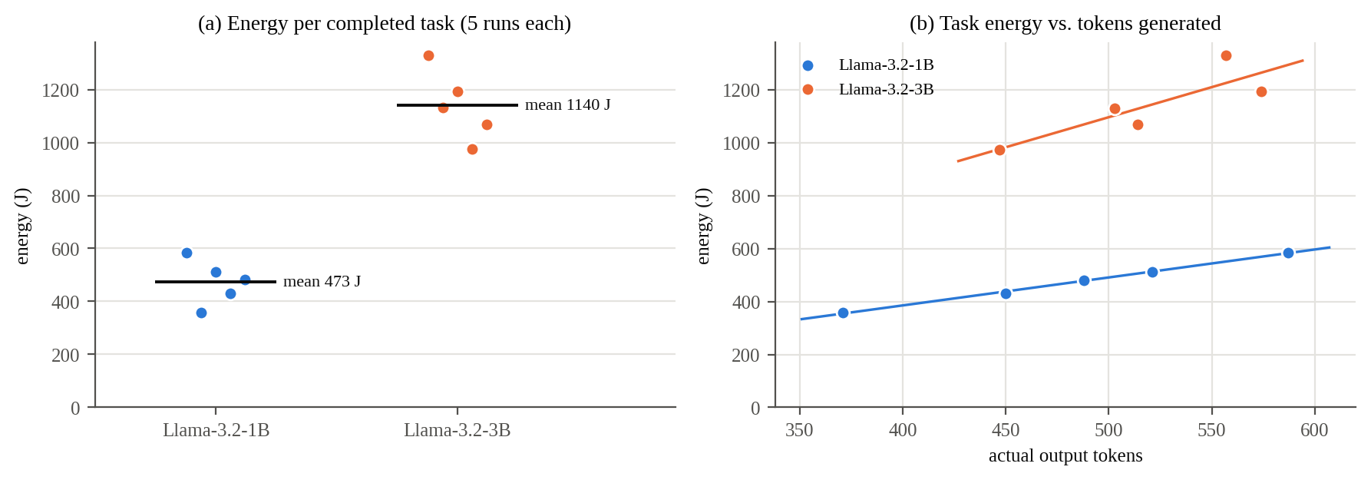
Figure D1. Energy per completed task, individual runs and mean (a), and task energy vs. number of tokens generated with per-model linear fit (b).

4. Cross-Model Summary
metric | Llama-3.2-1B | Llama-3.2-3B | 3B / 1B
Parameters (approx.) | 1.2 B | 3.2 B | 2.6x
Decode marginal cost (J/token) | 0.875 | 1.880 | 2.15x
Prefill marginal cost (J/token) | 0.238 | 0.536 | 2.26x
Constant overhead per run (J) | 131 | 305 | 2.32x
Decode speed at 104 / 1693 input tokens (tok/s) | 27.0 / 16.3 | 10.6 / 6.1 | 0.39x / 0.37x
Average power, Exp 1 output sweep (W) | 22.6 | 18.4 | 0.81x
Exp 2 mean energy per 256-token run (J) | 373.0 | 825.4 | 2.21x
Exp 2 working functions, of 20 (harness / re-scored) | 8 / 19 | 8 / 16 | -
Exp 3 energy per completed task (J) | 473.4 | 1139.7 | 2.41x
Exp 3 working functions, of 5 (harness / re-scored) | 5 / 5 | 5 / 5 | -

Data notes
- Code checks are shown twice: as recorded by the harness during the runs (scripts from commit 7d8b567, unchanged through eed365e), and re-scored from the saved outputs with the fixed checker (scripts/rescore_code.py -> *_rescored.csv, column passes_tests_v2; originals untouched). The harness failed every run whose output ended mid example-usage line even when the function was complete, e.g. all 5 greedy runs per model. Exp 3 is unaffected (identical in both).
- The llama_cpp_commit field in these runs' meta.txt files is the fyp repo commit at the time (c18adb8 for 1B, 0d96dbc for 3B), not the llama.cpp build: the harness picked up the enclosing git repo. Both models ran the same llama.cpp binary path.
- Week 3 vs. week 5 (Llama-3.2-1B): decode slope 0.76 -> 0.87 J/token and overhead 168 -> 131 J. Week 5 has more points and 5 repeats, and extracted text is now stripped of carriage returns (slightly changes token counts), so treat direct week 3 comparisons with care.

