PAPER FORMAT OF EXTENDED ABSTRACT FOR
SCaLE CONFERENCE PROCEEDINGS 2026
(TIMES NEW ROMAN, 14 FONT SIZE, BOLD, ALL CAPS, CENTERED)

Author’s Name and Surname¹, Author’s Name and Surname² (11 Font Size)
¹Affiliation, Department, Institution, Country – Email
²Affiliation, Department, Institution, Country – Email

ABSTRACT (Times New Roman, 12 pt, all caps, bold, left aligned)
These instructions provide the basic guidelines for preparing extended abstracts for the SCALE Conference Proceedings 2026. The abstract should be between 200–250 words and written in Times New Roman, 11 pt, single line spacing, and justified alignment. It should clearly summarize the objective, methodology, key findings, and contribution of the study. The abstract must be concise and self-contained without citations.
Keywords: A maximum of five keywords should be provided in 11 font size and separated with semi-colon.

INTRODUCTION (Times New Roman, 12 pt, all caps, bold, left aligned)
Extended abstracts should include the following sections: abstract and keywords, introduction and objective, methodology, results and discussion, and conclusion. Each section should be clearly defined and logically organized to reflect the study’s contribution. The document must be written in Times New Roman, 11 pt font, with single line spacing and justified alignment. Figures, tables, equations, and images may be included where necessary. The page format should be B5 size with moderate (top & bottom: 1” and right & left: 0.75”) margins on all sides. Text should be fully justified without hyphenation or syllable breaks. The extended abstract must not exceed three (3) pages, including references, and page numbers should not be included.
Authors should review relevant literature and clearly identify the research gap, novelty, and contribution of their work in the introduction section.

METHODOLOGY (Times New Roman, 12 pt, all caps, bold, left aligned)
This section should describe the methodology used in the study in sufficient detail to ensure reproducibility. Data sources, modeling approaches, simulation techniques, experimental design, or analytical frameworks should be clearly explained.

Subsection Title (11 pt, bold, title case, left aligned)
First degree titles (2.) should be written left aligned, all caps and bold. Second and 3rd degree subtitles (2.1, 2.1.1) should be written left aligned, bold and with title case. A blank line should be placed between the paragraphs and there should not be any paragraph indentation.

RESULTS AND DISCUSSION (Times New Roman, 12 pt, all caps, bold, left aligned)

Figure Guidelines (11 pt, bold, title case, left aligned)
All figures and images should be centered and numbered consecutively (e.g., Figure 1). Figure captions should be placed below the figure, centered, and written in italic. References for figures and tables, if applicable, should be provided below the caption using the author’s surname and publication year.

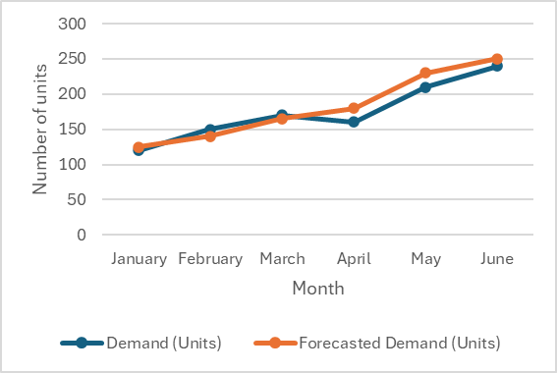
Figure 1: Figure Caption (9 pt, italic, centered)

Table Guidelines (11 pt, bold, title case, left aligned)
All tables should be centered and numbered consecutively (e.g., Table 1). Table titles should be placed above the table, centered, and written in italic. Sources, if any, should be indicated below the table using author surname and publication year.

Table 1: Table Caption (9 pt, italic, centered)
Parameter | Unit | Minimum | Maximum
Temperature | °C | 20 | 80
Processing time | min | 10 | 60
Flow rate | L/min | 0.5 | 2.0
Reference: author’s surname and publication date (e.g.: Smith, 2024)

CONCLUSION (Times New Roman, 12 pt, all caps, bold, left aligned)
This section should briefly summarize the key findings of the study (3–5 lines). It should also highlight practical implications and suggest directions for future research.
ACKNOWLEDGEMENT
Authors may acknowledge funding agencies, institutional support, or individuals who contributed to the work.
REFERENCES
References should be listed in order of appearance in the text and should not exceed 15 entries. Citations in the text should be numbered in square brackets [1]. The references should be formatted according to the following examples:

Journal Article Example;
1. Mentzer, J. T., DeWitt, W., Keebler, J. S., Min, S., Nix, N. W., Smith, C. D., & Zacharia, Z. G. (2001). Defining supply chain management. Journal of Business logistics, 22(2), 1-25.

Book Example;
2. Chopra, S., & Meindl, P. (2001). Strategy, planning, and operation. Supply Chain Management, 15(5), 71-85.

Book Chapter Example;
3. Zijm, H., Klumpp, M., Clausen, U., & Hompel, M. T. (2015). Logistics and supply chain innovation. Lecture Notes in Logistics. Springer, Cham.

Conference/ Declaration Example;
4. Timm, I. J., & Lorig, F. (2015, December). Logistics 4.0-A challenge for simulation. In 2015 Winter Simulation Conference (WSC) (pp. 3118-3119). IEEE.

