Research Article Title (Times New Roman, 14 point, title case, bold)
First Author^{1*}[ORCID iD] and Second Author²[ORCID iD]
¹ Affiliation of Author 1, Institution, City, Country
² Affiliation of Author 2, Institution, City, Country
*email of correspondingauthor
Abstract. The abstract should be between 200–250 words and written in Times New Roman, 9 pt, single line spacing, and justified alignment. It should clearly summarize the objective, methodology, key findings, and contribution of the study.
Keywords: First keyword, Second keyword, Third keyword… (up to five keywords)
- First Section (First Level - Times New Roman, 12 pt, title case, bold)
  - A Subsection Title (Second Level - Times New Roman, 10 pt, title case, bold)
The document must be written in Times New Roman, 11 pt font, with single line spacing and justified alignment. Figures, tables, equations, and images may be included where necessary. Please note that the first paragraph of a section or subsection is not indented. The first paragraphs that follow a table, figure, equation etc. does not have an indent, either.
Subsequent paragraphs, however, are indented. The article must not exceed fifteen (15) pages, including references.

Sample Heading (Third Level – Times New Roman, 10 pt, title case, bold)).
Only two levels of headings should be numbered. Lower-level headings remain unnumbered; they are formatted as run-in headings.

Sample Heading (Forth Level - Times New Roman, 10 pt, Title case, italic).
The research article should contain no more than four levels of headings. The following Table 1 gives a summary of all heading levels. All tables should be centered and numbered consecutively. Table titles should be placed above the table, centered, and written in italic. Sources, if any, should be indicated below the table using author surname and publication year.

Table 1. Table captions should be placed above the tables.
Level | Font size & style | Style example
First level | 12 pt, title case, bold | - Times New Roman
Second level | 10 pt, title case, bold | - Times New Roman
Third level | 10 pt, title case, bold | Times New Roman
Fourth level | 10 pt, title case, italic | Times New Roman
Displayed equations should be centered, placed on a separate line, and numbered consecutively.
$E=mc^{2}$ (1)
All figures and images should be centered and numbered consecutively (see Fig. 1). Figure captions should be placed below the figure. Short captions are centered, while long ones are justified. References for figures and tables, if applicable, should be provided below the caption using the author’s surname and publication year.
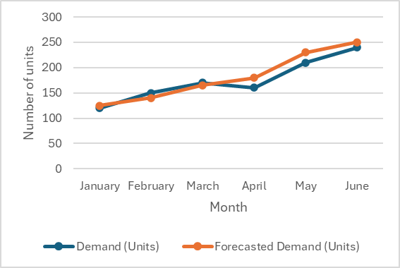
Fig. 1. A figure should be placed below the illustration.
The citations of references should use square brackets with consecutive numbering. The following bibliography provides a sample reference list with entries for journal articles [1], a book chapter [2], a book [3], proceedings without editors [4], as well as a URL [5]. It is desirable to include the DOI for each reference.
Acknowledgments. A third-level heading in 9-point font size should be used at the end of the paper for general acknowledgments. For example: This study was funded by X (grant number Y).
Disclosure of Interests. It is required to declare any competing interests, or explicitly state that the authors have none. This statement should appear under a third-level heading in 9-point font size below the (optional) Acknowledgments section. For example: The authors declare no competing interests relevant to the content of this article. Alternatively: Author A has received research grants from Company W; Author B has received a speaker honorarium from Company X and holds stock in Company Y; Author C is a member of committee Z.

References
- Author, F.: Article title. Journal 2(5), 99–110 (year). DOI…
- Author, F., Author, S.: Title of a proceedings paper. In: Editor, F., Editor, S. (eds.) Conference, vol. 9999, pp. 1–13. Publisher, Location (year). DOI…
- Author, F., Author, S., Author, T.: Book title. 2nd edn. Publisher, Location (year). DOI…
- Author, F.: Article title. In: Xth International Proceedings on Proceedings, pp. 1–2. Publisher, Location (year). DOI…
- Website homepage, http://www.url.com/homepage, last accessed date: year/month/date

