Career



**Life at Botsuite**

Technology is most powerful when it empowers everyone. Botsuite, where individual imaginations gather together to pave the way to innovation. We are on a journey to stimulate passionate individuals, entrepreneurs & revolutionize the business ecosystem & serve them better every single day.

See Open Roles (button)



Pictures of workspace & team activities like on About Page

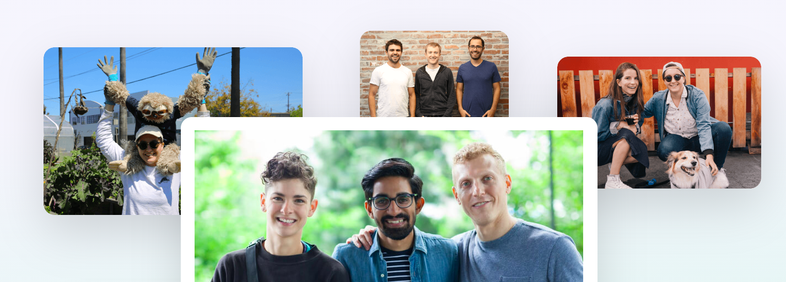

**The Company Culture**

We know when we’re healthy and happy we do our best work.

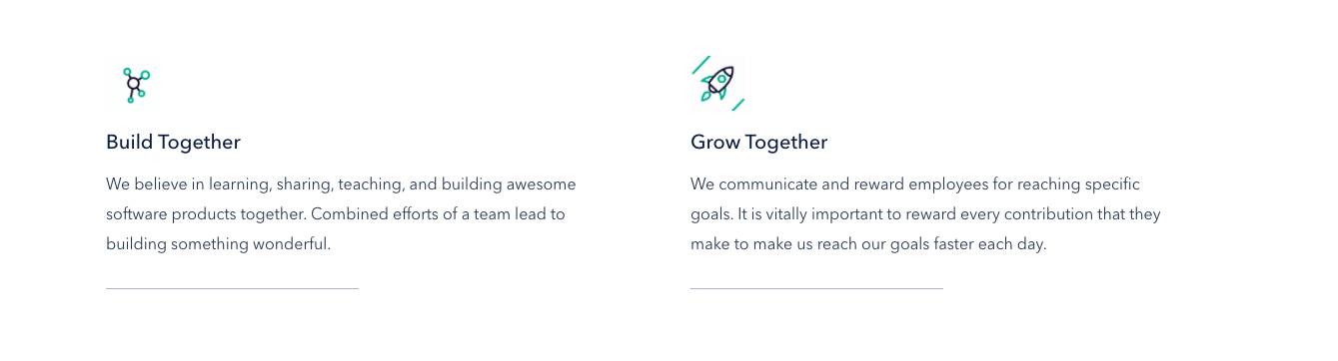

Work Hard, Party Harder

We produce awesomeness and we do it together for our customers. But we party even harder! Celebrate every moment, celebrate every success, celebrate every learning, together!

Grow Together

Communicate, plan, execute and reward! Success is the byproduct of process and we make sure to follow the process thoroughly. We deliver and then reward our team mates who help us in attaining the goals.

**Explore Opportunities**

An open invitation to open minds

Tabs - All Jobs, Engineering & Technology, Marketing, Support

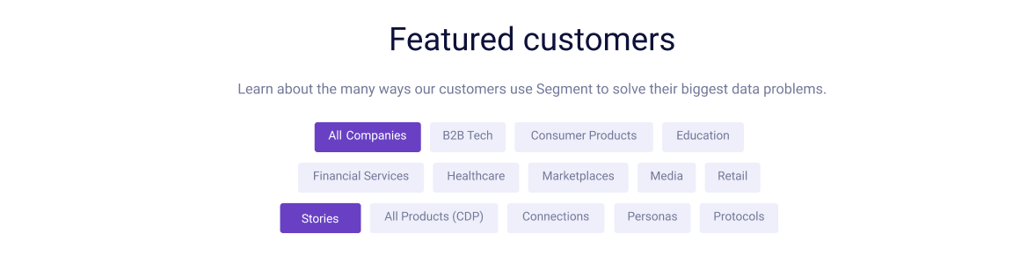

----------------------------------------------------------------------------------------

Tiles below will show up as per the clicks above. By default it will be on all jobs.

-----------------------------------------------------------------------------------------

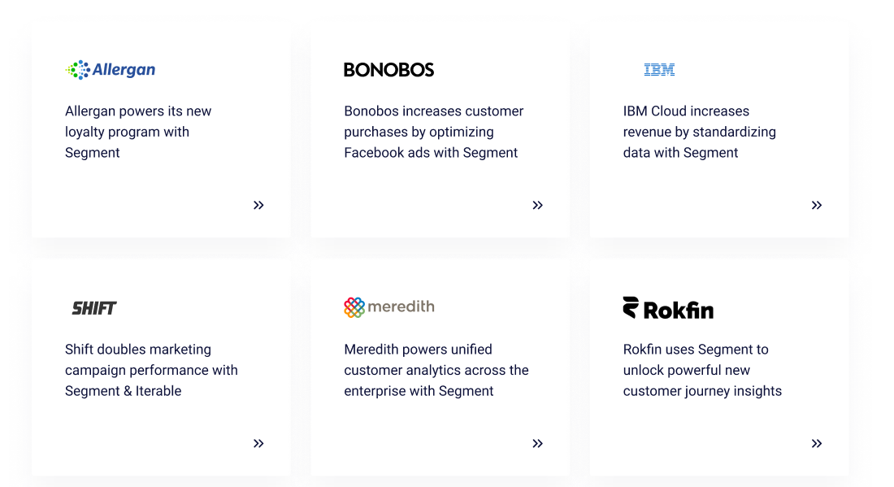

Engineering & Technology - Full-Stack Developer, Sr. Software Developer

Marketing - Business Development Executive, Product Marketing Manager

Support - Customer Happiness Hero

## **Our offices**

Headquarters are in New Delhi, but we have four other offices, including in Sydney, Toronto, California, London

Reference for map:-

<https://segment.com/careers/?ref=nav>