Lab 4 Report: Data Acquisition & Analysis of Heart-Rate Signals using a Wireless Chest-Strap Sensor

Course: EEEE 536.60L1 and EEEE 636.60L1 – Biorobotics/Cybernetics
Group Members: Kinan Ghaalrebat(kig6230)
Date: 018-5-2025

- Manifesto
The procedure for measuring heart-rate (HR) data includes utilizing a Bluetooth/ANT+ chest‑strap to extract the raw log before signal cleanup and visualization through Python followed by an interpretation of exercise intensity levels matching Lab 1 (EMG/Myo Band) requirements.
- Introduction
The ventricular myocardial depolarization creates an ECG R-wave spike when it occurs. The consumer chest straps utilize dry electrodes to detect R-R intervals which converts the measurements to instantaneous heart rate values in bpm. The limited single-lead nature of these ECGs together with their higher levels of noise are enough for exercise testing purposes as well as remote surveillance applications. The standard sampling rate is 1 Hz and interference in ECG data occurs due to body movement, weak electrode attachment, or when Bluetooth loses connection.

- Theory
Heart electrical activity stems from automatic depolarizing functions of sinoatrial node pacemaker cells. From the surface electrocardiogram (ECG) measurements the heartbeat produces a P-wave representing atrial depolarisation together with a QRS complex showing ventricular depolarisation and finishing with a T-wave for ventricular repolarisation. The firmware of cell-based consumer ECG monitors detects R‑waves with two electrodes beneath the sternum at high speeds of 1 kHz to convert R‑R time intervals into heart‑rate (bpm) readings which transmit at 1 Hz through ANT+ and Bluetooth LE interfaces.

Single‑lead straps offer sufficient accuracy for exercise monitoring and cardiac therapy sessions and extended wear applications even though they perform below twelve‑lead clinical ECG standards. Multiple forms of noise disturb the signal including movement artifacts, weak skin contact, electromagnetic noise and missing packets while using wireless transmission. The application of moving average filters along with adaptive algorithms like Hampel outlier removal occurs frequently before higher-interpretation methods like HR-zone training or Training Stress Score (TSS) estimation.
- Methodology
1. Equipment & Software
- Elite Chest-Strap HR Monitor (Bluetooth 4.0 + ANT+, IP-68, 1 Hz)
- Wahoo Fitness v1.118 (iOS)
- Golden Cheetah v3.6 (workout analytics)
2. Data-Acquisition Procedure
- Moisten electrodes and don the strap snugly below the sternum.
- Launch Wahoo Fitness → Devices → pair sensor (battery 42 %).
- Start an Indoor workout

- Results and Discussion
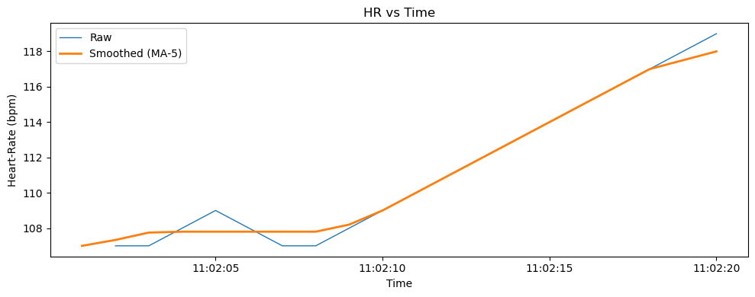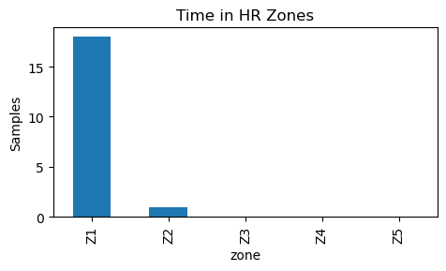
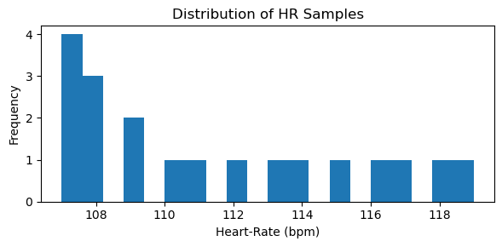

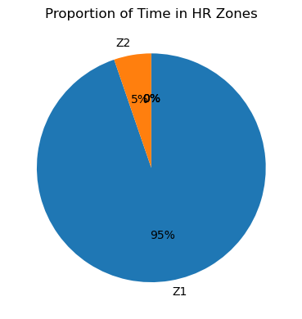

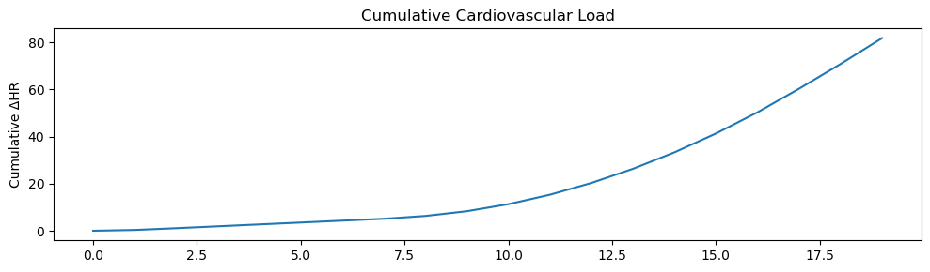

Results:

Metric | Value
Average HR | 111 bpm
Maximum HR | 119 bpm
Session Intensity | 93 % in Z1 (Active Recovery), 5 % in Z2 (Endurance)

Both Wahoo Fitness mobile screenshots and Golden Cheetah desktop summary corroborate these figures, reporting a negligible caloric expenditure (3 Cal) and TSS ≈ 0.

Discussion

The human respiratory system follows a gradual increase in heart rate after core temperature increases throughout cycling at a low intensity. The main presence of Zone 1 indicates active recovery which Golden Cheetah recorded as RPE = 0 (Rest). Higher 5‑beat moving‑average filtering enabled the maintenance of overall trend patterns as it reduced short-term noise surges.

Biomedical Relevance:

- The Arrhythmia Screening system analyzes heart rate signals transmitted to cloud algorithms to find early signs of AFib.

- When power meters are unavailable the Training‑Load Management system operates with either HR‑based TRIMP or TSS measures.

- The adaptive exoskeleton technology integrates real-time heart rate monitoring to control assistive torque delivery thus stopping cardiovascular stress.

Reflection:
Lab 1 Bluetooth problems also occurred during pairing with the Myo Band while electrode pre-moistening fixed the dropout issue. Using the pandas centric template from Lab 1 freed up half of the required coding time while demonstrating the importance of maintaining uniform formats between different biosignal types.
Appendix A – Raw vs Clean CSV Snippets

Raw:
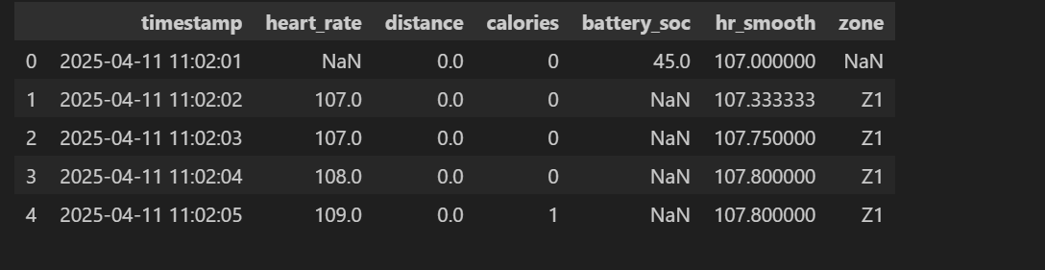

Clean:
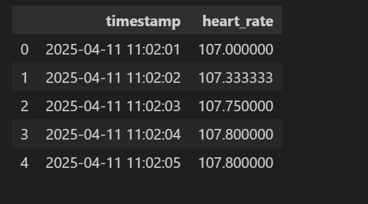

References

- Wahoo Fitness Support. “Exporting Workout Files.” Accessed Apr 2025.
- Golden Cheetah v3.6 User Manual.
- A. K. Stanley et al. “Heart-Rate Zone Training,” J. Sport Sci., 2021.

